Ryan Christopher
CS695 – Lab 5

Web Browser Security



Table of Contents:

1 Title Page

2 Table of Contents

3 Part 1 – History

9 Part 2 – Tracker and Cookies

13 Part 3 – Firefox Privacy Add-ons

17 Part 4 – Security

22 Questions

27 Reflection

Part 1 – History
1)

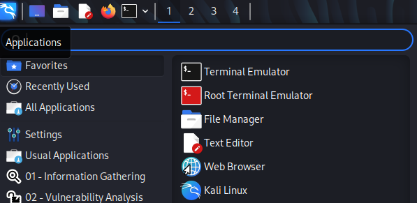

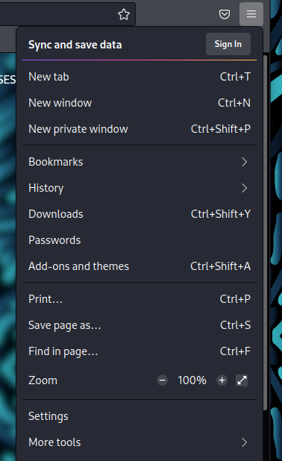

2)
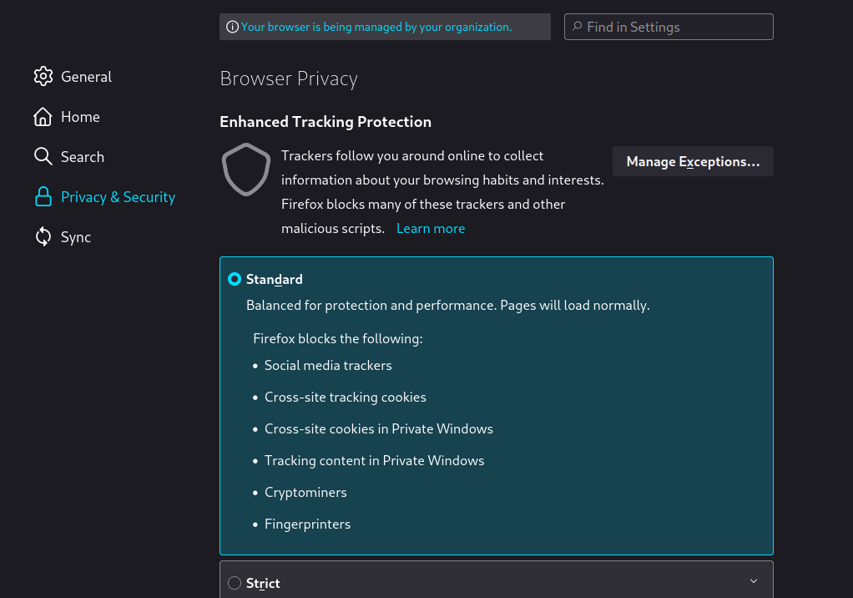
3)
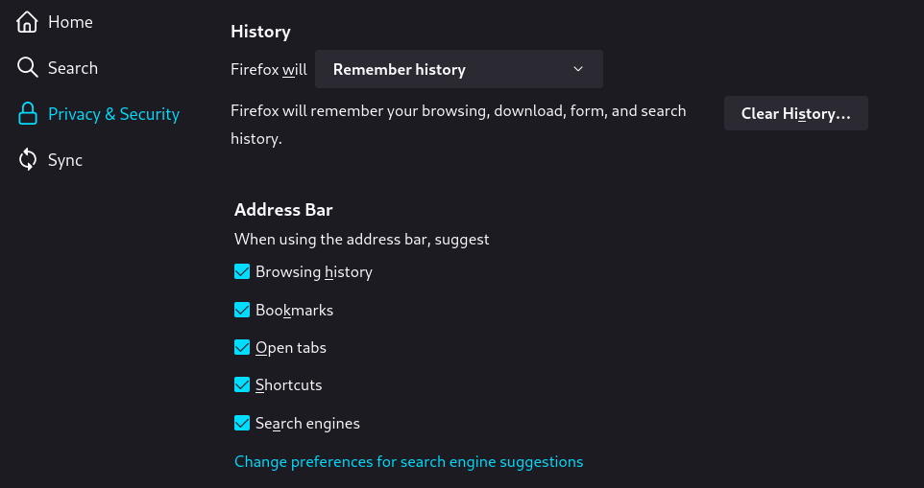
4)
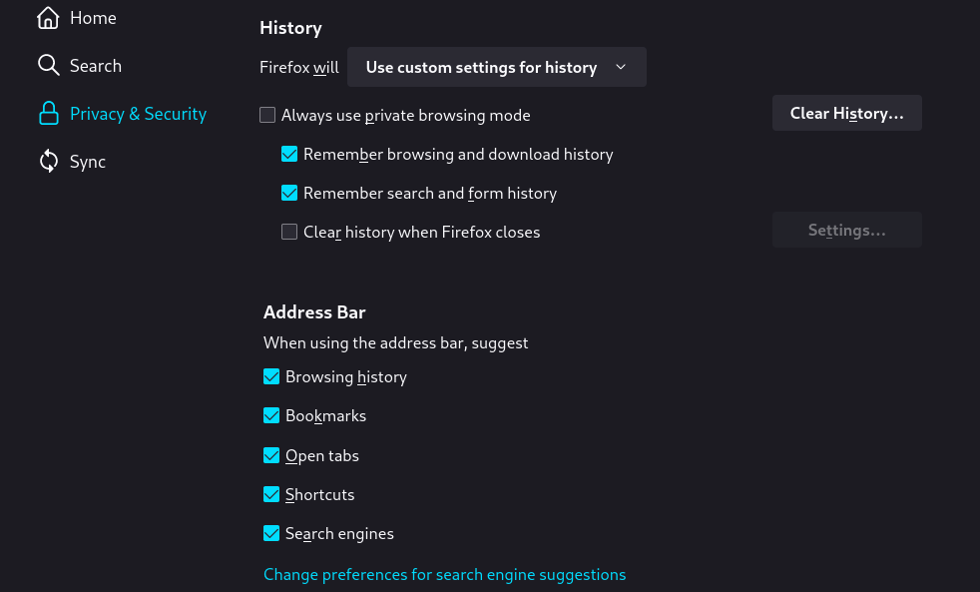

5)
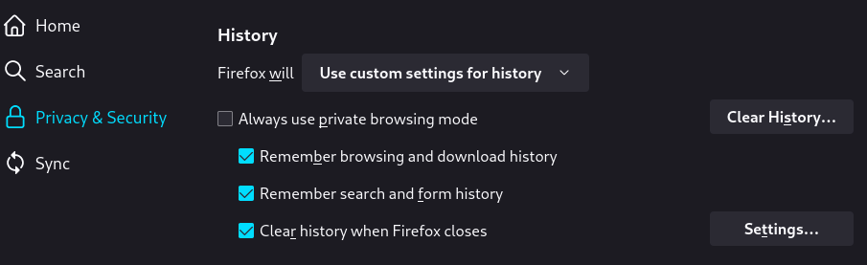
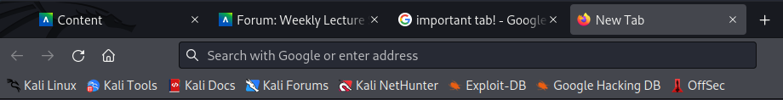
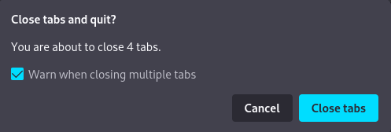
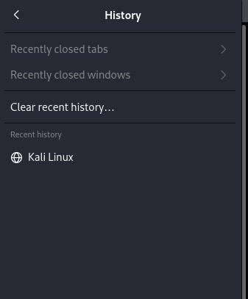
Despite having had four tabs open (3 of which with addresses), when I closed Firefox and reopened it there was no record of them in the history tab. Additionally, when I went to close Firefox, it provided a warning that normally isn’t there since the history of the tabs was not going to be kept.

6)
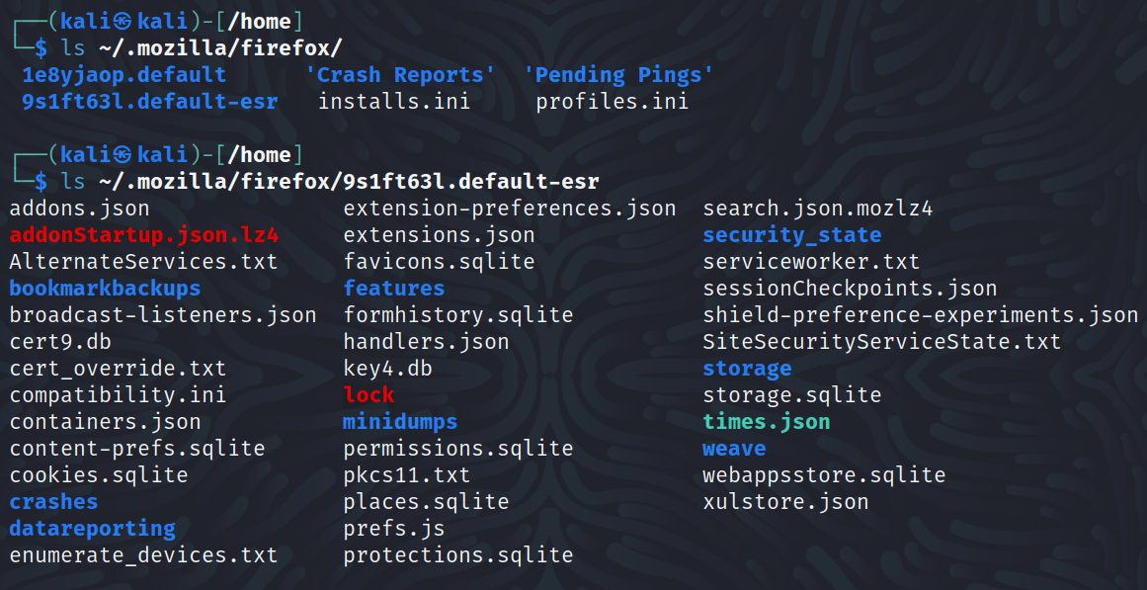

7)
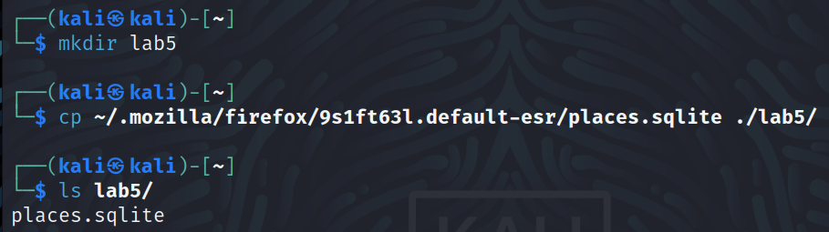
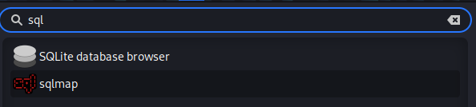

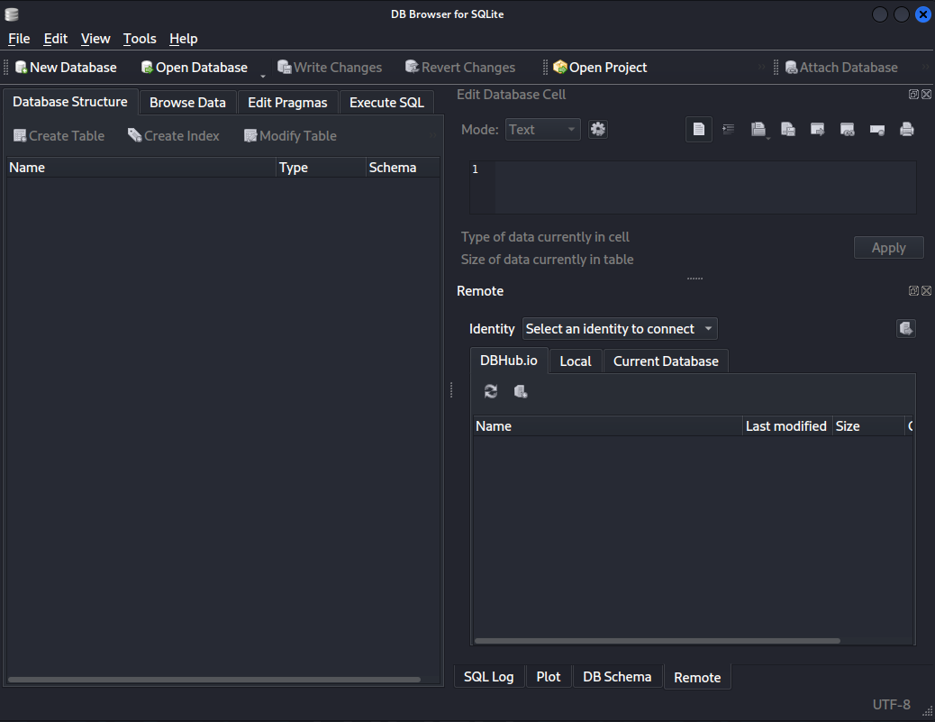
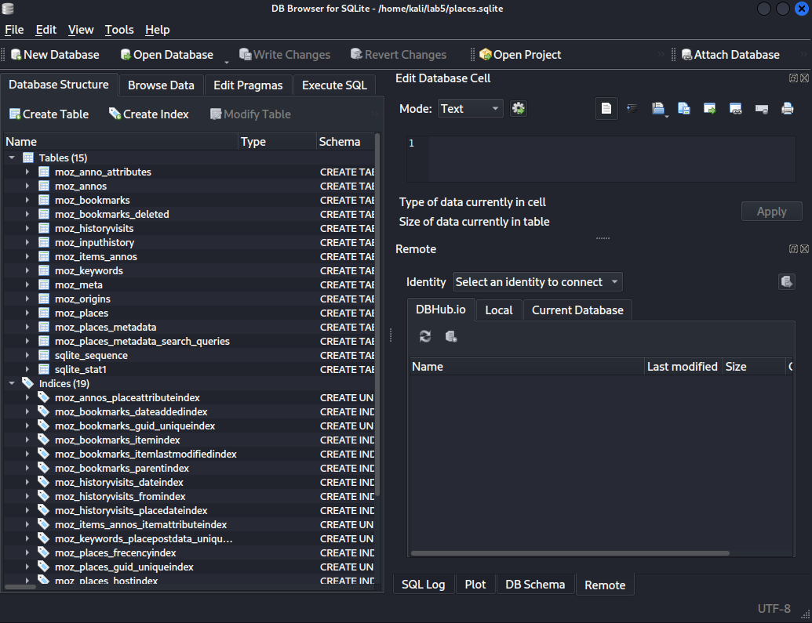
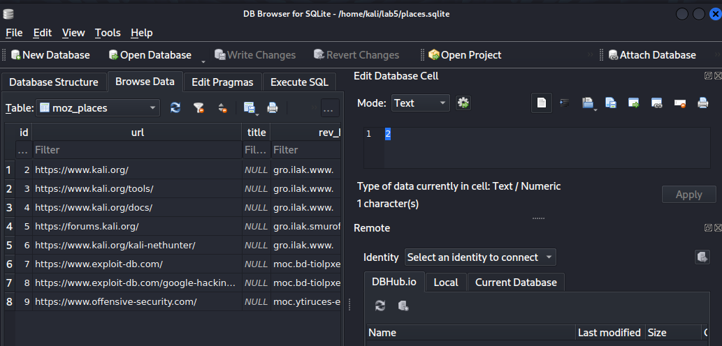

8)
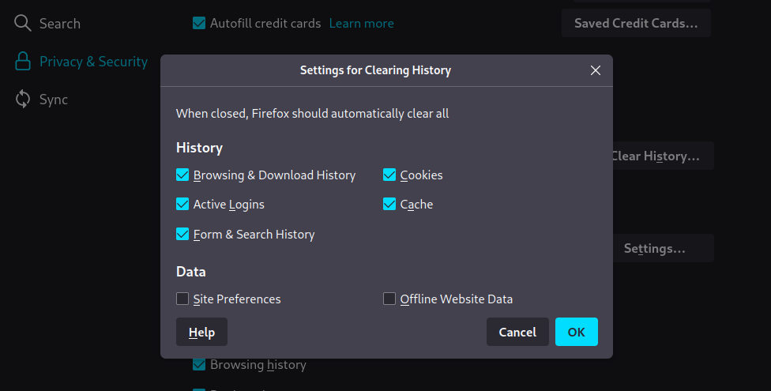

Part 2 – Tracker and Cookies
9)
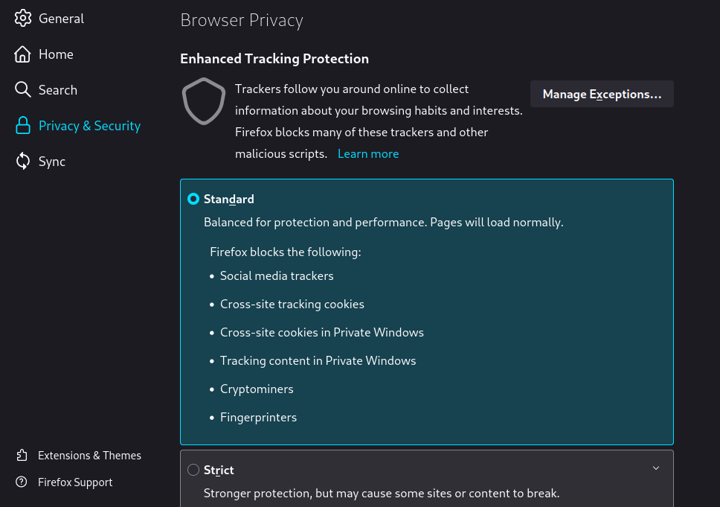

10)
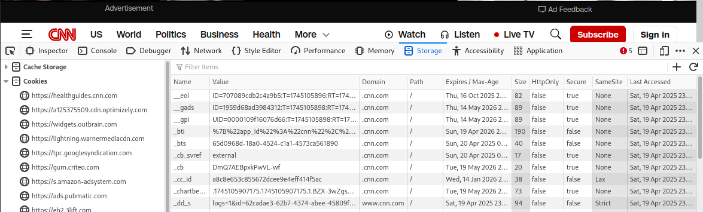

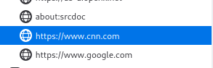

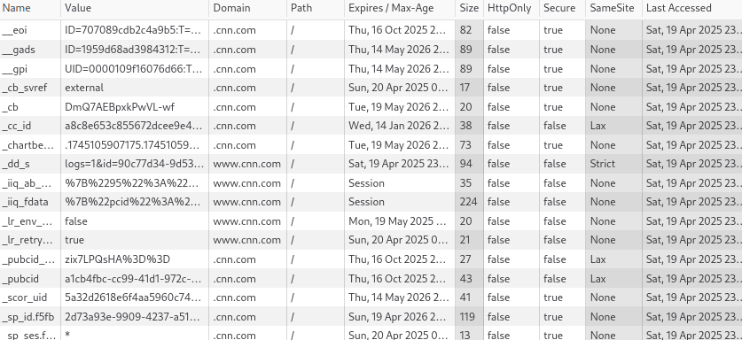
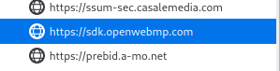
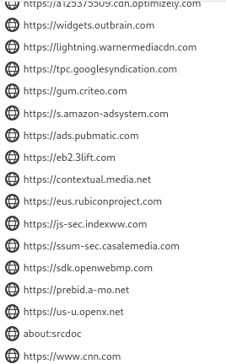

11)
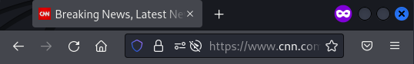
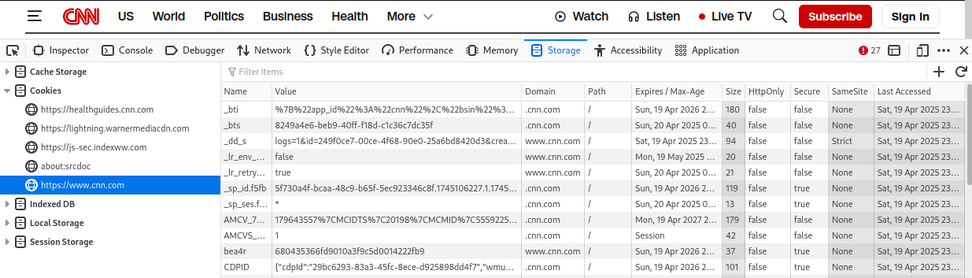

12)
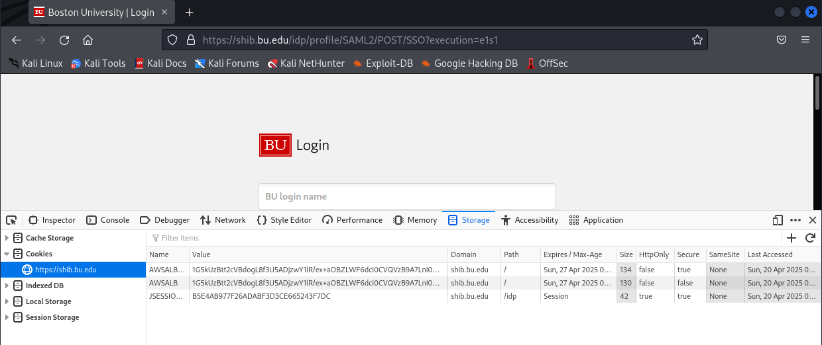
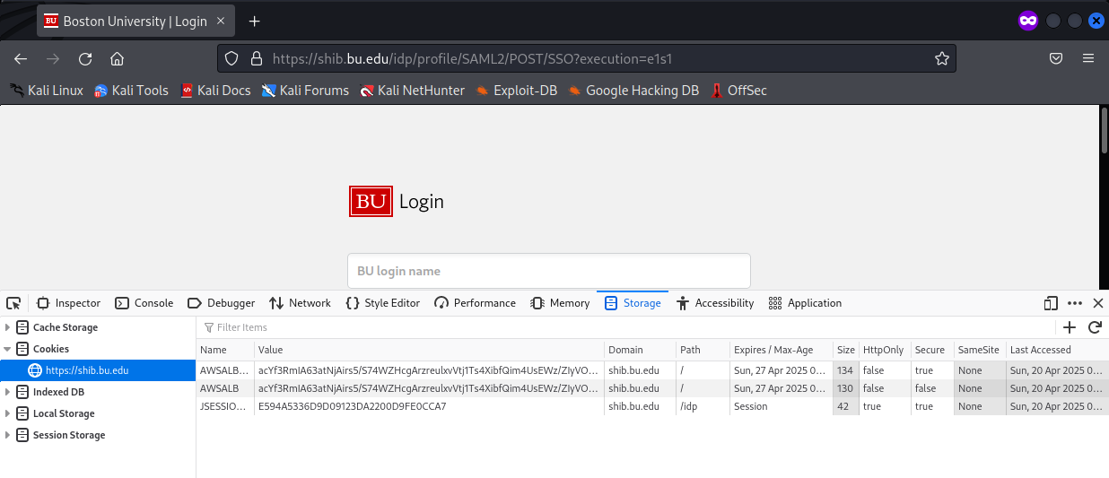

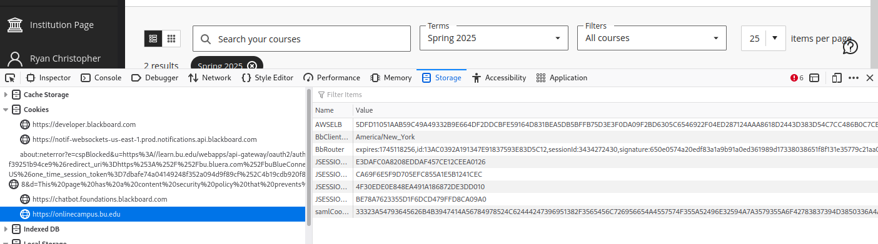
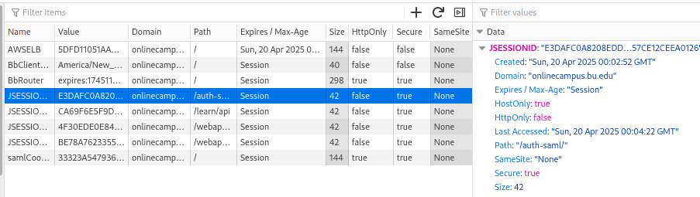

13)
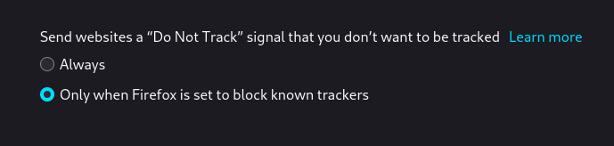
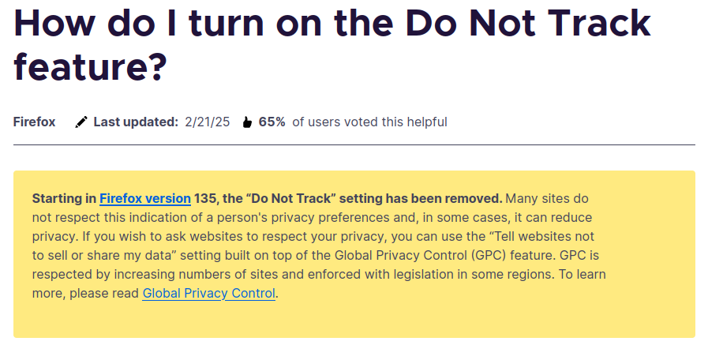
Interestingly, after clicking on the “learn more” link, Mozilla included a disclaimer that the “Do Not Track” setting will be removed starting in Firefox version 135.

Part 3 – Firefox Privacy Add-ons
14)
Initially, the page would not load and I would get stuck on a cloudflare “verifying you are a human” page that would freeze. I tried changing the network from bridged connection to NAT, and that seemed to fix the issue.

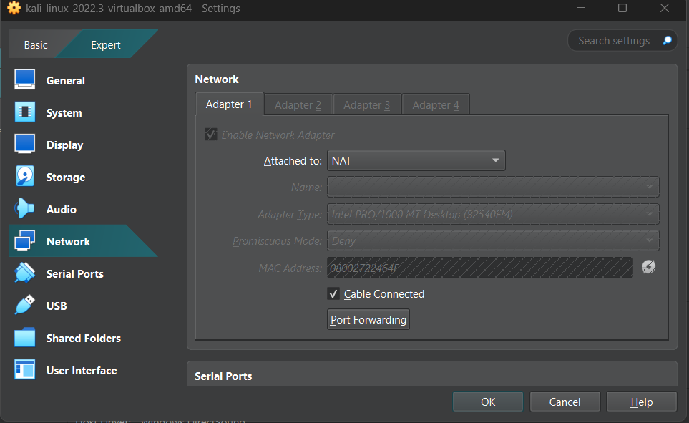
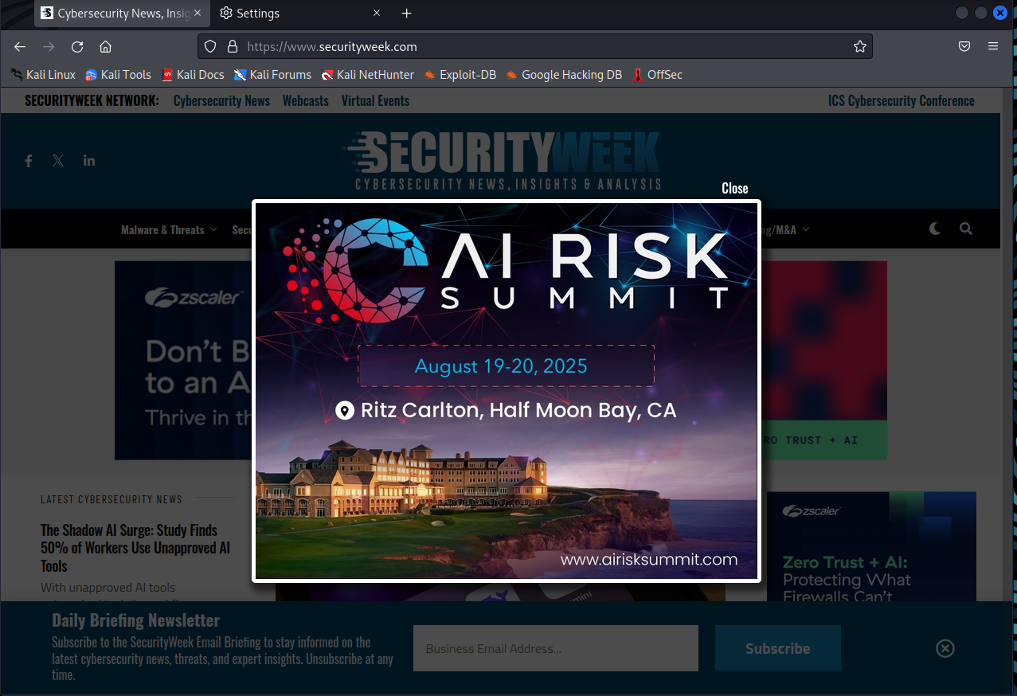

15)
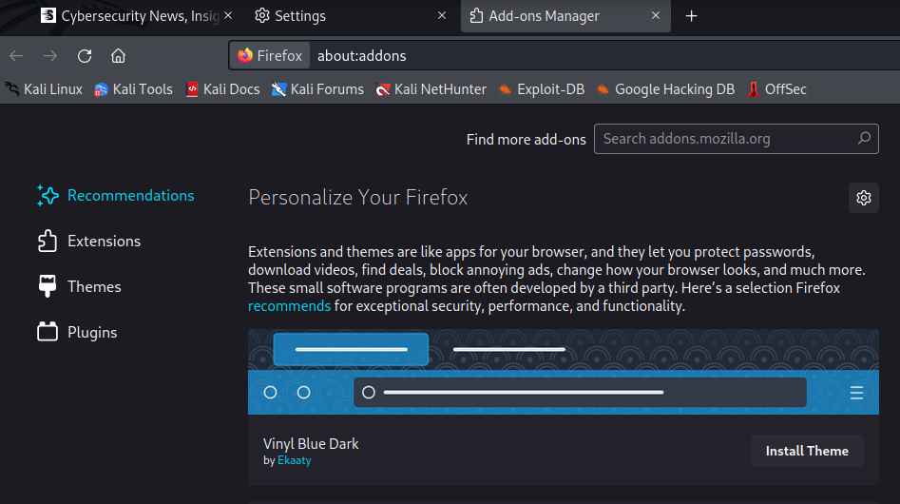

16)
I could not install AdBlocker Ultimate at first due to Firefox being out of date, however after updating it via the terminal I was able to install it without any further issues.
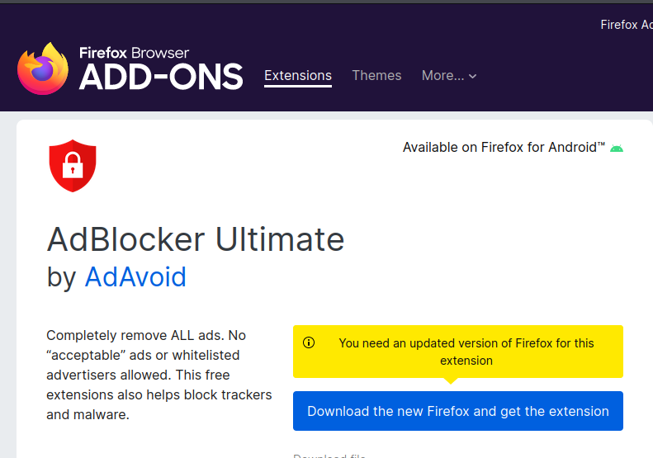
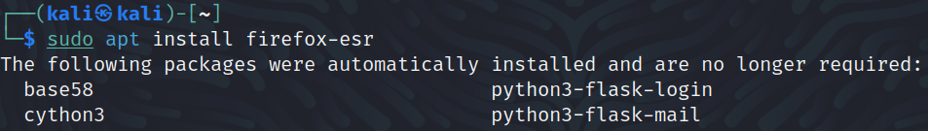
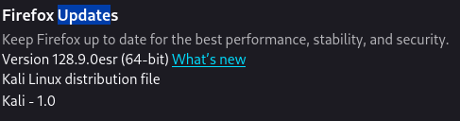

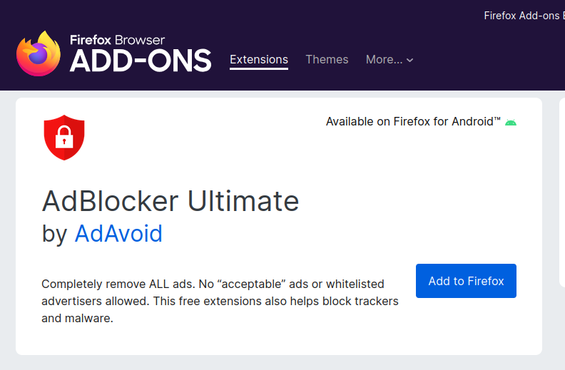

17)
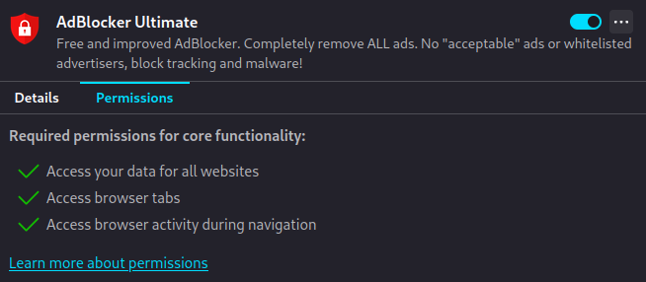
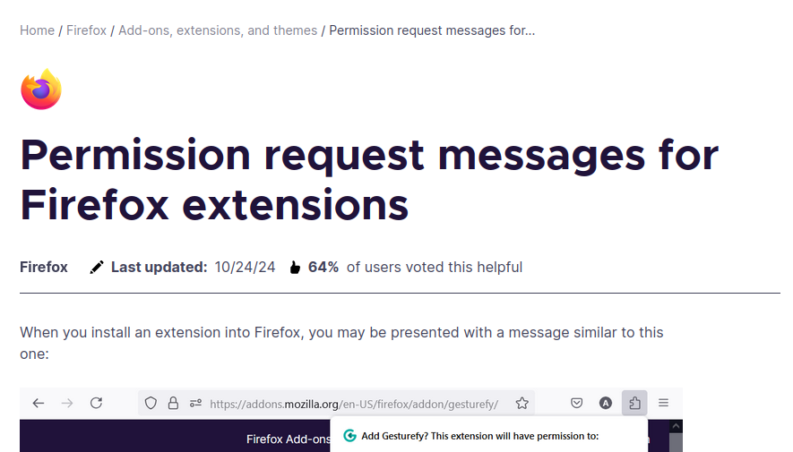

18)
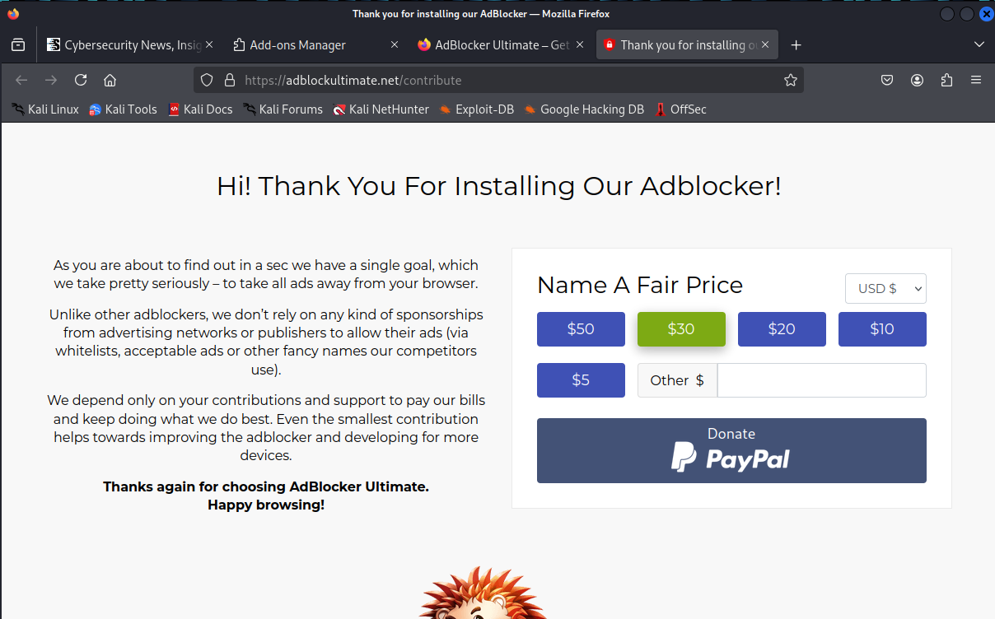

19)
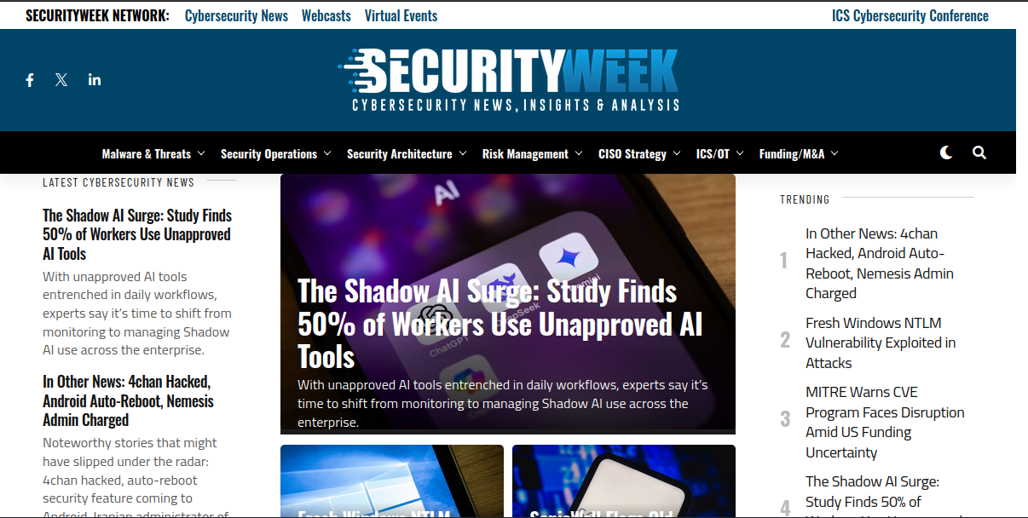

Part 4 – Security
20)
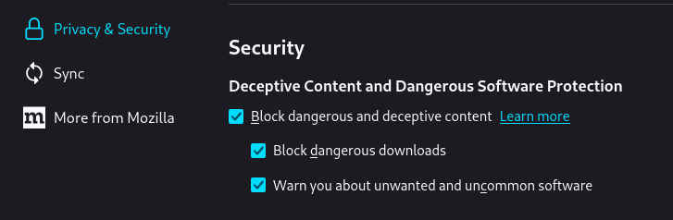
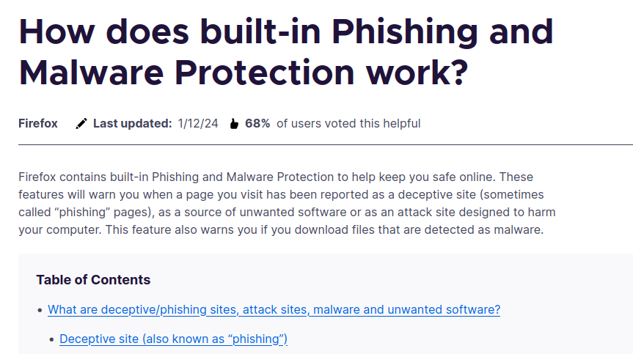

21)
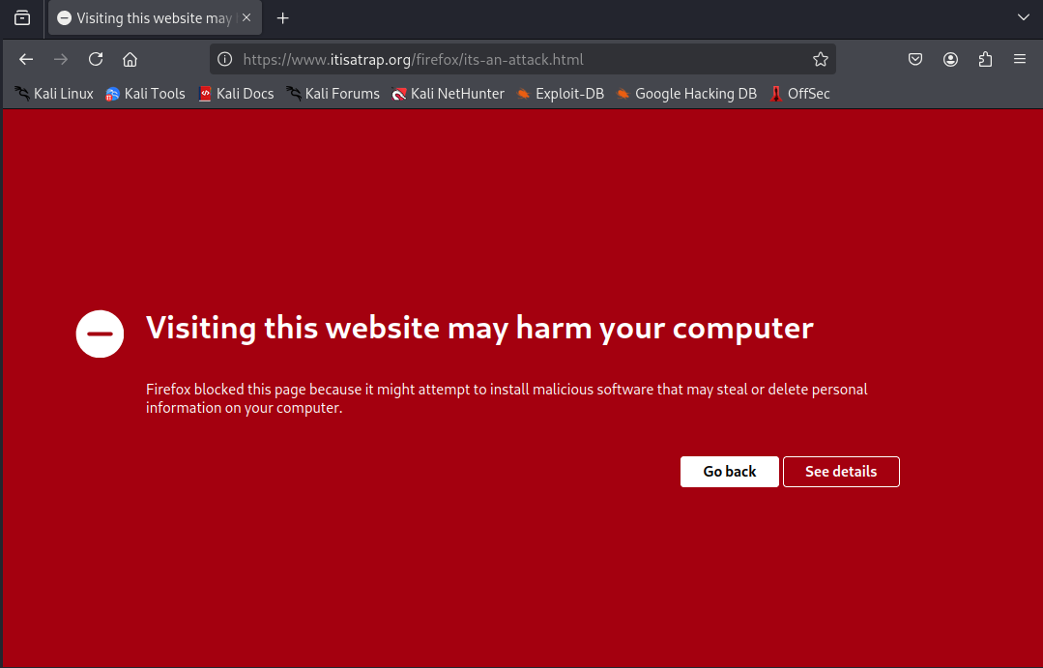

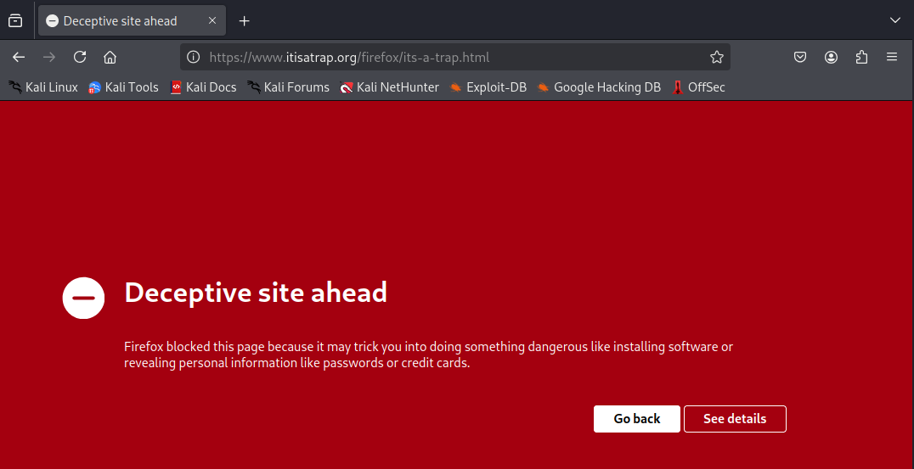

22)
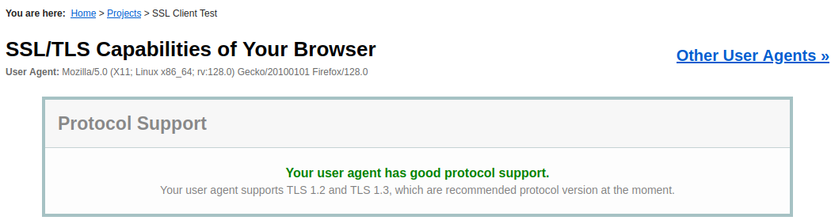

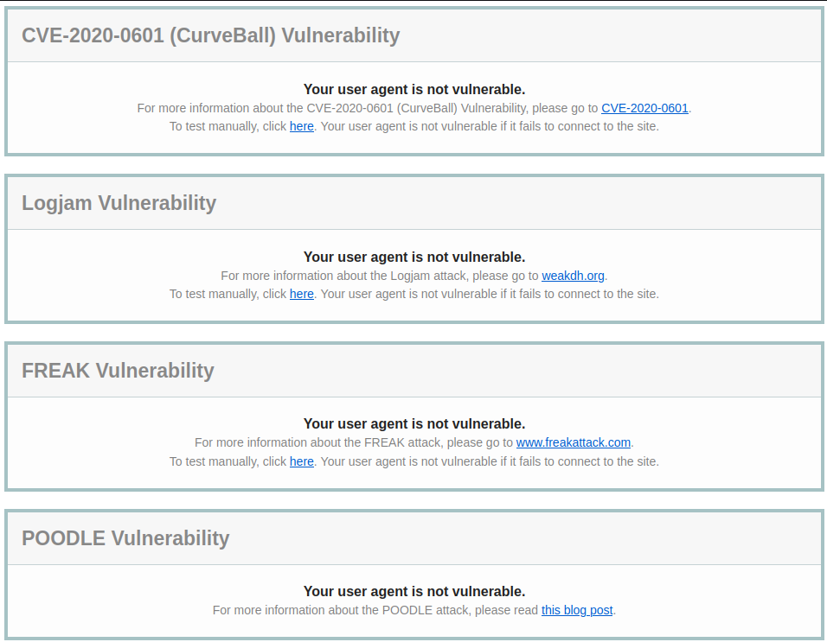

23)
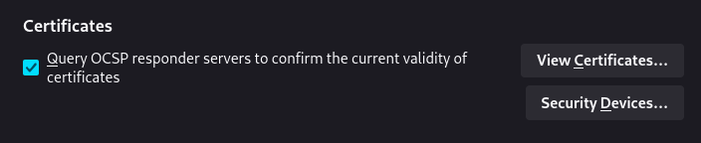

24)
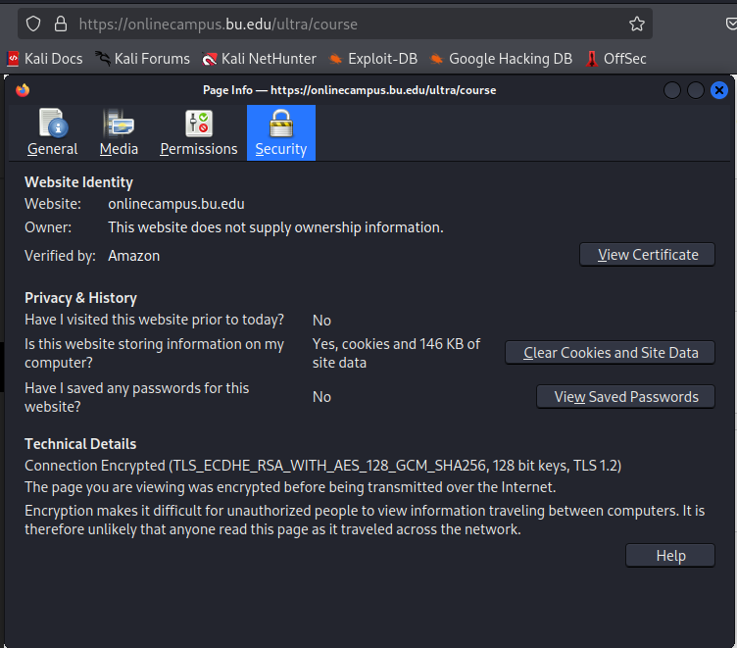

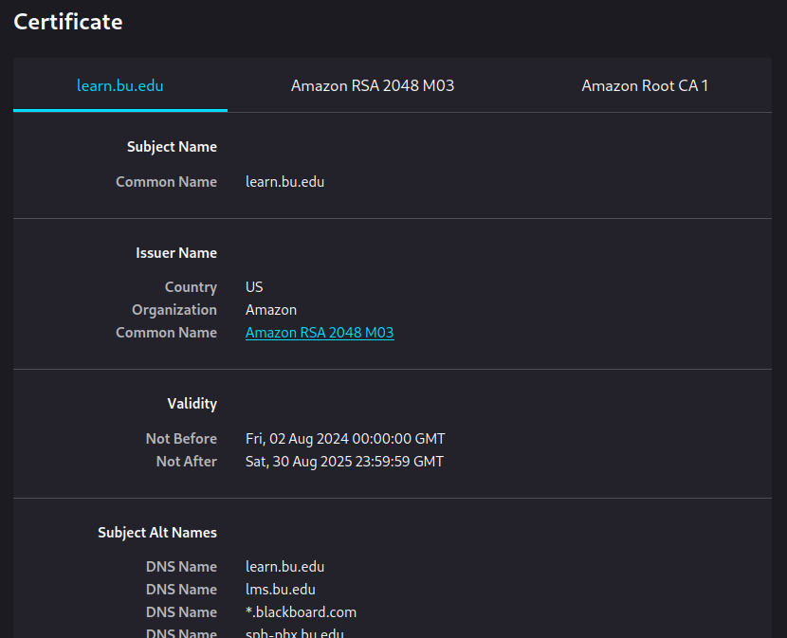

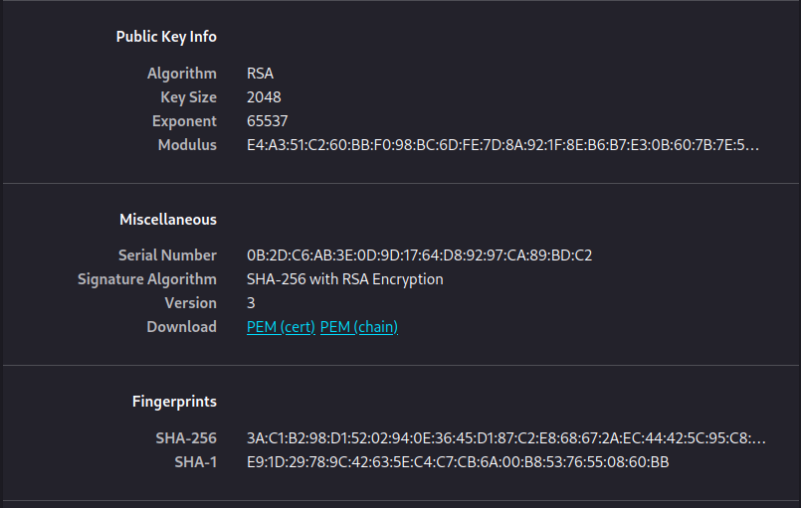

25)
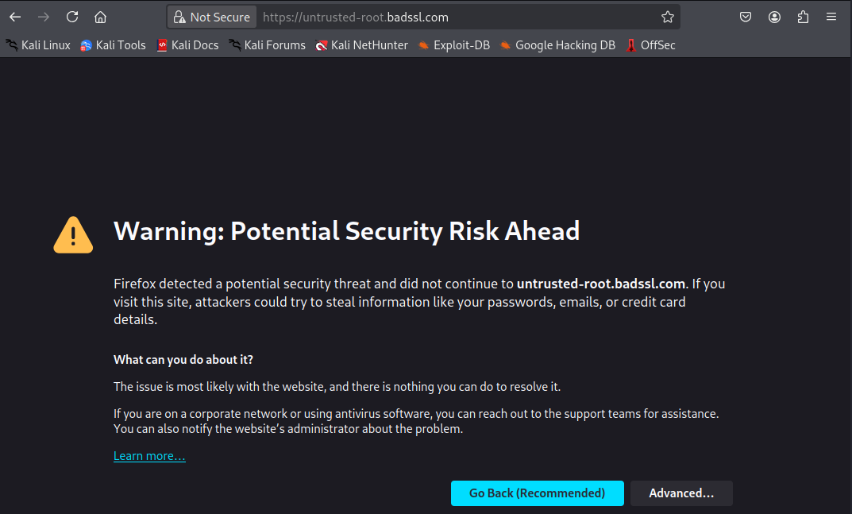
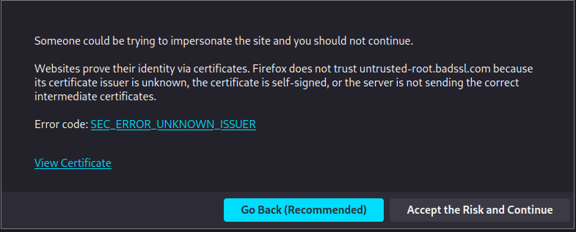

Questions

1) Perform online research to identify what kind of browsing history information is saved when the “Always use private browsing mode” checkbox is selected. Be sure to cite your source(s) of information.

According to Mozilla’s private browsing page and “common myths about private browsing” page, private browsing mode keeps no history of the sites you visit and does not save cookies, however any files downloaded and addresses bookmarked will be saved on your computer despite using private browsing mode. In particular, Mozilla makes a point to highlight that any malicious files downloaded while using private browsing such as keyloggers or spyware will still be on the device, emphasizing that private browsing does not protect against those kinds of threats.

2) Perform online research and answer the following questions. Be sure to cite your source(s) of information:

a) What are web trackers?

The Mozilla blog Distilled has an entry on web tracking, and it breaks web trackers down to scripts on websites that are designed to “derive data points” that can help show your preferences and how you interact with the sites that you visit.

b) Provide a definition for the term first-party cookie.

The same blog entry from part A includes information on first-party cookies, and defines them as cookies that come from the same website you are visiting and can include information such as a saved login or suggested content for the site.

c) Provide a definition for the term third-party cookie.

The same blog entry from part A has a section on third-party cookies, where they are defined as trackers belonging to an entity other than the site you are visiting at the time. They could be from “ad networks” or websites you have never been to or heard of, but collect data and share it with other groups.

d) What kind of privacy risk could third-party cookies possibly represent?

MDN Web Docs has a page on third-party cookies, where some of the risks identified include the ability to target users via spam emails and calls, “chasing” users with targeted advertisements when searches on particular products are performed, and can even lead to identity theft when information if collected from multiple different third-party cookies across the web of a particular user.

3) Perform online research and answer the following questions. Be sure to cite your source(s) of information.

a) What are your findings regarding cookies when visiting https://www.cnn.com in the normal browsing window and in the private browsing window?

When using a normal browsing window, there are a collection of third-party cookies that are present from groups such as Pubmatic, Google, and Amazon. However, in the private browsing window the only cookies that are loaded are first-party from the CNN domain.

b) What are your findings when visiting https://onlinecampus.bu.edu in the normal browsing window and in the private browsing window?

In both the normal window and private window, the only cookie present is from shib.bu.edu, which is used for authentication.

c) What is a session cookie? What are the purposes of the following flags: HttpOnly, HostOnly, secure. Are there any vulnerabilities related to the session cookie used by https://onlinecampus.bu.edu?

The Geeks for Geeks page on cookies includes information on session cookies, explaining that they are temporary cookies that are “present as long as the user’s browser is open,” and are deleted either when the browser is closed or the time that the session cookie is valid for expires.

For security flags, the MDN Web Docs cookie.Cookies API page includes information for the httpOnly, hostOnly, and secure flags. The ‘httpOnly’ flag is set to true when the cookie is inaccessible to client-side scripts, the ‘hostOnly’ flag is set to true when the request’s host must exactly match the domain of the cookie, and the ‘secure’ flag is set to true when the cookie’s scope is limited to secure channels such as HTTPS.

4) Perform online research to determine what the “Do Not Track” setting does and whether websites are required to honor it. Be sure to cite your source(s) of information.

In the Firefox settings, there is a link to a Mozilla page on the “Do Not Track” feature, and it’s removal from the browser. The setting, when toggled on, tells the websites that are accessed that you do not want your browsing behavior tracked. The reason this was removed is that the option is entirely voluntary to honor on the website’s side – they do not need to respect the choice. Mozilla recommends that the Global Privacy Control (GPC) feature can be used and is “enforced with legislation in some regions.”

5) Perform online research and answer the following questions. Be sure to cite your source(s) of information.

a) Briefly describe how the adblocker works. Why does it require those permissions?

Both the Mozilla Distilled blog and Cybernews have informative pages on how adblockers work as well as trusted ones that are recommended. According to both sites, adblockers are able to prevent ads from displaying on a page by viewing and modifying the content of a webpage before it is rendered for you to see. Since they are modifying the code of a page before it loads for you, access is required to browser tabs, data for websites, and browsing activity in order for them to work correctly.

b) Are all extensions safe? Are there any potential security risks and why?

Absolutely not, extensions should be treated with caution and only installed when their authenticity and services are verified. Since extensions can request access to the data within your browser, information such as your login information passed to sites, browsing history, and activity on each page can be seen by a bad actor via malicious programs in an extension.

6) Based on the result from ssllabs.com, answer the following questions:

a) Which SSL and TLS protocol versions are supported by your browser?

Firefox version 128 has support for both TLS 1.2 and TLS 1.3.

b) Which cipher suite is preferred by your browser? Describe each of the components in your preferred cipher suite. Each component should be separated by an underscore character. So, explain what each item between the underscores means. Be sure to cite your source(s) of information.

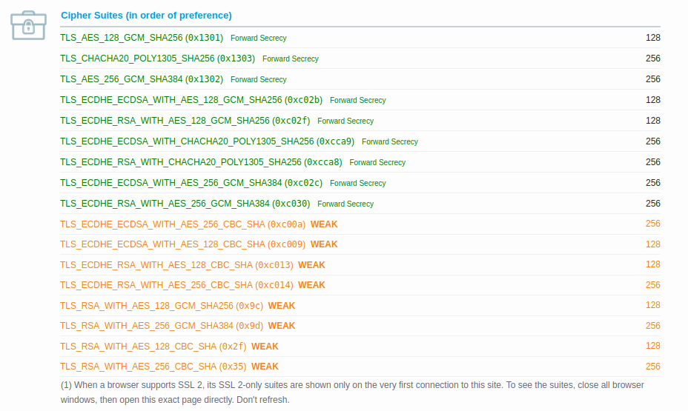
Firefox version 128 prefers the cipher suite TLS_AES_128_GCM_SHA256. The information provided on ciphersuite.info and scanigma.com break down the components that make up the ciphersuite name:

TLS → Protocol Layer
AES_128 → Encryption type - Advanced Encryption Standard with 128 bit key size
GCM → Encryption mode – Galois/Counter Mode
SHA256 → Hashing algorithm – Secure Hashing Algorithm with 256 bit hash size

c) Several vulnerabilities are checked against your browser. Is your browser vulnerable to any of them? Choose one vulnerability and perform online research. Briefly explain that vulnerability.

Of the vulnerabilities listed in step 22 (CurveBall, Logjam, FREAK, and POODLE) Firefox was determined to not be vulnerable to any of the four.

The FREAK attack in particular stands out to me as interesting, and pages on Digicert, FreakAttack, and SmackTLS contained some background information on the vulnerability. Standing for “Factoring RSA-Export Keys,” the attack is a type of man in the middle attack where an attacker intercepts HTTPS connections between vulnerable clients and servers, then forces a weaker encryption to be used. This weakened encryption is known to the attacker, which is then broken and allows the bad actor to steal and/or manipulate the data being communicated between the target clients and servers.

7) Perform online research to identify what OCSP is and what problem it is trying to solve. Be sure to cite your source(s) of information.

Online Certificate Status Protocol, or OCSP, is defined by Mozilla in their security blog to address the problem of obtaining certificate revocation information. Certificate revocation had been prioritized in order to determine when events such as the CA issuing certificates with incorrect information, transferring ownership of a domain, website operators losing control of their private key, or the theft a private key. With OCSP, the browser asks the CA who issued the certificate for the site if there are any issues, and the CA can respond with a signed confirmation if the certificate is valid or revoked.

8) Based on the information provided by the certificate, describe how the https://onlinecampus.bu.edu certificate is verified in detail. What are potential vulnerabilities associated with certificates?

The certificate from onlinecampus is verified by Amazon by confirming details like the validity range (in this case “not before August 2nd, 2025” and “not after August 30th, 2025”) and the fingerprints containing the signatures of the certificate that can be verified by the issuer. Potential vulnerabilities associated with certificates can include spoofed issuer names, signatures, and using the certificate after it has expired.

9) Perform online research and answer the following questions. Be sure to cite your source(s) of information.

a) How did your browser conclude the connection to https://untrustedroot.badssl.com was not secure? What processes did it undertake to definitively state there is a security problem with the connection?

The error that caused the browser to conclude that the connection was not secure was the certificate having an unrecognized issuer. When Firefox did not recognize the CA that issued the certificate, it showed the warning page before going to the site.

b) What do you need to do to permanently prevent that error message from displaying in your own browser? What do the website maintainers need to do in order to prevent this message from displaying for all visitors’ browsers?

For a user to prevent the error message, they have to first see the error code by clicking the “Advanced…” button, then can choose “accept the risk and continue.” For website maintainers to prevent this message for all visitors’ browsers they must have their certificate signed by a trusted CA such as Amazon or Entrust.

Reflection
a) What is the purpose of the lab in your own words?

This lab, in my opinion, was made to introduce us to the security standards that web browser like Firefox employ to make browsing the internet a safer experience. Through the use of security settings, viewing cookies in developer settings, and becoming familiarized with different security standards used on the web, we were able to gain an understanding of some of the security checks that are performed that many users are unaware of in their day-to-day browsing.

b) What did you learn? Did you achieve the objectives?

I believe I accomplished the objective, and throughout this lab I learned about the ciphersuite that Firefox uses, how websites are able to verify their authenticity through the browser, and the “background” work that browsers like Firefox perform in order to combat against exploits and human error.

c) Is this lab hard or easy? Are the lab instructions clear?

The instructions for this lab were well written and clear, however there were two steps that were difficult to accomplish due to the browser being outdated (at least for the Kali Linux that I was using). It would seem that my browser being out of date was the cause for the issues mentioned in steps 14 and 16, however aside from those all other steps were made approachable through the instructions.

d) What do you think about the tools used? What worked? What didn’t? Are there other better alternatives?

While I am familiar with Firefox, SQLiteBrowser, and extensions like adblockers, I had not delved into the settings and information they provided as much before. It is particularly interesting to me how much information is available in Firefox such as cookie information, certificate hashes, and browsing information databases that most users aren’t even aware of. All of the tools in the lab worked except for the issues in steps 14 and 16 that were easily fixed with a Firefox update. There are plenty of alternatives for browsers, however I don’t think that any are better than Firefox as Mozilla has a strong interest in privacy and data protection compared to most of the competitors.

e) Other feedback

I enjoyed this lab as it turned a daily used application like Firefox into a valuable tool for learning about web privacy and data tracking. The thing I would suggest is to include a step for students to verify that Firefox is updated and able to work as intended for the websites accessed and extensions installed.

