CS695 – Lab 1

Introduction to Kali Linux and Basic CLI Commands



Ryan Christopher
Table of Contents:

1 Title Page

2 Table of Contents

3 Part 1 – Set up VirtualBox and Explore Kali

8 Part 2 – Basic Linux Commands

16 Questions

19 Reflection

Part 1 – Set up VirtualBox and Explore Kali
1) What is a virtual machine? Why use a virtual machine?
A virtual machine is an application that functions as a computer. This allows us to run
another operating system that does not have access to the data or resources outside of the
virtual machine, allowing us to have a “sandbox” like computer to use.

2) What is a snapshot of a virtual machine?
A snapshot of a virtual machine is a saved state at the specific point in time you take the
snapshot. Similar to a save file of a video game, it allows us to “go backwards” to that point
in the event we want to undo a large number of actions or changes that occurred in the
virtual machine.

3) What is Kali Linux? (What distribution, based OS, open source?). Why use it instead of a
basic Linux distribution?
Kali Linux is an open source Debian-based Linux distribution founded and maintained by
the cybersecurity company Offensive Security. Using Kali Linux instead of a basic Linux
distribution is beneficial for this class since it comes pre-installed with applications used
for cybersecurity, specifically penetration testing.

4) Tools in the Kali menu:
Nmap, standing for “Network Mapper”, is a tool for scanning IP addresses and ports of a
network. It can be used for tasks like finding which devices are connected to a network, the
applications running on a network, and determining what types of firewalls a network is
using. It is found in the “Information Gathering” and “Vulnerability Analysis” categories.

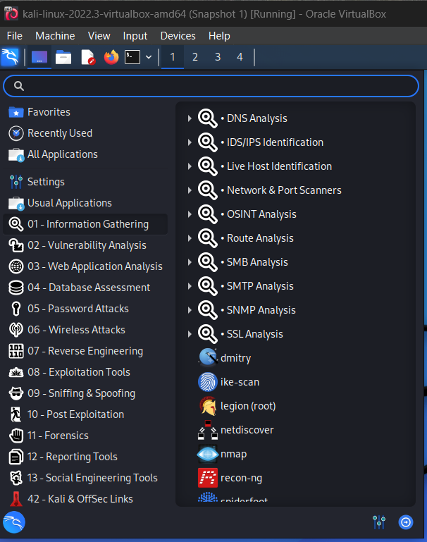
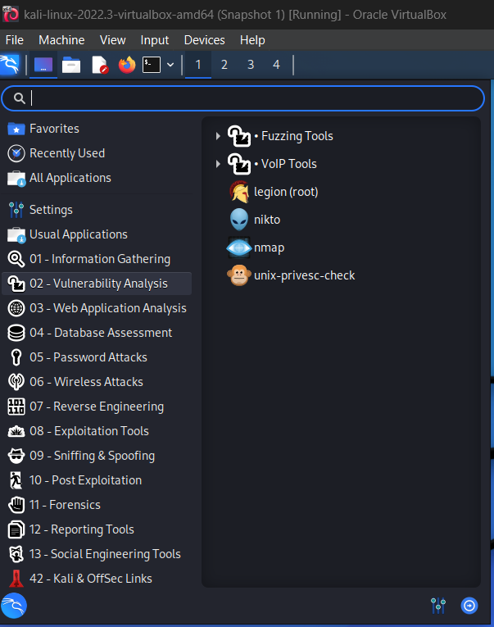
Burpsuite is a tool used for penetration testing web applications. It can be used to find
vulnerabilities web apps through tactics like manipulated requests. It is found in the “Web
Application Analysis” category.
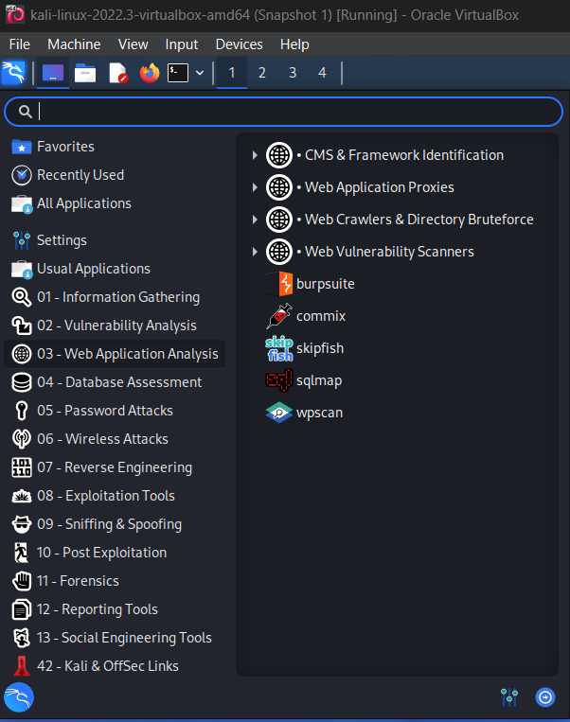

SQLMap is a tool used to find vulnerabilities in databases of web applications, often
through SQL injection. It is found in the “Web Application Analysis”, “Database
Assessment”, and “Exploitation Tools” categories.
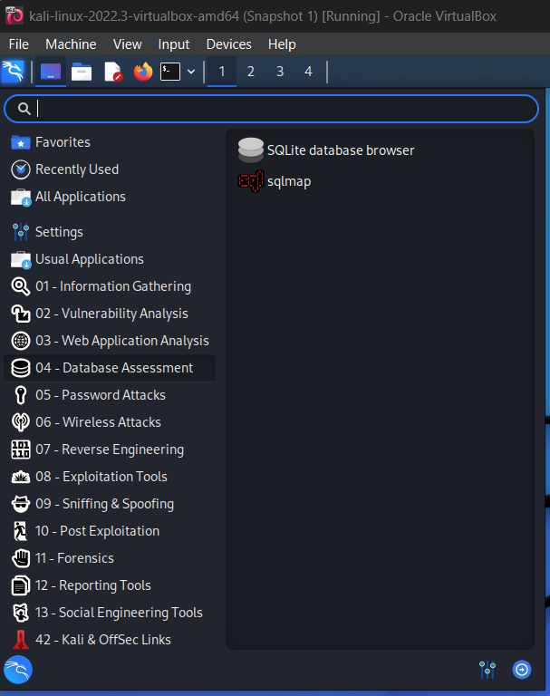
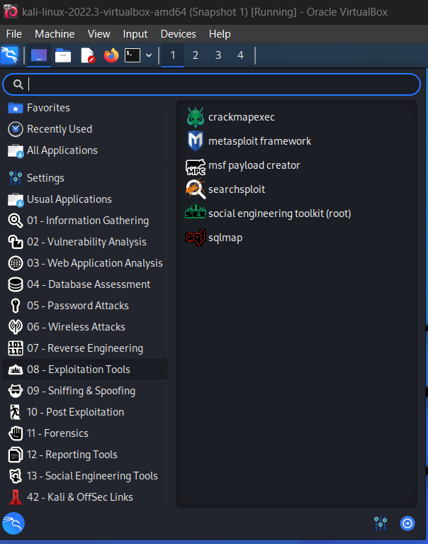
Mimikatz is a tool for extracting data like passwords and login information specifically
from devices using Windows as their operating system. It is found in the “Post
Exploitation” category.
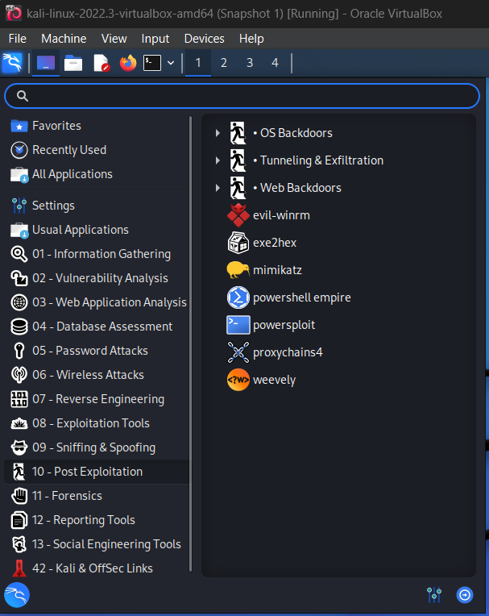
Aircrack-ng is a tool that is used to assess WiFi network security through methods like
monitoring, attacking, testing, and cracking on a wireless network. It is found in the
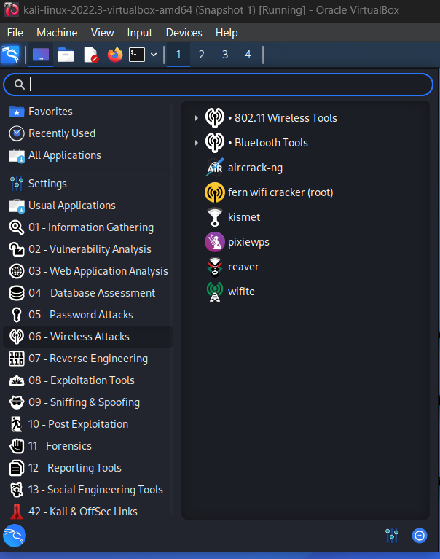
“Wireless Attacks” category.
John, also known as John the Ripper, is a tool used for password cracking that can run on
multiple operating systems such as Windows, macOS, and Unix. It is found in the
“Password Attacks” category.
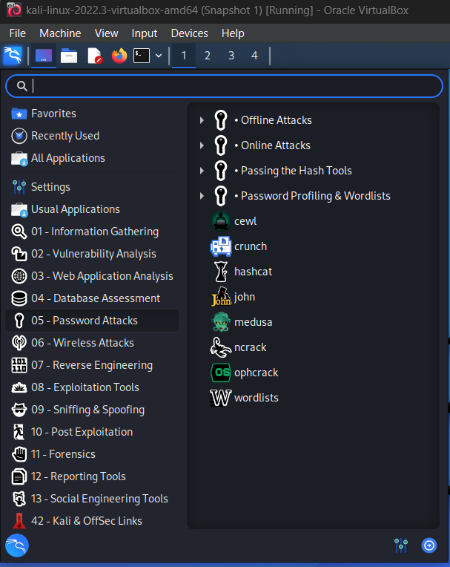

Wireshark is a network packet analyzer tool. It can be used to measure the traffic of a
network in real-time. It is found in the “Sniffing & Spoofing” category.
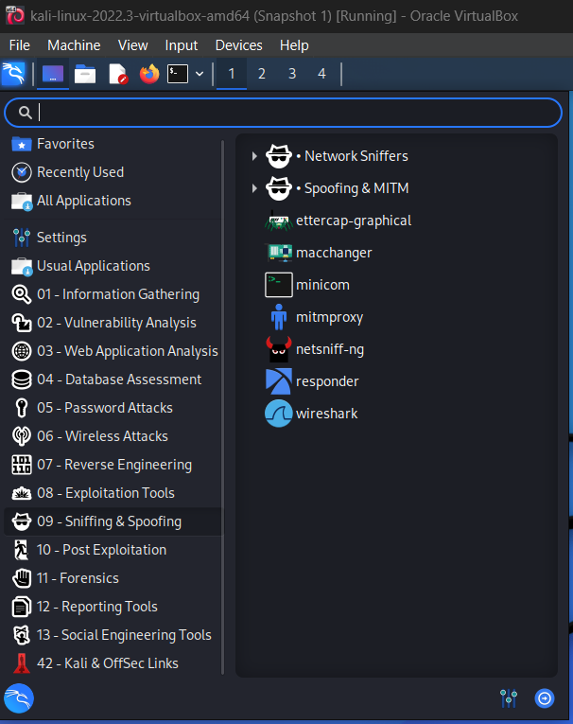
SET (Social Engineering Toolkit) is a tool used for penetration testing through Social-
Engineering tactics like spear-phishing, QR codes, and websites. It is found in the “Social
Engineering Tools” category.
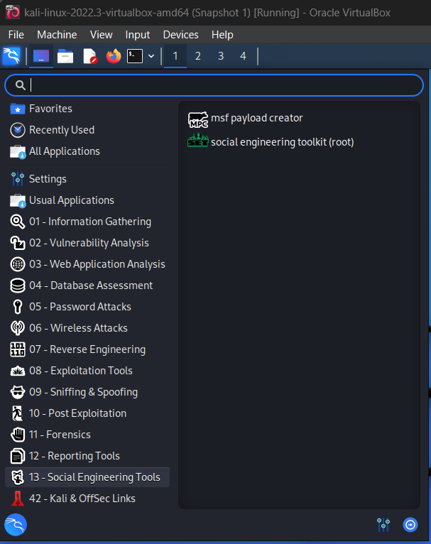

Part 2 – Basic Linux Commands
1) pwd
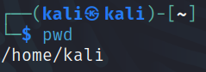

2) ls
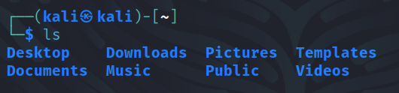

3) mdkir
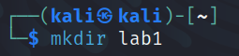

4) cd
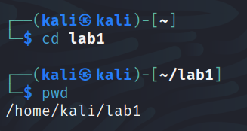
Compared to step 1, pwd now shows the working directory as lab1 now that the cd command
was executed.

5) touch
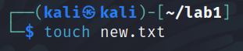

6) sudo
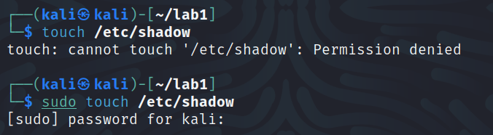
When attempting to create/update a file that requires root privilege, a “permission denied”
message will be returned. However, when creating/updating with the sudo prefix, I was
prompted for the password and was able to access /etc/shadow.

7) apt-get
This step I encountered a mild roadblock as the “sudo apt-get update” command returned
an error each time I tried running it. I eventually ended up on the Kali Linux 2018.1 Release
page which included a solution to the GPG error. Unfortunately, I could not run that
command as it required me to be the root user, however I found this StackExchange post
that included a command to retrieve the latest key.

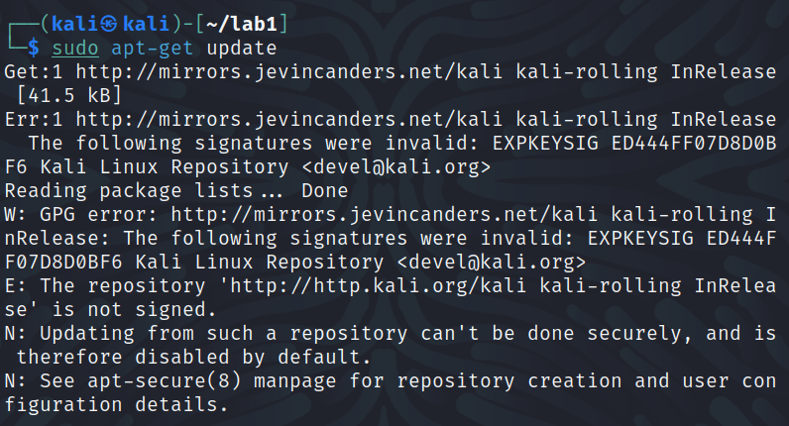

After running the command from the above post, I was able to use the “sudo apt get-
update” command without any errors.
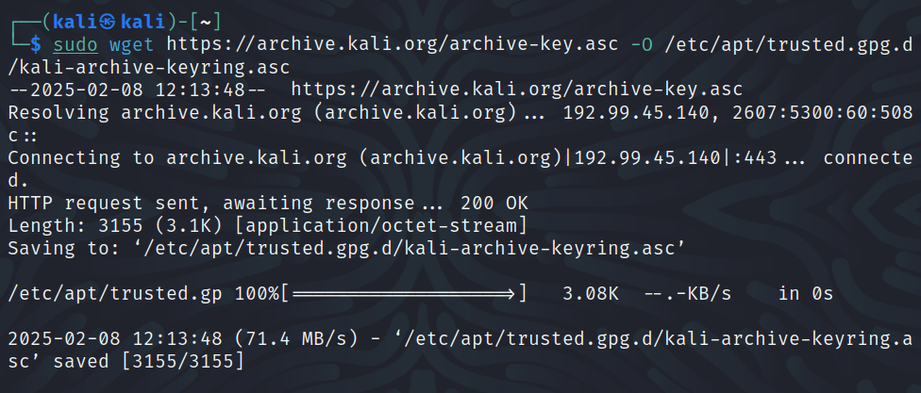

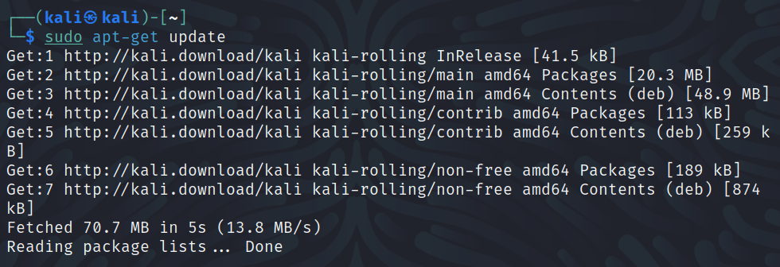

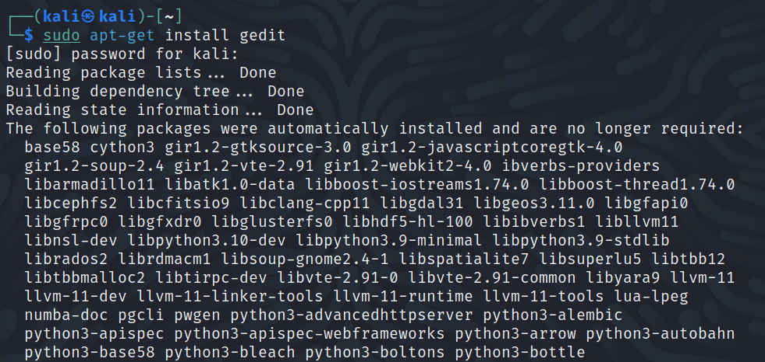

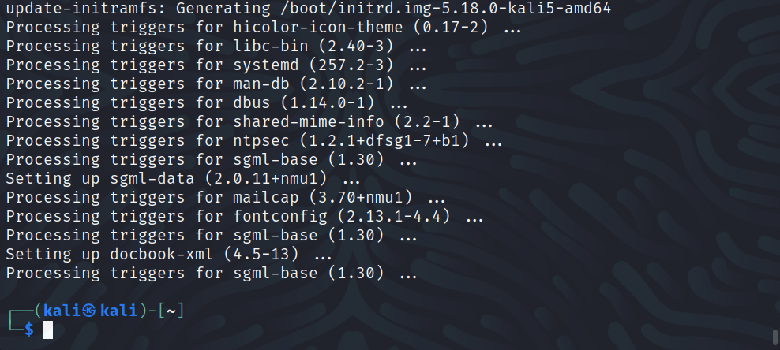

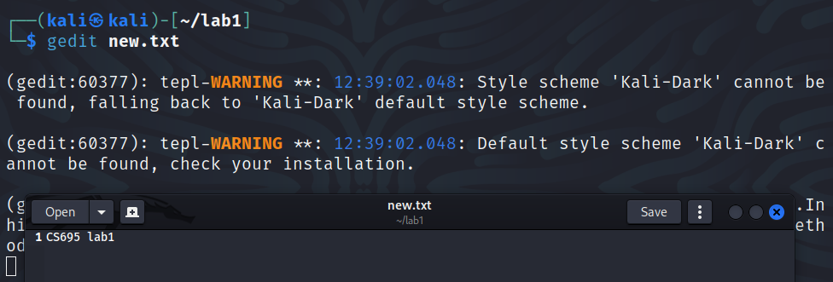

8) cat
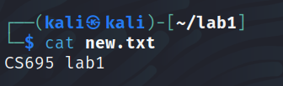

9) cp
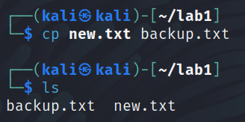

10) mv
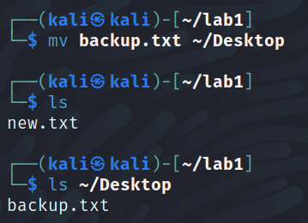

11) rm
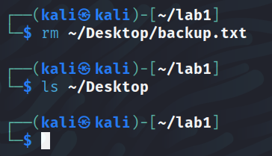
12) man
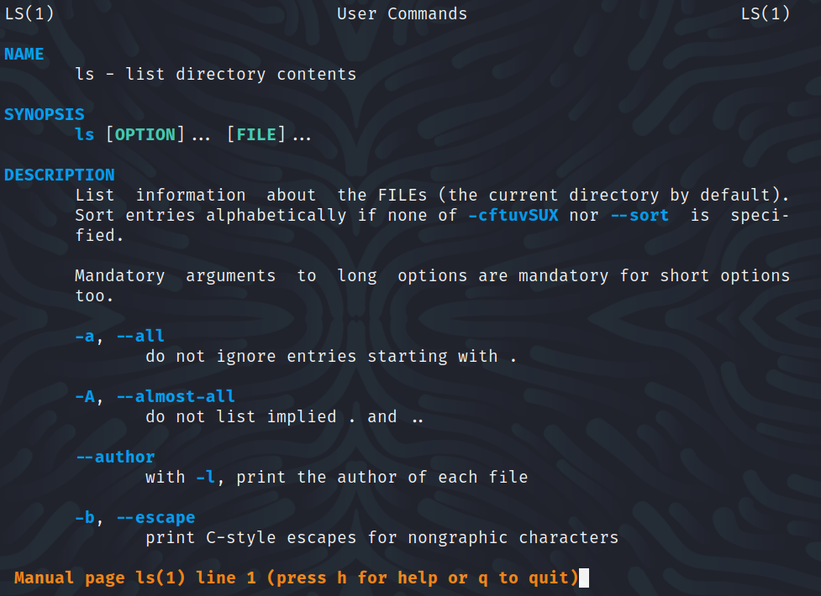
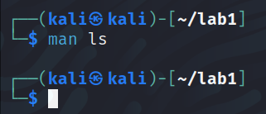

13) useradd

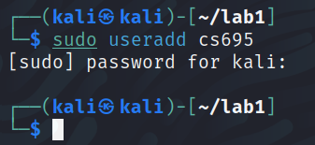

14) passwd
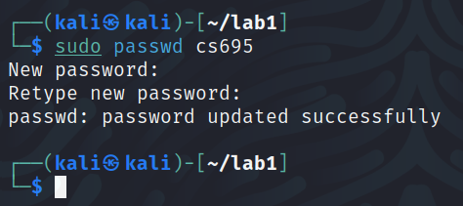

15) userdel
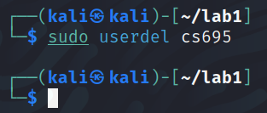

16) zip/unzip
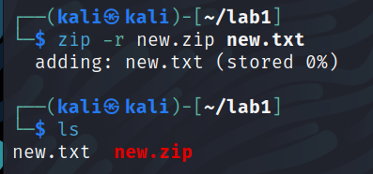
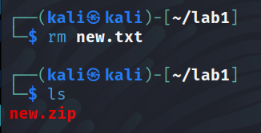
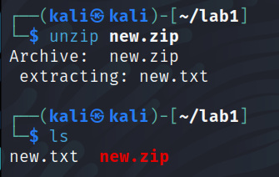
17) tar
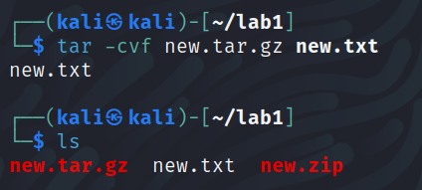
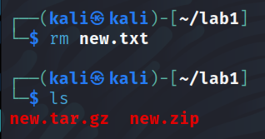
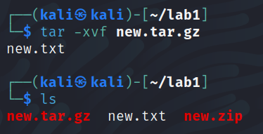

18) uname
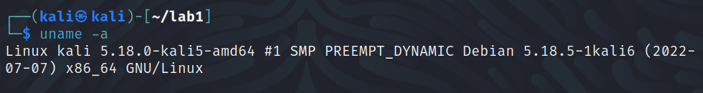

Questions
a) Find the /bin and /sbin folder and show their contents (provide a screenshot of the used
commands). Explain what you have found in the /bin and /sbin folder and the difference
between these two folders.
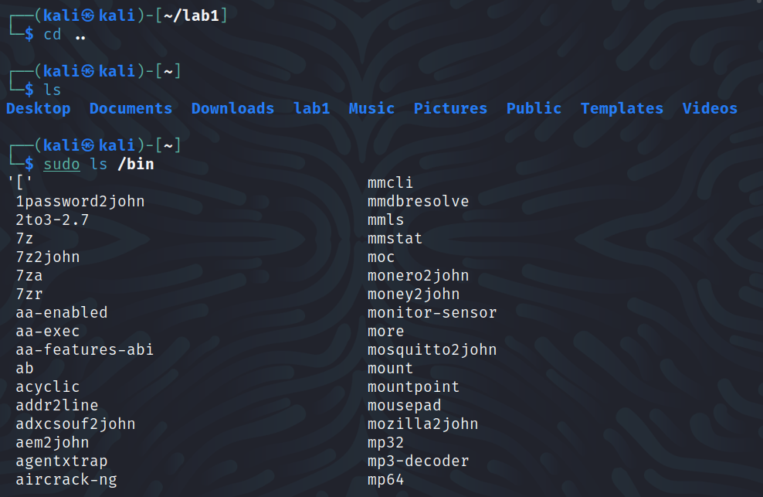
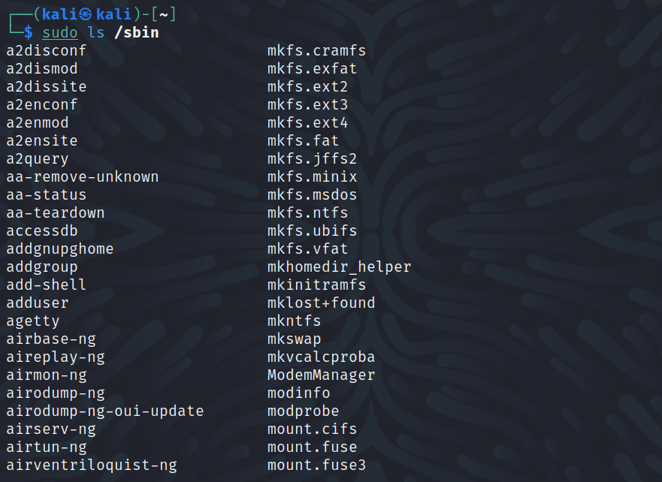
The /bin and /sbin folders contain the list of binaries (or executables) that can be
performed. While they both contain a list of binaries, /bin is accessible for a normal user to
run, whereas /sbin (standing for system binary) contains the binaries where superuser
privileges are required.

b) Get the virtual machine network information using ifconfig (provide a screenshot of the
used command). What is your IP address? Are you connected to the public network?
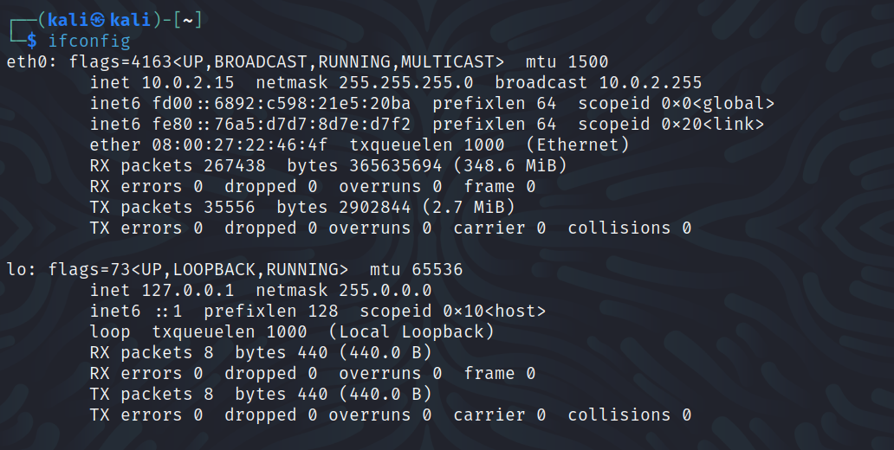
My IP address in the above screenshot is 10.0.2.15. This address falls within the Class A
network IP range, and is a private network connection. The IP showing a private network
connection is because the virtual machine is using the computer running it as a host and is
forwarding traffic to the internal network being used by VirtualBox.

c) Get process information using the ps command. What are the 4 information printed by the
ps command?
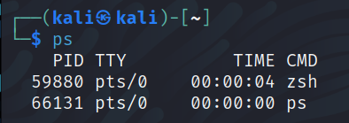
The four pieces of information printed by ps are:
PID – Process ID
TTY – Terminal Type
TIME – The amount of CPU time that the process has used
CMD – The command that launched the process

d) Get Linux processes information using the top command (type q to return to the terminal
from the output of the top command). What is the information in the header of the result of
the command?
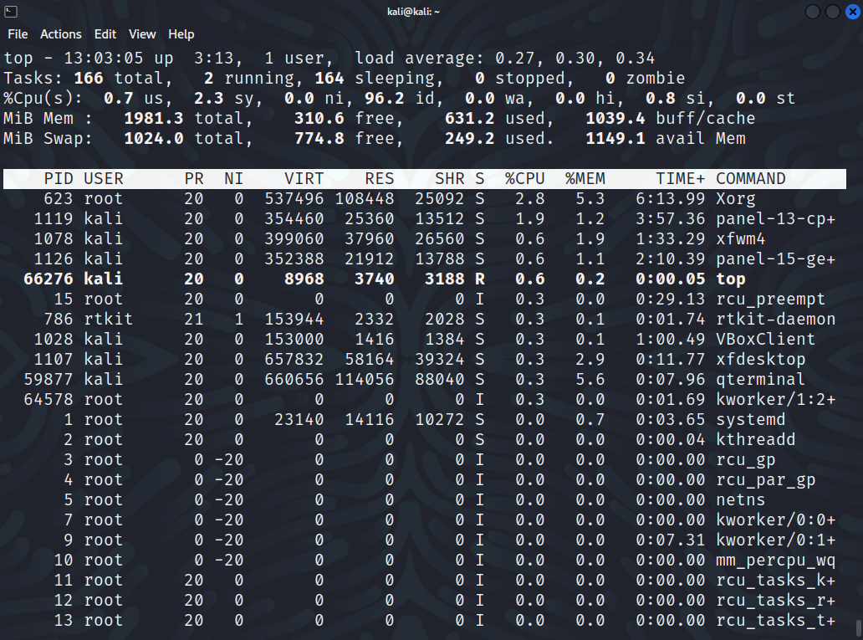
In the header op the result of the top command, we are given the following information:
top – the uptime information (up), how long the system has been running (3:13 in this case),
number of users (user), and load averages for the last minute, five minutes, and fifteen minutes (load average)
Tasks – total number of processes (total), how many processes are currently executing
(running), processes awaiting resources (sleeping), processes exiting (stopped), and
processes waiting for a parent process to release it (zombie)
%Cpu(s) – CPU time spent running user processes (us), kernel processes (sy), processes
with a nice value (ni), idle processes (id), waiting for I/O operations to complete
(wa), hardware interrupts (hi), software interrupts (si), and stolen time from the
virtual machine by the hypervisor (st)
MiB Mem – total installed memory (total), amount of available memory (free), amount of used
memory (used), and amount of memory buffered and cached (buff/cache)
MiB Swap – total amount of virtual memory (total), amount of available virtual memory (free),
amount of used virtual memory (used), and amount of virtual memory
available for starting applications without swapping (avail Mem)

e) What is the difference between the ps and the top commands?
The ps and top commands both provide information on processes running, however ps
provides a snapshot of the information on processes running at that specific time whereas
top provides dynamic data that updates as the processes are running.

Reflection
a) What is the purpose of the lab in your own words?

I think that the purpose of this lab is setting us up for the future assignments and labs in
this course using Kali Linux and the suite of software it comes with. Prior to this class, I
have only used Ubuntu and handful of times, however I have quite enjoyed setting up Kali
and seeing a brief preview of the tools that can be used in it.

b) What did you learn? Did you achieve the objectives?

Up until this lab I was not aware Kali Linux existed, so for starters I learned that Kali is a
thing! I am also now aware of the different tools that Kali has to offer that were discussed in
part 1.4. Becoming familiar with and getting to use the tools such as Nmap, John, and
Mimikatz is something that I am particularly looking forward to now that I have the virtual
machine set up. I believe I have achieved the objectives, and that the virtual machine I am
using is configured properly for the upcoming work in this class.

c) Is this lab hard or easy? Are the lab instructions clear?

I would say that this lab was on the easier to follow side due to the clear instructions. I
appreciate that each section contains steps that are well written and easily followed.
The only difficulty I had was on step 7 of part 2 where I encountered the GPG error for
updating. Fortunately, the Kali blog contained the solution to the problem.

d) Other feedback

Having the lab session recording available was a great resource for this lab and it was very
helpful for me at times when I wanted to make sure what I was doing was correct. I’m eager
to work more in this virtual machine as it is the first time I have encountered most of the
applications listed and I am curious what kinds of information and data can be gathered.
The only detail I would suggest for this lab is including a note for the GPG error if others
have encountered the same message when working through part 2 of the lab.

