**HOMEWORK**

Quick Questions About YOU, and one more:

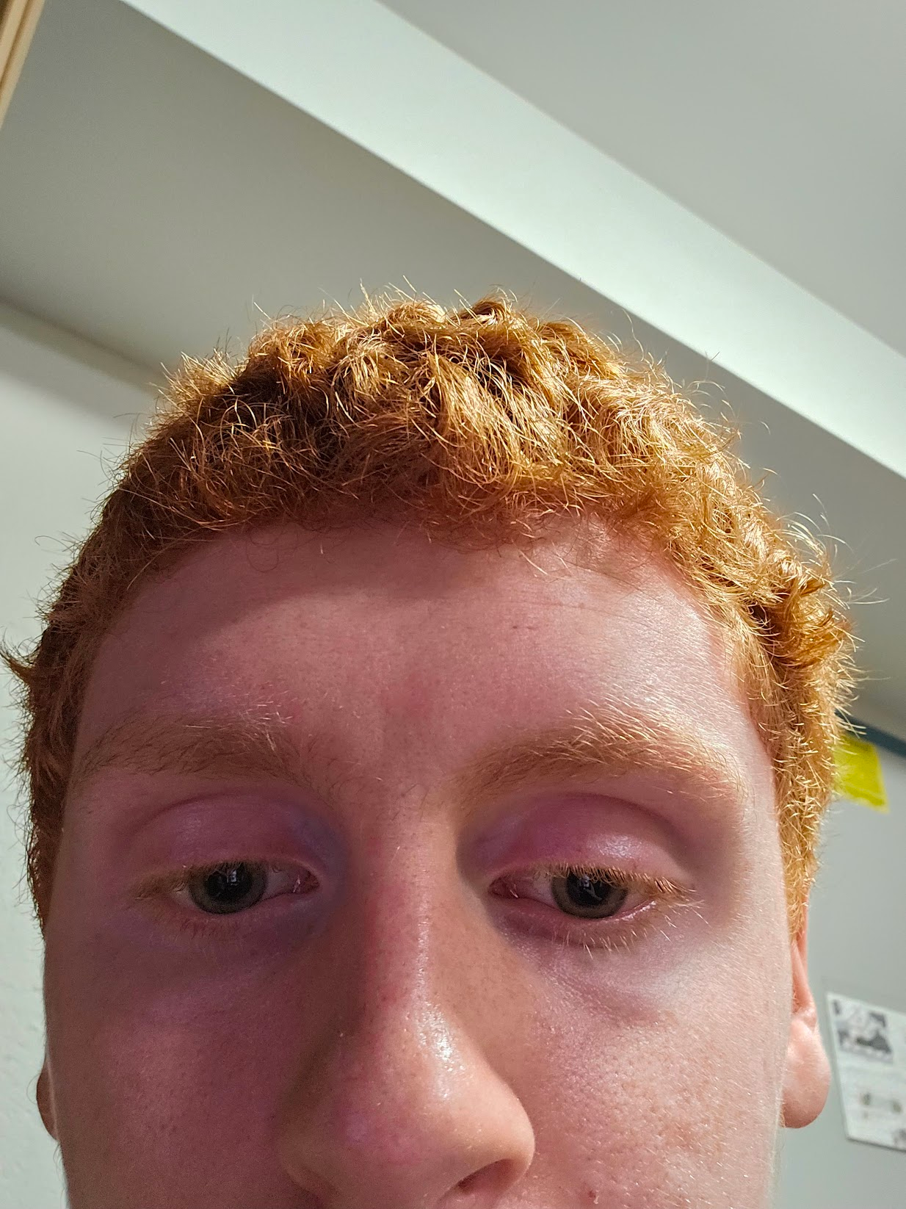

INSERT PHOTO* HERE:

1. Name we should call you in class

Ryan

2. Your pronouns, if you want to share

He/Him

3. Class, e.g. frosh, sophomore, etc. :

frosh

4. Major(s)/Minor(s):

Computer Science

5. Arts organizations? (Band/orchestra, drama/dance, etc.)

None

6. Sports teams / Club team at WPI?

I don’t know yet

7. Tell us one thing about yourself that, well, makes you you!

I am a ginger

8. What are you most looking forward to out of this class, this term, this year, your time at WPI?

I am looking forward to meeting people who have the same interests as me.

Bonus (but required): What is your favorite Computer Science hidden gem or guilty pleasure?

Book, movie, video game, graphic novel … whatever. [Mine is the movie ``Real Genius’’.]

The Matrix

*We have access to your ID ~~mug shots~~ photos.

We’d prefer a picture of you in your natural habitat.