**Initialize the project**

1. Go to POM to change to your name.

2. Import the project into Eclipse.

3. run “swagger-ui.html” on server as below, in order to create all the DB tables.

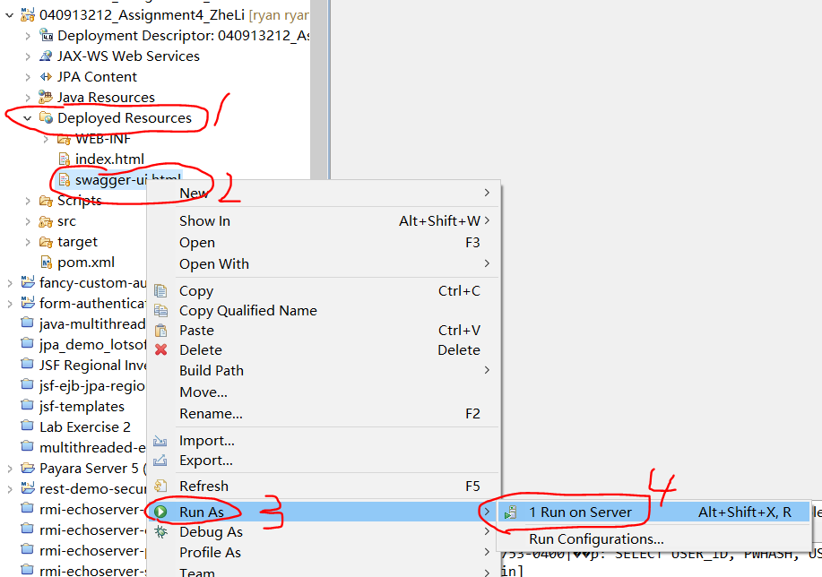

4. Open “mysql-init.sql”, copy all the SQL scripts, and paste to the SQL Editor in next step.

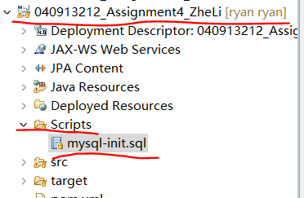

5. Go to “DBeaver” view, right click on “H2-Assignment 4”, choose “SQL Editor”. Then run the scripts of “mysql-init.sql”.

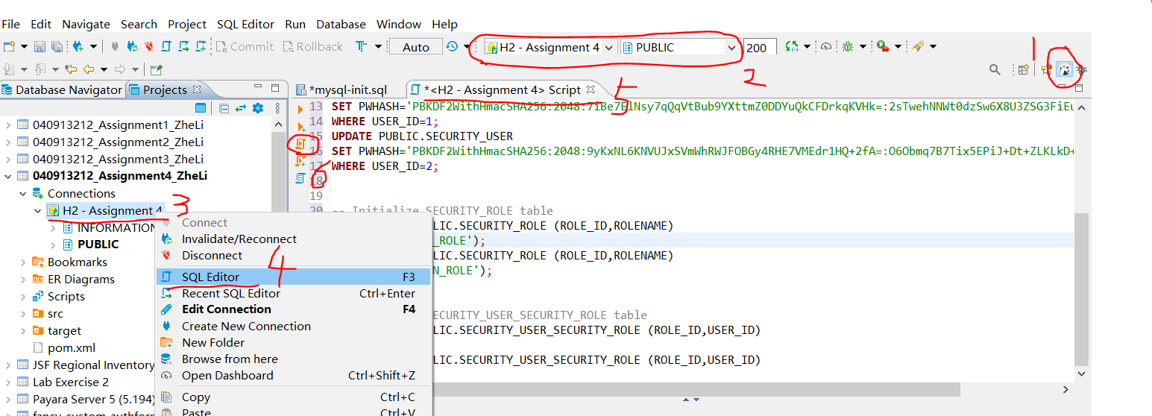

6. Go to “Java EE” view, run “PBKDF2HashGenerator.java” as “Java Application”. (It will give error this time)

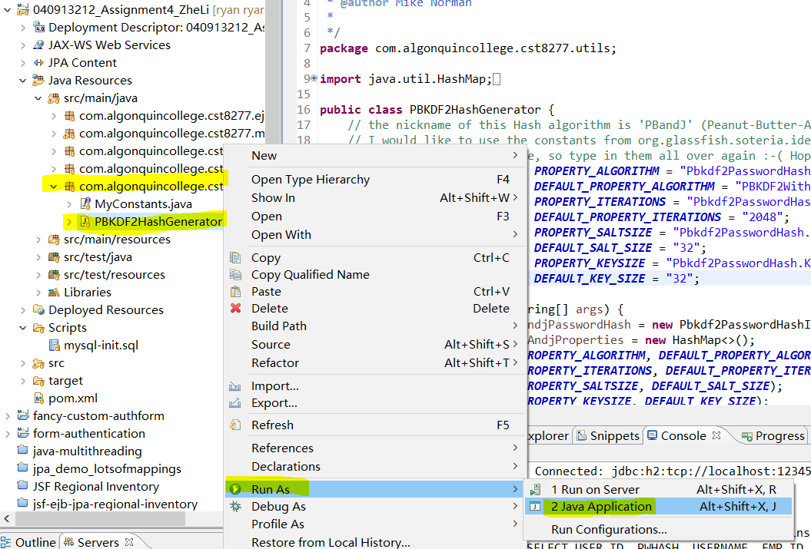

7. run “PBKDF2HashGenerator.java” as “Run Configuration”.

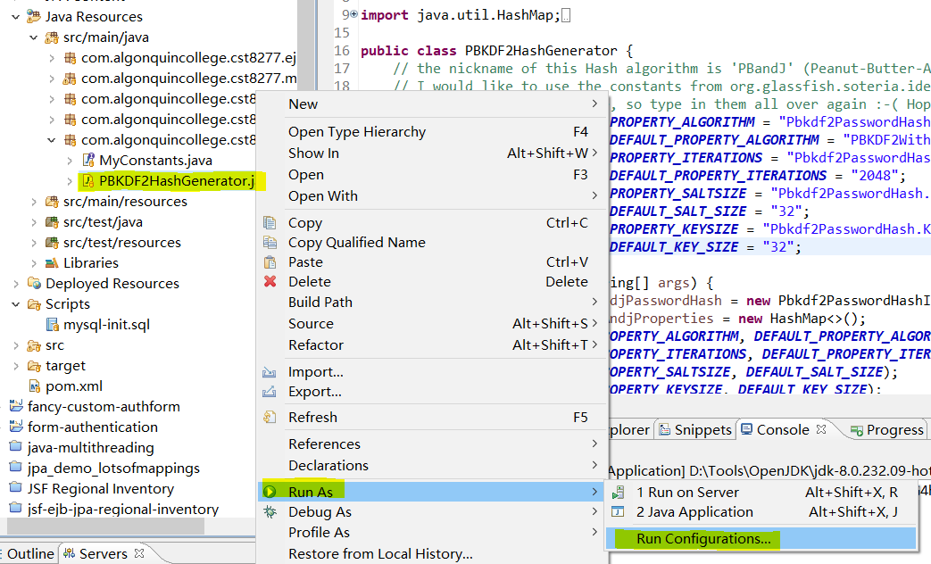

8. in the coming up dialog, click on “Arguments”, then type in “password”, click “Run”.

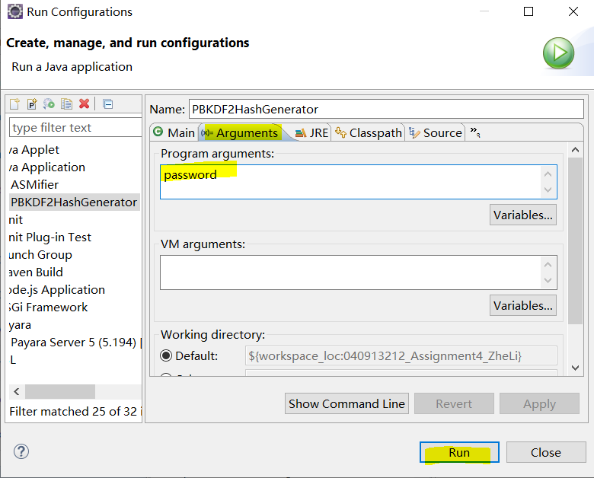

9. go to “Console”, copy the highlighted part to a text file, it’s the encrypted password for “user1” (the password is “password”). Then do the same process, and type in “admin” for the argument, and copy & paste the encrypted password for “admin” (the password is “admin”). We will use them in next step.



10. Go to “DBeaver” view, right click on “Security_User” -> “Edit Data”. Then double click the password, and copy & paste above encrypted password to the correct users, then click “save”.

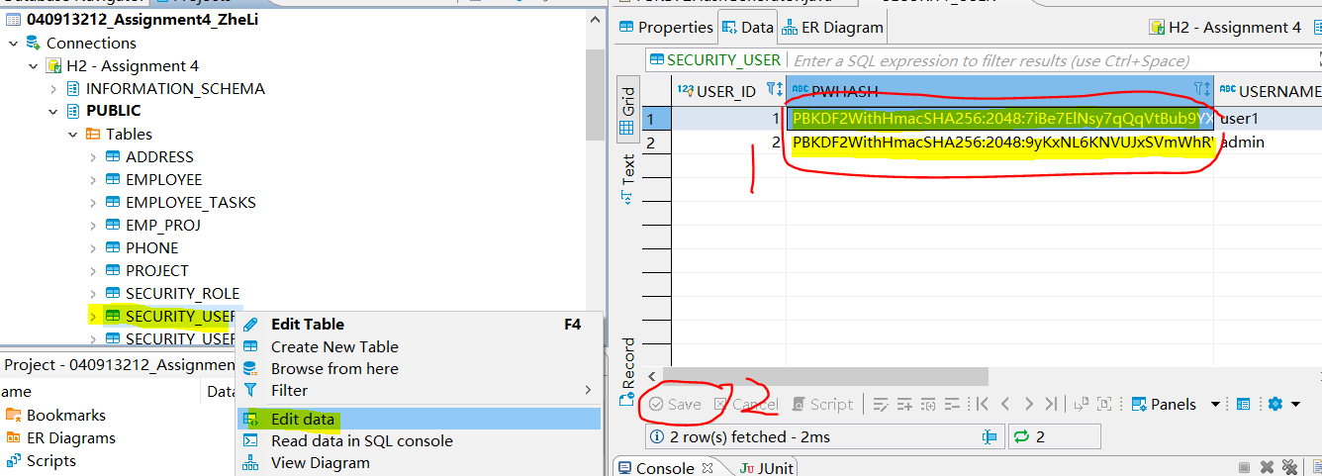

11. Go back to “Java EE” view, run “swagger-ui.html” on server. You should be able to see below page. Change the port number to your payara’s port number (8080 or 9090, see the red circle part below in your browser). Then click on “Authorize” at right corner, then type in “admin” for user name, and “admin” for password.

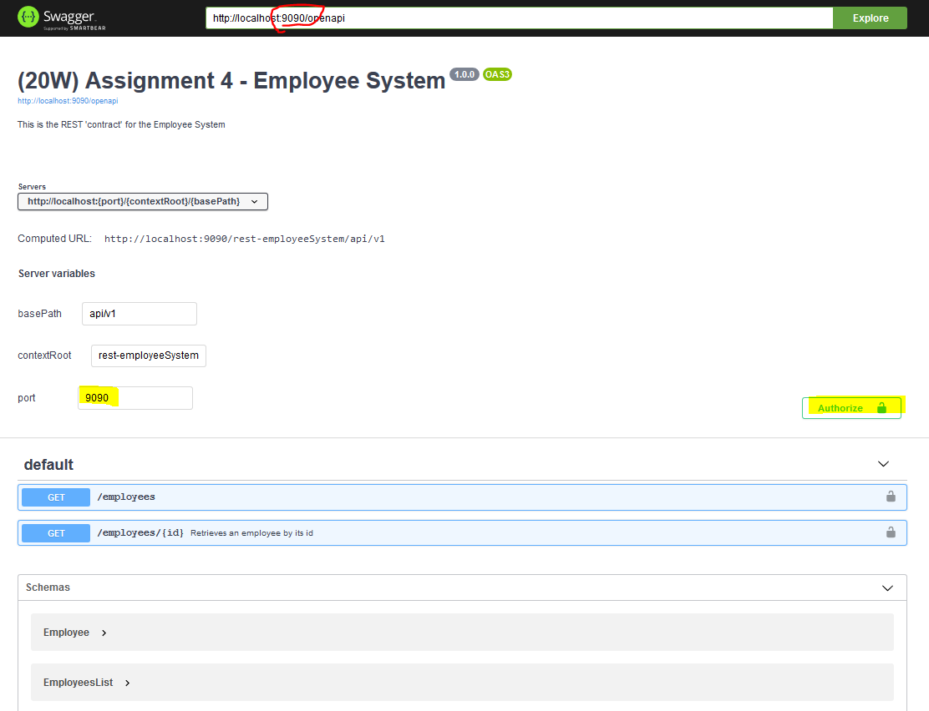

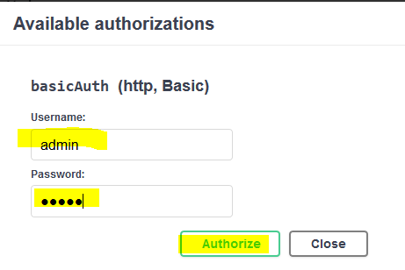

12. click on “Get”, then “Try it out”.

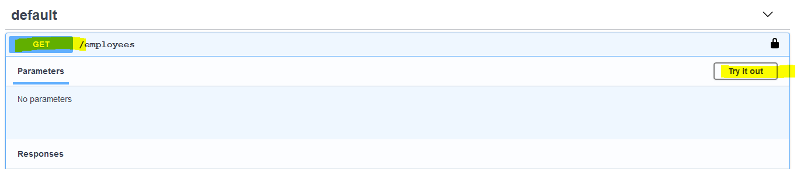

Then click “Execute”. If you see “200” code, then everything is set up.

