ARDL_MODEL()

2024-09-13

RYAN LITSWA r-markdown for the PANEL-ARDl() model

data <- read.csv("Countries.csv")  
# Convert data to a panel data frame (replace 'Country' and 'Year' with your column names)  
pdata <- pdata.frame(data, index = c("Country", "Year"))

Summary Statistics

summary(pdata)

## Country Year Unemployment_Rate GDP   
## Egypt :31 1992 : 5 Min. :0.02615 Min. :1.769e+09   
## Kenya :31 1993 : 5 1st Qu.:0.03810 1st Qu.:1.574e+10   
## Nigeria :31 1994 : 5 Median :0.09860 Median :9.668e+10   
## Republic of Congo:31 1995 : 5 Mean :0.11859 Mean :1.600e+11   
## South Africa :31 1996 : 5 3rd Qu.:0.19926 3rd Qu.:2.920e+11   
## 1997 : 5 Max. :0.28840 Max. :5.740e+11   
## (Other):125   
## FDI Population_Rate Inflation   
## Min. :-1.983e+09 Min. :0.00388 Min. :-0.00882   
## 1st Qu.: 2.287e+08 1st Qu.:0.01977 1st Qu.: 0.04619   
## Median : 1.140e+09 Median :0.02383 Median : 0.07215   
## Mean : 2.660e+09 Mean :0.02306 Mean : 0.09974   
## 3rd Qu.: 4.298e+09 3rd Qu.:0.02736 3rd Qu.: 0.11379   
## Max. : 4.066e+10 Max. :0.04243 Max. : 0.72835   
##

Summary Statistics for Indivdual countries:

# Create a summary statistics table for each country  
summary_by_country <- pdata %>%  
 group_by(Country) %>%  
 summarise(  
 Mean_Unemployment_Rate = mean(Unemployment_Rate, na.rm = TRUE),  
 SD_Unemployment_Rate = sd(Unemployment_Rate, na.rm = TRUE),  
 Mean_GDP = mean(GDP, na.rm = TRUE),  
 SD_GDP = sd(GDP, na.rm = TRUE),  
 Mean_FDI = mean(FDI, na.rm = TRUE),  
 SD_FDI = sd(FDI, na.rm = TRUE),  
 Mean_Inflation = mean(Inflation, na.rm = TRUE),  
 SD_Inflation = sd(Inflation, na.rm = TRUE),  
 Mean_Population_Rate = mean(Population_Rate, na.rm = TRUE),  
 SD_Population_Rate = sd(Population_Rate, na.rm = TRUE)  
 )  
  
# Print the summary statistics by country  
print(summary_by_country)

## # A tibble: 5 × 11  
## Country Mean_Unemployment_Rate SD_Unemployment_Rate Mean_GDP SD_GDP Mean_FDI  
## <fct> <dbl> <dbl> <dbl> <dbl> <dbl>  
## 1 Egypt 0.0996 0.0184 1.85e11 1.26e11 4.29e9  
## 2 Kenya 0.0328 0.00926 4.29e10 3.50e10 3.75e8  
## 3 Nigeria 0.0410 0.00551 2.79e11 1.67e11 3.14e9  
## 4 Republi… 0.202 0.00800 8.68e 9 5.74e 9 7.64e8  
## 5 South A… 0.217 0.0258 2.84e11 1.12e11 4.73e9  
## # ℹ 5 more variables: SD_FDI <dbl>, Mean_Inflation <dbl>, SD_Inflation <dbl>,  
## # Mean_Population_Rate <dbl>, SD_Population_Rate <dbl>

Multiocollinearity test

# Check for multicollinearity using VIF  
vif_model <- lm(Unemployment_Rate ~ GDP + FDI + Inflation + Population_Rate, data = pdata)  
vif(vif_model)

## GDP FDI Inflation Population_Rate   
## 1.591556 1.383609 1.023912 1.357700

Step 1 Unit root test for stationarity

# STEP 1 Stationairy check for each varaible   
#Im, Pesaran, and Shin (IPS) test for panel unit root  
ips_unemployment <- purtest(pdata$Unemployment_Rate, test = "ips", exo = "intercept")  
  
# JUST IF P-value not <0.05 for unemployment i tested earlier I(1) is the right one  
diff_Unemployment <- diff(pdata$Unemployment_Rate)  
ips_unemployment_diff <- purtest(diff_Unemployment, test = "ips", exo = "intercept")

## Warning in purtest(diff_Unemployment, test = "ips", exo = "intercept"): NA  
## value(s) encountered and dropped, results may not be reliable

summary(ips_unemployment_diff)

## Im-Pesaran-Shin Unit-Root Test   
## Exogenous variables: Individual Intercepts   
## Automatic selection of lags using SIC: 0 - 4 lags (max: 10)  
## statistic (Wtbar): -7.403   
## p-value: 0   
##   
## lags obs rho trho p.trho mean var  
## Egypt 0 29 -0.7309515 -4.330654 3.878506e-04 -1.5248 0.793  
## Kenya 0 29 -0.3029927 -2.257298 1.861992e-01 -1.5248 0.793  
## Nigeria 4 25 -1.2125795 -2.941271 4.075427e-02 -1.3630 1.005  
## Republic of Congo 1 28 -1.9860206 -5.889344 2.201282e-07 -1.5170 0.843  
## South Africa 0 29 -1.2879104 -7.255803 6.616018e-11 -1.5248 0.793

# IPS test for GDP  
ips_GDP <- purtest(pdata$GDP, test= "ips", exo = "intercept")  
  
#IF GDP p-value not <0.05 same for GDP I(1)  
diff_gdp <- diff(pdata$GDP)  
ips_gdp_diff <- purtest(diff_gdp, test = "ips",lags = 1, exo = "intercept")

## Warning in purtest(diff_gdp, test = "ips", lags = 1, exo = "intercept"): NA  
## value(s) encountered and dropped, results may not be reliable

summary(ips_gdp_diff)

## Im-Pesaran-Shin Unit-Root Test   
## Exogenous variables: Individual Intercepts   
## User-provided lags  
## statistic (Wtbar): -4.797   
## p-value: 0   
##   
## lags obs rho trho p.trho mean var  
## Egypt 1 28 -0.6852519 -3.166926 0.0220095108 -1.517 0.843  
## Kenya 1 28 -0.4660732 -2.392980 0.1437183815 -1.517 0.843  
## Nigeria 1 28 -0.8720308 -3.612629 0.0055523624 -1.517 0.843  
## Republic of Congo 1 28 -1.0221412 -3.965797 0.0016053339 -1.517 0.843  
## South Africa 1 28 -1.0602489 -4.295786 0.0004468051 -1.517 0.843

# IPS TEST FOR FDI  
ips_FDI <- purtest(pdata$FDI, test= "ips", exo = "intercept")  
summary(ips_FDI)

## Im-Pesaran-Shin Unit-Root Test   
## Exogenous variables: Individual Intercepts   
## Automatic selection of lags using SIC: 0 - 0 lags (max: 10)  
## statistic (Wtbar): -3.133   
## p-value: 0.001   
##   
## lags obs rho trho p.trho mean var  
## Egypt 0 30 -0.1760005 -1.490035 5.389239e-01 -1.526 0.789  
## Kenya 0 30 -0.3431427 -2.545625 1.046977e-01 -1.526 0.789  
## Nigeria 0 30 -0.1425229 -1.434317 5.669852e-01 -1.526 0.789  
## Republic of Congo 0 30 -0.6129167 -3.657826 4.772323e-03 -1.526 0.789  
## South Africa 0 30 -0.8523709 -4.724265 7.229154e-05 -1.526 0.789

#IF GDP p-value not <0.05 FOR FDI it is BOth I(0) and I(1)  
diff_FDI <- diff(pdata$FDI)  
ips_FDI_diff <- purtest(diff_FDI, test = "ips", exo = "intercept")

## Warning in purtest(diff_FDI, test = "ips", exo = "intercept"): NA value(s)  
## encountered and dropped, results may not be reliable

summary(ips_FDI_diff)

## Im-Pesaran-Shin Unit-Root Test   
## Exogenous variables: Individual Intercepts   
## Automatic selection of lags using SIC: 0 - 5 lags (max: 10)  
## statistic (Wtbar): -11.315   
## p-value: 0   
##   
## lags obs rho trho p.trho mean var  
## Egypt 0 29 -0.8955274 -4.301327 4.369061e-04 -1.5248 0.7930  
## Kenya 0 29 -1.1863623 -6.510719 6.433871e-09 -1.5248 0.7930  
## Nigeria 0 29 -1.2173355 -5.996649 1.220450e-07 -1.5248 0.7930  
## Republic of Congo 5 24 -3.2896058 -3.750304 3.477374e-03 -1.3434 1.0782  
## South Africa 0 29 -1.8367152 -10.211024 6.959427e-20 -1.5248 0.7930

# IPS TEST FOR Population  
ips_population <- purtest(pdata$Population_Rate, test= "ips", exo = "intercept")

## Warning in adj.ips.wtbar.value(x, y, exo = exo): lags should be an integer  
## between 0 and 8

#IF GDP p-value not <0.05 for population it is I(1) and lags =1 was deliberately set to 1 for it to work  
diff_Population <- diff(pdata$Population_Rate)  
ips_Population_diff <- purtest(diff_Population, test = "ips",lags = 1, exo = "intercept")

## Warning in purtest(diff_Population, test = "ips", lags = 1, exo = "intercept"):  
## NA value(s) encountered and dropped, results may not be reliable

summary(ips_Population_diff)

## Im-Pesaran-Shin Unit-Root Test   
## Exogenous variables: Individual Intercepts   
## User-provided lags  
## statistic (Wtbar): -6.426   
## p-value: 0   
##   
## lags obs rho trho p.trho mean var  
## Egypt 1 28 -0.3525810 -2.303761 1.707775e-01 -1.517 0.843  
## Kenya 1 28 -0.4209774 -2.704640 7.316687e-02 -1.517 0.843  
## Nigeria 1 28 -0.4202771 -2.937813 4.112265e-02 -1.517 0.843  
## Republic of Congo 1 28 -1.3163372 -6.056446 8.752517e-08 -1.517 0.843  
## South Africa 1 28 -1.5709939 -6.774536 1.323978e-09 -1.517 0.843

# IPS TEST FOR INFLATION  
ips_inflation <- purtest(pdata$Inflation, test= "ips", exo = "intercept")  
summary(ips_inflation)

## Im-Pesaran-Shin Unit-Root Test   
## Exogenous variables: Individual Intercepts   
## Automatic selection of lags using SIC: 0 - 3 lags (max: 10)  
## statistic (Wtbar): -4.579   
## p-value: 0   
##   
## lags obs rho trho p.trho mean var  
## Egypt 0 30 -0.5342383 -3.301543 0.0148418003 -1.526 0.789  
## Kenya 0 30 -0.5061153 -3.434549 0.0098685155 -1.526 0.789  
## Nigeria 0 30 -0.2371858 -2.252989 0.1876699064 -1.526 0.789  
## Republic of Congo 0 30 -0.7834617 -4.392085 0.0003013765 -1.526 0.789  
## South Africa 3 27 -0.7398035 -3.423299 0.0102227237 -1.441 0.934

#Intresting that inflation is I(0) but only I(1) if lags=1 so i left it at just I(0)

Step 2 Lag-Length selection criteria

lag_selection <- VARselect(pdata[, c("Unemployment_Rate", "GDP", "FDI", "Inflation", "Population_Rate")], lag.max = 5, type = "const")  
lag_selection$selection

## AIC(n) HQ(n) SC(n) FPE(n)   
## 4 1 1 4

# Display optimal lag lengths based on AIC, BIC, HQ

Step 3 Cointegration test

# Adjust ARDL model to include all variables  
ardl_model <- dynlm(Unemployment_Rate ~ L(Unemployment_Rate, 1) +  
 L(GDP, 1) +  
 L(FDI, 1) +  
 L(Inflation, 1) +  
 L(Population_Rate, 1), data = pdata)  
  
# Extract residuals  
residuals <- resid(ardl_model)  
  
# Test for cointegration (unit root test on residuals)  
cointegration_test <- ur.df(residuals, type = "none")  
summary(cointegration_test)

##   
## ###############################################   
## # Augmented Dickey-Fuller Test Unit Root Test #   
## ###############################################   
##   
## Test regression none   
##   
##   
## Call:  
## lm(formula = z.diff ~ z.lag.1 - 1 + z.diff.lag)  
##   
## Residuals:  
## Min 1Q Median 3Q Max   
## -2.513e-17 -1.396e-18 -3.398e-19 1.850e-18 1.275e-17   
##   
## Coefficients:  
## Estimate Std. Error t value Pr(>|t|)   
## z.lag.1 -1.00506 0.11598 -8.666 6.45e-15 ***  
## z.diff.lag 0.07087 0.08617 0.822 0.412   
## ---  
## Signif. codes: 0 '***' 0.001 '**' 0.01 '*' 0.05 '.' 0.1 ' ' 1  
##   
## Residual standard error: 4.186e-18 on 151 degrees of freedom  
## Multiple R-squared: 0.4457, Adjusted R-squared: 0.4383   
## F-statistic: 60.7 on 2 and 151 DF, p-value: < 2.2e-16  
##   
##   
## Value of test-statistic is: -8.6657   
##   
## Critical values for test statistics:   
## 1pct 5pct 10pct  
## tau1 -2.58 -1.95 -1.62

Now cointegration test Interpretation: The ADF test statistic value is -8.6657. With: 1% critical value: -2.58 5% critical value: -1.95 10% critical value: -1.62

Since the test statistic (-8.6657) is much more negative than all the critical values (for 1%, 5%, and 10% significance levels), we can reject the null hypothesis of no cointegration.

By rejecting the null hypothesis, we conclude that the residuals are stationary. This indicates that there is a long-run equilibrium relationship (cointegration) between Unemployment Rate, GDP, FDI, Inflation, and Population Rate.

In practical terms, despite short-term fluctuations, GDP, FDI, Inflation, Population Rate, and Unemployment Rate are tied together in the long term.

STEP 4 ECM

countries <- unique(pdata$Country)  
for (country in countries) {  
 country_data <- subset(pdata, Country == country)  
 ts_country <- ts(country_data[, -c(1, 2)], start = 1992, frequency = 1)  
   
 # Estimate long-run model  
 long_run_model <- dynlm(Unemployment_Rate ~ GDP + FDI + Inflation + Population_Rate, data = ts_country)  
   
 # Extract residuals  
 residuals_long_run <- resid(long_run_model)  
   
 # Estimate ECM  
 ecm_model <- dynlm(d(Unemployment_Rate) ~ L(Unemployment_Rate, 1) +   
 d(GDP) +   
 d(FDI) +   
 d(Inflation) +   
 d(Population_Rate) +   
 L(residuals_long_run, 1), data = ts_country)  
   
 # View the summary for each country  
 print(paste("ECM for", country))  
 print(summary(ecm_model))  
}

## [1] "ECM for Egypt"  
##   
## Time series regression with "ts" data:  
## Start = 1993, End = 2022  
##   
## Call:  
## dynlm(formula = d(Unemployment_Rate) ~ L(Unemployment_Rate, 1) +   
## d(GDP) + d(FDI) + d(Inflation) + d(Population_Rate) + L(residuals_long_run,   
## 1), data = ts_country)  
##   
## Residuals:  
## Min 1Q Median 3Q Max   
## -0.015181 -0.006390 0.002027 0.005411 0.016806   
##   
## Coefficients:  
## Estimate Std. Error t value Pr(>|t|)   
## (Intercept) -4.276e-03 1.289e-02 -0.332 0.74313   
## L(Unemployment_Rate, 1) 6.517e-02 1.235e-01 0.528 0.60285   
## d(GDP) -5.472e-14 7.414e-14 -0.738 0.46793   
## d(FDI) 1.650e-13 8.678e-13 0.190 0.85082   
## d(Inflation) 1.938e-02 3.064e-02 0.632 0.53336   
## d(Population_Rate) 8.510e+00 2.750e+00 3.094 0.00512 **  
## L(residuals_long_run, 1) -4.766e-01 2.001e-01 -2.382 0.02589 *   
## ---  
## Signif. codes: 0 '***' 0.001 '**' 0.01 '*' 0.05 '.' 0.1 ' ' 1  
##   
## Residual standard error: 0.008795 on 23 degrees of freedom  
## Multiple R-squared: 0.5039, Adjusted R-squared: 0.3745   
## F-statistic: 3.894 on 6 and 23 DF, p-value: 0.007897  
##   
## [1] "ECM for Kenya"  
##   
## Time series regression with "ts" data:  
## Start = 1993, End = 2022  
##   
## Call:  
## dynlm(formula = d(Unemployment_Rate) ~ L(Unemployment_Rate, 1) +   
## d(GDP) + d(FDI) + d(Inflation) + d(Population_Rate) + L(residuals_long_run,   
## 1), data = ts_country)  
##   
## Residuals:  
## Min 1Q Median 3Q Max   
## -0.0039907 -0.0009785 -0.0000466 0.0005785 0.0046020   
##   
## Coefficients:  
## Estimate Std. Error t value Pr(>|t|)   
## (Intercept) -4.437e-03 2.017e-03 -2.200 0.0381 *  
## L(Unemployment_Rate, 1) 1.454e-01 6.335e-02 2.295 0.0312 *  
## d(GDP) 2.328e-13 1.563e-13 1.489 0.1500   
## d(FDI) -1.542e-12 1.351e-12 -1.142 0.2653   
## d(Inflation) 5.582e-03 4.965e-03 1.124 0.2725   
## d(Population_Rate) 3.518e-01 6.414e-01 0.548 0.5887   
## L(residuals_long_run, 1) -2.728e-01 1.209e-01 -2.255 0.0339 *  
## ---  
## Signif. codes: 0 '***' 0.001 '**' 0.01 '*' 0.05 '.' 0.1 ' ' 1  
##   
## Residual standard error: 0.002358 on 23 degrees of freedom  
## Multiple R-squared: 0.3714, Adjusted R-squared: 0.2074   
## F-statistic: 2.265 on 6 and 23 DF, p-value: 0.0729  
##   
## [1] "ECM for Nigeria"  
##   
## Time series regression with "ts" data:  
## Start = 1993, End = 2022  
##   
## Call:  
## dynlm(formula = d(Unemployment_Rate) ~ L(Unemployment_Rate, 1) +   
## d(GDP) + d(FDI) + d(Inflation) + d(Population_Rate) + L(residuals_long_run,   
## 1), data = ts_country)  
##   
## Residuals:  
## Min 1Q Median 3Q Max   
## -0.0102633 -0.0012112 -0.0001849 0.0010238 0.0051954   
##   
## Coefficients:  
## Estimate Std. Error t value Pr(>|t|)  
## (Intercept) 5.953e-03 8.045e-03 0.740 0.467  
## L(Unemployment_Rate, 1) -1.398e-01 1.957e-01 -0.714 0.482  
## d(GDP) -1.282e-14 1.435e-14 -0.893 0.381  
## d(FDI) 7.758e-13 4.845e-13 1.601 0.123  
## d(Inflation) 4.822e-03 5.745e-03 0.839 0.410  
## d(Population_Rate) -2.121e+00 1.873e+00 -1.132 0.269  
## L(residuals_long_run, 1) -1.174e-01 4.117e-01 -0.285 0.778  
##   
## Residual standard error: 0.003146 on 23 degrees of freedom  
## Multiple R-squared: 0.2775, Adjusted R-squared: 0.08904   
## F-statistic: 1.472 on 6 and 23 DF, p-value: 0.2315  
##   
## [1] "ECM for Republic of Congo"  
##   
## Time series regression with "ts" data:  
## Start = 1993, End = 2022  
##   
## Call:  
## dynlm(formula = d(Unemployment_Rate) ~ L(Unemployment_Rate, 1) +   
## d(GDP) + d(FDI) + d(Inflation) + d(Population_Rate) + L(residuals_long_run,   
## 1), data = ts_country)  
##   
## Residuals:  
## Min 1Q Median 3Q Max   
## -0.0151153 -0.0022970 -0.0006778 0.0019748 0.0152523   
##   
## Coefficients:  
## Estimate Std. Error t value Pr(>|t|)  
## (Intercept) -3.179e-02 5.783e-02 -0.550 0.588  
## L(Unemployment_Rate, 1) 1.595e-01 2.856e-01 0.558 0.582  
## d(GDP) -5.779e-13 6.704e-13 -0.862 0.398  
## d(FDI) -2.790e-14 6.621e-13 -0.042 0.967  
## d(Inflation) 2.089e-04 1.092e-02 0.019 0.985  
## d(Population_Rate) -1.025e-01 2.220e-01 -0.462 0.649  
## L(residuals_long_run, 1) -5.619e-01 3.589e-01 -1.566 0.131  
##   
## Residual standard error: 0.0056 on 23 degrees of freedom  
## Multiple R-squared: 0.3175, Adjusted R-squared: 0.1395   
## F-statistic: 1.783 on 6 and 23 DF, p-value: 0.1471  
##   
## [1] "ECM for South Africa"  
##   
## Time series regression with "ts" data:  
## Start = 1993, End = 2022  
##   
## Call:  
## dynlm(formula = d(Unemployment_Rate) ~ L(Unemployment_Rate, 1) +   
## d(GDP) + d(FDI) + d(Inflation) + d(Population_Rate) + L(residuals_long_run,   
## 1), data = ts_country)  
##   
## Residuals:  
## Min 1Q Median 3Q Max   
## -0.0250002 -0.0034779 0.0001198 0.0041100 0.0146344   
##   
## Coefficients:  
## Estimate Std. Error t value Pr(>|t|)   
## (Intercept) -6.612e-02 2.150e-02 -3.075 0.00536 **  
## L(Unemployment_Rate, 1) 3.107e-01 9.852e-02 3.154 0.00444 **  
## d(GDP) 7.259e-14 5.043e-14 1.439 0.16349   
## d(FDI) 7.268e-13 1.965e-13 3.698 0.00119 **  
## d(Inflation) -6.002e-02 7.329e-02 -0.819 0.42118   
## d(Population_Rate) -7.814e-01 5.302e-01 -1.474 0.15406   
## L(residuals_long_run, 1) -4.117e-01 1.452e-01 -2.835 0.00938 **  
## ---  
## Signif. codes: 0 '***' 0.001 '**' 0.01 '*' 0.05 '.' 0.1 ' ' 1  
##   
## Residual standard error: 0.008455 on 23 degrees of freedom  
## Multiple R-squared: 0.5244, Adjusted R-squared: 0.4003   
## F-statistic: 4.227 on 6 and 23 DF, p-value: 0.005204

Key Takeaways:

Error Correction Term: Significant in Egypt, Kenya, and South Africa, indicating the system adjusts toward long-run equilibrium in these countries.

Short-Run Variables: Population growth significantly affects unemployment in Egypt, and FDI has a strong impact in South Africa.

Unemployment Persistence: Lagged unemployment is significant in Kenya and South Africa, indicating that unemployment tends to persist over time in these countries.

OKUN’LAW GRAPH

# Create a data frame to store the results  
okun_results <- data.frame(Country = character(),  
 Slope = numeric(),  
 Intercept = numeric(),  
 R_squared = numeric(),  
 stringsAsFactors = FALSE)  
  
# Loop over each country to calculate changes and run the regression  
for (country in countries) {  
 # Subset the data for each country  
 country_data <- subset(pdata, Country == country)  
   
 # Convert country data to a regular data frame to avoid pseries issues  
 country_data <- as.data.frame(country_data)  
   
 # Calculate the change in unemployment and the GDP growth rate  
 country_data$diff_unemployment <- as.numeric(diff(country_data$Unemployment_Rate))  
 country_data$gdp_growth_rate <- 100 * diff(log(country_data$GDP)) # Calculate GDP growth rate in percentage form  
   
 # Remove NA values that result from differencing  
 country_data <- na.omit(country_data)  
   
 # Run the linear regression (Change in Unemployment Rate ~ GDP Growth Rate)  
 okun_model <- lm(diff_unemployment ~ gdp_growth_rate, data = country_data)  
   
 # Extract the regression results  
 slope <- coef(okun_model)[2]  
 intercept <- coef(okun_model)[1]  
 r_squared <- summary(okun_model)$r.squared  
   
 # Store the results in the data frame  
 okun_results <- rbind(okun_results, data.frame(Country = country,  
 Slope = slope,  
 Intercept = intercept,  
 R_squared = r_squared))  
   
 # Create a scatter plot with a regression line  
 plot <- ggplot(country_data, aes(x = gdp_growth_rate, y = diff_unemployment)) +  
 geom_point(color = "red") +  
 geom_smooth(method = "lm", se = FALSE, color = "black") +  
 labs(title = paste("Okun's Law for", country),  
 x = "GDP Growth Rate (%)",  
 y = "Change in Unemployment Rate",  
 caption = paste("R-squared:", round(r_squared, 2))) +  
 theme_minimal() +  
 scale_x_continuous(labels = scales::percent_format(scale = 1)) # Format X-axis as percentage  
   
 # Print the plot for each country  
 print(plot)  
}

## `geom_smooth()` using formula = 'y ~ x'

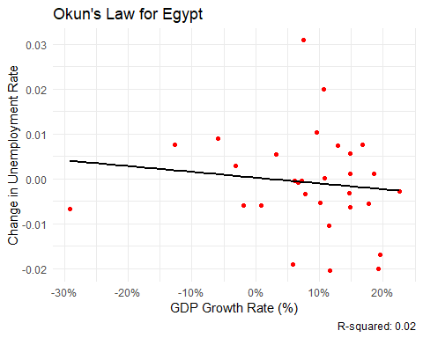

## `geom_smooth()` using formula = 'y ~ x'

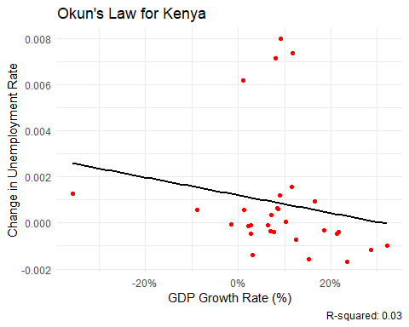

## `geom_smooth()` using formula = 'y ~ x'

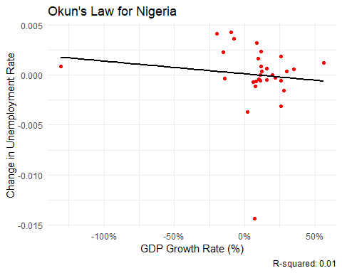

## `geom_smooth()` using formula = 'y ~ x'

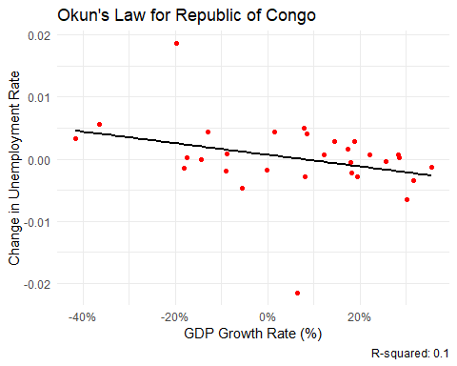

## `geom_smooth()` using formula = 'y ~ x'

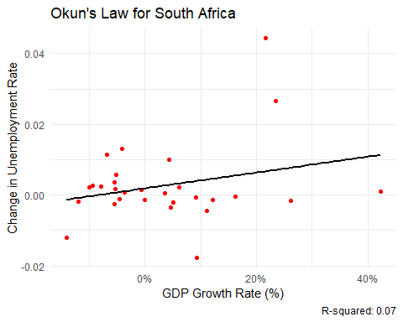

# View the Okun's Law results summary for all countries  
print(okun_results)

## Country Slope Intercept R_squared  
## gdp_growth_rate Egypt -1.292854e-04 0.0002076258 0.01548348  
## gdp_growth_rate1 Kenya -3.873249e-05 0.0012098736 0.03223942  
## gdp_growth_rate2 Nigeria -1.275900e-05 0.0001128524 0.01391063  
## gdp_growth_rate3 Republic of Congo -9.313137e-05 0.0006874160 0.09797549  
## gdp_growth_rate4 South Africa 2.237141e-04 0.0018759197 0.06906475