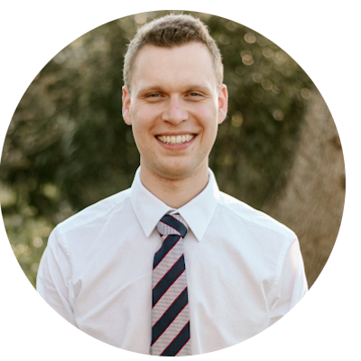
Ryan McClue
 re.mcclue@protonmail.com  0404316124  Sydney, NSW
❶ linkedin.com/in/ryan-mcclue ❼ github.com/ryan-mcclue
EXECUTIVE SUMMARY
Final year computer science student with military experience. I’m passionate about program optimisation and how I can use this to solve emerging problems and deliver business value.

(target for specific internship; how will it help reach my career goals)
Specifically, I'm eager to
apply and expand my expertise in web/software development in a real-world setting. I'm excited about the opportunity to
contribute meaningfully to projects while also furthering my own growth and development.

SKILLS SUMMARY  - Performance-Aware Programming  - UI Design  - Data Processing and Analysis  - Database Management  - Team Collaboration  - Discipline and Leadership | SKILLS DEMONSTRATED  Music Visualiser GUI 2024  Linux Fast Fourier Transform visualiser in C/C++  (video demonstration)  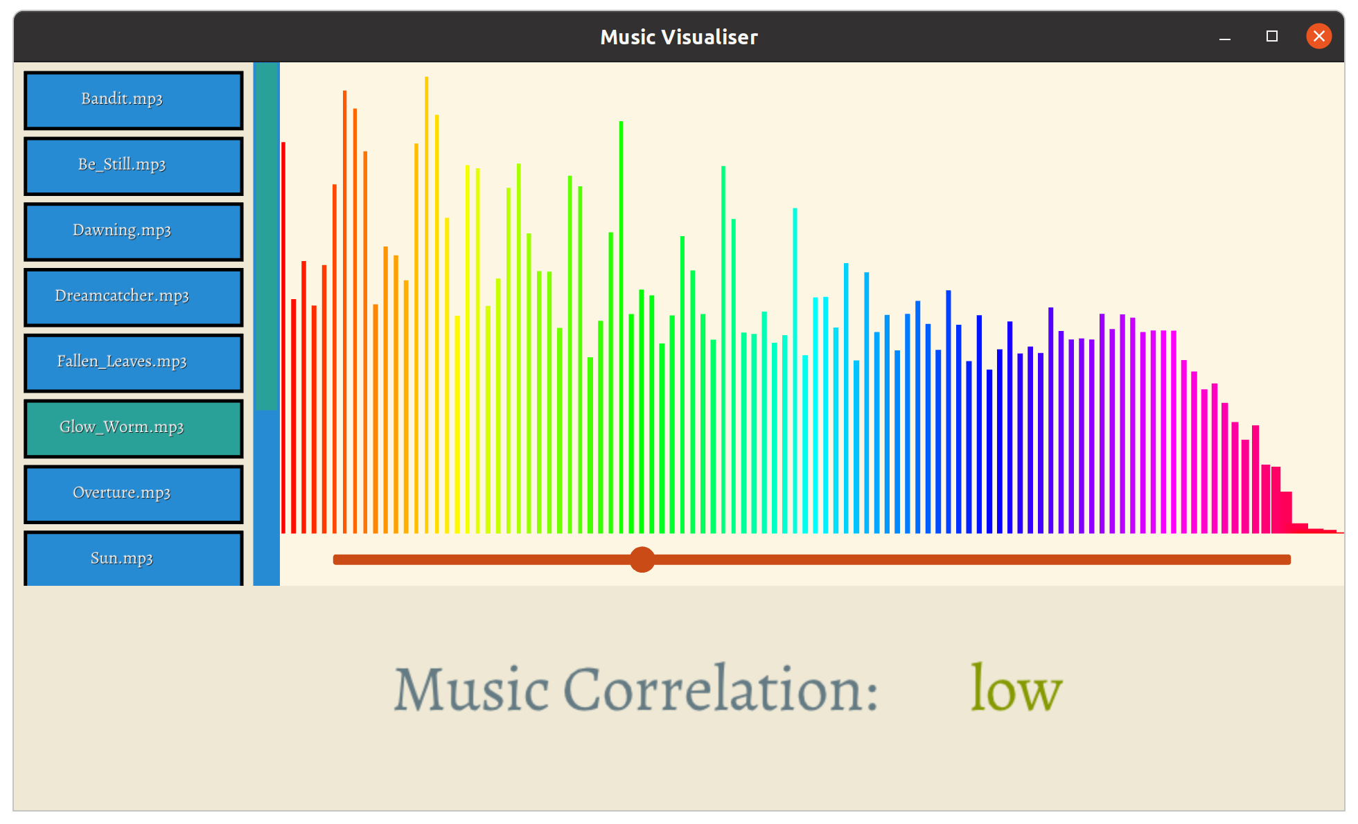  - Implemented animated UI widgets from scratch using custom zsorted push buffer with primitive draw routines, resulting in an interactive user experience.  - Asynchronously loaded/parsed a 1million entry dataset file using pthreads, improving system load performance by reducing file processing time by 50%.  - Created a code and asset hot-reloading system that allowed runtime application modification, improving iteration speed.  - Incorporated a Gitlab workflow CI system that ran application in headless mode, allowing static and dynamic analysis to be performed to enhance code security.  Marine Technician - Royal Australian Navy 2020    HMAS Cerberus, Victoria  - Leading a class of 24, coordinating marching drills and other basic training fundamentals.  - Balancing individual responsibilities such as kit maintenance with group requirements such as unit readiness whilst adhering to military schedules and protocols.  - Working in a team of 6 to clean living areas, stations and managing inventory.  - Performing weekly early morning activities at 4am and completing intensive milestone events.

INTERESTS  - Running  - Pressure Cooking  - Hiking  - Basketball  - Cold-Brew Tea  - Human evolution  REFERENCES  Available upon request | VOLUNTEERING  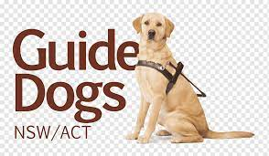  Guide Dogs NSW/ACT 2014-2022 Assisted with puppy raising Labrador till 24months old.  - Took dog on regular walks, issuing prescribed commands at crossings and traffic lights.  - Performed obedience training by following issued protocols, ensuring dog was familiar with kennel enclosure, eating procedures, human space awareness, etc.  EDUCATION  University of New South Wales 2021-2024  Bachelor of Computer Science  Custom Object Detection Algorithm (Major Group Project)  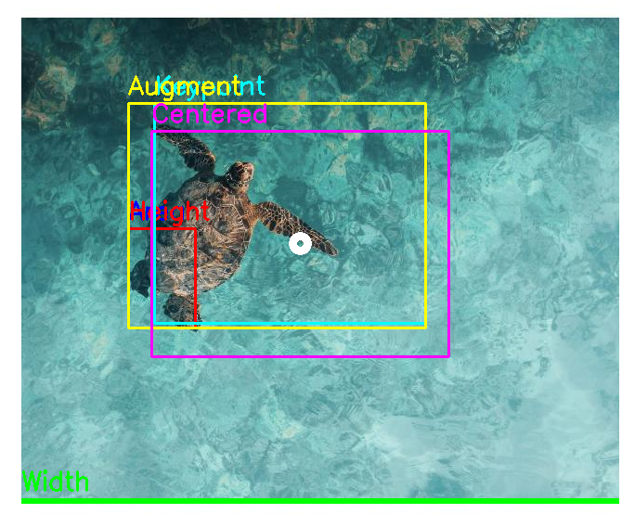  Ensemble learning penguin/turtle computer vision detector using OpenCV and PyTorch.  - Designed a genetic algorithm that approximated bounding boxes of animals within images, providing team of 4 with annotated training data that was used for the neural network and decision tree components of the detector.  - Organised Agile sprints with Jira, storyboarding with Figma and code reviews through MS teams, providing a streamlined workflow to ensure adaptable code.

