Ryan McClue
✉ re.mcclue@protonmail.com 📞 0404316124 📍Sydney, NSW
⌨ github.com/ryan-mcclue
EXECUTIVE SUMMARY
Recent computer science graduate with military experience. I’m passionate about program optimisation and how I can use this to solve emerging problems and deliver business value.

SKILLS SUMMARY  - Performance-Aware Programming  - UI Design  - Data Processing and Analysis  - Database Management  - Team Collaboration  - Military Discipline and Leadership | SKILLS DEMONSTRATED  Music Visualiser GUI 2024  Linux Fast Fourier Transform visualiser in C/C++  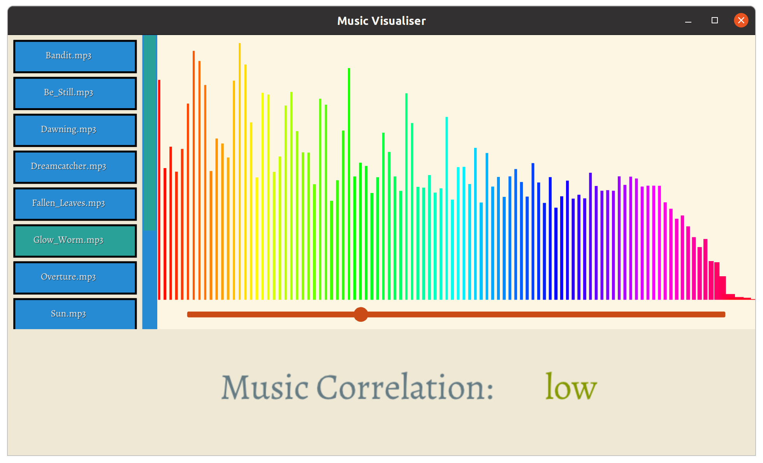  - Implemented animated UI widgets from scratch using custom zsorted push buffer with primitive draw routines, resulting in an interactive user experience.  - Asynchronously loaded/parsed a 1million entry dataset file using pthreads, improving system load performance by reducing file processing time by 50%.  - Created a code and asset hot-reloading system that allowed runtime application modification, improving iteration speed.  - Incorporated a Gitlab workflow CI system that ran application in headless mode, allowing static and dynamic analysis to be performed to enhance code security.  Marine Technician - Royal Australian Navy 2020  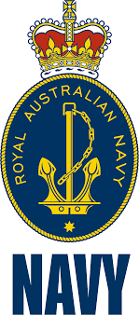  HMAS Cerberus, Victoria  - Lead class of 24 by coordinating marching drills and other basic training fundamentals, utilising clear communication skills and an ability to convey information accurately.  - Balanced individual responsibilities such as kit maintenance with group requirements such as unit readiness whilst adhering to rigid military schedules and protocols through disciplined and punctual behaviour.  - Worked in a team of 6 to clean living areas and stations, requiring precise attention to detail and ability to maintain high standards.  - Performed weekly early morning activities at 4am and completed intensive milestone events honing the ability to perform in physically and mentally demanding environments.  - Operated within a strict hierarchical structure, reporting activities and requesting instructions to and from class leaders, leading seaman and officers, fostering respect for authority and accountability for actions.

INTERESTS  - Running  - Cooking  - Hiking  - Basketball  - Tea  - Human evolution  REFERENCES  Available upon request | VOLUNTEERING  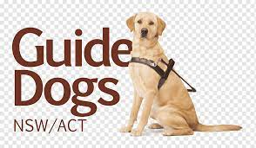  Guide Dogs NSW/ACT 2014-2022 Assisted with puppy raising Labrador till 24months old.  - Took dog on regular walks, issuing prescribed commands at crossings and traffic lights.  - Performed obedience training by following issued protocols, ensuring dog was familiar with kennel enclosure, eating procedures, human space awareness, etc.  EDUCATION  University of New South Wales 2021-2024  Bachelor of Computer Science  Custom Object Detection Algorithm (Major Group Project)  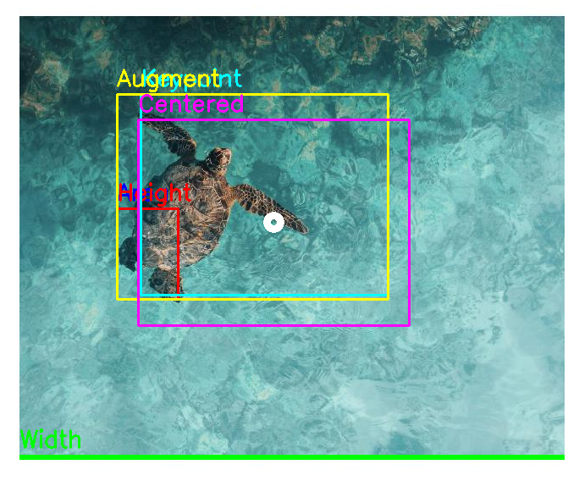  Ensemble learning penguin/turtle computer vision detector using OpenCV and PyTorch.  - Designed a genetic algorithm that approximated bounding boxes of animals within images, providing team of 4 with annotated training data that was used for the neural network and decision tree components of the detector.  - Organised Agile sprints, storyboarding and code reviews through MS teams and Trello, providing a streamlined workflow to ensure adaptable code.

