Ryan McClue - z5346008
COMP4920 – Group Report – AI Heart Monitoring – KardiaMobile 6L
Ryan McClue (RM), Ethan Tan (ET), Mia Waddington (MW), Hanan Hassan (HH)

Introduction (RM)
KardiaMobile 6L is a personal ECG/EKG (Electrocardiogram) device that leverages AI. An ECG is a test that measures the electrical pulses that trigger a heartbeat. The 6 leads in the KardiaMobile refers to 6 pulses, e.g from arm-to-arm, arm-to-leg etc. In a traditional ECG, the lead count corresponds to the number of contact points. However, in KardiaMobile the number of contact points is half the lead count.
Purpose
In its current state, the purpose of the KardiaMobile 6L is to facilitate the early detection of heart rhythm abnormalities to reduce the negative impact of heart disease in the community (AliveCor, n.d). Our proposed adoption of KardiaMobile would see this purpose amended to provide accessible and accurate heart monitoring for NDIS (National Disability Insurance Scheme) clients situated in NSW, Australia. The goal of this would be to promote heart health for high needs individuals. The NDIS is an Australian Government initiative that provides funding to people with a disability to improve their quality of life (NDIS, 2024).

Objectives
The objectives of the KardiaMobile 6L are:
- Comprehensive: Capture a more detailed view compared to traditional ECG wearables
- Accurate: Perform AI ECG analysis to detect up to 6 types of arrhythmias.
- Adaptable: Perform AI trend analysis to identify trigger points specific to an individual's heart rhythm changes.
- Accessible: Easy to use and interpret by a non-technical user.

Time Frame
In its current deployment, the time frame of KardiaMobile is to provide a detailed ECG analysis in a 30 second window. In addition, previous ECG reports can be saved for cumulative analysis to support routine monitoring. Our suggested use of KardiaMobile has time frames in line with regular reporting periods matching individual NDIS health plans. In addition, this would include scheduled monitoring aligned with NDIS carer visits.

Location
Currently, KardiaMobile is primarily used in North America and Western Europe in a relaxed home setting. However, the portable design allows for use in other locations such as a hospital or health clinic. This also gives the potential for integration in telemedicine and remote patient monitoring programs. In our proposed plan, KardiaMobile would be used in NSW, Australia. This would include NDIS approved accommodation settings such as a communal living arrangements or NDIS day programs with support workers.

Use Case
Currently, KardiaMobile is mainly used to perform regular heart monitoring at home for individuals with known heart conditions. In addition, it also enables the sharing of ECG data with healthcare providers to allow for more informed decision making. In our use case, KardiaMobile would provide an easy-to-use heart monitoring system for NDIS participants. Furthermore, it would integrate ECG sharing between NDIS support teams and healthcare providers.

Needs & Benefits (HH)
The primary motivation for our proposed adoption of KardiaMobile is to tackle cardiovascular disease. In 2023, this was among the top five disease causing burden in Australia (). People with disabilities are at a higher risk for heart disease, with cardiac events occuring up to eight times more frequently within this population ().

...

Users (MW)
Practitioners
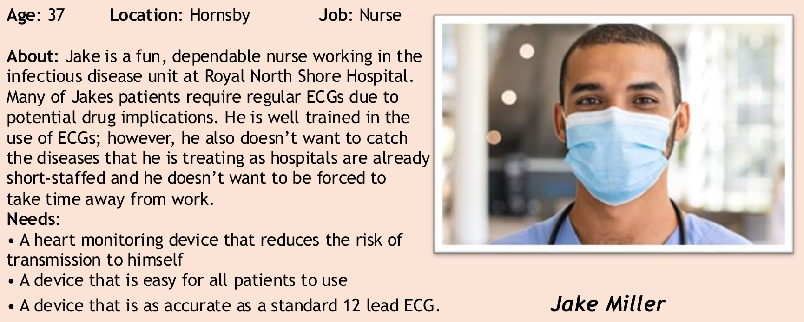

Patients
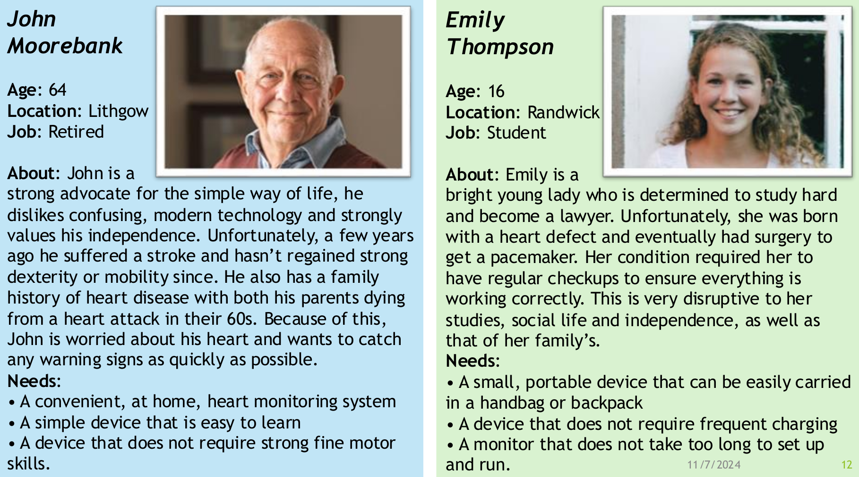

Caretakers
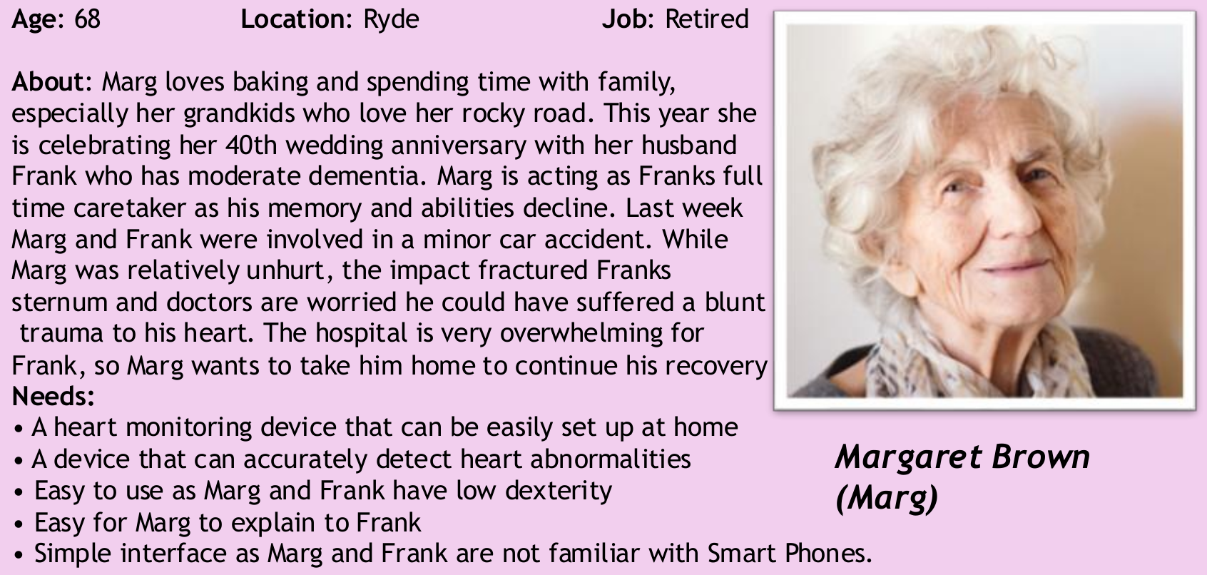

Stakeholders (ET)
This group includes any stakeholders which have an interest in ECG devices and the development of new technologies for these devices. People in this group could be investors who wants to invest in the company making these ECG devices so that the company could focus on research and development of new technologies. Or some of these people are just lay people who would like to invest in the health sector as they think it is a good sector to invest in as new technologies evolve.
NDIS Manager
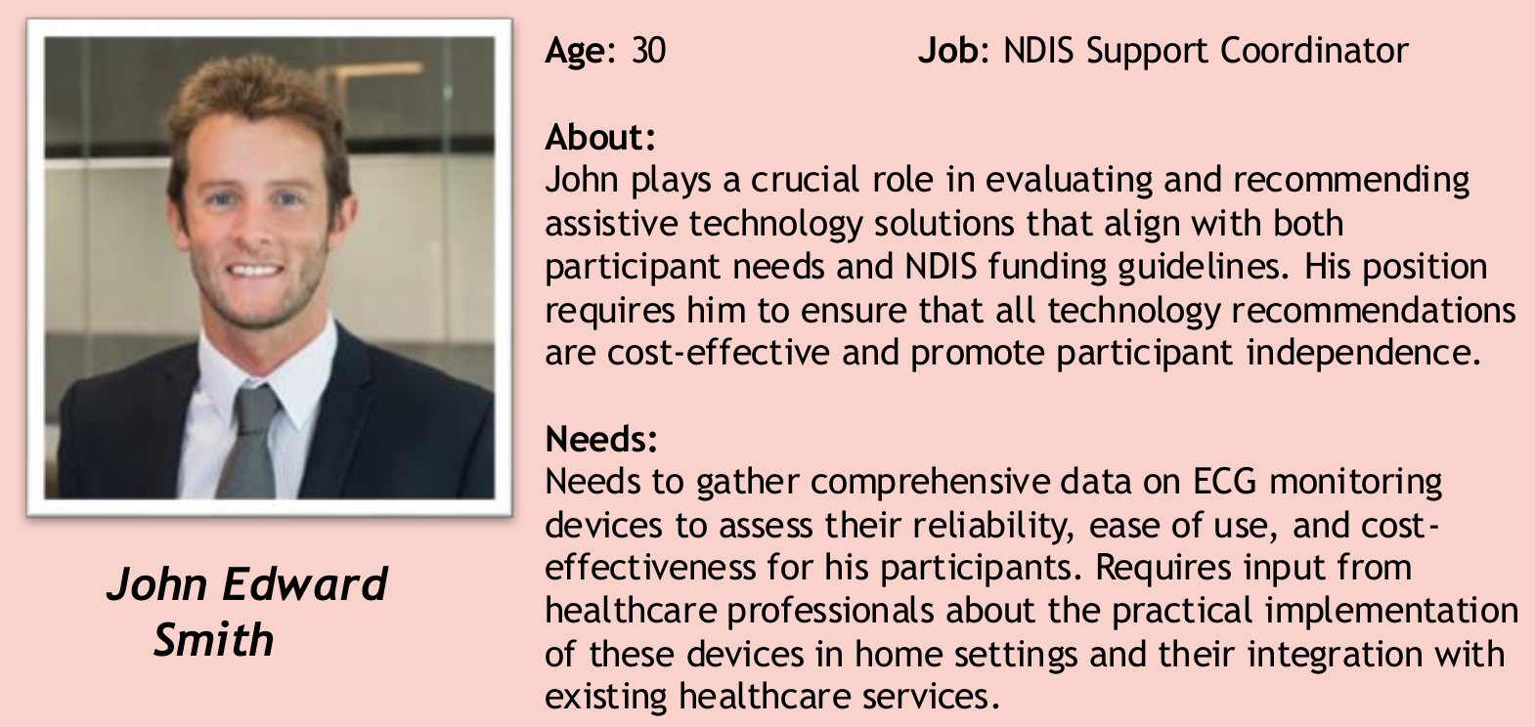

Practicioners
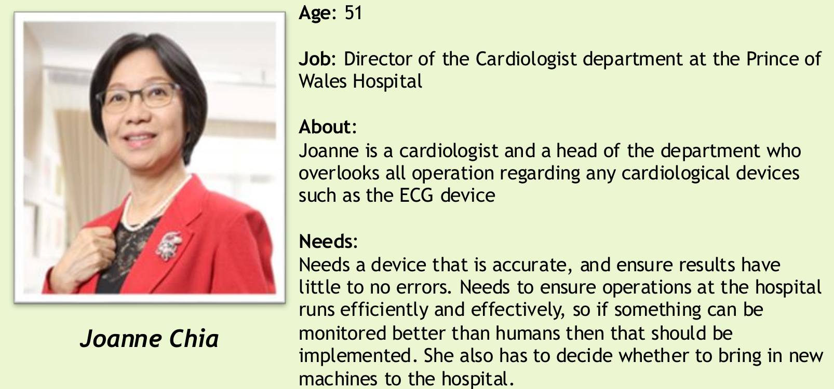

Medical Companies
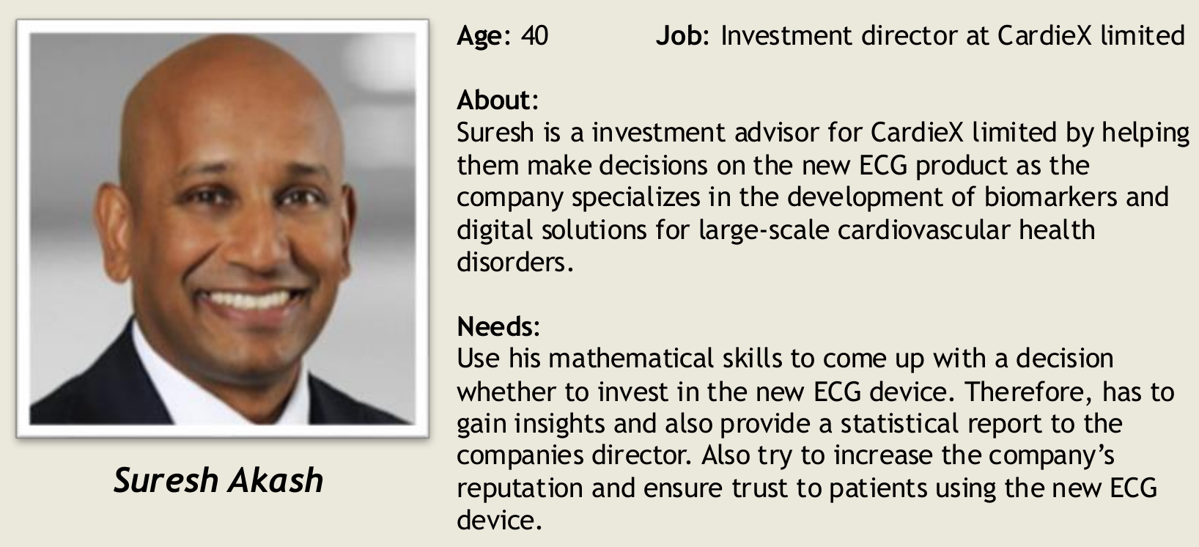

Health Minister
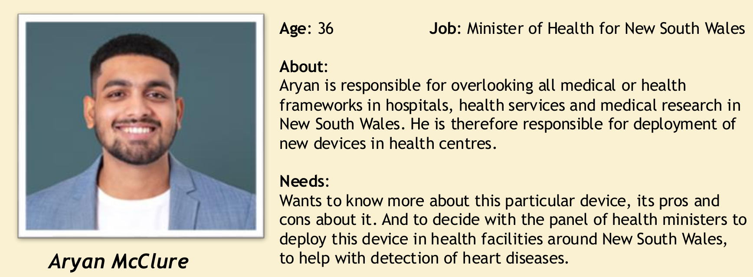

Conceptual Value Sensitive Design (Everybody)
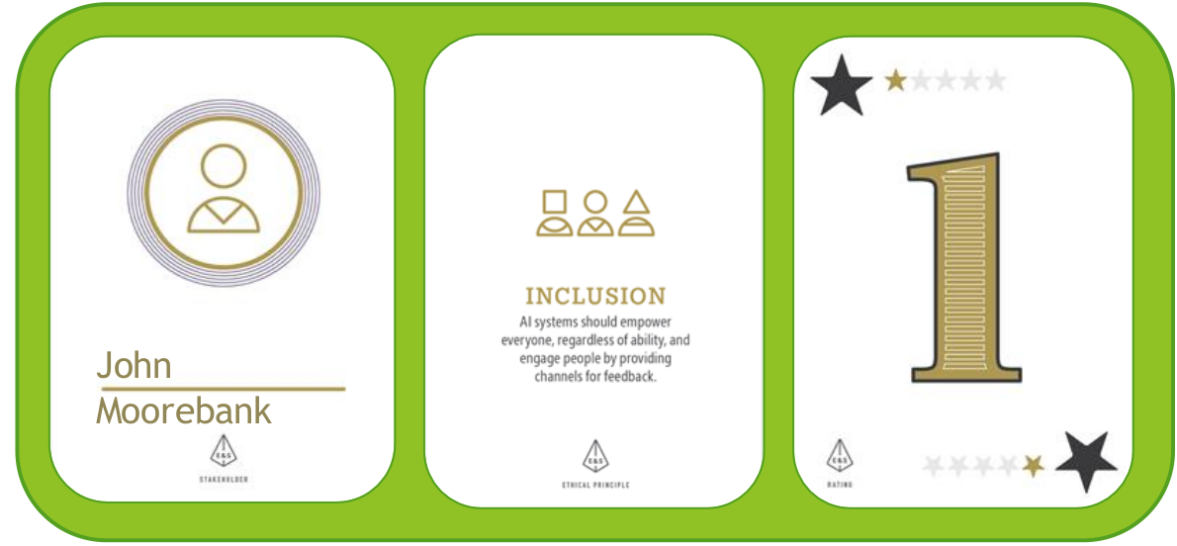

Issues | Mitigation | Judgement
Has difficulties with holding and using the Kardia due to small profile and loss of fine motor skills from a previous stroke.​  - Has difficulties with technology and did not own a smartphone prior to owning the Kardia. | Ergonomic case to make it easier to hold​  ​  - Provide an optional add on smart device with preinstalled software | Be aware of physical limitations when using the device

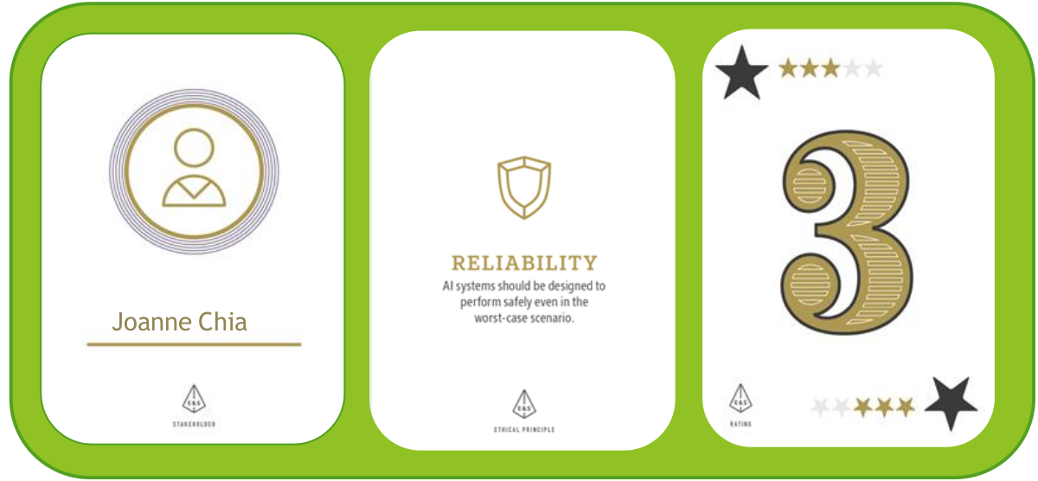

Issues | Mitigation | Judgement
Effective 6-lead ECG to provide patients with peace of mind​  - Convenient for patients to conduct ​  - Can produce false readings​  - Overreliance could be harmful to patients' health. | Ensure users are aware of device limitations. ​  - Do not prescribe casually | Use as a precautionary device, not as a medical diagnosis.

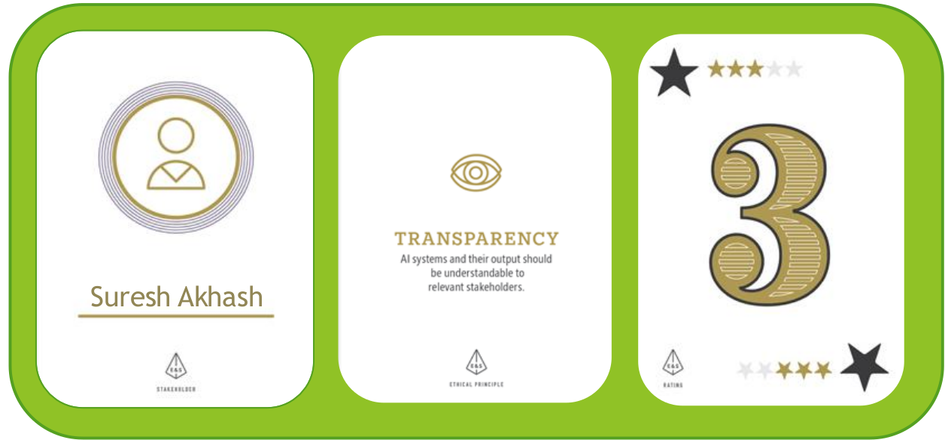

Issues | Mitigation | Judgement
Pleased with access to high-level financial and technical details.​  - To assess viability of investment, want AI algorithm specifics to be disclosed. | Provide details on source/scale of AI training data​  - Implement explainable AI techniques | Strike a balance between transparency and intellectual property protection.

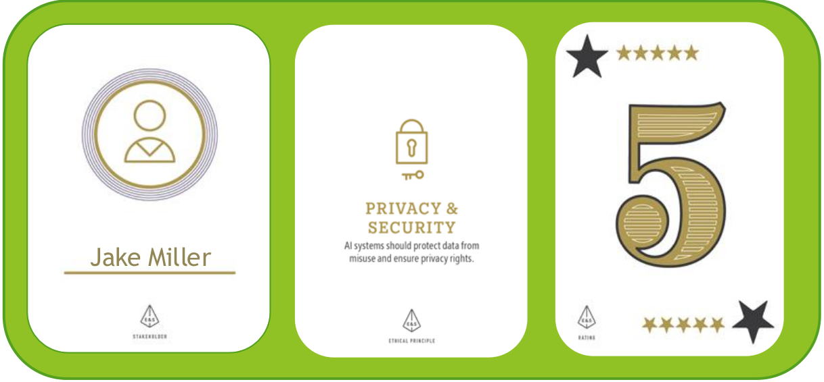

Issues | Mitigation | Judgement
Customers want to know how their data is being stored and is the method used secured | Options to withdraw from storing data on servers​  - Store sensitive data securely by using a secured cloud server like Microsoft azure, Google cloud | Secure data storage and provide optionality to customers to withdraw

Stakeholder Concerns (Everybody)

Fairness – Economic - NDIS
Fairness – Accuracy – Apple Watch
Transparency – Explainability – Technomed
Transparency – Obsolescence – Cochlear Implant

Comparison (RM & ET)
Fairness
VSD | Real World | Conclusion
Equitable access to device | Economic barriers to device (NDIS)​  - Biases in AI results (Apple Watch) | Beyond the accuracy of the device, financial and physical barriers are influential​

Transparency
VSD | Real World | Conclusion
Access to AI internals​  - Awareness of device limitations​  - Storage of personal data | Explainability of results (Technomed)​  - Device obsolescence (Cochlear) | Technical results tend to be opaque to users. ​  - Finer details with regards to device usage may not be easily found/immediately obvious.

Recommendations (HH & MW)

We think we should deploy the technology with some recommendations:​
- Software should follow medical device software standards (ISO IEC 62304:2006) (Brönneke JB, 2021)​
- Keep prices in line with retail price to avoid price gouging​
- Optional add on for basic tablet/smartphone with software preinstalled (limited functionality to Kardia software, single use device)​
- Informational session for users and stakeholders receiving the device so they are made aware of the technical details and finer terms and conditions behind usage of the device.​
- This includes disclaimers about accuracy of the device, its lifespan, privacy policy, and not using as sole diagnostic tool​
- Ergonomic case for the device to make it easier to hold and guide correct hand placement​
- Use XAI techniques to troubleshoot/verify the device input/output

References
- Sequoiah-Grayson, S. (N/A) The Unsatisfiable Triad: A Problem for Automated Decision Making. [unpublished manuscript].
- Bickel, P.J., Hammel, E.A. and O'Connell, J.W., 1975. Sex Bias in Graduate Admissions: Data from Berkeley: Measuring bias is harder than is usually assumed, and the evidence is sometimes contrary to expectation. Science, 187(4175), pp.398-404.
- Malinas, G. and Bigelow, J. (2016). Simpson’s Paradox (Stanford Encyclopedia of Philosophy). [online] Available at: https://plato.stanford.edu/entries/paradox-simpson/ [Accessed 28 Oct. 2024]
- Julia Dressel and Hany Farid. 2018. The accuracy, fairness, and limits of predicting recidivism. Science advances 4, 1 (2018), eaao5580.
- Caroline Wang, Bin Han, Bhrij Patel, and Cynthia Rudin. 2023. In pursuit of interpretable, fair and accurate machine learning for criminal recidivism prediction. Journal of Quantitative Criminology 39, 2 (2023), 519–581.
- David K Lewis. 1986. Causation. (1986). Peter Lipton. 1990. Contrastive explanation. Royal Institute of Philosophy Supplements 27 (1990), 247–266. Ilkka Niiniluoto. 1981. Statistical explanation reconsidered. Synthese (1981), 437–472.
- Alexandra Chouldechova. 2017. Fair prediction with disparate impact: A study of bias in recidivism prediction instruments. Big data 5, 2 (2017), 153–163.
- Lecture Slides Week 7 - Transparency, XAI, Interpretability, University of NSW, 2024.
- Stephen Kearns and Daniel Star. 2008. Reasons: Explanations or evidence? Ethics 119, 1 (2008), 31–56.
- Adminko (2023). Llama 2 model sizes (7B, 13B, 70B). [online] Llama 2. Available at: https://llama-2.ai/llama-2-model-sizes/. [Accessed 30 Oct. 2024]
- Campbell, M., Hoane, A. J., & Hsu, F. H. (2002). Deep blue. Artificial intelligence, 134(1-2), 57-83.
- Galhotra, S., Pradhan, R. and Salimi, B., 2021, June. Explaining black-box algorithms using probabilistic contrastive counterfactuals. In Proceedings of the 2021 International Conference on Management of Data (pp. 577-590).
- Solon Barocas, Andrew D Selbst, and Manish Raghavan. 2020. The hidden assumptions behind counterfactual explanations and principal reasons. In Proceedings of the 2020 conference on fairness, accountability, and transparency. 80–89.
- John Brunero. 2013. Reasons as explanations. Philosophical Studies 165 (2013), 805–824.

