
REALITY CHECK: THE COMPLEXITY BEHIND SCIENTISTS IN FILM

Ryan McClue, z5346008

Supporting Statement
This free form piece is written as an article. It's intended to be published in a science education magazine. The target audience is young people who are interested in pursuing a career in science and/or their parents. It's expected that this audience has a basic understanding of fundamental scientific concepts. The article aims to deconstruct the glamourisation of scientists in cinema, emphasising the challenges and mistakes they face in reality. In doing so, the article intends to provide information to assist in fostering a realistic understanding of a scientific career and encouraging resilience in the face of challenges experienced on this journey.

Scientists in film are often portrayed as infallible characters. They are depicted as having incredible intelligence and an ability to individually solve the most difficult of problems in a short period of time. In the pursuit of exciting plot lines, films can obscure the authentic scientific process. I believe it's worth questioning the facades that cinema constructs around the figure of the scientist for the sake of younger minds interested in pursuing a career in science. As parents often play a crucial role in guiding their children's career choices, I also believe this exploration can benefit them as well. The disparity between film and real world science can potentially dishearten individuals who fall short of the idealised experiences they have seen on film. In film, the speed of scientific discoveries are often exaggerated, the image of a scientist working in isolation is perpetuated and the reverence for scientists is often overly emphasised. Scientists, akin to everyone else, are human and susceptible to making mistakes. When watching scientists in film, it's important to realise that film often leaves out the nuanced and undeniably human journey of a career in science.
The Speedy Scientist
It's common for scientific progress to be marked by long periods of time. Scientific research is iterative by nature to allow for thorough experimentation. Although this is a time consuming process, it's to ensure reliable and valid results are obtained. In the film Outbreak (1995), Colonel Daniels and his team are able to isolate the Motaba virus in a remarkably short period of time. Daniels instructs Major Salt to "Separate samples, thaw them and put under microscope". Within 8 hours they make a determination based on the samples effects on kidney cells. Later on in a similar fashion, Major Schuler quickly ascertains that the "protein code has changed" of the new Cedar Creek strain. This depiction dramatically accelerates the scientific procedures involved in virus identification. The process of sequencing a virus's genome, studying its proteins and understanding its molecular characteristics require a significant amount of time (Dothard, M. et al. 2019). This can be seen in the real world SARS (Severe Acute Respiratory Syndrome) virus. In what was considered a "technological Blitzkrieg", it took approximately 5 months from the first reported case to completely sequence (Cherry, J., and Krogstad, P., 2004). Not a matter of a few days or weeks.

This accelerated scientific process is also seen in the film The Day After Tomorrow (2004). Jack Hall and his team are able to convert their climate model to "factor in storm scenarios" as suggested by Janet Tokada. This modification is made and subsequent results obtained within 24 hours. From this, they are able to make the claim that in 6 to 8 weeks, there will be a "major climate shift". In reality, modelling the intricacies of climatic processes takes months to years. Not only this, but the results of these models output significant amounts of data to sift through. A series of numbers that are easily interpreted are not what is produced (Naughten, K., 2012). An example of a climate model in the real world is IPCC (Intergovernmental Panel on Climate Change) Fourth Assessment Report. Extensive research and data collection over a period of years took place to develop this. It was an evolving, intricate process that couldn't simply factor in a weather scenario without many points of refinement (IPCC Team, 2024). It's important for aspiring scientists to not be disheartened by a lack of quick results. Scientific progress is inherently iterative and requires continuous learning and adaptation. Embrace the complexity and remember that patience and dedication are paramount.
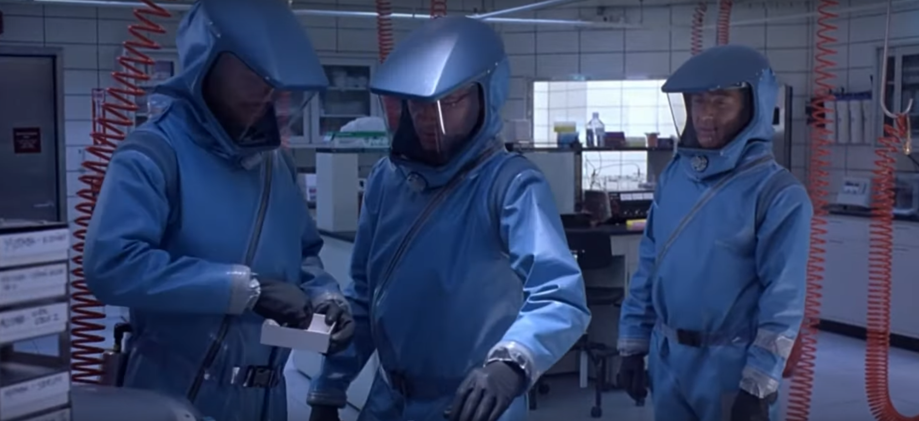Isolating the Motaba virus in Outbreak (1995).
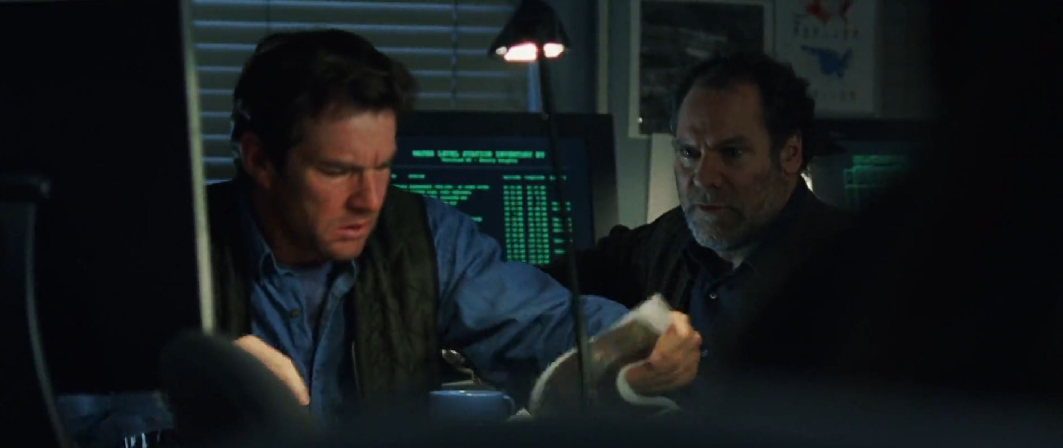Modifying the climate model in The Day After Tomorrow (2004).

The Lone Scientist
Scientific breakthroughs are seldom achieved by a lone scientist. Due to the increasingly complex nature of contemporary science, a collaborative approach is required. In the film The Boys From Brazil (1978), Dr Josef Mengele is presented as a lone scientist who is able to become the first person to clone humans. At the beginning of the film, Mengele's bright white suit in amongst greys and blues highlights his solitary nature. His unwillingness to accept advice is reflected when he says to Captain Mundt "Do not question your orders. Simply obey them". The difficulty of Mengele's innovation is expressed in the film when Professor Brucknor says "impossible" to Liebermann when asked about the possibility of cloning humans. In the real world, the first mammal to be cloned from an adult cell occurred with Dolly the sheep in 1996 (The Roslin Institute, 2021). The film predates this milestone, dramatically elevating the complexity of Mengele's achievements. By looking at the real world gene editing technology CRIPSR, it can be seen that a collective effort from scientists is required for innovation. Major breakthroughs in the fields of molecular biology, bioinformatics and genetics were needed for CRISPR. This knowledge was pooled together to ultimately allow scientists to edit specific DNA sequences (Gostimskaya, I., 2022). As a result, it's unrealistic to think that a single scientist would be able to successfully implement human cloning on their own.

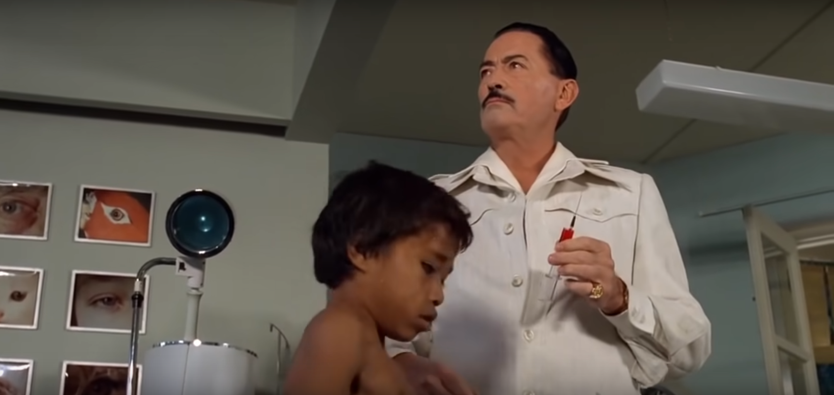Mengele working in his secret laboratory in The Boys From Brazil (1978)
In the film Ex Machina (2014), Nathan Bateman is portrayed as a reclusive scientist who is able to create an advanced artificial intelligence (AI) known as Ava. Sweeping shots of his huge estate showcasing mountains, waterfalls and glaciers that can only be reached by helicopter hammer home how isolated he is. The significance of his achievements is made clear when he expresses to Caleb that Ava is "The greatest scientific event in the history of man". Ava's brain is described as a revolution of material science "Away from circuitry; able to arrange and rearrange at the molecular level". In the real world, to create even the most rudimentary artificial brain requires extensive knowledge in electrical engineering, neuroscience and bioengineering (Chu, J., 2020). This exemplifies the unrealistic level of knowledge Nathan must have. Inspecting the development of self driving cars demonstrates the extensive collaboration required in making cutting edge technological advancements. Like Ava, they require electrical engineers to develop complex hardware and sensor arrays, computer science specialists for advanced algorithms and AI experts for autonomous operation (Y Mobility Team, 2023). This collaborative approach stands in stark contrast to the isolated genius of Nathan Bateman. For aspiring scientists, it's essential to understand that a successful career doesn't hinge on having all encompassing knowledge. Embracing collaboration, learning from mentors and being open to interdisciplinary teamwork are keys to success.
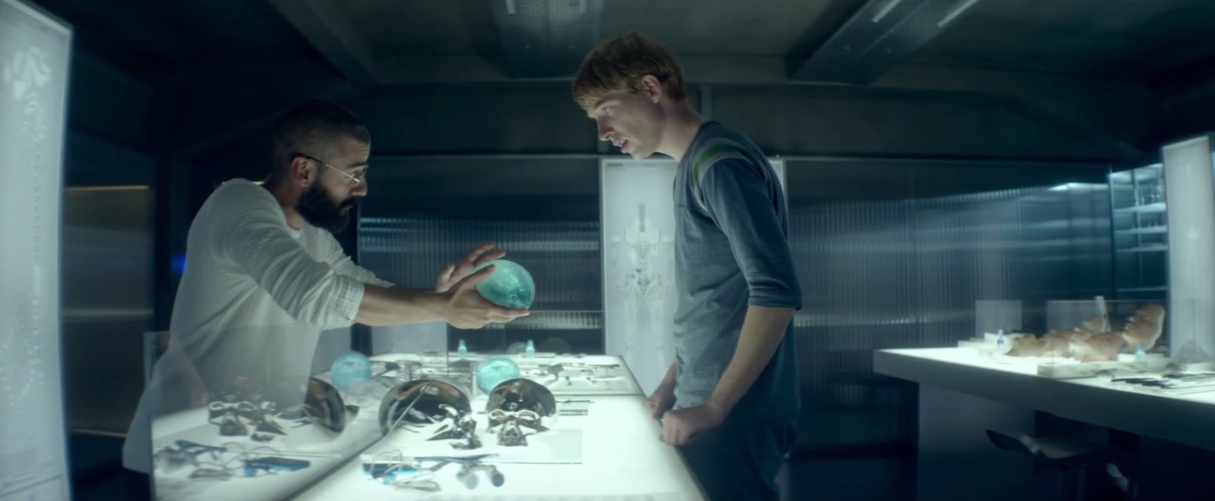Nathan showing Ava's brain to Caleb in Ex Machina (2014)
The Celebrity Scientist
It's unlikely for society to elevate a scientist to celebrity status for their work. The complex and specialised knowledge involved isn't immediately relatable to the average person. In the film Blade Runner (1982), Eldon Tyrell is viewed as a celebrity due to his work in genetic engineering, creating advanced humanoid robots known as Replicants. Tyrell's opulent office and towering headquarters above the dystopian metropolis serve to demonstrate the immense societal significance of his scientific achievements. The influence of his work extends beyond the laboratory, causing a paradigm shift in the way society interacts with technology. His title of the "god father of bioengineering" is further evidence of how he is revered. In the real world, it's most likely that the extent of a scientists acclaim will be limited to within their respective fields. Considering one of the inventors of the transistor, William Shockley, this can be seen. The transistor revolutionised the field of electronics, having far reaching implications for telecommunications and computing (Amonett, N., 2022). Despite being a pivotal figure in its development, Shockley did not achieve the level of household name (de la Plaza, I. M., 2018).
Tyrell Corporation Building in Blade Runner (1982)

In the film I, Robot (2004), Dr Alfred Lanning acheives widespread recognition for his innovations in robotics and AI. He pioneers the creation of the nestor class (NS) humanoid robots and a central command AI system known as VIKI. The building of Lanning's company, U.S Robotics is symbolic of his own global status. Dwarfing nearby buildings, it's shown to be the centrepoint of the city to underscore the high regard society has for Lanning's achievements. Calvin remarks to Spooner that "Robots are realisation of a dream. Dr Lannings dream". As there are more NS robots than people, this signifies the extent to which Lanning has brought about a profound societal shift. In the real world, it's most likely that a scientist's recognition will remain confined to their areas of expertise. This is illustrated by Claude Shannon, often referred to as the father of information theory. Shannon's work had tremendous impact on computer science and AI. He laid the groundwork for modern digital communication, paving the way for the development of the digital computer (Collins, P. G., 2002). Yet, despite his ground breaking innovations, he did not achieve widespread recognition beyond academic circles during his lifetime. (Reshma, A., 2022). It's important to recognise that a lack of widespread recognition does not diminish the value of a person's contribution to science. You should not be deterred by any societal expectations of fame. The true act of science lies in the passion for discovery and the impact on the scientific community.

U.S.R Headquarters in I, Robot (2004)
Conclusion
The portrayal of scientists in film is an exaggeration of the real work they do. The idealised image perpetuated by films of speedy discoveries, isolated geniuses and revered individuals is unlikely to be experienced in a career in science. However, any aspiring minds should not be deterred by this. The scientific community is one that embodies perseverance, infallibility and collaboration in the pursuit of knowledge. As long as you are resilient, open minded and humble, you will be able to navigate any challenges science throws at you.

References
- Scott, R. (Director). (1982). Blade Runner. Warner Bros. Pictures. Film.
- Emmerich, R. (Director). (2004). The Day After Tomorrow. 20th Century Studios. Film.
- Schaffner J., F. (Director). (1978). The Boys From Brazil. 20th Century Studios. Film.
- Garland, A. (Director). (2014). Ex Machina. Universal Pictures. Film.
- Proyas, A. (Director). (2004). I, Robot. 20th Century Fox. Film.
- Peterson, W. (Director). (1995). Outbreak. Warner Bros. Pictures. Film.
- Dothard, M., Leiby, J., Fitzgerald A., and Khatib L. (2019). How Do You Find a Virus That’s Completely Unknown?. Penn Medicine News. Available at: https://www.pennmedicine.org/news/news-releases/2019/may/how-do-you-find-a-virus-thats-completely-unknown-study-says-look-to-the-genome
- Cherry, J., and Krogstad, P. (2004). SARS: The First Pandemic of the 21st Century. National Library of Medicine. Available at: https://www.ncbi.nlm.nih.gov/pmc/articles/PMC7086556/
- Naughten, K. (2012). The Day After Tomorrow: A Scientific Critique. ClimateSight. Available at: https://climatesight.org/2012/04/26/the-day-after-tomorrow-a-scientific-critique/
- IPCC Team. (2024). IPCC Preparing Reports. IPCC. Available at: https://www.ipcc.ch/about/preparingreports/
- The Roslin Institute. (2021). The Life of Dolly. University of Edinburgh. Available at: https://www.ed.ac.uk/roslin/about/dolly/facts/life-of-dolly
- Gostimskaya, I. (2022). CRISPR–Cas9: A History of Its Discovery and Ethical Considerations of Its Use in Genome Editing. National Library of Medicine. Available at: https://www.ncbi.nlm.nih.gov/pmc/articles/PMC9377665/
- Chu, J. (2020). Engineers put tens of thousands of artificial brain synapses on a single chip. MIT News. Available at: https://news.mit.edu/2020/thousands-artificial-brain-synapses-single-chip-0608
- Y Mobolity Team. (2023). The Role of Partnerships & Collaboration in Autonomous Driving. Y Mobility. Available at: https://www.y-mobility.co.uk/the-role-of-partnerships-collaboration-in-autonomous-driving/
- Amonett, N. (2022). The Transistor – an Invention Ahead of its Time. Standard Electric Supply Co. Available at: https://www.standardelectricsupply.com/blog/brief-history-transistors
- de la Plaza, I. M. (2018). William Shockley and the Invention of the Transistor. OpenMind. Available at: https://www.bbvaopenmind.com/en/science/leading-figures/william-shockley-and-the-invention-of-the-transistor/
- Collins, P. G. (2002). Claude E. Shannon: Founder of Information Theory. Scientific American. Available at: https://www.scientificamerican.com/article/claude-e-shannon-founder/
- Reshma, A. (2022). The Greatest Achievements of Claude Shannon that Aided in Transforming the Future!. Byju's Future School. Available at: https://www.byjusfutureschool.com/blog/the-greatest-achievements-of-claude-shannon-that-aided-in-transforming-the-future/

