**COMP4920 – Group Report – AI Heart Monitoring – KardiaMobile 6L**

Ryan McClue, Ethan Tan, Mia Waddington, Hanan Hassan

Introduction (Ryan McClue)

KardiaMobile 6L is a personal ECG/EKG (Electrocardiogram) device that leverages AI. An ECG is a test that measures the electrical pulses that trigger a heartbeat. The 6 leads in the KardiaMobile refers to 6 pulses, e.g from arm-to-arm, arm-to-leg etc. In a traditional ECG, the lead count corresponds to the number of contact points. However, in KardiaMobile the number of contact points is half the lead count.

Purpose

In its current state, the purpose of the KardiaMobile 6L is to facilitate the early detection of heart rhythm abnormalities to reduce the negative impact of heart disease in the community (AliveCor, n.d). Our proposed adoption of KardiaMobile would see this purpose amended to provide accessible and accurate heart monitoring for NDIS (National Disability Insurance Scheme) clients situated in NSW, Australia. The goal of this would be to promote heart health for high needs individuals. The NDIS is an Australian Government initiative that provides funding to people with a disability to improve their quality of life (NDIS, 2024).

Objectives

The objectives of the KardiaMobile 6L are:

* Comprehensive: Capture a more detailed view compared to traditional ECG wearables
* Accurate: Perform AI ECG analysis to detect up to 6 types of arrhythmias.
* Adaptable: Perform AI trend analysis to identify trigger points specific to an individual's heart rhythm changes.
* Accessible: Easy to use and interpret by a non-technical user.

Time Frame

In its current deployment, the time frame of KardiaMobile is to provide a detailed ECG analysis in a 30 second window. In addition, previous ECG reports can be saved for cumulative analysis to support routine monitoring. Our suggested use of KardiaMobile has time frames in line with regular reporting periods matching individual NDIS health plans. In addition, this would include scheduled monitoring aligned with NDIS carer visits.

Location

Currently, KardiaMobile is primarily used in North America and Western Europe in a relaxed home setting. However, the portable design allows for use in other locations such as a hospital or health clinic. This also gives the potential for integration in telemedicine and remote patient monitoring programs. In our proposed plan, KardiaMobile would be used in NSW, Australia. This would include NDIS approved accommodation settings such as a communal living arrangements or NDIS day programs with support workers.

Use Case

Currently, KardiaMobile is mainly used to perform regular heart monitoring at home for individuals with known heart conditions. In addition, it also enables the sharing of ECG data with healthcare providers to allow for more informed decision making. In our use case, KardiaMobile would provide an easy-to-use heart monitoring system for NDIS participants. Furthermore, it would integrate ECG sharing between NDIS support teams and healthcare providers.

Needs & Benefits (Hanan Hassan)

The primary motivation for our proposed adoption of KardiaMobile is to tackle cardiovascular disease. In 2023, this was the leading cause of death in Australia (Australian Bureau of Statistics, 2023). People with disability have cardiovascular disease more often and earlier than the general population (NDIS Commission, 2022). People with disabilities may also have barriers to treatment due to fears around certain tests such as a standard ECG. The Kardia is less invasive and may help alleviate this.

There are a number of benefits from rolling out KardiaMobile to NDIS participants:

* Economic: Early detection can prevent unnecessary hospital visitation, saving on hospital admission and ambulance transportation costs. Can also save on specialised disability transport costs.
* Accessibility: The device is non-invasive and requires minimal training, making it easier for support workers and carers to use effectively.
* Infection Control: Enables self-administered ECGs, reducing infection risks for both healthcare practitioners and patients with compromised immune systems.
* Healthcare Delivery: Early detection of atrial fibrillation (AF), the most common heart arrhythmia, can prevent stroke and heart failure risks. Supports telemedicine capabilities, reducing travel needs for patients with disabilities.

Users (Mia Waddington)

|  |
| --- |
| Practitioners |
|  |

|  |
| --- |
| Patients |
|  |

|  |
| --- |
| Caretakers |
|  |

Stakeholders (Ethan Tan)

|  |
| --- |
| NDIS Manager |
|  |

|  |
| --- |
| Practicioners |
|  |

|  |
| --- |
| Medical Companies |
|  |

|  |
| --- |
| Health Minister |
|  |

Conceptual Value Sensitive Design (Everyone)

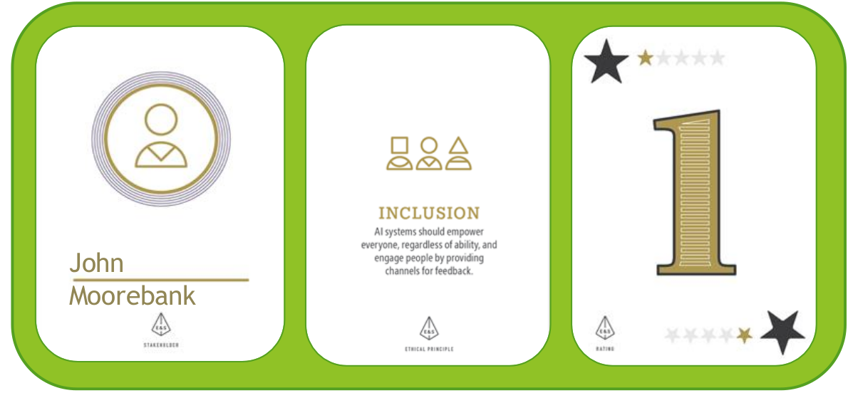

|  |  |  |
| --- | --- | --- |
| Issues | Mitigation | Judgement |
| *“I have difficulty holding and using the KardiaMobile due to its small profile and the loss of my fine motor skills due to a previous stroke. I’m also not very tech-savy and don’t own a smartphone to use with the device”* | Create an ergonomic case to make the device easier to hold.  Provide an optional add on smart device with preinstalled software. | In the design process, be aware of physical limitations when using the device. |

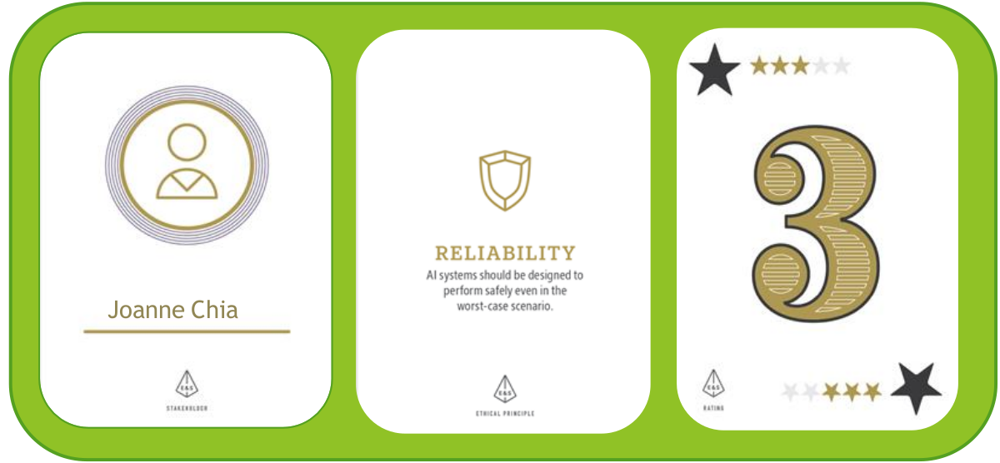

|  |  |  |
| --- | --- | --- |
| Issues | Mitigation | Judgement |
| *“KardiaMobile is an effective 6-lead ECG that is convenient and provides patients with peace of mind regarding their heart health. However, it can produce false readings and there is a potential that patients may become over-reliant on its results.”* | Make sure users are aware of KardiaMobile’s limitations.  In addition, don’t prescribe casually. | Use as a precautionary device, not as a medical diagnosis. |

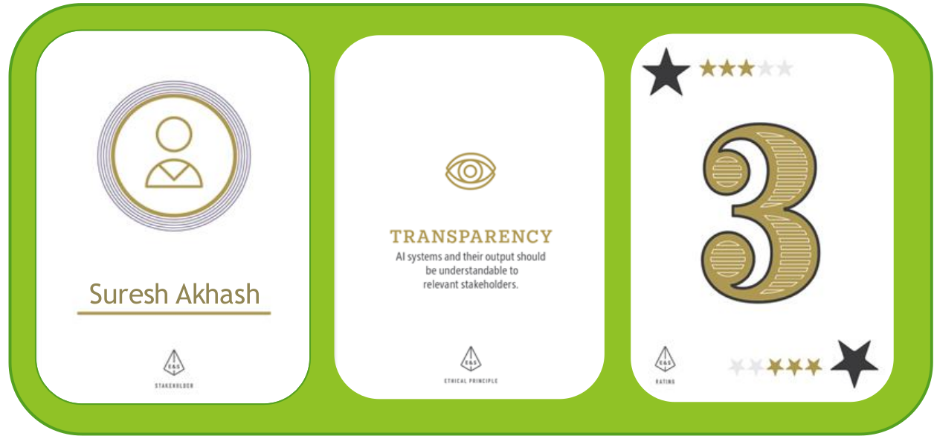

|  |  |  |
| --- | --- | --- |
| Issues | Mitigation | Judgement |
| *“I’m pleased with the access I have to KardiaMobile’s high-level financial and technical details. However, to assess the viability of my investment, I want the AI algorithm specifics to be disclosed”* | Provide details on source/scale of AI training data.  Also, implement explainable AI techniques | Strike a balance between transparency and intellectual property protection. |

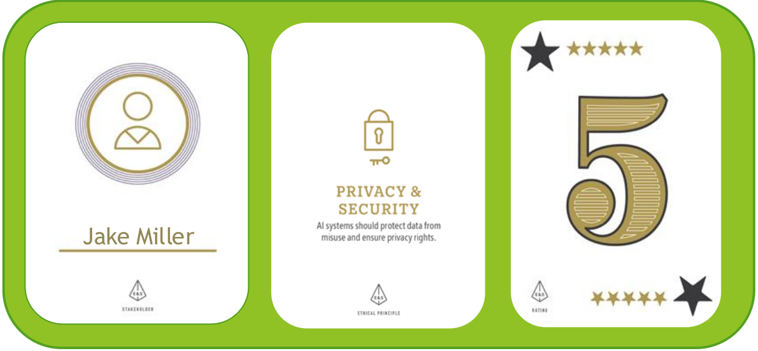

|  |  |  |
| --- | --- | --- |
| Issues | Mitigation | Judgement |
| *“Customers want to know how their data is being stored and is the method used secured”* | Provide users with the option to withdraw from storing their personal data on KardiaMobile servers.  Store personal data securely by using a secured cloud server. | Secure data storage and provide optionality to customers to withdraw. |

Stakeholder Concerns (Everyone)

Fairness – Economic - NDIS

Purchasing just the KardiaMobile device for $129, will only receive a limited version of the AI. To gain full access, require subscribing to KardiaCare for $99-$200/year. This provides:

* 3 more types of arrhythmia determinations
* Permanent ECG cloud storage
* 'Insights' functionality, helping to identify individual triggers and symptoms

This unfairness manifests itself in that access to health services may correlate with wealth rather than medical need.

In the NDIS, there have been cases of providers exploiting a 'twin pricing' model, where NDIS clients are charged significantly more than regular retail price (NDIS Review, 2023). In the case of KardiaMobile, NDIS participants might be treated as a funding source rather than a valued customer. For example, the retail price of KardiaMobile may be artificially inflated to match the NDIS price cap. Furthermore, NDIS clients may be automatically steered toward the premium $200 KardiaCare Plus subscription, even if their condition doesn’t require the features offered. The end result is that NDIS clients will have their allocated funds eaten away uncessarily. This could limit their access to other essential health services.

Fairness – Accuracy – Apple Watch

The backbone of KardiaMobile is its AI algorithm that detects six types of heart arrhythmias and performs optional heart rhythm analysis. While studies show high levels of accuracy, there are inherent limitations in the system. Certain arrhythmias are detected with varying confidence levels, creating potential fairness issues for users who predominantly experience arrhythmias that have lower detection accuracy rates. These accuracy variations manifest in two ways:

* False positives can trigger unnecessary anxiety and costly medical visits
* False negatives might miss significant arrhythmia requiring medical attention

Similar challenges have been documented in the Apple Watch (Series 4 and above). This is a wearable device that incorporates health-orientated capabilities (Apple Support, n.d). Specifically, it provides an ECG app that acts as single-lead ECG. It has shown reduced accuracy in heart rate tracking for users with darker skin tones or obesity (Ajmal et al., 2021). This highlights a critical consideration for KardiaMobile: the AI model must be trained on sufficiently diverse data to ensure consistent performance across all demographics.

Transparency – Explainability – Technomed

The "black box" nature of AI algorithms may make it difficult for general users to understand how KardiaMobile makes diagnoses. In addition, it may make it challenging for healthcare providers to explain results to patients. Furthermore, general users might over-rely on KardiaMobile’s interpretations, potentially delaying seeking professional medical care.

Technomed is a remote ECG monitoring service with AI-assisted analysis that has been implemented in the NHS, specifically at Bradford District Care NHS Foundation Trust (BDCT) (NHS Transformation Directorate, n.d a). An NHS study examining AI implementation in healthcare systems like Technomed revealed concerning trends (NHS Transformation Directorate, n.d b):

* Only about 50% of AI developers seek ethical approval during early development stages
* Regulatory requirements for AI systems lack clarity, leading some companies to develop technologies without adequately addressing explainability and bias concerns

These findings have implications for KardiaMobile's implementation. AliveCor's transparency regarding their AI development process, including ethical oversight and explainability becomes crucial. Without clear regulatory frameworks, there's a risk that KardiaMobile's AI algorithm might face similar issues around explainability. To avoid this, KardiaMobile should follow along with the Explainability and Transparency guidelines mentioned in Australia's AI Ethics Principles (Department of Industry, Science and Resources, 2024). This means KardiaMobile must clearly disclose the AI's presence to users, provide understandable explanations for their decisions, and ensure this information is readily accessible, documented and regularly reviewed.

Transparency – Obsolescence – Cochlear Implant

KardiaMobile maintains software compatibility only with newer phone models, regularly retiring support for older devices. This is particularly evident with their latest Kardia12L device, which supports significantly fewer phone models compared to the 6L model. The company's long-term device support timeline remains unclear.

Similar obsolescence issues have been documented in the Cochlear Implant, an electronic medical device that helps provide a sense of sound to people with hearing loss (National Institute on Deafness and other Communication Disorders, 2021). For instance, in India, users have faced situations where their processors became obsolete and required upgrades, as manufacturers ceased servicing existing models (Friedner, M. 2023). These necessary upgrades were often financially out of reach for patients. This precedent raises concerns about KardiaMobile's long-term support model and the potential financial burden on users when device or software upgrades become mandatory rather than optional.

Comparison (Everyone)

Fairness

|  |  |  |
| --- | --- | --- |
| VSD | Real World | Conclusion |
| Equitable access to device | Economic barriers to device (NDIS)  Biases in AI results (Apple Watch) | Beyond the accuracy of the device, financial and physical barriers are influential. |

Transparency

|  |  |  |
| --- | --- | --- |
| VSD | Real World | Conclusion |
| Access to AI internals  Awareness of device limitations  Storage of personal data | Explainability of results (Technomed)  Device obsolescence (Cochlear) | Technical results tend to be opaque to users.  Finer details with regards to device usage may not be easily found/immediately obvious. |

Recommendations (Everyone)

We think we should deploy the technology with some recommendations:

* Under the Australia Therapeutic Goods Administration (TGA), KardiaMobile is considered a medium risk medical device (Therapeutic Goods Administration, 2024). As a result, KardiaMobile should provide clinical and technical evidence to demonstrate its safety and performance inline with the approriate TGA requirements.
* Keep prices in line with retail prices to avoid NDIS price gouging.
* Introduce an optional smartphone/tablet device that can substitue the need for a smartphone. This device would have the Kardia software pre-installed and would be designed with an accessible user interface.
* Commence rollout of the device after the Australian Government designs a new NDIS model in line with the recommendations from the NDIS Provider and Worker Registration Taskforce released in August 2024 (www.dss.gov.au. n.d.)
* Ensure secure cloud storage is used to store personal ECG data. This could include providers with healthcare specific compliance features, e.g. Microsoft Azure Health Data Services (azure.microsoft.com. n.d.). In addition, encrypt all data both in transit and at rest using industry-standard encryption protocols.
* Hold informational session for users and stakeholders receiving the device so they are made aware of the technical details and finer terms and conditions behind usage of the device.
* This includes disclaimers about accuracy of the device, its lifespan, privacy policy, and not using as sole diagnostic tool.
* Develop an ergonomic case for the device to make it easier to hold and guide correct hand placement.
* Use XAI techniques to troubleshoot/verify the device input/output.

**References**

1. Kardia. (n.d.). Portable Six-Lead Heart Monitor | KardiaMobile 6L. [online] Available at: https://kardia.com/kardiamobile-6l. [Accessed 2 Nov. 2024]
2. Alivecor. (n.d.). Mission. [online] Available at: https://alivecor.com/mission. [Accessed 2 Nov. 2024]
3. National Disability Insurance Agency (2024). What is the NDIS? [online] NDIS. Available at: https://www.ndis.gov.au/understanding/what-ndis. [Accessed 2 Nov. 2024]
4. Australian Bureau of Statistics (2023). Causes of Death, Australia, 2022 | Australian Bureau of Statistics. [online] www.abs.gov.au. Available at: https://www.abs.gov.au/statistics/health/causes-death/causes-death-australia/2022. [Accessed 9 Nov. 2024]
5. NDIS Commission. (2022). Available at: https://www.ndiscommission.gov.au/sites/default/files/2022-06/Practice%20Alert%20-%20Cardiovascular%20disease%20in%20people%20who%20have%20a%20disability.pdf. [Accessed 9 Nov. 2024]
6. NDIS Review. (2023). References. [online] Available at: https://www.ndisreview.gov.au/node/170#_fn53. [Accessed 2 Nov. 2024]
7. Apple Support. (n.d.). Your Apple Watch. [online] Available at: https://support.apple.com/en-au/guide/watch/apd2054d0d5b/watchos. [Accessed 9 Nov. 2024]
8. Ajmal, Boonya-Ananta, T., Rodriguez, A.J., Du Le, V.N. and Ramella-Roman, J.C. (2021). Monte Carlo analysis of optical heart rate sensors in commercial wearables: the effect of skin tone and obesity on the photoplethysmography (PPG) signal. Biomedical Optics Express, 12(12), p.7445. doi:https://doi.org/10.1364/boe.439893.
9. NHS Transformation Directorate. (n.d. a). Remote ECG monitoring and AI-assisted analysis to improve reporting times and accuracy. [online] Available at: https://transform.england.nhs.uk/key-tools-and-info/digital-playbooks/cardiology-digital-playbook/remote-ecg-monitoring-and-ai-assisted-analysis-to-improve-reporting-times-and-accuracy/.
10. NHS Transformation Directorate. (n.d. b). Artificial Intelligence: How to get it right. [online] Available at: https://transform.england.nhs.uk/ai-lab/explore-all-resources/understand-ai/artificial-intelligence-how-get-it-right/artificial-intelligence-how-to-get-it-right/.
11. Department of Industry, Science and Resources (2024). Australia’s AI Ethics Principles. [online] Industry.gov.au. Available at: https://www.industry.gov.au/publications/australias-artificial-intelligence-ethics-principles/australias-ai-ethics-principles.
12. National Institute on Deafness and other Communication Disorders (2021). Cochlear Implants. [online] NIDCD. Available at: https://www.nidcd.nih.gov/health/cochlear-implants.
13. Friedner, M. (2023). From Obsolescence to Abandonment: Exploring the Precarious Use of Cochlear Implants in India. Science, Technology, & Human Values, 0(0). https://doi.org/10.1177/01622439231211099
14. Therapeutic Goods Administration (2024). Understanding regulation of software-based medical devices. [online] Therapeutic Goods Administration (TGA). Available at: https://www.tga.gov.au/resources/guidance/understanding-regulation-software-based-medical-devices#artificial-intelligence-chat-text-and-language [Accessed 8 Nov. 2024].
15. www.dss.gov.au. (n.d.). NDIS Provider and Worker Registration Taskforce | Department of Social Services, Australian Government. [online] Available at: https://www.dss.gov.au/disability-and-carers-standards-and-quality-assurance/ndis-provider-and-worker-registration-taskforce.
16. azure.microsoft.com. (n.d.). Azure Health Data Services - FHIR, DICOM & MedTech | Microsoft Azure. [online] Available at: https://azure.microsoft.com/en-au/products/health-data-services.