Lab 5: Analytic Hierarchy Process (AHP)

Submitted by: Ryan Nguyen (216334336)

Submitted to: Afnan Ahmad

Submitted on: March 24, 2022

Course code: LSE/ESSE 4600 GIS and Data Integration – W2022

Introduction

This lab is based off the first lab, Site Selection Using Model Builder. Instead of using the provided weights, students are to compute their own weighting using the pair-wise comparison table and comparing their results to their lab 1 results.

Methodology and Results

**Q1)**

The pair-wise comparison table I conducted:

Table 1: Pair-wise Comparison Table based on Lab 1

|  |  |  |  |  |
| --- | --- | --- | --- | --- |
|  | Distance to rec_sites | Distance to schools | Slope | Landuse |
| Distance to rec_sites | 1 | 4 | 7 | 8 |
| Distance to schools | ¼ | 1 | 7/4 | 2 |
| Slope | 1/7 | 4/7 | 1 | 7/8 |
| Landuse | 1/8 | 1/2 | 7/8 | 1 |

I based these values similar to the previous assignment. With distance to rec_sites having the most weighting, followed by distance to schools, where distance to school had around double the weighting of slope and landuse. The weighting values I developed:

Distance to rec_sites: 0.66

Distance to schools: 0.16 (which I turned to 0.17 for a sum of 100)

Slope: 0.09

Landuse: 0.08

**i)**

Figure 1: Suitability Map Using Lab 5 Weighting

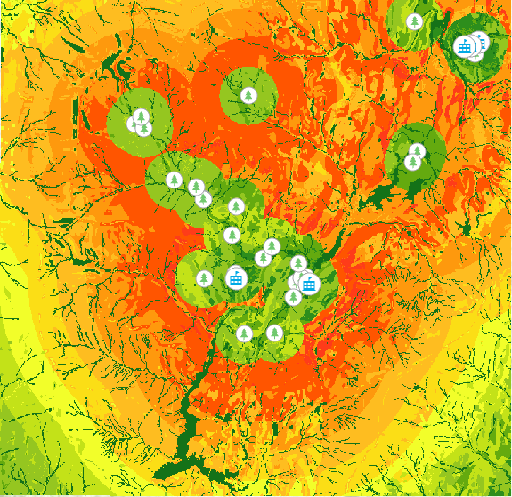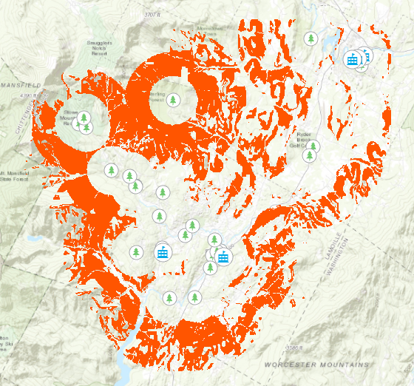

Full Map

Filtered Map

Figure 2: Suitability Map Using Lab 1 Weighing

Full Map

Filtered Map

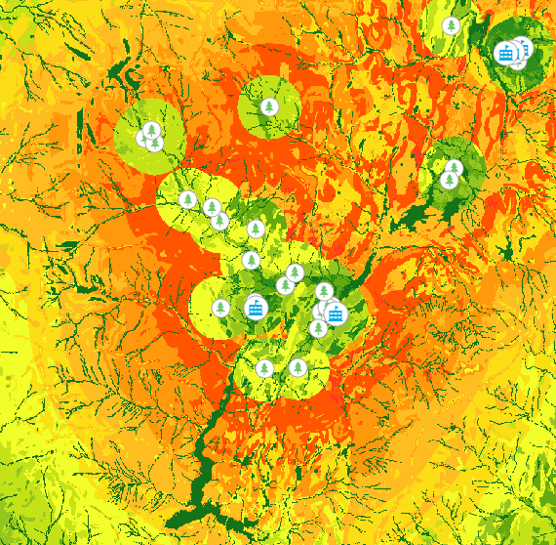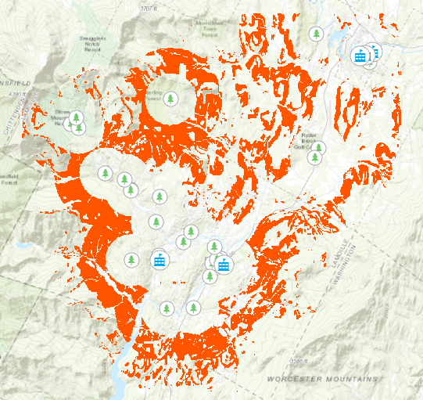

**ii)**

Comparing the two suitability maps, it seems that the lab 5 weighing produces more optimal areas than the lab 1 original weighting. We can see that the optimal areas have more area and look “thicker” than its lab 1 counterpart especially in the north-west where it forms 2 circles. I believe lab 5 produced more optimal areas due to its increased weighting towards distance to rec_sites which is why we see an increase of optimal area in the north-west as there are 3 recreational sites in that area.

**iii)**

Surprisingly, this weighting produced the most optimal areas than all weightings I produced in lab 1. It seems that the more weighting I give to the distance to rec_sites, the more optimal areas are produced. It seems that slope and landuse have negligent effect on optimal area. However, we only assessed optimal areas. It is unsure if an increase in weighting towards distance to rec_sites could also increase the number of least optimal areas.

**Q2)**

I computed the weightings based on how long I think the lines would be if I were to stretch them out. Based off the nodes, it seems that B is twice the length of C, C is twice the length of D, and D is twice the length of A. I computed a simple weighting which is also reflective of my idea of the double multiple I had of each line.

Table 2: Pair-wise Comparison Table for Question 2

|  |  |  |  |  |
| --- | --- | --- | --- | --- |
|  | B | C | D | A |
| B | 1 | 3 | 6 | 9 |
| C | 1/3 | 1 | 2 | 3 |
| D | 1/6 | ½ | 1 | 3/2 |
| A | 1/9 | 1/3 | 2/3 | 1 |

This produced a weighting of B: 0.62, C: 0.2, D: 0.1, and A: 0.07.

Comparing to the results given in the lab manual, it seems my perceived shorter lengths are more accurate to what was measured. With A having a difference of 0.01, D having a difference of 0.048, C having a difference of 0.07, and B having a difference of 0.118.

Calculations

