LAB #3: Processing of Single Beam Echosounding Data

Submitted by: Ryan Nguyen (216334336)

Submitted to: Jiahuan Hu

Submitted on: March 4, 2022

Course Code: ESSE 4650

Introduction

This lab tasks students to use the CARIS HIPS and SIPS program to complete following tasks. Things such as vessel dimension creation, processing survey lines, and analyzing sound velocity profiles. The ArcGIS program was used for the last task to process parameters for survey lines.

Methodology and Discussion

**DELIVERABLE 1**:

Figure : Deliverable 1 Workflow

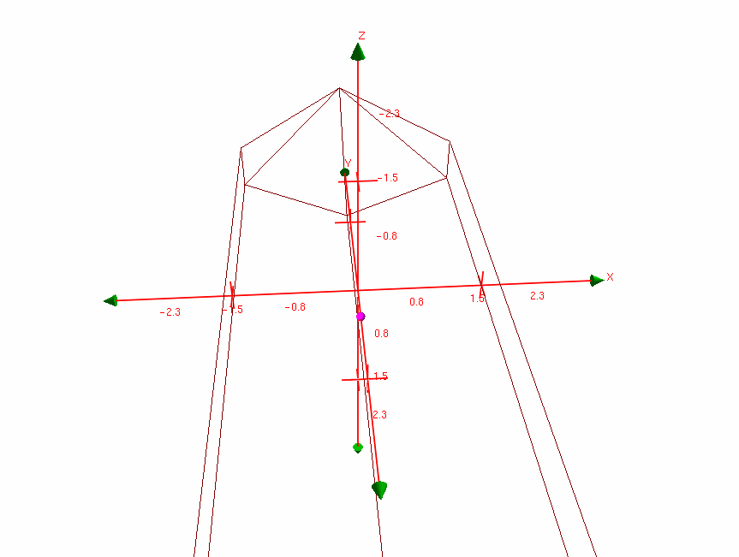

Width of 3m

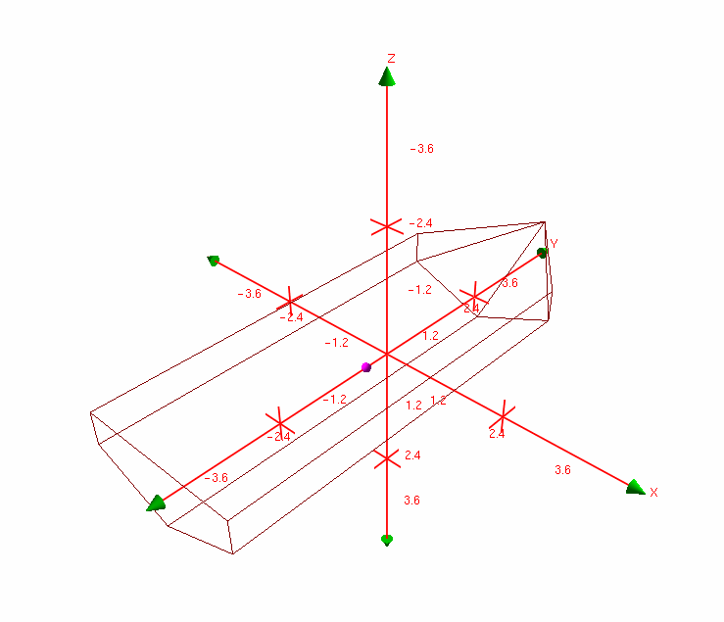

Angle from 3D Plane

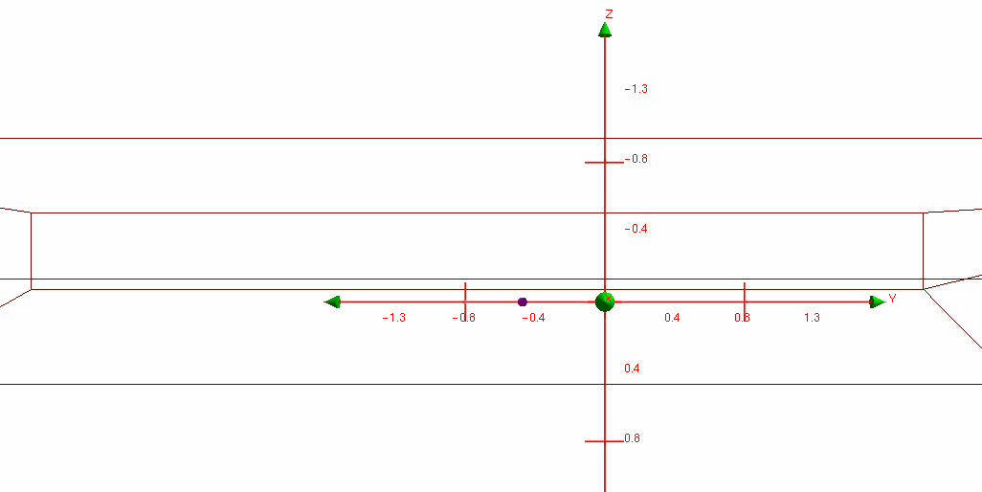

RP is approximately 0.5 m from the Keel

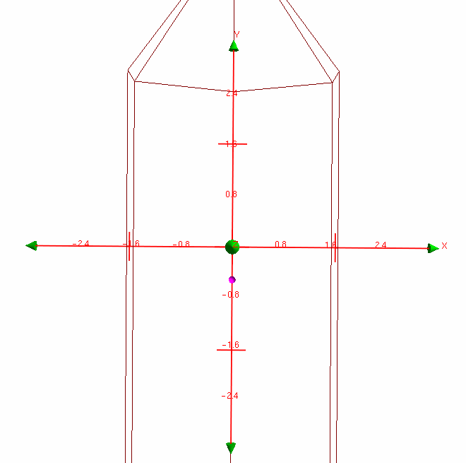

RP is approximately in the middle of the 3m beam

Figure : Images of Vessel Shape w.r.t Reference Point (Purple Point)

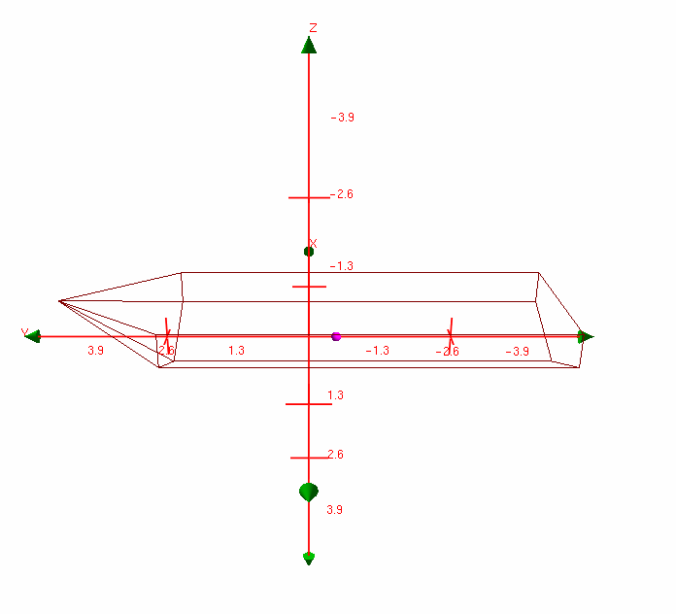

Figure : Plan View of Vessel Shape

This 4m from the RP to the stern is a little questionable as the RP is not at the origin of the axis and the length of the Y axis arrow shows that the back of the stern to the origin is 4m. The image shows that the RP to the stern is a little less than 4m.

We can see the dimensions of the vessel aligned to the grid created. Looking at the figures, there is an interception or an “x” shape on the grid to show what the length is at that interception.

**Deliverable 2**

Figure : Deliverable 2 Workflow

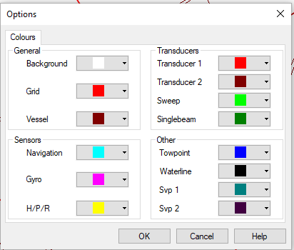

Figure : Sensor Colour Legend

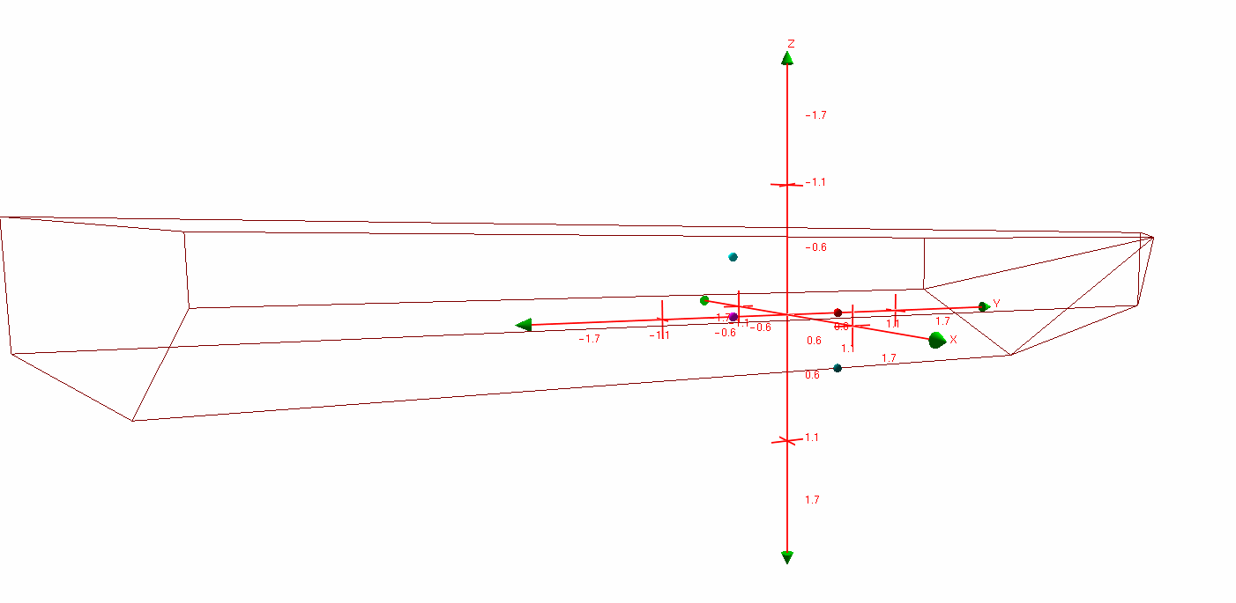

Figure : Location of the Sensors in the Vessel

SVP1 is bottom most point, transducer point is above SVP1, Gyro point is on the same plane as Transducer point, and Navigation is above the Gyro point

**Deliverable 3**

Figure : Deliverable 3 Workflow

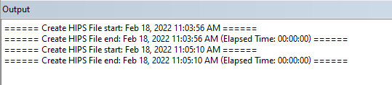

Figure : Output Window showing the Creation of the HIPS file

HIPS file created at 11:05 AM is the one with the correct co-ordinate system [WGS 84 UTM zone 12N]

**Deliverable 4**

Figure : Deliverable 4 + 5 Workflow

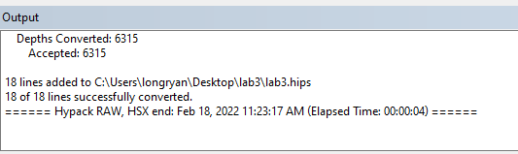

Figure : Output Window of the 18 Survey Lines

18 Survey lines have been read in.

**Deliverable 5**

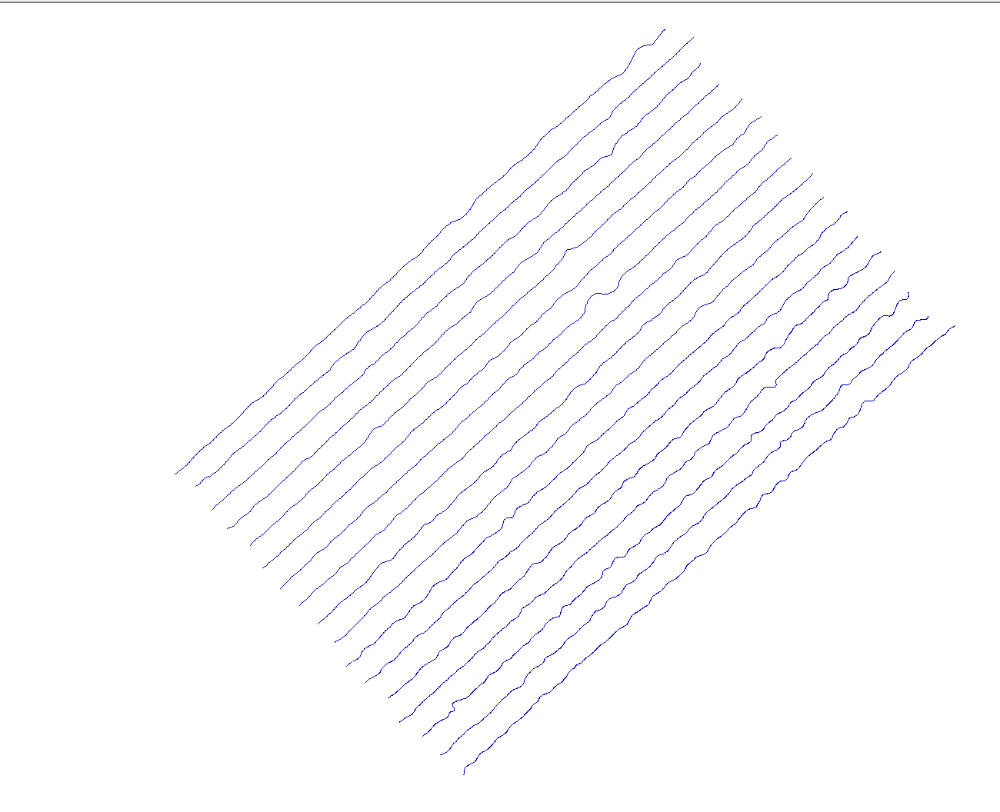

Figure : Figure of the 18 Survey Lines

**Deliverable 6**

Figure : Deliverable 6 Workflow

We can use the area of a rectangle equation as the survey lines depict that shape and divide by 1 million to convert the area to kilometers squared. We will also break this up using a figure I will create to find the total area.

Equation 1: Area of a Rectangle

Equation 2: Area of a Triangle

Table 1: UTM Coordinates of the Geographical Coverage

|  |  |
| --- | --- |
| Corner | UTM Coordinate (m) |
| North | (579417.59, 7582294.91) |
| East | (581640.95, 7580011.94) |
| South | (577843.95, 7576524.90) |
| West | (575608.66, 7578855.55) |

Figure 13: Computation of Area

The area of the coverage is 16.5 km2.

**Deliverable 7 and 8**

Figure : Deliverable 7 + 8 Workflow

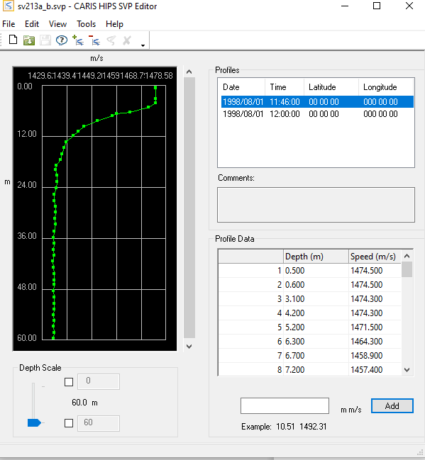

Figure : Screenshot of Sound Velocity Profile

Table 2: Depths and Speed at 11:46

|  |  |
| --- | --- |
| Depth (m) | Speed (m/s) |
| 0.5 | 1474.5 |
| 5.2 | 1471.5 |
| 6.7 | 1458.9 |

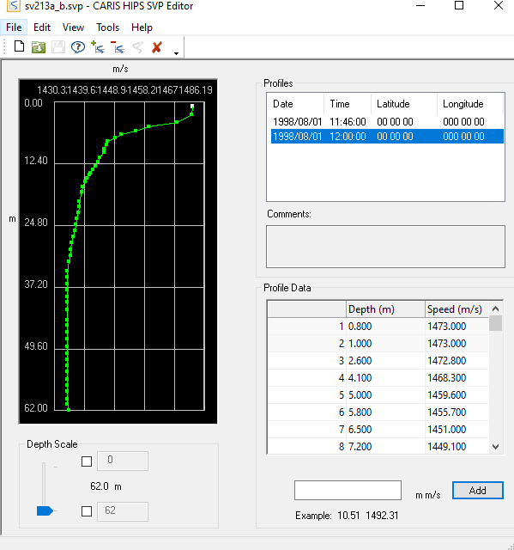

Figure : Sound Velocity Profile for 12:00

Time 12:00 doesn’t provide the depths.

**Deliverable 9**

Figure : Deliverable 9 Workflow

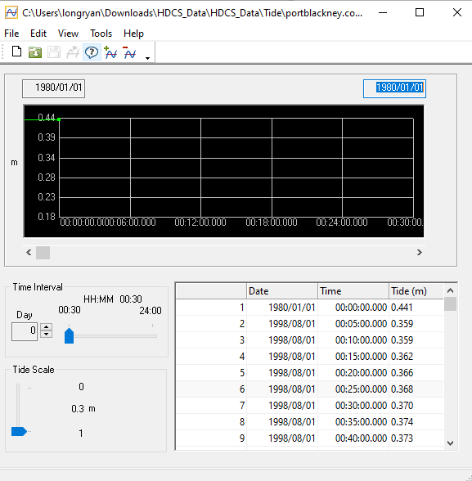

Figure : Deliverable 9 Screenshot

**Deliverable 10**

2 Maximum tied at

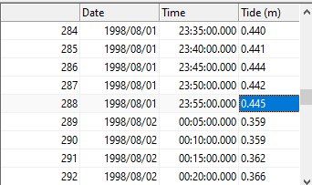



Figure : Maximum Tides

3 minimum tied at

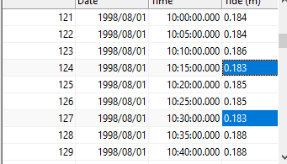

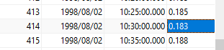

Figure : Minimum Tides

**Deliverable 11**

Figure : Deliverable 11 Workflow

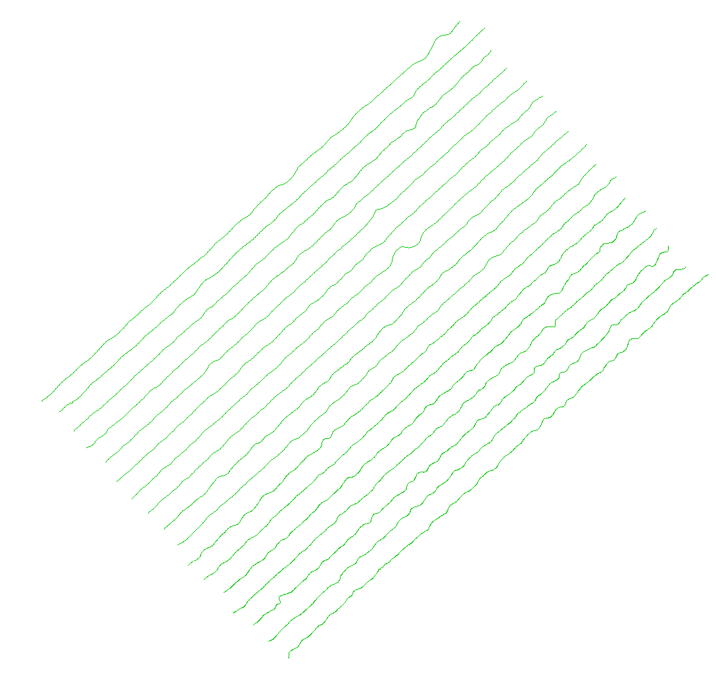

Figure : SVP and Tide Corrections Applied to Survey Lines

After the SVP correction, the surface the depth refers to the observed depths and chart datum.

After applying the Tide correction, the depth is relative to the tide stations.

**Deliverable 12**

Figure : Deliverable 12 Workflow

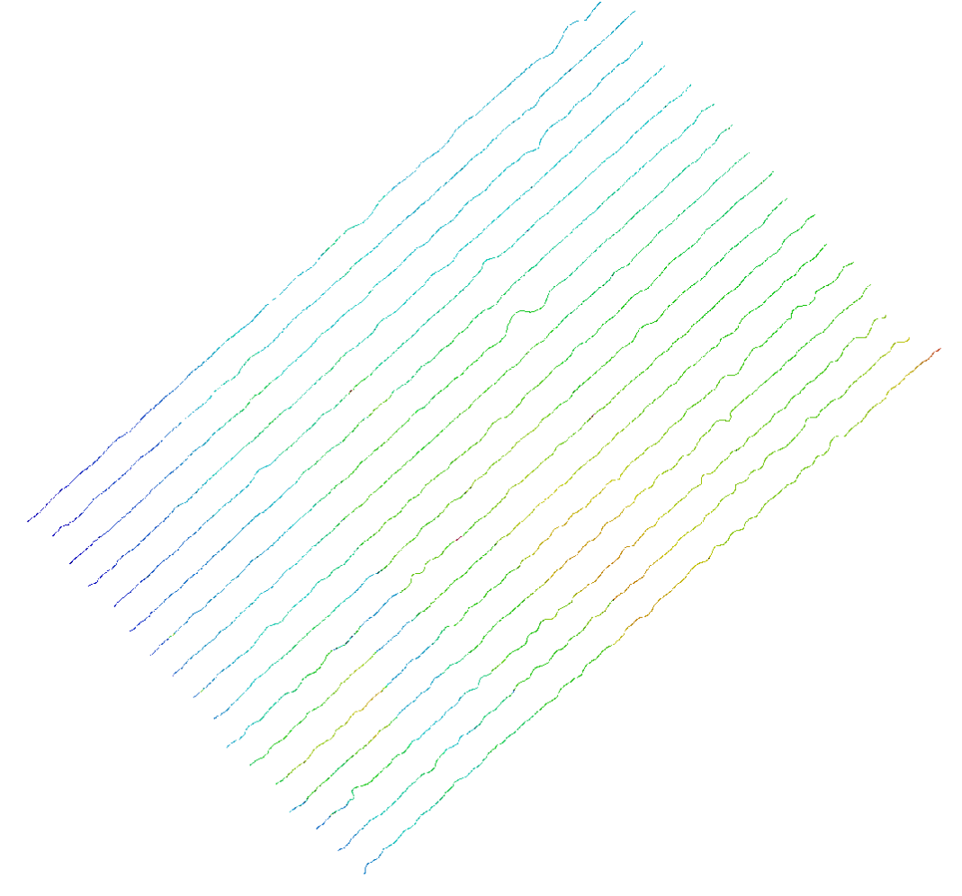

Figure : Generated Regular Gridded Surface

**Deliverable 13**

Figure : Deliverable 13 Workflow

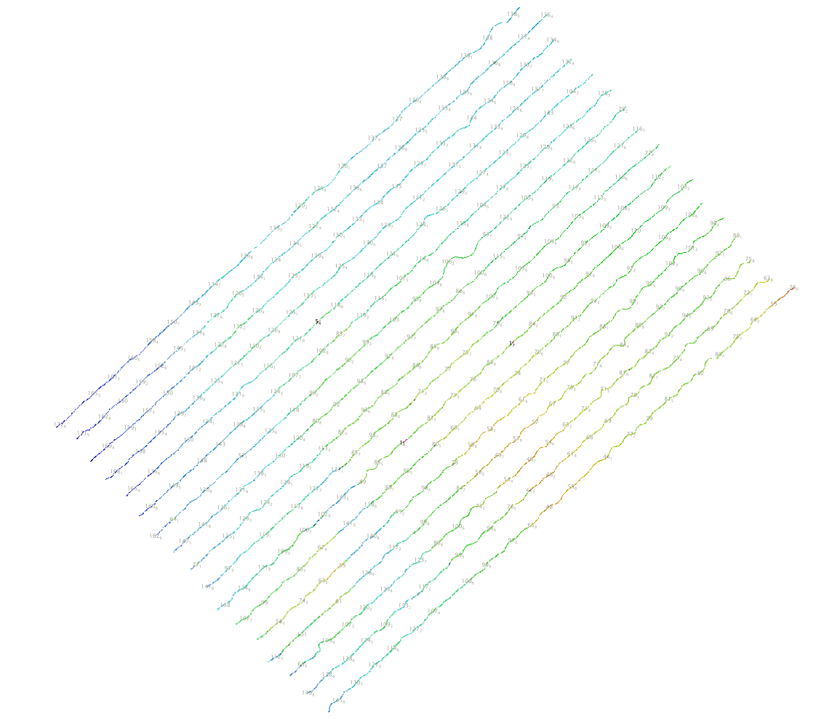

Figure : Generated Plot of Selected Soundings

**Deliverable 14**

Figure : Deliverable 14 Workflow

1. The length of the survey line can be found in the layers list (look at blue line in image)

Figure 28: Layer List of Survey Lengths

Note: One survey line is cutoff and continued again, see [Figure 29]. Therefore, it seems that there are 17 survey lines imported. I added this length to the survey line.

Figure 29: Survey Line Cutoff

Table 3: Lengths of Survey Lines

|  |  |
| --- | --- |
| Survey Line # | Survey Length (m) |
| 1 | 5192.05 |
| 2 | 5244.14 |
| 3 | 5181.78 |
| 4 | 5172.60 |
| 5 | 5192.13 |
| 6 | 5254.18 |
| 7 | 5303.92 |
| 8 | 5186.61 |
| 9 | 5251.09 |
| 10 | 5183.78 |
| 11 | 5280.55 |
| 12* | 61.62 + 5214.48 |
| 13 | 5308.01 |
| 14 | 5307.44 |
| 15 | 5343.81 |
| 16 | 5245.74 |
| 17 | 5334.03 |

The average survey length based off those measurements: 5250.47 m.

1. The Measure Tool found at the toolbox located at the top of the screen was used to find the distances between survey lines. I measured between approximately in the middle of survey lines.

Figure 30: Measurement Tool Between Survey Lines

Table 4: Distances Between Survey Line

|  |  |
| --- | --- |
| Survey Line # | Distances Between Survey Line (m) |
| 1 | 211.15 |
| 2 | 203.21 |
| 3 | 205.78 |
| 4 | 193.29 |
| 5 | 211.41 |
| 6 | 205.05 |
| 7 | 194.34 |
| 8 | 194.34 |
| 9 | 200.47 |
| 10 | 195.89 |
| 11 | 208.20 |
| 12 | 200.20 |
| 13 | 195.18 |
| 14 | 209.87 |
| 15 | 207.8 |
| 16 | 185.78 |
| 17 | 194.67 |

The average distance between survey lines based off those measurements: 210.41 m.

c) This is a table of the depths of the first and last point of each survey line:

Table 5: Table of Depths for Survey Lines

|  |  |  |
| --- | --- | --- |
| Survey Line # | Depth at First Point (m) | Depth at Last Point (m) |
| 1 | 173.3 | 139.7 |
| 2 | 171.8 | 136.4 |
| 3 | 170.8 | 135.6 |
| 4 | 171.0 | 133.3 |
| 5 | 166.4 | 128.8 |
| 6 | 167.5 | 125.5 |
| 7 | 163.3 | 120.9 |
| 8 | 167.9 | 116.7 |
| 9 | 152.9 | 113.6 |
| 10 | 147.8 | 111.3 |
| 11 | 139.6 | 105.0 |
| 12 | 115.8 | 103.1 |
| 13 | 108.7 | 95.3 |
| 14 | 133.5 | 89.1 |
| 15 | 151.4 | 76.8 |
| 16 | 149.8 | 63.8 |
| 17 | 147.5 | 26.6 |