LAB #4: Processing of Multi Beam Echo-Sounding Data

Part A: Data import and Project creation

Submitted by: Ryan Nguyen (216334336)

Submitted to: Jiahuan Hu

Submitted on: March 15, 2022

Course Code: ESSE 4650

Introduction

This lab is part of a 3-part lab based on the processing of multibeam data. This lab covers data import and project creation.

Methodology and Discussion

**Deliverable 1**

Figure : Deliverable 1 Workflow

I created vessel file and stored on March 4, 2022 at 11:30 AM

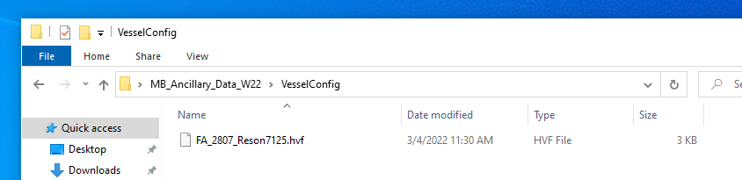

Figure : Vessel File Created and Stored

This view is from the X axis perspective. We can see the water level (gray level) is adjusted to sink the vessel into the water 0.9 meters. The Transducer 1 sensor (blue point) offsets are inputted w.r.t to the RP (yellow point).

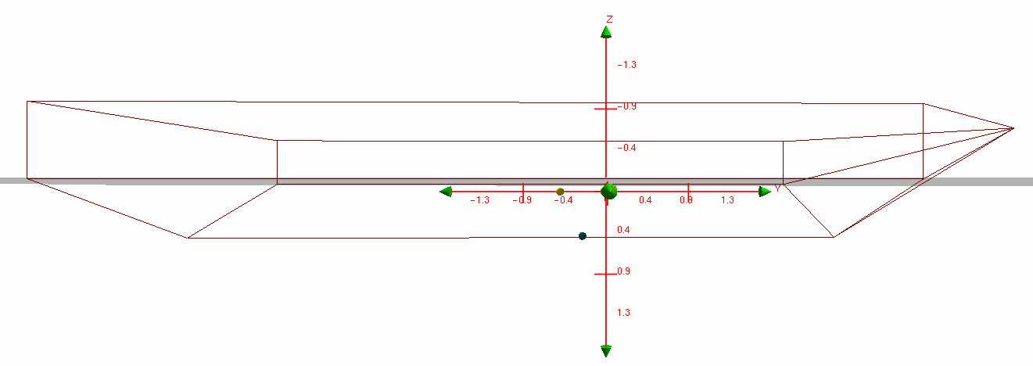

Figure : Vessel Shape Including Sensors with Applied Parameters

**Deliverable 2**

Figure : Deliverable 2 Workflow

We can see the time of where the file was created which can be matched to the file saved in the folder.

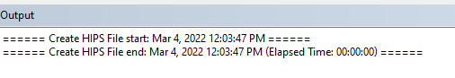

Figure : Output Window in CARIS HIPS and SIPS Program

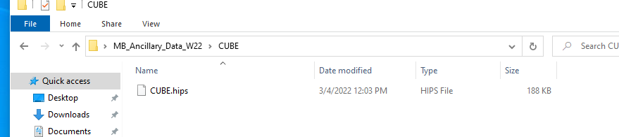

Figure : Location of the File Stored

**Deliverable 3, 4, 5, and 6**

Figure : Deliverable 3,4,5, and 6 Workflow

We can see 14 survey lines have been read in from the two Julian Dates.

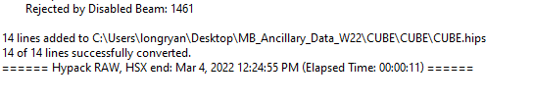

Figure : Output Window of Survey Lines

Here are the survey lines stored in the file. There is a copy of each survey line due to an error with a missing output window.

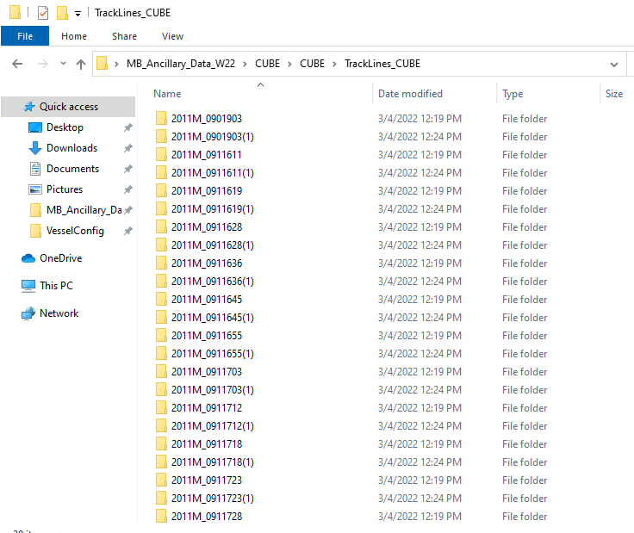

Figure : Survey Lines Saved in Track Lines Folder

This is what the survey lines look in the CARIS HIPS and SIPS Program

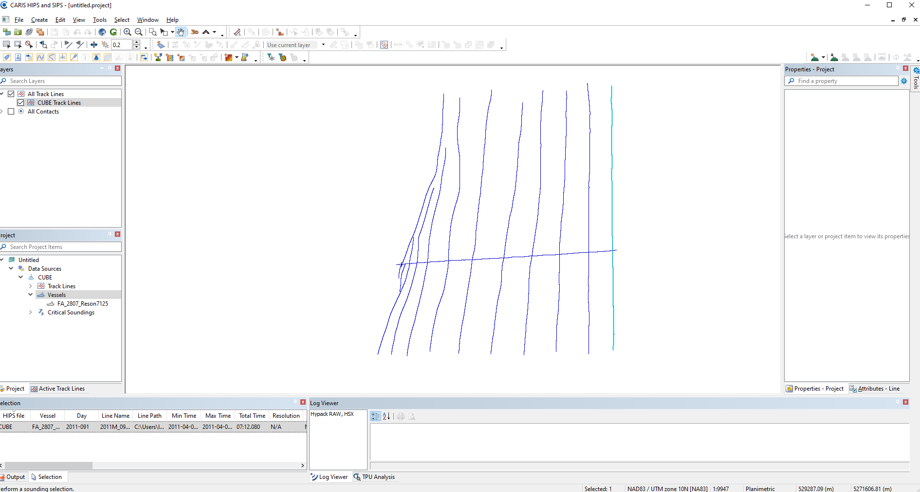

Figure : Survey Lines Imported on CARIS HIPS and SIPS Program

This cross line represents a “check” line that is used to check if the depths are similar to the depths going in the other direction to make sure the depths are accurate, that the measurements look reasonable, and follow survey order. This line runs across so that it covers all the track lines.

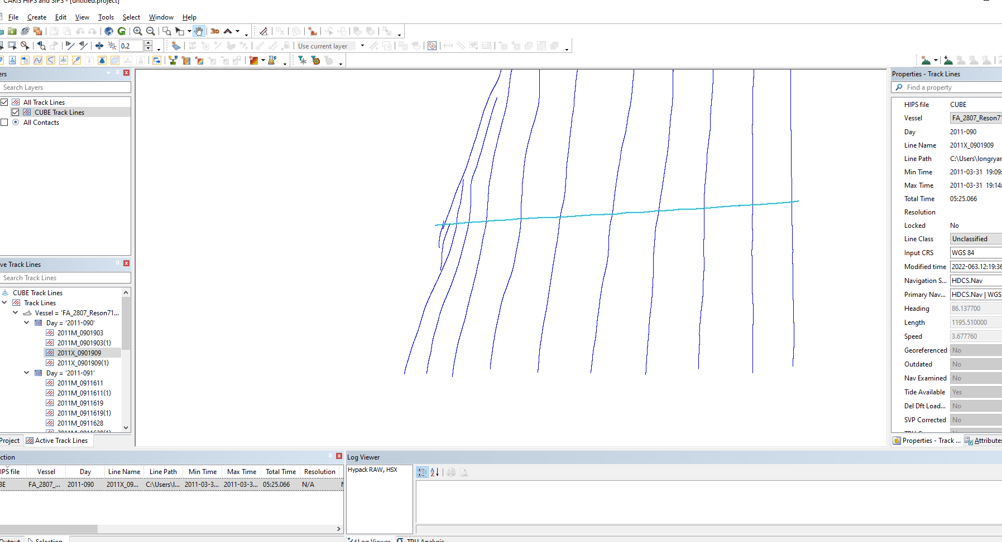

Figure : Cross Line Highlighted

Using the lengths of the cross line and one of the survey lines, we can find the geographical coverage or area that the survey encompasses.

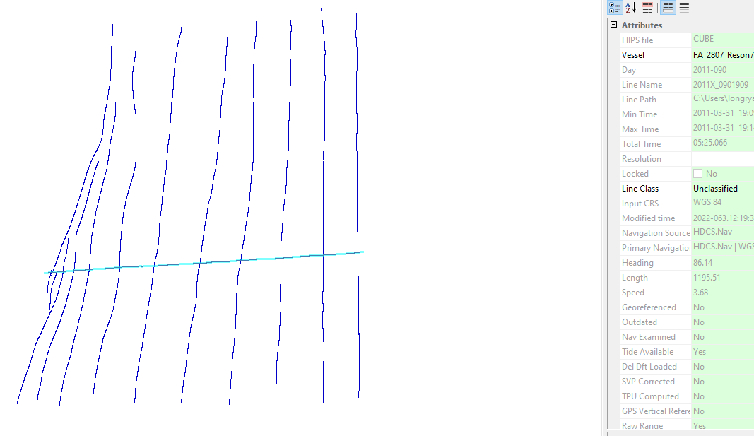

Figure : Length of the Cross Line

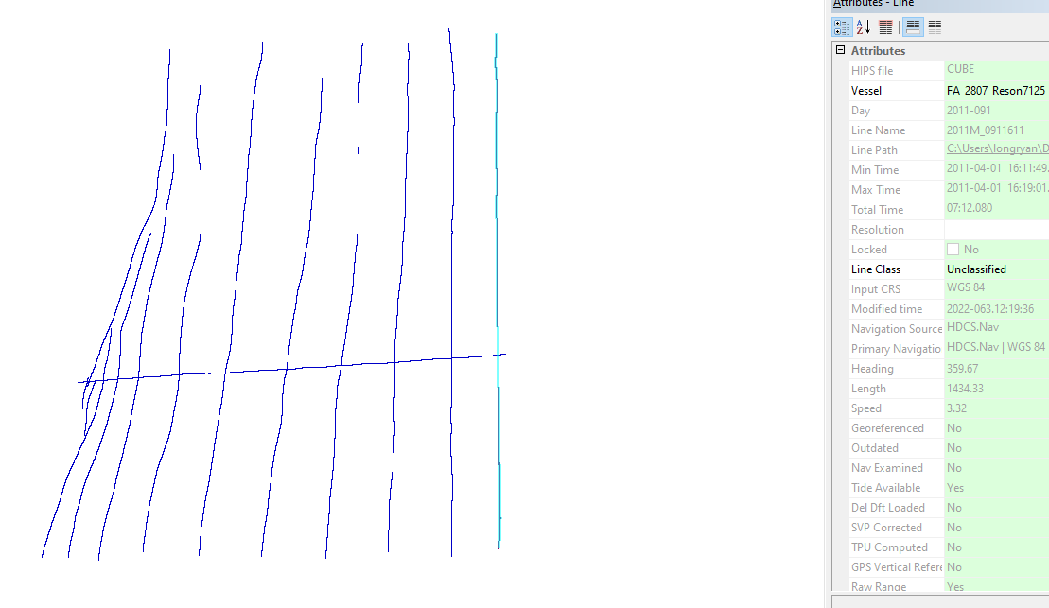

Figure : Length of One of the Survey Lines

Cross Line length: 1195.51 m.

Survey Line length: 1434.33 m.

The area of the survey is 1195.51 x 1434.33 = 1,714,755.86 m2

**Deliverable 7 and 8**

Figure : Deliverable 7 and 8 Workflow

We can see 2 new layers were added, US5WA14M and 18474_1 along with the CUBE Track Lines for a total of 3 layers. This is a screenshot of background data layers with the blue box representing the survey lines.

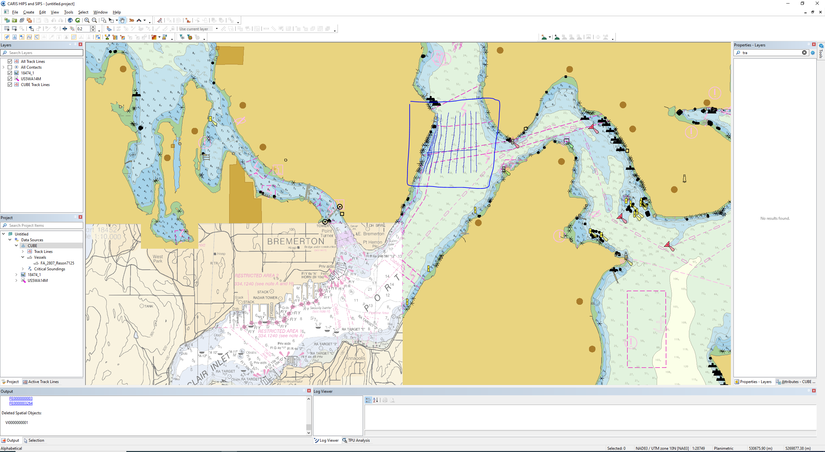

Figure : Background Data Layers + Survey Lines

**Deliverable 9**

Figure : Deliverable 9 Workflow

Here are figures of the data imported. Real time uncertainty data is required because it shows if the navigation of the boat is on the right path to adjust in real time so that the errors aren’t increasing. This is so we can fix in real time as soon as possible and to keep the boat on path to record accurate measurements.

Figure : Figure of Map

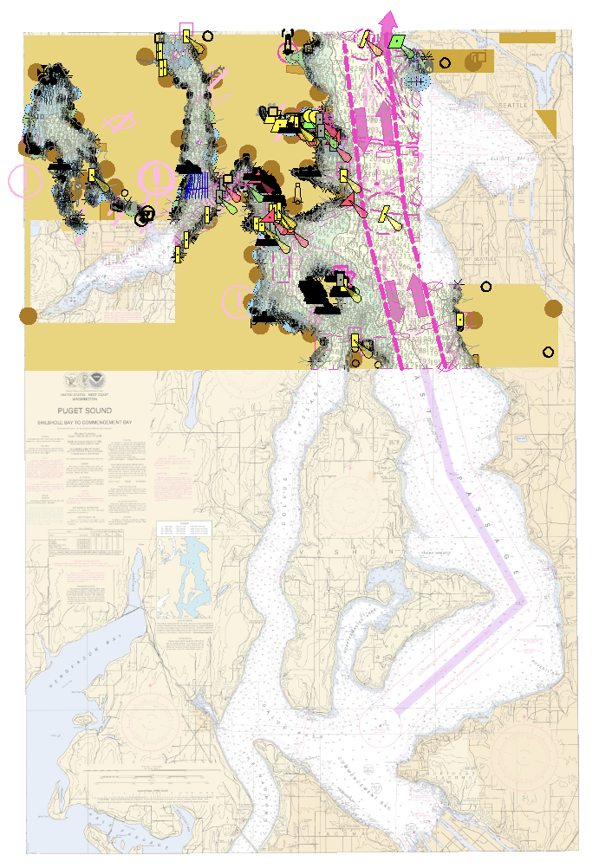

Figure : Figure of Entire Data Imported