LAB #5: Processing of Multi Beam Echo-Sounding Data

Part B: Generation of Georeferenced Bathymetry

Submitted by: Ryan Nguyen (216334336)

Submitted to: Jiahuan Hu

Submitted on: March 22, 2022

Course Code: ESSE 4650

Introduction

This is the second part of the multi-beam lab where students are to process Georeferenced Bathymetry data.

Methodology and Results

**Deliverable B1 and B2**

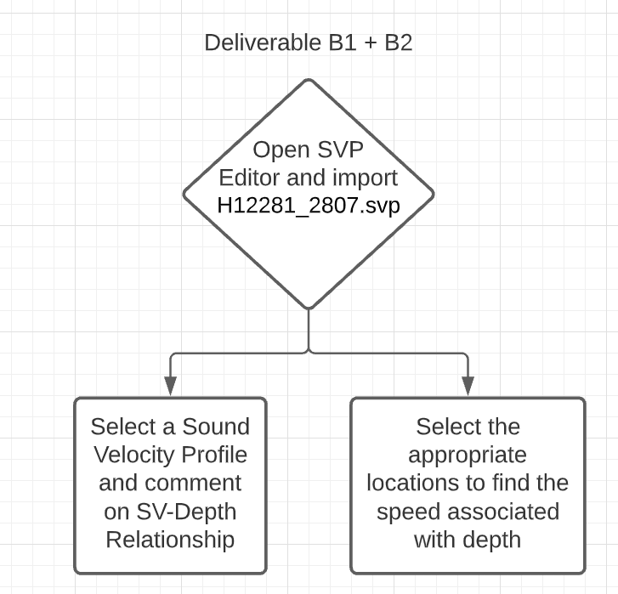

Figure : Deliverable B1 and B2 Workflow

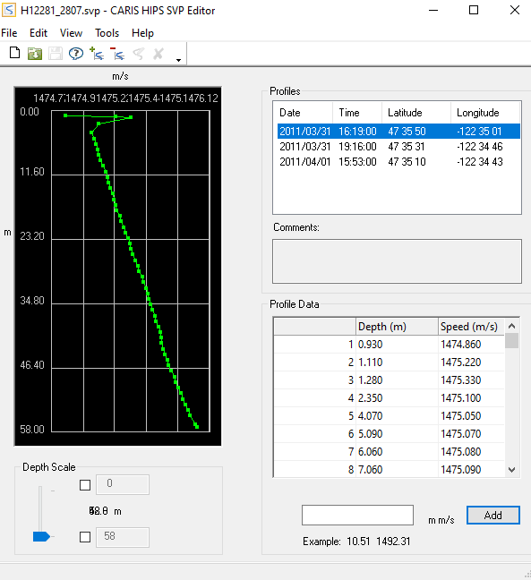

Figure : Screenshot of Sound Velocity Profile

The speed of the sound in water increases rapidly and reaches a spike then rapidly decreases. From there, it gradually increases its speed in the water. Since these depths are recorded under 60m, the speed could be beginning to enter the thermocline or halocline region due to its short depth.

Table 1: Depth and Speed Table at Lat: 47°35’ 31”; Lon: -112°34’46”

|  |  |
| --- | --- |
| Depth (m) | Speed (m/s) |
| 1.24 | 1475.48 |
| 10.04 | 1475.27 |
| 25.04 | 1475.45 |
| 41.02 | 1475.56 |

Table 2: Depth and Speed Table at Lat: 47°35’10”; Lon: -112°34’43”

|  |  |
| --- | --- |
| Depth (m) | Speed (m/s) |
| 0.86 | 1475.42 |
| 10.08 | 1475.35 |
| 25.02 | 1475.47 |
| 39.98 | 1475.70 |

**Deliverable B3**

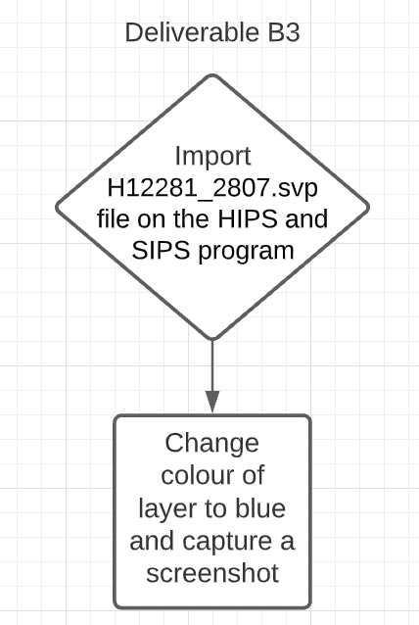

Figure : Workflow of Deliverable B3

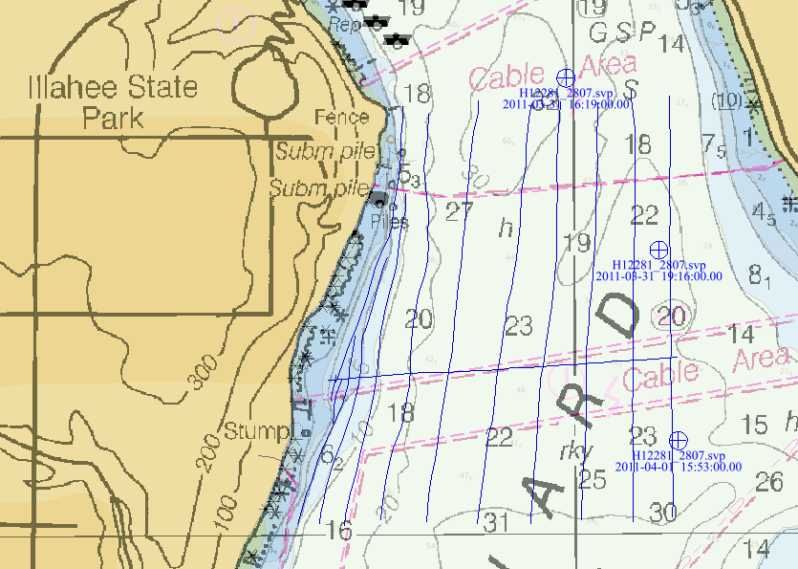

Figure : Screenshot of Sound Velocity Casts

**Deliverable B4**

**a)**

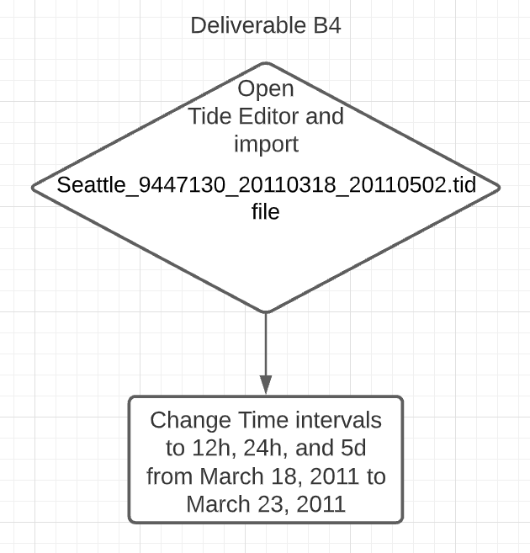

Figure : Workflow for Deliverable B4

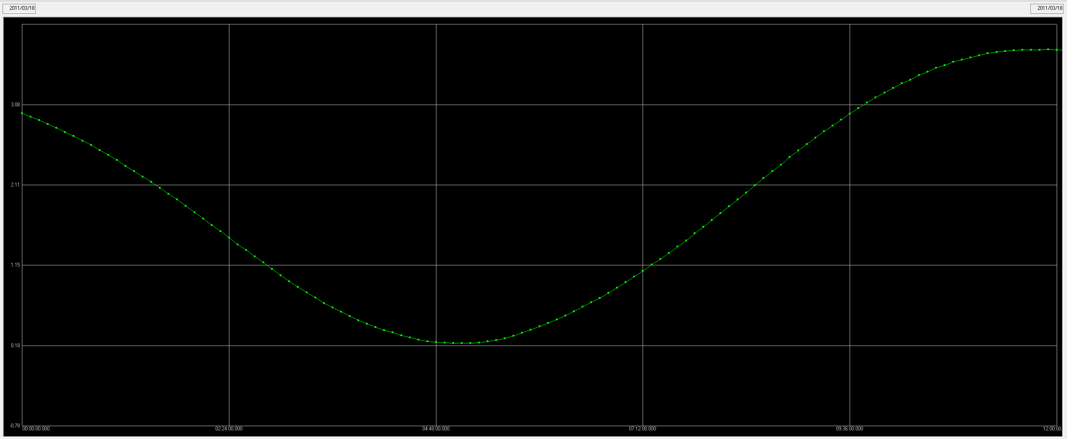

Figure : Tide Graph from 00:00 to 12:00

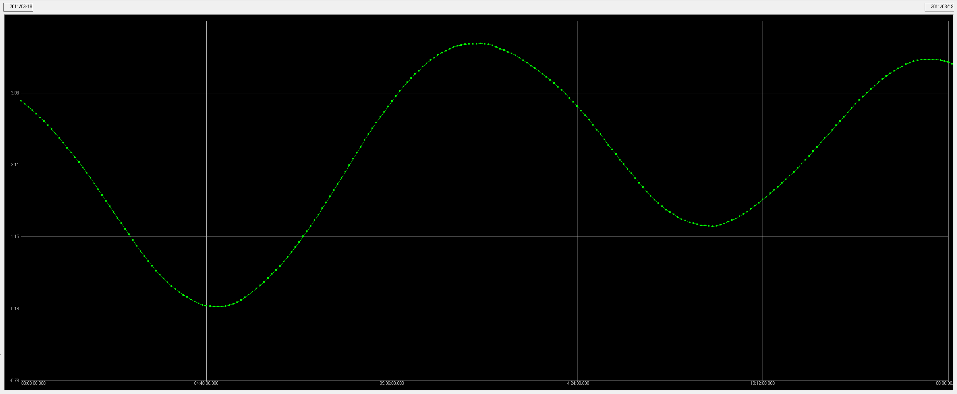

Figure : Tide Graph from 00:00 to 24:00

**b)**

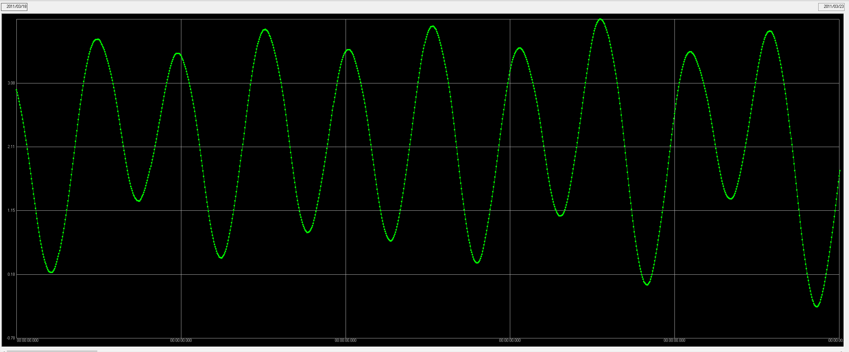

Figure : Tide Graph from March 18 to March 23

**Deliverable B5**

The Total Propagated Uncertainty (TPU) is composed of uncertainty estimates of the contributing sensors in the multi-beam survey. For example, it’s the errors of the transducer, navigation, SVP 1, and other sensors that we selected from lab 4. It’s computed by finding the errors in the depth and horizontal position:

Figure : Reduced Depth Uncertainty

Figure : Total Positioning Uncertainty

**Deliverable B6**

Figure : Deliverable B6 Workflow

SV Profile

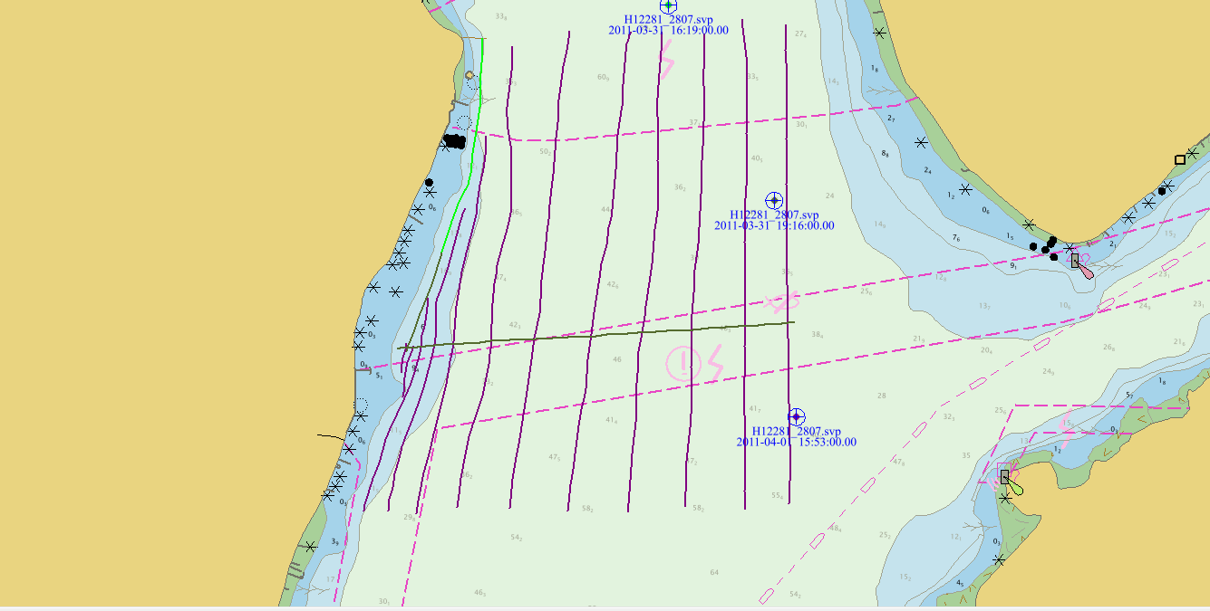

Figure : Colour Survey Lines of SV Profile

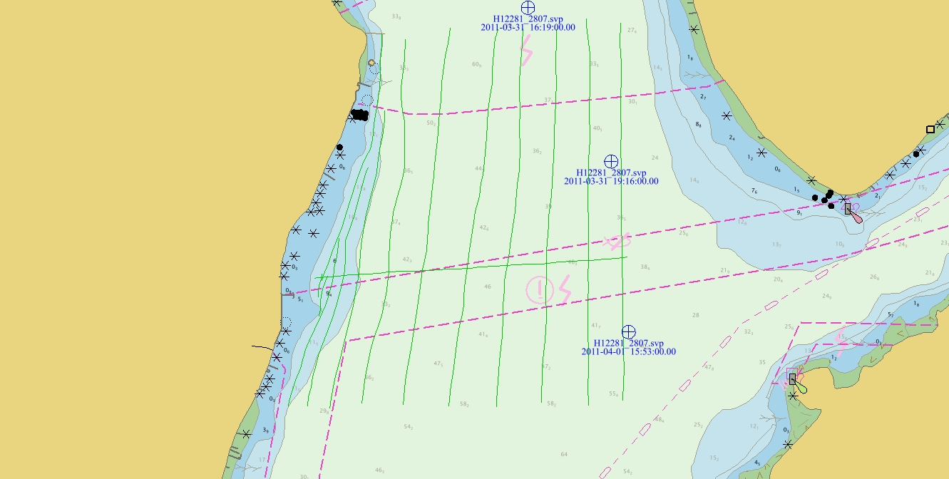

Figure : Colour Survey Lines of State

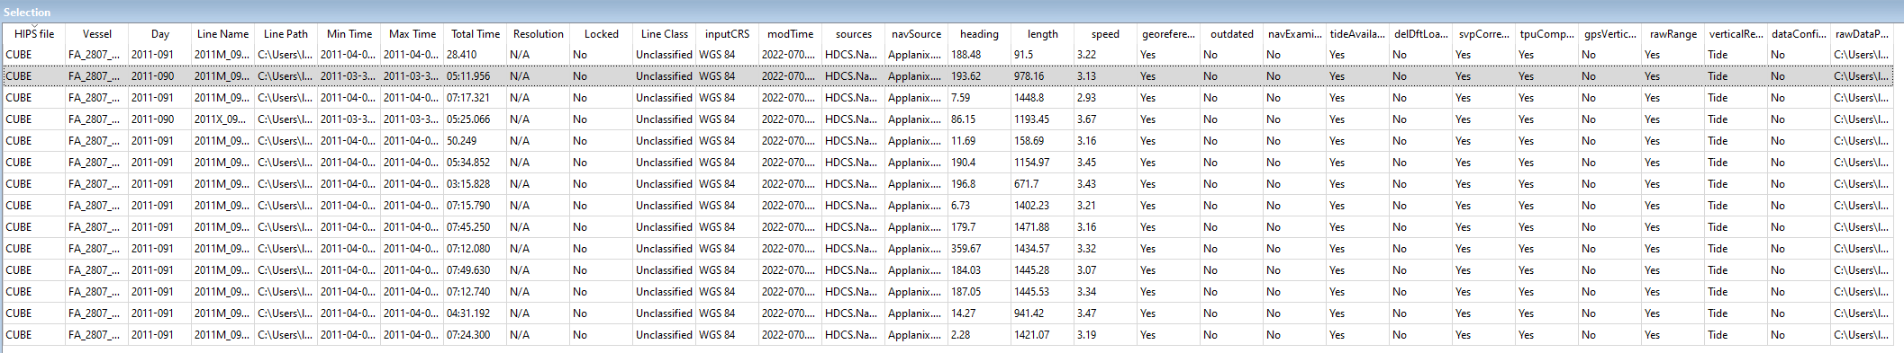

Figure : Selection Window Showing Georeference and All Corrections Applied