Analysis of “Hate Tweets” and Their Relationship to U.S. Demographics and 2016 Presidential Results

By: Ryan Larson and Bailey Hesse-Withbroe

**Introduction**

One week after inauguration as the President of The United States of America, Donald Trump delivered on his promise to ban travel into The United States from the Muslim majority counties of Iraq, Syria, Iran, Libya, Somalia, Sudan and Yemen. This executive order received incredible amounts of attention throughout the world. Both critics and supporters of the executive order took to Twitter to voice their opinions. Due to the contentious nature of this executive order, there was an increased amount of hate speech spreading across the globe via Twitter.

The goal of this project was to visualize the geospatial and temporal spread of these hate tweets. This report will focus on the prevalence of these hate tweets in the United States. There will also be analysis and discussion on various population attributes that may lead to an increase in creation of hate tweets in certain areas of the United States.

**Data Sources**

We obtained the Geospatial data used for this project from the [United States Census Bureau](https://www.census.gov/geo/maps-data/data/cbf/cbf_counties.html). The cartographic boundary shapefiles were created in 2016. A shapefile of the United States Counties, as well as a shapefile of the 50 states of the United States.

To establish a baseline understanding of each counties make up we grabbed generic *population* data about U.S. counties produced by the United States Census Bureau. Via the [American Fact Finder](https://factfinder.census.gov/faces/nav/jsf/pages/searchresults.xhtml?refresh=t#acsST) website we investigated population characteristics. To constrain our problem scope we opted to focus only on population and racial breakdown. The values for race included White, Black, American Indian, Asian, Pacific Islander, and Multi Race. Included was the county population. All the population data came from the 2015 ACS 1-year estimates.

Both the education and employment data were provided by the United States Department of Agriculture's Economic Research Service [on ers.usda.gov](https://www.ers.usda.gov/data-products/county-level-data-sets/). For *employment* we obtained the following 2015 county-level attributes: total labor force population, total employed population, total unemployed population, unemployment rate and Median Household Income (U.S. dollars).

To evaluate counties' *education* attributes we gathered: Percent of population with less than a High School diploma, Percent of the population with only a high school diploma, percent of the population with some college experience and percent of population with a bachelors degree or higher. The education attributes are displayed as an average from 2011-2015.

We obtained the 2016 U.S. Presidential *Election* data from precompiled sources(thanks [@tonmcg!](https://github.com/tonmcg/County_Level_Election_Results_12-16)). The following attributes were obtained and used: total democratic votes, total republican votes, and total votes by county. The rates of votes for both democrat and republican on the county level are calculated by us. And finally, the vote differential between the leading party and the runner up, and the percent point differential were obtained. The raw data was obtained from [TownHall.com](https://townhall.com/election/2016/president/), which was then cleaned and made accessible on [GitHub](https://github.com/tonmcg/County_Level_Election_Results_12-16).

And finally the main source of our data was a Tweet stream from Twitter’s public API. An automated scraper polled Twitter for tweets containing #ban, #BuildTheWall, #immigrants, #muslim and other contentious hashtags. The scrape consisted of 136 days, from December 22nd until April 5th.

**Methods**

Our first order of business was to look at the Tweet attribute distributions. We constrained the attributes to tweet languages, GPS coordinates, and hashtags. We stayed at a high level, sticking to distributions and counts. We wanted to include all of the scraped files for an overview of each variable. Thus, we took the counts for each language and language grouping, tweets with valid GPS points, and hashtags.

Quickly it became evident that our scrape was too large for Github to host. Size limits forced us to filter down the tweets in order to keep our web files under 100mb. We utilized Python’s Natural Language Toolkit, a list of racial slurs from Abodo, and a labeled hate-tweet dataset provided by CrowdFlower. We implemented a trivial ensemble classifier using all three with majority vote. After traversing the tweets and evaluating the message’s negativity and ‘hate’ values, we had a small dataset of particularly vicious tweets.

Finally, we gather U.S. county level information for our correlation analysis. After downloading the various datasets (see previous section), we performed a small amount of geoprocessing in order to obtain exclusively the U.S. tweets. This involved synchronizing the projection systems used by both datasets and performing an intersecting spatial join between the tweets and the U.S. counties.

**Results**



Every bar on these side by side charts represents one U.S. County. Percent of voters for Democrats and percent of voters for Republicans are represented on the x-axis. The blue bars represent Democrats and the red bars represent Republicans. Hate Tweet Rate by county is represented on the y-axis. This data was obtained by normalizing the raw number of tweets by the county population. It can be deduced from the above data that a hateful tweet is more likely to come from a U.S. county that had a higher percent of their votes for the Republican presidential candidate than the Democratic candidate



To better understand where the hate tweets were geographically located, it was essential to calculate the average tweet rate by state. This is shown in the graph above titled “Average Tweet Rate by State”. An average line was inserted to help interpret which states had an unusual amount of hate tweets. While many states were well below the national average, there were six states that were shown to be much higher than the average. The states above the national average are: Delaware, Kansas, Maryland, Nevada, Oregon and Virginia. Ness County, Kansas had the highest rate of hate tweets. New Castle County, Delaware was also ranked nationally in the top 10 of counties with the highest rates of hate tweets, at number four. These states will be highlighted through the rest of the report to understand what causes the high hate tweet rates.



After concluding that a county with a high rate of hate tweets was more likely to have been a county that had a higher percentage of votes cast for the Republican candidate Donald Trump in the 2016 presidential election, it was questioned if the same conclusion could be made on the state level. The top graph depicts the average percent of votes for a republican in each state, and the graph below it depicts the hate tweet rate for each state. Our six states of interest are highlighted, and the average line for both percent of votes for Republicans and the tweet rate are shown on their respective graphs. A 50% line is included in the voting graph to show whether each state averaged more votes for the republican candidate or the democratic candidate. Five of the six states had a vote percentage greater than 50% in favor of the Republican candidate. The lone state that had a vote percentage less than 50% was Delaware, with a percentage of 47.2%. Two of the five states that were above 50% in republican favor were also above the national average. These two states were Nevada and Kansas, who were also had the 1st and 3rd highest hate tweet rates respectively. An interesting outlier in this data set is the District of Colombia. Interestingly, it was the only area that had a hate tweet rate of zero, and was also the area with the lowest average percentage of votes for the republican candidate. There must be a consideration for experimental error while working with such a large data set of tweets, and it cannot be assumed that there are no hateful twitter accounts in this region.



A variable that was hypothesized to have a direct relationship with the rate of hate tweets was the education level of the state’s population. It was hypothesized that a state with a higher percentage of less educated people would have a higher hate tweet rate. Education level was broken down into four attributes: Less than High School, Only High School, Some College, and Bachelor’s Degree or Higher. Again, the six states of interest were highlighted to find correlation. Delaware, Nevada and Virginia were the only states that had an average percentage of individuals who had less than a high school education, with Delaware having an insignificant amount more than the average. Every state of interest had less than the national average of people with only a high school education. Kansas, Nevada and Oregon all had an average percentage of people who completed some college that was higher than the national average. Lastly, Delaware, Maryland and Virginia had a higher percent average of bachelor degrees or higher than the national average. This analysis was not able to prove the hypothesis that a state with a less educated population would have a higher rate of hate tweets.



The hate tweets examined in this project were hateful in a racial way. Due to this reason, it was important to consider the racial makeup of the United States, and more specifically the six states that were of interest due to their above average prevalence of hate tweets. Six racial categories were used to divide the population of each state; American Indian, Asia, Black, Pacific Islander, White, and Multi Race. All six categories will sum to be the total population of the state, so individuals could only identify as one of the six categories. The national average for each race was included in each bar graph to help identify outliers. Overall, the six highlighted states showed little deviance from the national averages of each racial category. A data set that included an attribute for people of Middle Eastern descent would have been especially helpful for this project, as there could be a correlation between the population of Middle Easterners and hate tweet rates.



Median household income was a variable that was considered relevant to the investigation as to why certain areas of the United States had high rates of hate tweets. The top graph in the image above depicts the average Median Household Income for each state. The national average median household income was found to be $52,105. Like the other variables discussed earlier, the six states with above average hate tweet rates were highlighted. Delaware, Maryland, Nevada, and Virginia all had average Median Household incomes higher than the national average. It is also worth noting that the average median household income for the six highlighted states was $55,940, almost $4,000 higher than the national average. Even with the strong increase in average median household income, only two of the highlighted states were in the top 10 states with the highest average median household income. Further analysis of income trends and cost of living would be needed to be able to claim that higher median income levels are positively correlated with hate tweet rates.



The last dataset that was hypothesized to have a correlation to the rate of hate tweets was unemployment rates. This dataset was created by averaging the unemployment rate of each states’ counties, and displaying the results in the top graph in the image above. As like before, the states with higher than average hate tweet rates were analyzed. The national unemployment rate average was drawn in on the top graph to display the highlighted states relationship to the national average. Maryland, Nevada, and Oregon all had unemployment rates higher than the national average. Nevada was ranked the highest highlighted state for unemployment with a 6.9& unemployment rate. Kansas ranked the lowest, and was ranked 7th lowest in the nation with a 4.0% unemployment rate. As similar to the average Median Household Income relationship, it cannot be determined if unemployment has any correlation with hate tweet rates in the United States.

*Languages*

Initially we examined the language counts individually, but this was far too granular. The figure below is a boxplot of the language groupings such that all of the English derivatives are together. Each dot is an instance of the number of tweets for that day’s grouping. We found that the five depicted below were the largest contributors. Though 97 different languages contributed to the stream over our collection period, English and Arabic were the most prolific.

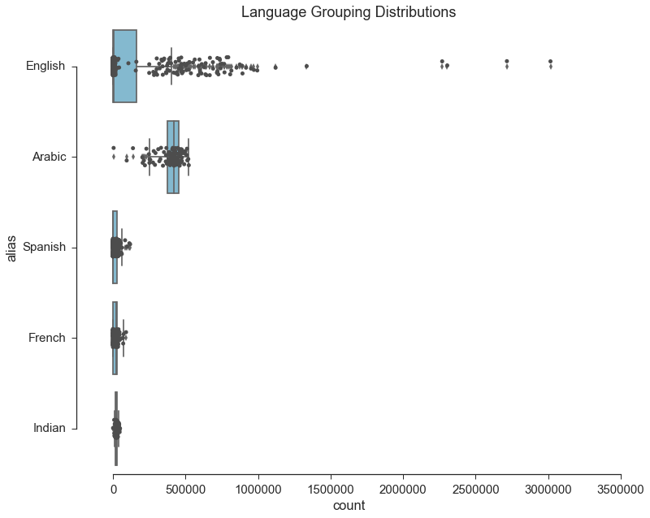

Below: A dirty index to assess how many different types of people were talking about the Immigration ban.

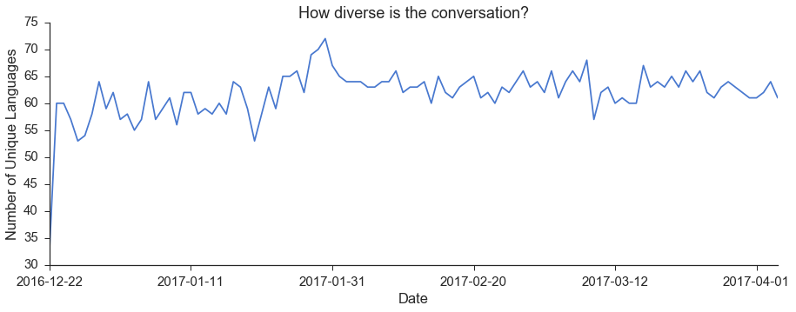

Next Page*: Most popular hashtags by position in tweet.*

*i.e. the first chart contains the most popular first hashtag in tweets.*

|  |  |
| --- | --- |
| **Position** | **Chart** |
| **1st** |  |
| **2nd** |  |
| **3rd** |  |
| **4th** |  |
| **5th** |  |

*Tweets by day:*

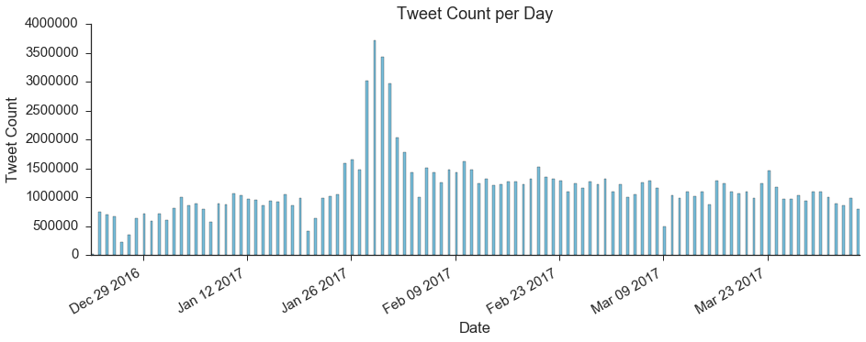

*Maps:*

*%* Democrat

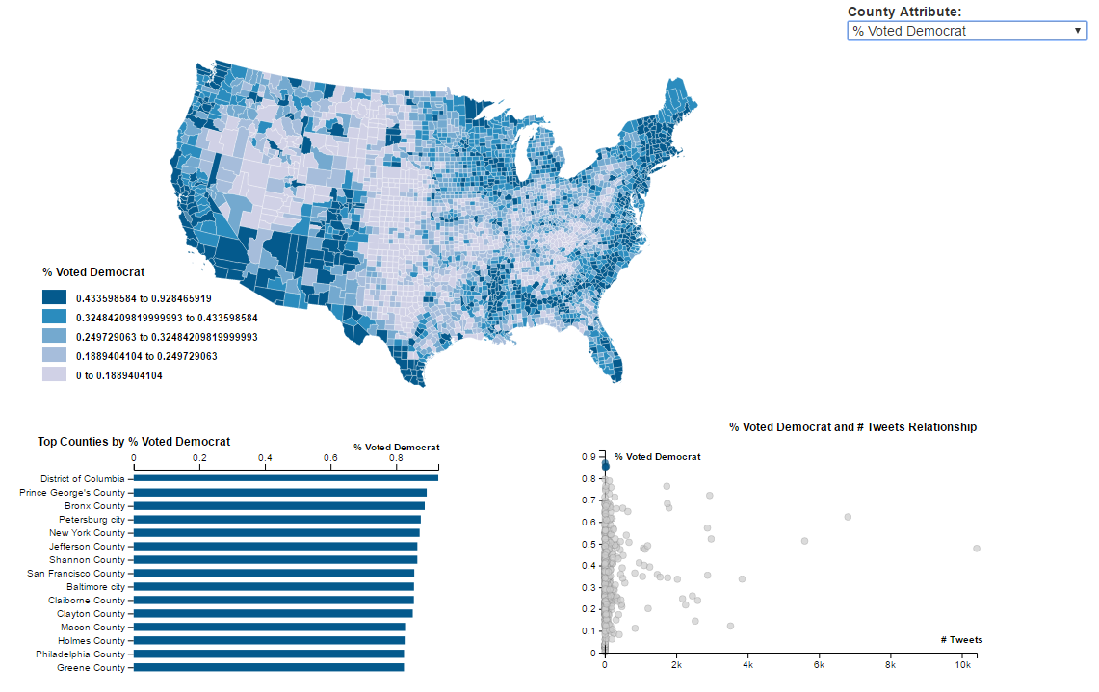% Republican