**CHAPTER 3**

**DESIGN AND METHODOLOGY**

This chapter includes discussion on conceptual design/system architecture/ block diagrams and algorithms.

**3.1 The Project Concepts**

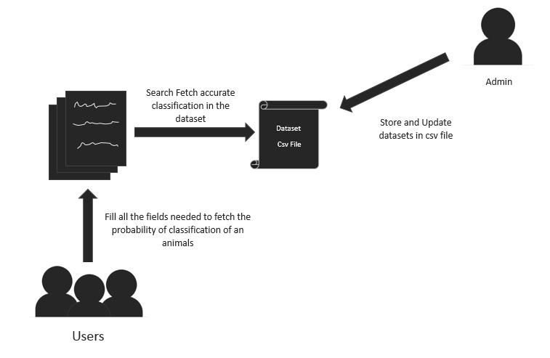

***Figure 1 Conceptual Diagram of the Classification of animal process***

The researchers/users will provide all the information of the given animals and by fill up all important fields and fetch the exact probability of classifications of the animals needed to know. The admin will also store and update datasets given by the professionals/experts to ensure the precision and trustworthiness of the datasets given in the system.

**3.2 System Analysis and Design**

**3.2.1 User Requirements**

Table 1. User Requirements

|  |  |  |  |
| --- | --- | --- | --- |
| Name of Project | Users | Main Module | Sub-Modules |
| Classification of animals using naïve base algorithm | Admin | Insert | Animals Classification datasets |
|  |
| Users | Insert | Classification Fields |
| View | Outcomes/results |
|  |

**3.2.2 Functional Requirements**

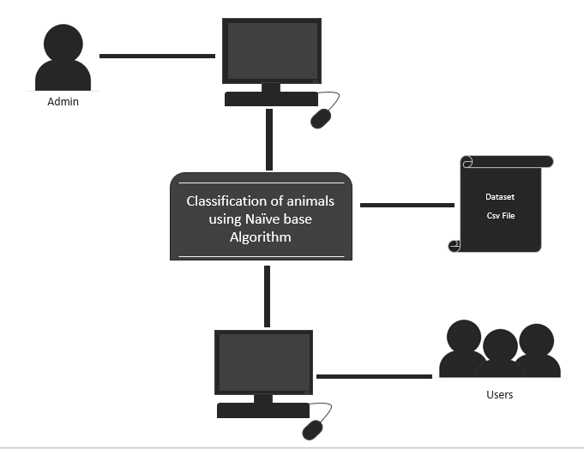**3.2.2.1 Operational Environment**

***Figure 2. Operational Environment***

The figure shows on how the users and admin access the system to dataset CSV file by using a Computer and a compatible browser which is Google Chrome.

**3.2.2.2 System Interface**

The following are the interfaces that the proposed system used.

* The system works in CSV file as its database server.
* The system works even if they are not connected to the Wi-Fi network as long that the computer is in a LAN based.
* The system works with URL Internet Protocol Address with the PHP files.
* The system works in any operating system,

**3.2.2.3 Communication Interface**

The following are the communication interfaces used:

* Bootstrap is the template of the system being used for it provides responsive and user-friendly interface.
* JavaScript is it every time the users click something in the design, the system has a corresponding response.
* PHP is the one to receive the request from JavaScript.

**3.2.2.4 Software Interface**

The following are the software interfaces being used:

* Xammp- used as the local server
* Jquery Library- the compiled script for the use of JavaScript scripting.

**3.2.2.5 Hardware Interface**

Table 2. Hardware Interface

|  |  |
| --- | --- |
| **Hardware Interface** | **Function** |
| Computer | Use for the system development and logical operations. |
| Power Supply | Supplies electricity to computer to power it on. |
| Hub, Switch, UTP Wires | For the connection of computers. |

**3.2.2.6 Function/ User Security Matrix**

The following symbols represent the level of access by each of the user groups:

|  |  |
| --- | --- |
| **A** | Add |
| **R** | Read |

Table 3. Function/User Security Matrix

|  |  |  |
| --- | --- | --- |
| **Function** | **Actor** | **Access Level** |
| Adding Datasets given by the experts | ADMIN | A |
| Search and Retrieve Animal classification by their given information | USERS | R |

**3.2.2.7 User Group & System Access Summary**

Table 4. User Groups & System Access Summary

|  |  |
| --- | --- |
| **User Group** | **System Access** |
| **Users** | Can view and retrieve information and classifications of animals they need to know |
| **Admin** | Are authorized to the section of datasets and maintain the system it also acts as a developer of the system |

**3.2.3 Non-Functional Requirements**

**3.2.3.1 Reliability**

* The system is able to give the users accurate information from the required data being stored.
* Records will be based upon the data stored in the database.
* The system is LAN-based, which makes it not liable from virus risk and security threats that could get by online-based systems.

**3.2.3.2 Operability**

* The users who will operate the system are the admin and the precise users/researchers
* Well-structured user manual.
* Well-formed graphical user interface.

**3.2.3.3 Maintainability**

The proponents planned to use the UPS (Uninterrupted Power Supply). This is a device that allows a computer to keep running for at least a short time when the primary power source is lost. It is helpful especially when the users transact to double check everything they’ve done before the power source is lost.

**3.2.3.4 Scalability**

* The system has 2 user types. Mainly, The admin and the users. These users have a specific module and scope in the system. The admin only will be given an account to login in the system.
* The maximum storage will be based upon the memory of the computer.

**3.2.3.5 Availability**

* The system is available always but they must be connected to the school Wi-Fi and LAN network for their transaction.
* The system works better in Google Chrome browser.
  + - 1. **Delivery**
* The researchers will be the one responsible in network installation with the help system technician for setting up the system to make it ready to use by the users/researchers.

**3.2.4 System Requirements**

**3.2.4.1 Hardware Requirements**

TheClassification of animals using naïve base algorithm is requires a computer that has hard disk that has 500GB, 2GB of memory and at least 1.90GHz i3 or AMD8 of CPU. For the connections of computers, the system requires an Internet connection within the specific area. For the LAN connection, it requires UTP or network cable, RJ45 or network port and switch hub.

**3.2.4.2 Software Requirements**

The Classification of animals using naïve base algorithm server needs an operating system (Windows 7 or higher) the minimum requirement to run the system. Any browser except IE7 below is used to run the system as it is a web-based system. XAMPP for all the uses which is required to run the system

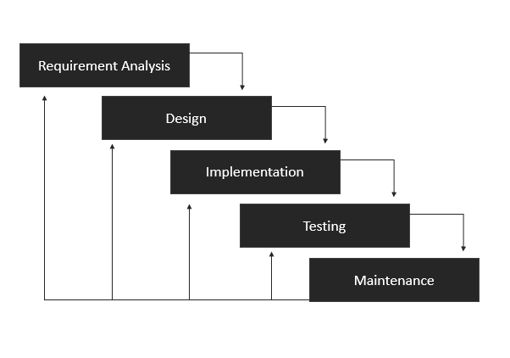**3.3 Development Model**

***Figure 3. Phase of System Development Life Cycle (Iterative Waterfall)***

The researchers used the System Development Life Cycle (SDLC) method and Iterative Waterfall Model. It is a step by step process where proponents will not proceed to the next step unless the proponents finish the first step. It involves the requirement gathering and analysis, design, implementation, verification, and maintenance.

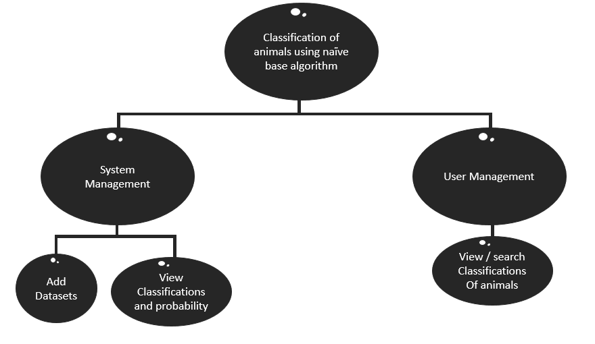**3.4 Development Approach**

***Figure 4. Top-Down Approach***

The researchers decided to use top-down approach which is essential in breaking down the modules of Classification of animals using Naïve Base Algorithm System to gain insight into its compositional sub-systems.

**3.4.1 Requirement Analysis**

During the requirement gathering and analysis phase, the researchers plan everything what are the things needed to do, use and possible outcome of the proposed system. Data gathering was also implemented during this phase. Title where formulated, scopes, modules and other matters such as timeline for making our project organize.

**3.4.2 Design**

During the Design Phase, the system is designed to satisfy the requirements identified in the previous phases. The requirements identified in the Requirements Analysis Phase are transformed into a System Design Document that accurately describes and was based on the module and scope that the proponents constructed.

**3.4.2.1 DFD Level 0**

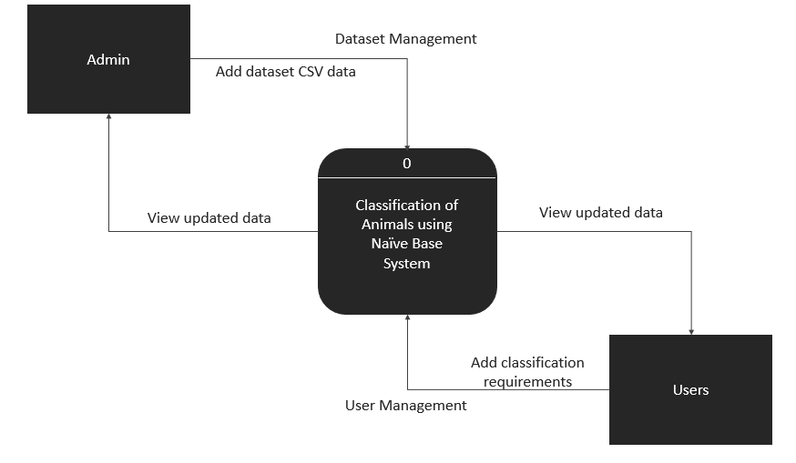

***Figure 5. Context Diagram (Proposed System)***

From the figure above, there are two modules in the proposed system, the user management and the system management. The user management module is only for view/read datasets referred to the specific classification needed by the users while the system management module is a module where admin can add datasets given by the professional/expert.

**3.4.2.2 DFD Level 1**

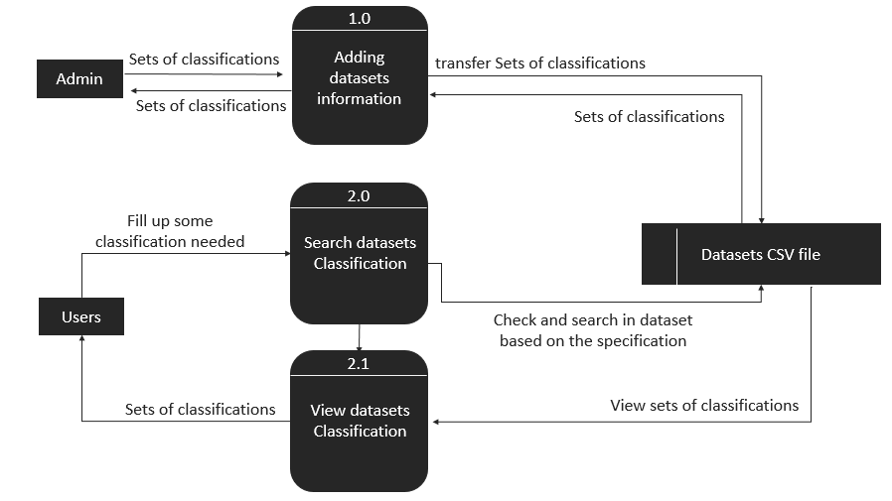

***Figure 6 Illustration of the DFD Level 1 (Proposed System)***

The figure above shows the flow of data and transactions of each entity to the proposed system.

**3.4.3 Implementation**

During implementation, the system functions were developed. The syntaxes and the fetching datasets by its given classifications needed to the system were created and build through the aid of different software indicated in our Software Development Tools in Chapter 3.5 in order to make the system runnable.

**3.4.4 Testing**

After the implementation phase, proponents will now recognize the result of application. This is to be done to recognize the original result and the predictable result. Please see section 3.9 for the Verification, Validation and Testing Plans.

**3.4.5 Maintenance**

The last phase is the maintenance. This phase can be work on after the completion of the project. The proponents decided to monitor the system every month. These are the types of maintenance that the proponents would possibly go through.

* Corrective Maintenance: Correct errors which were not discovered during the product development phases.
* Perfective Maintenance: Improve implementation of the system. It enhances functionalities of the system.
* Adaptive Maintenance: Port software to a new environment.

**3.5 Software Development Tools**

**3.5.1 Front-end (Tool)**

* Bootstrap – The researchers will use this Graphical User Interface (GUI). This is to have a more professional approach for the system.
* Browser – Preferably Google Chrome browser this is used to run the system as it is web-based system**.**

**3.5.2 Back-end (Tool)**

* Apache – The proponents will use this to run the PHP functions.
* Sublime – The proponents will use this as the code editor to create the back-end of the system.
* Codeigniter – The proponents will use this framework to have a clean and simple routing. Laravel is a popular PHP Framework having simple, expressive and elegant syntax that helps in creating an application.
* Xammp- The proponents use this to run the system.

**3.6 Schedule and Timeline**

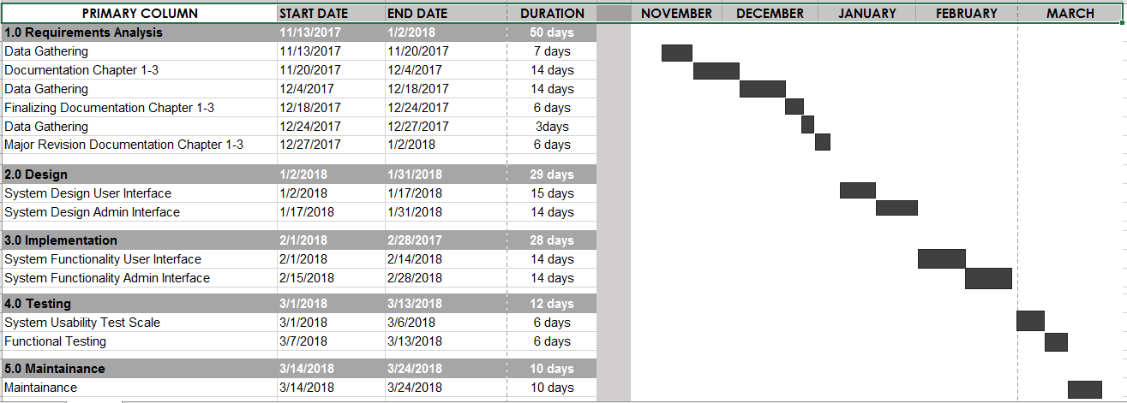

***Figure 8. Schedule and Timeline***

The figure shows the timeline for the process and development of the project starting from the month of November to the month of march.

**3.7 Project Teams and Their Responsibilities**

Table 5. Project Teams and Responsibilities

|  |  |  |  |
| --- | --- | --- | --- |
| **Team Member**  **Name** | **Responsibilities** | **Description** | **Module** |
| John Conrad Ballos | Team Leader | Provides guidance, instructions, direction and leadership to a group of other individuals (the team) for the purpose of achieving a key result or group of aligned results. | System (supervice) |
| John Kenneth Suse | Researcher | Researcher and assigned in the documents | Documents |
| Rustom Pedales | Developer | assigned to the program other functionality of the system | User and admin module |

* 1. **Budget Cost Management Plan**

**3.8.1 Development Cost (Work Force)**

Table 6. Development Cost (Work Force)

|  |  |  |
| --- | --- | --- |
| **Function** | **Salary**  **(day)** | **Monthly**  **Cost** |
| Team Leader/  Project Manager | 1000.00 | 25,000.00 |
| System Analysts/Researcher | 1000.00 | 23,000.00 |
| Developer | 800.00 | 20,000.00 |
| **Total** |  | **73,000.00** |

**3.8.2 Hardware Cost**

Table 7. Hardware Cost

|  |  |  |
| --- | --- | --- |
| **Description** | **Quantity** | **Amount** |
| 1TB, HDD, 8GB RAM,i7 or AMD8 CPU Windows 10 OS or higher | 1 (Data Server) | 300,000.00 |
| Wi-Fi Connection including router | 1 | 1,500.00 |
| UTP or network cable | 150 meters | 1,500.00 |
| RJ45 or network port | 2 boxes | 742.00 |
| Hub, Switch | 1 | 4,100.00 |
| **Total** |  | **306,342.00** |

**3.8.3 Facilities**

Table 8. Facilities

|  |  |
| --- | --- |
| **Description** | **Total Budget Cost**  **(1 Month Development)** |
| Work Cost | 93,000.00 |
| Electric Expense | 1,000.00 |
| Internet Expense | 1,000.00 |
| **Total** | **95,300.00** |

**3.9 Verification, Validation and Testing Plan**

This part contains the plan of activities to be conducted with developers and the direct beneficiary of the system.

 **3.9.1 Functionality Tests**

***Figure 9. Functional Testing***

The proponents will be using HP Load Runner to test the functionalities of the system with the users.

**3.9.2 System Usability Test Scale**

In testing the effectiveness, efficiency and satisfactory performance of the proposed system the proponents will use the quick and dirty usability scale which is designed to capture the extreme responses of the user based on the 10 questions given to them. System Usability Test Scale is a Likert Scale that gives five options to the respondents and rate the system based on the question with 5 as the highest and 1 as the lowest.

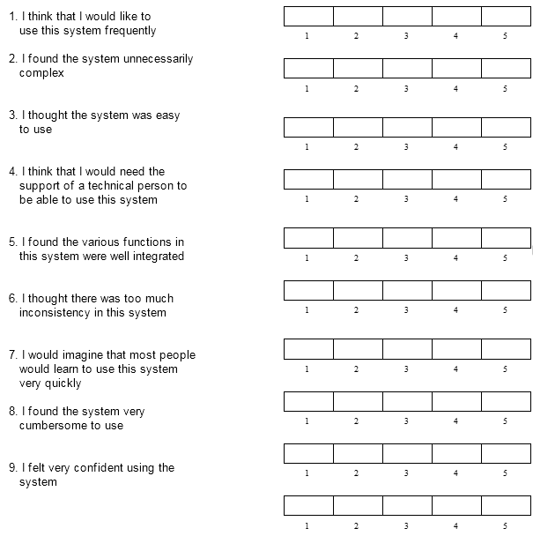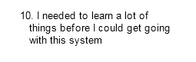

**Figure 10. System Usability Test Scale Questionnaire**

The figure shows the system usability test scale questionnaire (SUS).