**Real-Time Carbon Emissions of Campus Buildings**

|  |  |  |
| --- | --- | --- |
|  | Ryan Policheri  The University of Iowa  Iowa City, Iowa, USA  [ryan-policheri@uiowa.edu](mailto:ryan-policheri@uiowa.edu) |  |

**Abstract**

Buildings on UIowa’s main campus do not have any way to directly meter their carbon emissions. This paper describes how to calculate a real-time carbon emissions value for buildings to support the “Carbon First” approach. Most buildings at UIowa use electric, steam, and chilled water for their energy needs and these energy resources are generated at the on-campus power plant or by the local utility provider, MidAmerican Energy Company. To calculate the real-time carbon emissions for a building we built a software system to collect building usage data and backtrack to the emissions that were associated with the building’s energy usage. Experimental results reveal an event of abnormally high carbon emissions factors due to major drop in chilled water production.

**1. Introduction**

In 2020 EIA estimates that 29% of U.S. energy went towards operating buildings [1]. Heating, cooling, and electric are the 3 typical energy consumers in a building. A building can do heating, cooling, or electrifying using a variety of energy sources. Heating can be fueled by natural gas, steam, concentrated solar thermal, geothermal, electric, etc. Cooling can be fueled by chilled water, geothermal, electric, etc. Electric can be fueled by solar, wind, coal, etc. Note that some of the listed sources could be dependent on other sources (I.E. steam could be produced by burning natural gas or coal).

Of the different energy sources a building could use for heating, cooling, and electric, it is almost obvious to say that the less carbon emissions associated with the source the better. If a building can do its heating using solar energy that is almost certainly better than burning natural gas because the associated carbon emissions is much less.

[2] Argues a “Carbon First” approach in the context of cloud computing. The Carbon First approach exclaims that it is more important to consider how much *carbon* an operation emits and not how much energy it uses. Using the Carbon First approach this paper argues that buildings should meter their carbon emissions and not just their energy usage. It matters less how much energy a building uses for heating, cooling, or electric; what matters more is how much carbon the heating, cooling, or electric emitted.

To observe a value for carbon emissions a building must backtrack its energy usage, which is typically already metered, for heating, cooling, and electric back to the energy sources used to fuel each operation and their associated carbon emissions. Due to the amount of data involved in backtracking, software is needed to calculate the real-time carbon emissions value.

**2. Goals**

One goal of this paper is to describe a custom software implementation that calculates a real-time hourly carbon emissions value for buildings on University of Iowa’s main campus. Between 50 and 100 data sources were needed to build a reasonably accurate carbon meter for buildings on campus and this paper can serve as a road map for data to consider when performing this calculation.

The second goal of this paper is to show experimental results for carbon emissions for buildings on campus and highlight the Carbon First approach.

**3. UIowa Energy Resources**

This section describes UIowa’s energy infrastructure to give the reader a basic understanding of UIowa’s energy system. This background is helpful when understanding how the software implementation works.

**3.1. Steam Heating**

Most buildings on campus use steam heating where steam is generated at the on-campus power plant or in other boilers spread throughout the campus (I.E. the UIowa Hospital has its own boiler outside of the main power plant). There are 7 total boilers, where 5 burn natural gas, 1 burns coal or biomass, and 1 burns a mixture of natural gas, plastic pellets, and biomass.

**3.2. Electric**

Most of campus electric is purchased from the local utility provider, MidAmerican Energy Company. However, the university does generate a significant amount of its own electric by running steam through turbines in a process known as cogeneration.

UIowa also has several natural gas engines that can generate electric in limited situations and a small solar array.

**3.3. Chilled Water Cooling**

Most buildings use chilled water for cooling. UIowa has 3 chilled water plants where each plant has 1 or more chillers producing chilled water. A chiller can either be an electric chiller or a steam chiller.

**4. Implementation**

The implementation section covers the general approach the software takes to calculate the carbon emissions. The software’s source code is located [here on GitHub.](https://github.com/ryan-policheri/UIowaCarbonEmissions)

**4.1. Data sources**

The implementation queries data from two APIs. The first is the PI Web API which contains detailed process data for on-campus energy. PI is a process intelligence system built by OSIsoft [4]. The second is the U.S. Energy Information Administration (EIA) Web API which the custom software uses to get grid operating data, specifically for the Midcontinent Independent System Operator (MISO) [5].

**4.2. Strategy**

The general strategy is to take the 3 energy resources, steam, electric, and chilled water, and compute an *emissions* *factor* for each resource. The emissions factor will be unit of CO2 mass per a unit of resource. Emissions factors are recalculated hourly, and table 1 shows an example of their values.

|  |  |
| --- | --- |
| **Resource** | **Emissions Factor** |
| Steam | 84.72 kilograms of CO­­2 per MMBtu |
| Electric | 289.20 kilograms of CO­2 per MWh |
| Chilled Water | 0.35 kilograms of CO2 per gallon |

Table : UIowa Emissions Factors on May 5th from 9AM to 10AM rounded to 2 decimal places.

Once emissions factors are calculated converting a building’s energy usage to carbon emissions is a simple calculation of multiplying each resource usage by its emissions factor. Table 2 shows an example of this for MacLean Hall, which is of course the primary building for UIowa’s computer science department.

|  |  |  |
| --- | --- | --- |
| **MacLean Hall 5/5/2022 from 9AM to 10AM** | | |
| **Resource** | **Usage** | **Emissions** |
| Steam usage | 1.02 MMBtu | 87.16 kilograms­of CO2 |
| Electric usage | 91.56 KWh | 26.48 kilograms of CO2 |
| Chilled water usage | 226.78 gallons | 80.67 kilograms of CO2 |

Table : Carbon emissions of MacLean Hall on 5/5/2022 from 9AM to 10AM rounded to 2 decimal places. Usage is multiplied by emission factors from table 1 to get total emission values.

**4.3 Computing Emissions Factors**

To compute emissions factors for each resource, one must look at all the fuel that went into producing that resource and for each fuel look at its quantity and its emissions factor. As noted in section 3 some electric at UIowa comes from steam and chilled water comes from both electric and steam. Due to these dependencies, it is best to calculate the emissions factor for steam first.

**4.3.1 Steam Emissions Factor**

As noted in section 3.1 power plant boilers use any of the inputs seen in table 3.

|  |  |
| --- | --- |
| **Fuel** | **Emissions Factor** |
| Natural Gas | 0.0551 Megagrams of CO2 per thousand cubic feet burned |
| Coal | 2.07 pounds of CO2 per pound burned |
| Plastic | 75 kilograms of CO2 per MMBtu |
| Biomass | Treated as carbon neutral (zero emissions) |

Table : Emissions factors for fuels used by UIowa boilers sourced from [6, 7, 8]. Biomass assumed to be carbon neutral.

Except for biomass, the emissions factors in table 3 are sourced from EPA sources [6, 7, 8] and are left in the units reported by the EPA. We take the liberty of treating biomass as zero emissions.

Using PI, we track the amount of each of these fuels going to the boilers and the total amount of steam (measured in MMBtus) coming out. Multiplying fuel inputs by their emissions factors gives a total amount of CO2 from the inputs and dividing that by MMBtus gives a preliminary emissions factor for steam. This emissions factor is later refined in section 4.4

**4.3.2 Electric Emissions Factor**

Our electric emissions factor is a product of the on-campus electric emissions factor and the grid electric emissions factor. Using data in PI, we track the ratio between campus electric and purchased electric and the calculation for the combined electric emissions factor considers this ratio.

**4.3.2.1 On-Campus electric**

For cogenerated electric our emissions factor is calculated by looking at how much steam went into the electric turbines and how much electricity came out. We meter these values using PI and use the emissions factor for steam to get the total carbon over the total cogenerated electric.

Currently we ignore electric from natural gas generators because they are used only in a limited way and we ignore electric from the solar array because the amount of energy is miniscule. These sources could be added in and electric emissions factor updated with little effort.

**4.3.2.2 Grid electric**

For electric purchased from the grid we implemented two strategies. The first was to use EIA’s API [5] to find out the hourly fuel mix for the MISO electric grid. Then we multiplied each of the following fuels by their emissions factors in table 4.

|  |  |
| --- | --- |
| **Fuel** | **Emissions Factor** |
| Natural Gas | 2.23 pounds per kWh |
| Coal | 0.91 pounds per kWh |
| Petroleum | 2.13 pounds per kWh |
| Other | 0.85 pounds per kWh |
| Wind | Zero emissions |
| Solar | Zero emissions |
| Hydro | Zero emissions |
| Nuclear | Zero emissions |

Table : Emissions factors from [9] reporting in pounds per kWh generated.

Note the emissions factors from table 4 do not necessarily line up with those from table 3 because these are reported in CO2 per kWh generated whereas table 3 reports in CO2 per amount burned.

The second grid strategy was to use MidAmerican Energy Company’s average energy mix [10] and assumed the breakdown shown in figure 1 when calculating emissions for electric purchased on the grid.

Figure : MidAmerican Energy Company's average fuel mix for 2021 [10]

There are pros and cons to each of these grid strategies. The pro of using MISO data is that we can get hourly fuel mixes, which better represents intermittent sources such as wind and solar. The con to using MISO data is that MidAmerican’s fuel mix is actually much better (lower carbon emissions factors) than MISO as a whole. It is possible there is a better public data source than either of these options, but in theory it seems the best option would be to get MidAmerican Energy’s hourly or instantaneous fuel mix and calculate emissions from that.

**4.3.3 Chilled Water Emissions Factor**

To calculate the emissions factor for chilled water we look at the amount of steam and amount of electric that went into all the chillers and how many gallons of chilled water came out. The emissions factor for chilled water is then a product of the inputs multiplied by their respective emissions factors divided by the amount of gallons produced.

**4.4 Considering Overhead**

To this point the emissions factors have only been considering fuel inputs and their outputs. We also decided to incorporate “overhead” values into the emissions factors. For example, the power plant itself uses auxiliary electric to run pumps, keep lights on, etc. and we incorporate that into the carbon cost. Likewise the power plant also consumes steam internally which will also impact emissions factors. By incorporating overhead into the carbon price for energy resources, we pass on those carbon emissions to the consumers of the energy, the buildings, which is ultimately what the power plant is here for.

**4.5 Unit Abstraction**

Internally the software uses an open-source library called UnitsNet [6] to abstract away units of mass, volume, power, etc. As noted in [11] this level of abstraction sacrifices an error of up to 1E-5 in exchange for ease of use.

**5. Experimental Results**

With a system in place to calculate both building carbon emissions and emissions factors over time, we ran 2 experiments in the timeframe of 12/16/2022 to 5/5/2022. Note this timeframe was selected because the system state on 12/15/2022 and before rendered our current implementation inaccurate and 5/5/2022 is the date of the experiment. We simply used the largest timeframe we could.

The first experiment uses a realistic but arbitrary usage to track the emission factors over time. The usage is a contrived building that consistently uses 100 kWh of electric, 1 MMBtu of steam, and 500 gallons of chilled water every hour. By keeping the usage consistent over the time frame, changes in carbon emissions can only be from a change in emissions factors. Figure 2 shows a graph of this experiment.

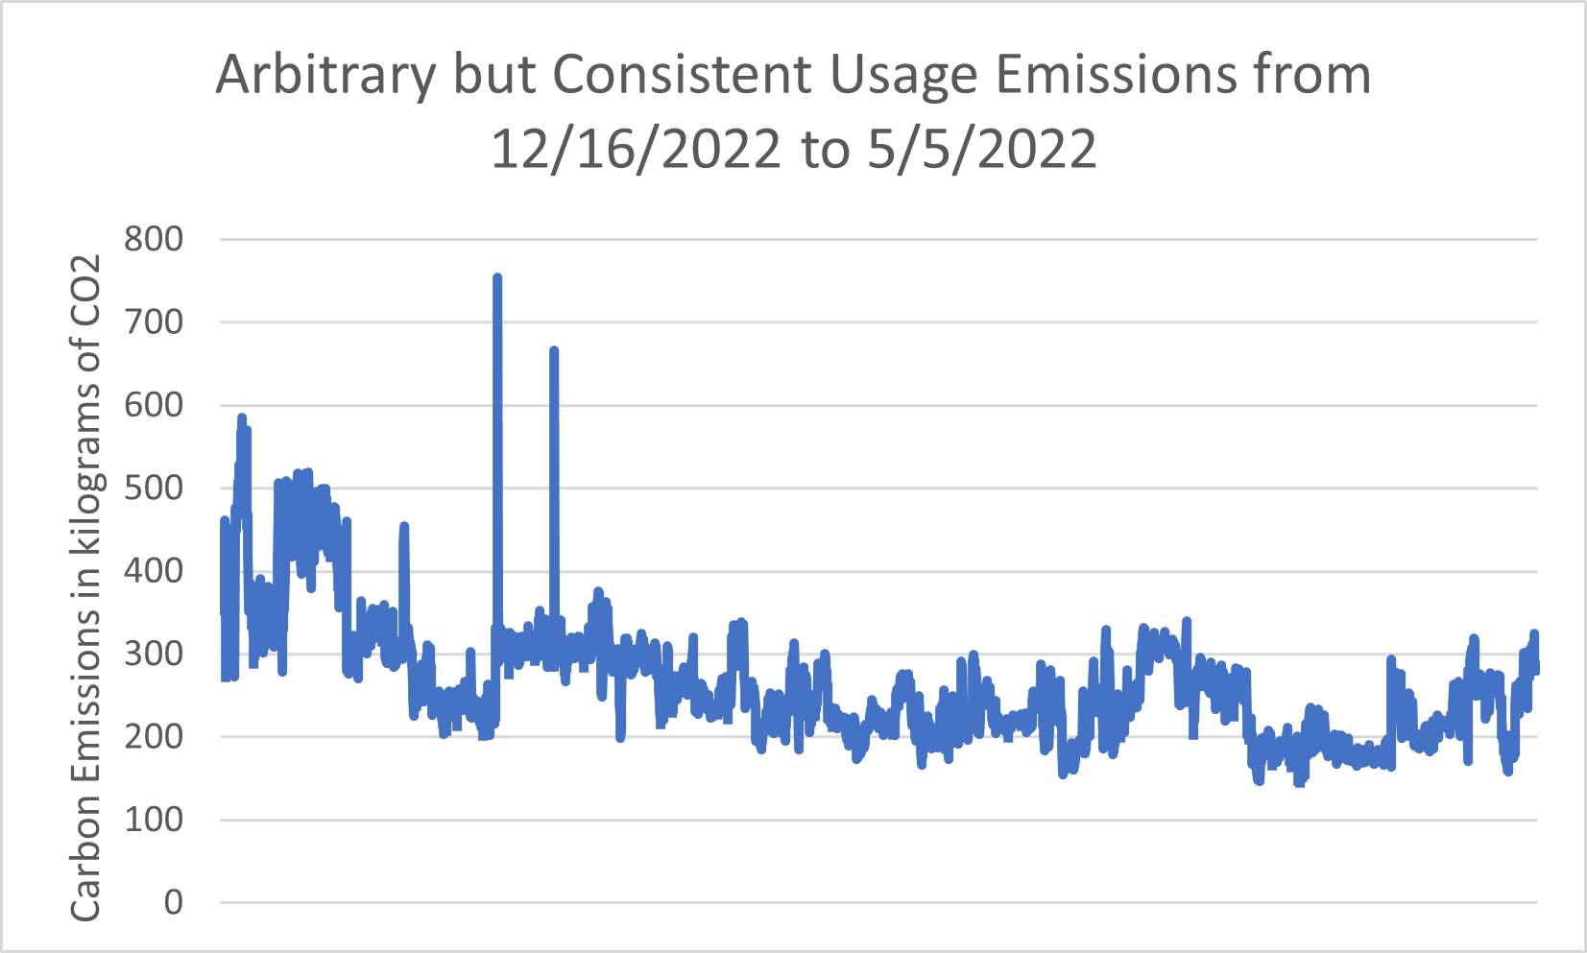

Figure : Experimental results showing the carbon emissions of a contrived building consistently using 100 kWh of electric, 1 MMBtu of steam, and 500 gallons of chilled water every hour from 12/16/2022 to 5/5/2022.

The largest spike in figure 2 is at 1/14/2022 from 10AM to 11AM where the emissions factor for chilled water spiked up to 1.26 kilograms of CO2 per gallon (see table 1 for a more typical chilled water emissions factor). After investigation the source of this spike was due to over a 5,000 gallon drop in chilled water production. This could have been due to a short maintenance or a blip in the data because the gallons restored the next hour. The second spike was on 1/20/2022 from 11AM to 12PM where a similar event happened.

The second experiment looked at the hourly carbon emissions of a real building, MacLean Hall, over time. The difference in this experiment is that with a real building both the *usage* and the *emissions factors* will change over time. Figure 3 shows a graph of this experiment, which takes place during the same timeframe.

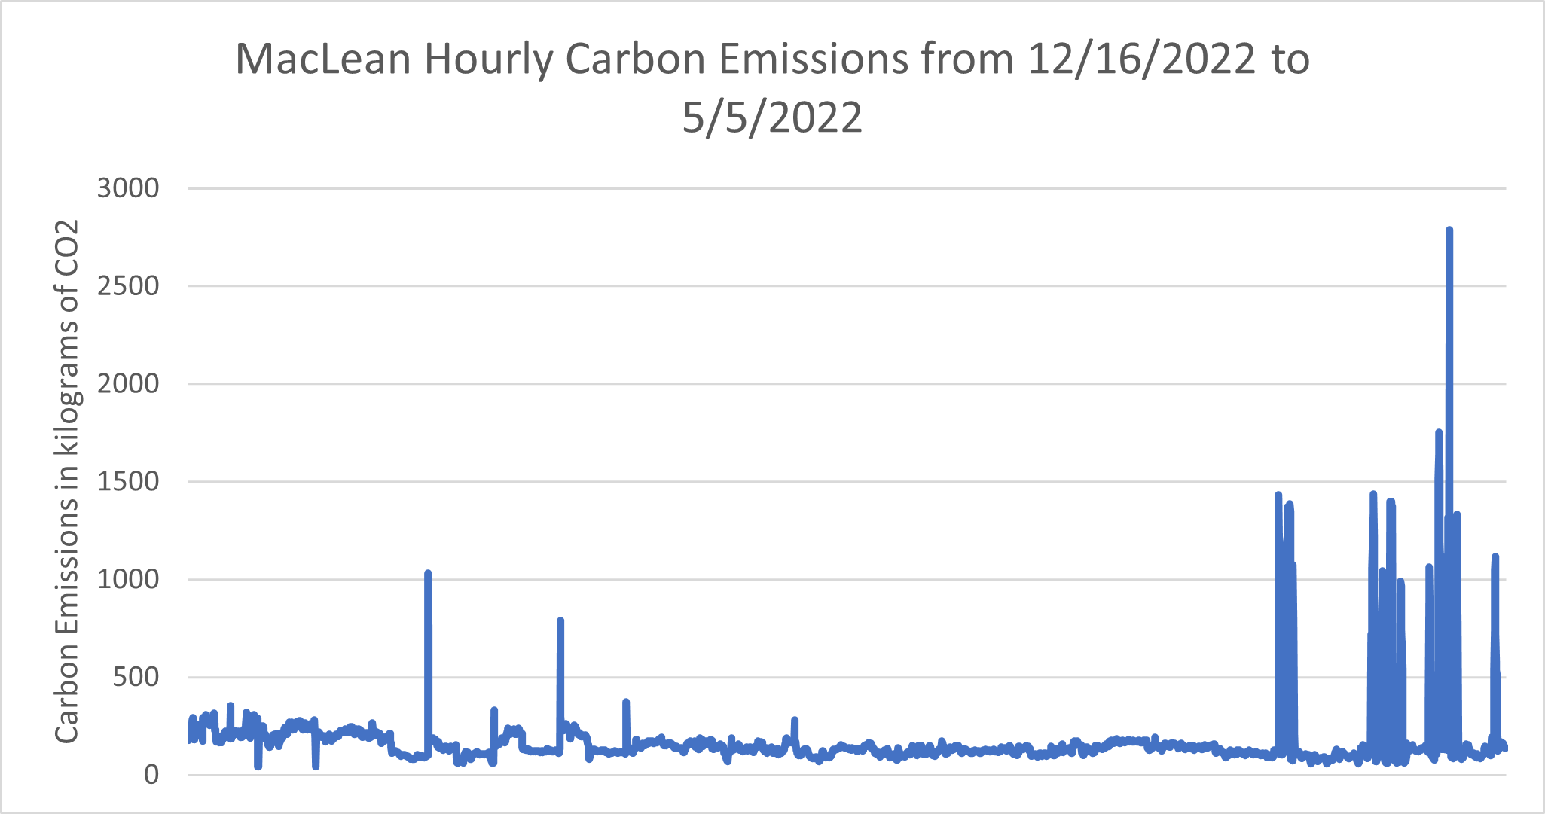

Figure : Experimental results showing the carbon emissions of MacLean Hall every hour from 12/16/2022 to 5/5/2022.

The largest spike in figure 3 was on 4/29/2022 from 8PM to 9PM where chilled water usage shot up from 2,792 gallons to over 9,000 gallons for the hour. The emissions factor for chilled water was not notably high at this time, so the spike is a consequence of the major usage increase.

**6. Future Work**

One goal we have is to display the real-time carbon emissions in kiosks at UIowa buildings to raise awareness on the underlying issue of climate change. We would display emissions is a relatable unit such as gasoline equivalent, so that stakeholders in that building can easily understand the carbon footprint of their building at a glance. There are some political issues to consider with this, but overall I believe it’s a good way to raise awareness and create a feedback cycle between the university and its members on this issue.

Another area to investigate is the improvement of some data sources. Neither electric grid strategy given in section 4.3.2.2 is ideal and improvements can be made with these data sources. Additionally, there are edge case buildings that have additional energy inputs that are not reflected in the strategies above. For example, the chemistry building has a natural gas line as well as buildings too far from the central steam system. Including data for these natural gas lines would improve the accuracy for this subset of buildings

We are also curious as to if we could drive any decision making based on this Carbon First metric. For example [2] describes how one can use the Carbon First approach to drive decisions in cloud computing. It is possible that UIowa has energy intensive processes that could be informed by the carbon metric.

Lastly, we could use the software model to evaluate potential changes in UIowa’s energy system. For example, we could run a “What If” analysis and see how replacing a boiler with a concentrated solar thermal system would impact our emissions factors. Potentially machine learning could be done to find system changes that would maximize carbon emissions reductions while minimizing costs.

**7. Acknowledgements**

This described project had 2 essential contributors that are not listed as authors in this writing. The first is George Paterson, who is the manager of the Energy Control Center at University of Iowa. George is an expert in the UIowa PI implementation and contributed his knowledge of UIowa’s energy data to make this project possible. The second contributor is Melissa Gilmartin who is an environmental engineer with the university’s energy services company (Engie). Melissa consulted on the emissions factors described in this paper to help ensure accurate results.

**8. Sources**

IEEE citation for scholarly sources, plain URLs for other sources.

[1 ] <https://www.eia.gov/tools/faqs/faq.php?id=86&t1>

[2] N. Bashir *κ.ά.*, ‘Enabling Sustainable Clouds: The Case for Virtualizing the Energy System’, στο *Proceedings of the ACM Symposium on Cloud Computing*, Seattle, WA, USA, 2021, σσ. 350–358.

[3] R. Jha, S. Lee, S. Iyengar, M. H. Hajiesmaili, D. Irwin, και P. Shenoy, ‘Emission-Aware Energy Storage Scheduling for a Greener Grid’, στο Proceedings of the Eleventh ACM International Conference on Future Energy Systems, Virtual Event, Australia, 2020, σσ. 363–373.

[4] <https://www.osisoft.com/>

[5] <https://www.eia.gov/opendata/>

[6] <https://www.epa.gov/energy/frequent-questions-epas-greenhouse-gas-equivalencies-calculator>

[7] <https://www.epa.gov/energy/greenhouse-gases-equivalencies-calculator-calculations-and-references>

[8] <https://www.ecfr.gov/current/title-40/chapter-I/subchapter-C/part-98/subpart-C/appendix-Table%20C-1%20to%20Subpart%20C%20of%20Part%2098>

[9] <https://www.eia.gov/tools/faqs/faq.php?id=74&t=11>

[10] <https://www.midamericanenergy.com/energy-mix>

[11] <https://github.com/angularsen/UnitsNet>

**9. Appendices**

**Software source code located here:** [**https://github.com/ryan-policheri/UIowaCarbonEmissions**](https://github.com/ryan-policheri/UIowaCarbonEmissions)