Energy Modeling and Carbon Footprint Software for Campus Energy Systems

An Interactive, Low-Code Software Environment for Modeling Energy Systems

|  |  |
| --- | --- |
| Ryan Policheri  Department of Computer Science  University of Iowa  Iowa City, IA, USA  ryan-policheri@uiowa.edu | Jerald Schnoor   Department of Civil & Environmental Engineering  University of Iowa  Iowa City, IA, USA Jerald-schnoor@uiowa.edu |

ABSTRACT

Managers of energy intensive operations and services such as cloud computing, manufacturing, and heating/cooling, are increasingly making efforts to become more carbon aware in their use and scheduling of energy resources (i.e., electric). For example, much work has been done in calculating and forecasting the carbon intensity of grid-scale electricity, and platforms such as Xbox are now using this information to schedule updates in effort to reduce carbon emissions. In this paper we discuss an energy modeling software tool, called Dynamic Emissions Modeler (DEM), for calculating carbon intensity of district energy resources, including electric, steam, and chilled water. The tool is designed to ingest data from an energy system’s digital twin (such as AVEVA PI) or other data sources (such as Energy Information Administration) to track, in real-time and with arbitrary granularity, how carbon and fuel costs flow throughout a campus or district energy system. In experiments we use the tool to predict the effects of changes to the University of Iowa energy system. We estimate the carbon and fuel cost impact of replacing coal with renewable “energy pellets”, composed of pelletized pre-consumer plastic and biomass, to yield a 12.5% drop in campus carbon emissions at the cost of spending 4.4% more on fuel. A similar analysis shows replacing coal with oat hulls to yield a 39.2% drop in carbon emissions at the cost of spending 1.7% more on fuel. We also demonstrate that replacing a 5,000 cooling ton steam chiller with an electric chiller drops emissions associated with chilled water production by upwards of 40% while also significantly lowering costs.

Permission to make digital or hard copies of part or all of this work for personal or classroom use is granted without fee provided that copies are not made or distributed for profit or commercial advantage and that copies bear this notice and the full citation on the first page. Copyrights for third-party components of this work must be honored. For all other uses, contact the owner/author(s).

*e-Energy’23, June 20–23, 2023, Orlando, Florida, USA*

© 2023 Copyright held by the owner/author(s). 978-1-4503-0000-0/18/06...$15.00

https://doi.org/??

CCS CONCEPTS

• General and reference 🡪 Cross-computing tools and techniques 🡪 Metrics • Hardware 🡪 Power and energy 🡪 Impact on the environment • Hardware 🡪 Power and energy 🡪 Energy generation and storage 🡪 Fuel-based energy

KEYWORDS

Energy systems, carbon-intensity, software modeling tools

ACM Reference format:

Ryan Policheri and Jerald Schnoor. 2023. Energy Modeling and Carbon Footprint Software for Campus Energy Systems: An Interactive, Low-Code Software Environment for Modeling Energy Systems. In *Proceedings of ACM e-energy conference (e-energy’23). ACM, Orlando, FL, USA, 9 pages.* https://doi.org/??

1 INTRODUCTION

Microsoft announced in 2023 that Xbox will be the world's first “carbon aware” console. That is, Xbox will consider the *carbon intensity* of grid electricity when scheduling updates [1]. Carbon intensity is commonly defined as the amount of carbon dioxide per a unit of energy (i.e. kilograms of CO2 per kWh). Grid electricity is generated using a multitude of energy sources from wind and solar to coal and natural gas, and each of these sources have different carbon intensities. In aggregate, an electric grid has a single carbon intensity for the electricity it provides that depends on its *fuel mix*. An Xbox will require the same amount of electricity to update no matter when the update occurs, but by applying the “carbon first” argument from [2] we consider that the best time to update is when the electric grid the Xbox draws power from has the *lowest* carbon intensity. As [2] establishes, “carbon first” can be applied widely in cloud computing; many computational tasks can be scheduled based on carbon intensity to reduce total carbon emissions.

One can calculate or predict the carbon intensity of an electric grid using a variety of data sources and methods. The Energy Information Administration (EIA) publishes the historical fuel mix of electric grids, which can in turn be used to calculate historical carbon intensities [3, 5]. For instantaneous carbon intensities one can look directly at their grid operator for the current fuel mix; for example the Midcontinent Independent System Operator (MISO) publishes their fuel mix in real-time [4]. Predicting carbon intensities [5] suggests using utility *dispatch schedules* and [6] details a machine learning tool for forecasting carbon intensities. Most of these sources and works revolve around electric grid carbon intensities.

This paper’s contribution is detailing a dynamic software system that systematically calculates historical and real-time carbon intensities for *district energy systems*. District energy systems typically provide energy in forms other than electricity. For example, the University of Iowa (UIowa) system provides steam for heating campus buildings and chilled water for cooling campus buildings as well as electricity. This means at UIowa there are three carbon intensities of interest: CO2 per MMBTU of steam, CO2 per gallon of chilled water (or CO2 per cooling MMBTU), and CO2 per kWh of electricity. See figure 1 for a visual tracking the hourly carbon intensity of these 3 energy resources over an 8-day period.

**Figure 1: Hourly carbon intensity factors for 3 energy resources; electric, steam, and chilled water; on the UIowa energy system from December 1st 2022 to December 9th 2022. Electric (top) is measured in kg-CO2 per kWh. Steam (middle) is measured in kg-CO2 per MMBTU. In this figure chilled water is measured in kg-CO2 per gallon (this is somewhat imprecise because it ignores the cooling differential).**

We developed and used a software system, called Dynamic Emissions Modeler (DEM), to model the University of Iowa energy system and to generate these carbon intensities. DEM is dynamic enough to do the same for any energy system.

In theory we can use these carbon intensities for various scheduling decisions just as Xbox can use the electric grid carbon intensity for scheduling updates [1] or a data center can use them for scheduling computational jobs [2]. On the campus level we can schedule vehicle charging or perhaps an industrial process that requires steam, for example. However, we have yet to perform any such scheduling based on these intensities.

What we have done is built a dashboard that renders carbon footprints for campus buildings. Because DEM can calculate carbon intensities of our energy resources and we know the energy usage of our buildings, calculating historical and real-time carbon footprints for our buildings is as straightforward as multiplying the energy usage by the corresponding carbon intensity. This supports quantitative analysis of the *carbon efficiency* of campus buildings compared to their *energy efficiency*. As [2] exclaims with “carbon first” it is more environmentally important to consider how much carbon a process uses rather than how much energy a process uses. See figure 2 for a visualization of this dashboard.

Lastly, and perhaps most interestingly, we use DEM to not only calculate the actual carbon emissions of the UIowa energy system, but also to predict the carbon and cost impact of changes to an energy system. In particular we evaluate the impacts of replacing coal with other fuels such as *energy pellets* and *oat hulls* as well as the impact of installing an electric chiller versus a steam chiller. The experimental results in this paper explore these aspects.

Figure 2: Carbon dashboard showing the carbon footprint for Seamans Center energy usage on Friday, December 9th from 2pm to 2:59pm.

2 BACKGROUND

This section details the UIowa energy system. This background is helpful for understanding the software implementation. The UIowa energy system is managed and operated by ENGIE North America. ENGIE partners with various institutions including University of Iowa, Ohio State University, University of Maryland, and Georgetown University for management and operation of their energy systems.

2.1 District Energy Systems

Campus energy systems, such UIowa’s energy system, fall into the category of district energy systems. In district energy systems, energy resources such as steam, chilled water, and electricity, are generated at centralized facilities and distributed to consumers (i.e., buildings) through pipes, electric lines, etc. [7]. This infrastructure provides economies of scale in areas with a high density of energy consumers (i.e., universities, hospitals, military bases, business districts) [7].

2.2 Steam Heating

All buildings on a campus need a source of heating. In the UIowa system most buildings are heated with steam that is generated at the central power plant, although there are a few exceptions where buildings heat via a natural gas furnace or electric heat pump. UIowa generates steam using boilers that burn natural gas, coal, *energy pellets*, or *oat hulls*. Each of these fuels has corresponding *emission factors*. An emissions factor describes how much of an emission is emitted per unit of fuel burned (i.e., kilograms of CO2 per pound of fuel burned). Fuels such as coal have multiple emissions factors, one for each type of emission (i.e., kilograms-CH4 per pound burned, kilograms-CO2 per pound burned, etc.). This paper is mostly focused on CO2 emission factors, but DEM supports modeling of any kind of factor. See table 1 for average CO2 emission factors of relevant fuels provided by the Environmental Protection Agency (EPA) [8]. Note: the terms carbon intensity and emission factor are sometimes used interchangeably. In this paper we use emission factor to discuss the result of a direct burn of a substance and use carbon intensity to talk about the carbon associated with an energy resource (electric, steam, and chilled water).

|  |  |
| --- | --- |
| **Fuel** | **Emission Factor** |
| Bituminous Coal | 2,325 kg of CO2 per short ton burned |
| Natural Gas | 0.05444 kg of CO2 per square foot burned |
| Plastics | 2,850 kilograms of CO2per short ton burned |
| Agricultural Byproducts | 975 kg of CO2 per short ton burned |

**Table 1: CO2 emissions factors for relevant fuels provided by the EPA [8]**

In aggregate we can determine the carbon intensity of UIowa steam by looking at how much of each fuel was burned and how much resulting steam was produced in a given time period. For example if 1 short ton of coal and 10,000 square feet of natural gas was burned and 30 MMBTUs of steam was generated, the carbon intensity of steam would be (1 * 2,325 + 10,000 * 0.0544) / 30 = 95 kgs of CO2 per MMBTU of steam.

*2.2.1 Energy Pellets.* UIowa is increasingly using energy pellets as a boiler fuel. Energy pellets are purchased from a company called Convergen Energy [9]. They are a hybrid fuel composed of plastics, biomass, and agricultural byproducts. The product UIowa purchases is 42.5% pre-consumer plastics and 57.5% biomass, where biomass is a mix of pre-consumer papers and miscanthus grass (which UIowa grows locally). Both pre-consumer papers and miscanthus grass use the agricultural byproduct CO2 emission factor. The price fluctuates, but ENGIE’s December 2021 fuel report marks energy pellets at $0.048 per pound.

*2.2.2 Oat Hulls.* UIowa has historically used and currently uses oat hulls from Quaker Oats as boiler fuel. Oat hulls are a byproduct of oat milling. Quaker Oats used to donate them to UIowa but as burning biomass has become more prominent, UIowa now pays for them. The price fluctuates, but ENGIE’s December 2021 fuel report marks oat hulls as $0.031 per pound.

2.3 Campus Electric

UIowa typically generates 15% to 30% of its electricity supply and purchases the rest from the local utility, MidAmerican Energy Company. UIowa generation mostly comes from *cogeneration*. That is, because steam is already being produced for heating buildings, any excess can be throttled through steam turbines to generate electricity for direct use. Other electric sources include four natural gas generators and two solar arrays. To calculate the carbon intensity of UIowa electricity, we need to aggregate the intensities of the utility electric and of campus electric sources.

*2.3.1 UIowa Cogenerated Electricity.* The carbon intensity of cogenerated electricity is a product of how much steam passed through turbines and the carbon intensity of that steam over how much electricity was generated. For example if 50 MMBTUs of steam with the average carbon intensity of 70 kgs-CO2 per MMBTU was sent through the turbines, and the turbines generated 30,000 MJs of electricity, the carbon intensity of the cogenerated electric is (50 MMBTUs * 70 kg-CO2/MMBTU) / 30,000 MJ ≈ 116.6 kgs-CO2 per MJ.

*2.3.2 UIowa Other Electricity Sources.* Most campus-generated electricity comes from cogeneration. Nonetheless calculating the carbon intensity of electricity from the natural gas generators simply involves taking the natural gas emissions factor from table 1, multiplying it by how much natural gas was used by the generators, and then dividing that by the amount of electricity they produced. For solar arrays, we treat the carbon intensity as 0.

*2.3.3 Utility Electricity*. UIowa meters how much electricity is being purchased from the utility at any given time. The fuel mix assumed of this electricity can be sourced from multiple sources, depending on the experiment. For historical analysis we have used both the MISO fuel mix provided by EIA [3] and the yearly average MidAmerican Energy Company fuel mix [10]. For instantaneous use-cases (i.e., a real-time carbon footprint), we have used the MidAmerican fuel mix or the instantaneous MISO fuel mix [4]. The fuel mix used can make a large difference in carbon intensity considering that the MidAmerican fuel mix is 62% wind (which we treat as 0 carbon), but the MISO fuel mix is closer to 20% wind [10, 4].

Once a fuel mix is determined, the carbon intensity of purchased grid electricity is an aggregate of, for each energy source in the mix, the *total electricity purchased* * *percent of fuel mix* * *the carbon intensity of the energy source* all divided by the *total electricity purchased*. For example, using the intensities from table 2, if 30 MWh of electric is purchased and 50% of the mix is wind, 30% is natural gas, and 20% is coal, then the carbon intensity of purchased electric is (30 * 0.5 * 0 + 30 * 0.3 * 0.97 * 1000 + 30 * 0.2 * 2.26 * 1000) / 30 ≈ 743 lbs. of CO2 per megawatt-hour (MWh)

|  |  |
| --- | --- |
| **Energy Source** | **Carbon Intensity (lbs. per kWh)** |
| Natural Gas | 0.97 pounds per kWh |
| Coal | 2.26 pounds per kWh |
| Petroleum | 2.44 pounds per kWh |
| Other | 0.85 pounds per kWh |
| Wind | 0 pounds per kWh |
| Solar | 0 pounds per kWh |
| Hydro | 0 pounds per kWh |
| Nuclear | 0 pounds per kWh |

Table 2: Carbon intensities by source fuel for utility scale electric reporting in pounds per kWh generated. Natural gas, Coal, Petroleum, and Other are sourced from [11] and 0 is assumed for other energy sources.

2.4 Chilled Water Cooling

Most buildings on UIowa’s campus are cooled using chilled water that is produced by three chilled water plants. Across these three plants both electric and steam chillers are used to produce chilled water. This means that in aggregate to determine the carbon intensity of chilled water we need to consider how much steam and campus electric was used and their corresponding carbon intensities. Similar to previously shown examples, the numerator will ultimately be a total amount of carbon associated with all energy inputs over a unit of chilled water. We have performed experiments both measuring chilled water in terms of gallons, which is somewhat lossy because of varying cooling differentials, and in terms of cooling MMBTUs. Another common way to measure cooling is in terms of *cooling tons*, where a cooling ton is defined as 12,000 BTUs of cooling over an hour.

2.5 Emission Scoping and System Overhead

An important system factor that informs our software design is that the district energy system not only provides energy to consumers, but is itself a consumer. For example, the central power plant and chilled water facilities use steam for interior heating and also use electricity for auxiliary purposes, lighting, offices, etc. Because these facilities are ultimately operating for the other consumers, our scoping decision was to incorporate these overheads into the carbon intensity of the energy resources. Mathematically all that entails is subtracting the amount of energy the *producers* consumed from the amount the data indicates they produced.

2.6 Digital Twins

Operation of an energy system typically involves the use of *digital twin* software that makes system data easily (and programmatically) accessible. UIowa uses the PI system [12] to manage energy system data. UIowa’s PI implementation provides granular data streams for nearly every component of the energy system; all the different fuels burned (coal, natural gas, energy pellets, etc.), all the energy resources generated from various equipment (boilers, turbines, chillers, etc.), all the energy resources consumed (by buildings, by the power plant, by sidewalk lighting, etc.) is all metered and made available to UIowa constituents through PI. UIowa’s implementation of PI contains thousands of data streams and is the primary data source for the experiments we performed in DEM.

3 MODELING PARADIGM

Generating carbon intensities for energy resources in the UIowa energy system required ingesting over 100 streams of data from PI, and the streams of data are often related through complex equations and contain data with dissimilar units and unit rates. Consider that if you want to calculate the real-time carbon footprint of a UIowa building you’ll be looking at an electricity consumption rate measured in joules per second, a steam consumption rate measured in MMBTUs per hour, and a chilled water consumption rate measured in gallons per minute! To derive a carbon metric for an arbitrary time frame and an arbitrary frequency within that time frame, all of these rates need to be adjusted and integrated to match the target frequency accordingly, which is error prone and difficult!

After correcting for the fact that the rates are all mismatched, consider that the units themselves need to be normalized, not only between simple things like pounds to kilograms but also between pounds of steam to BTUs of steam, which requires enthalpy constants which require system expertise. Regarding energy pellets or other alternative fuels, you are going to need to understand the biochemical makeup of those in order to calculate the carbon intensity of the steam they yield.

Now consider you don’t want to just produce these carbon metrics for UIowa, but also for any other ENGIE partnering institution and by extension any energy system (or at least any energy system that has a digital twin). The methodology is inherently unscalable, error prone, and mandates a software abstraction.

3.1 Exchange Nodes

Emissions first come into our scope when fuel is burned in campus boilers. As [2] establishes with electricity, there is a disconnect between the use of an energy resource and the actual environmental impact of generating that energy resource. In this paper we apply the same idea to district energy resources such as steam and chilled water. If steam came from burning biomass or from concentrated solar thermal, its carbon intensity is lower and environmental impact lesser versus if that steam came from burning natural gas or coal. DEM abstracts this idea as an *exchange node* and boilers, natural gas generators, solar panels, wind turbines, and anything that initiates the creation of an energy resource are all encoded as exchange nodes.

An exchange node exchanges a single product (i.e., steam) for one-to-many costs. In UIowa’s implementation of DEM all exchange nodes have both a carbon cost and a fuel cost associated with them. However carbon and fuel costs are not directly available as data streams in the UIowa digital twin (unlike sulfur dioxide or nitrous oxide, which are available because they are regulated as pollutants). For this reason, an exchange node will need three things: data streams related to your product, data streams related to your costs, and a set of *functions* that encode how to get from the data you have to the products and costs you wish to model. Figure 3 shows a diagram of a boiler with multiple fuel inputs modeled as an exchange node.

Figure 3: Diagram of a UIowa boiler represented as an exchange node. The boiler takes in data streams that meter how much oat hulls, coal, and energy pellets are being fed into the boiler and how much steam the boiler yields along with its associated costs. Because CO2 and fuel cost are not directly metered by the data we have, functions are added to the node that tell us how to get from the data streams we have (fuel inputs, steam output) to the data streams we want (steam output, carbon output, and cost output).

DEM provides all the support needed to design these nodes with a graphical user interface to drag-and-drop data streams into your nodes and a code-editor to write type enforced functions. Figure 4 shows part of the exchange node from figure 3 in DEM. An important note about functions in DEM is that they are written in a rate agnostic fashion. That is, even if data streams meter data in joules per second or MMBTUs per hour, the rate is automatically integrated out of the data before being passed to the function. This design decision, which was partially inspired by the Lustre modeling language [13], makes it easier to write functions correctly and enables DEM to render carbon intensities over time at any frequency (i.e., daily, hourly, every second, etc.).

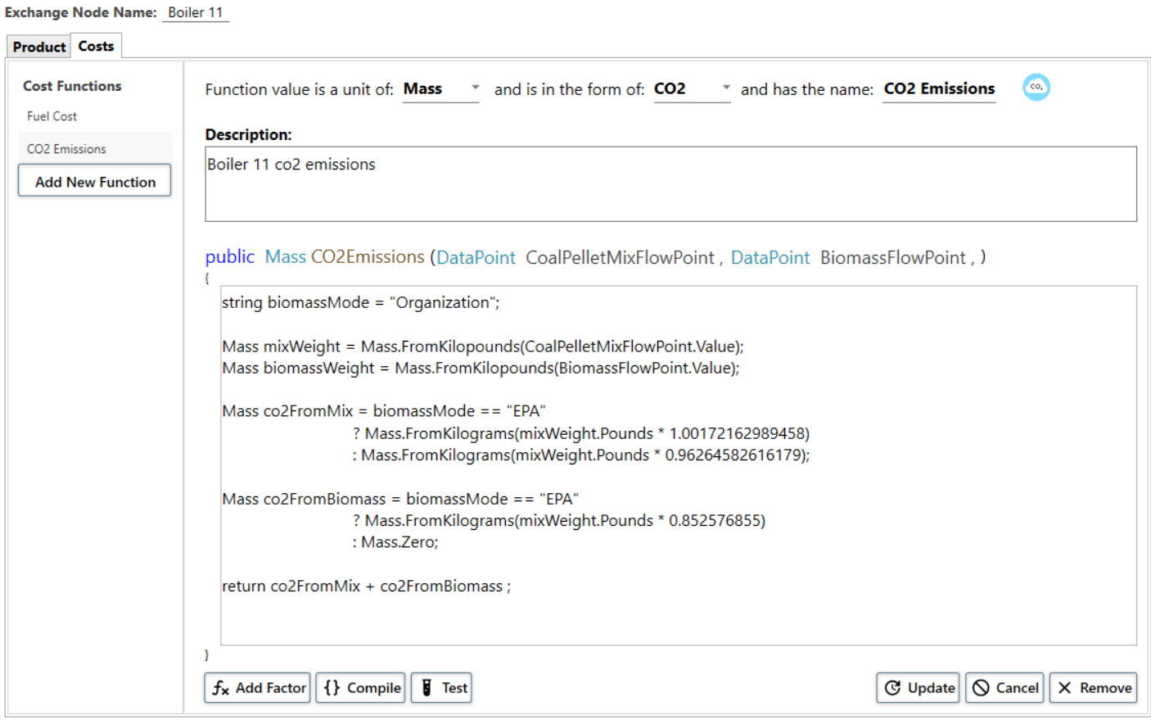

Figure 4: Part of an exchange node shown in DEM. The part shown is the function that takes in a data stream metering a coal/energy pellet fuel mix and a data stream metering oat hulls. The function returns the amount of CO2 that resulted from burning these fuels in the boiler.

3.2 A Network of Nodes

DEM needs several other types of nodes to get from the exchange nodes to the final energy products and their associated costs per unit (i.e., kilograms of CO2 and dollar cost per MMBTU of steam). These nodes are connected and arranged in a directed graph. All nodes without parents are exchange nodes. All nodes without children are considered the final products of the energy system and consumers (i.e., campus buildings) can link up to these nodes to calculate their footprint. All the other nodes are one of the other types of nodes detailed in 3.2.1. Figure 5 shows a directed graph of the UIowa energy system that loosely represents the structure the UIowa DEM model.

Figure 5: A directed graph that loosely represents the structure of UIowa’s DEM model. Nodes without parents are all exchange nodes and nodes without children are the final energy products of the system along with their associated costs.

*3.2.1 Other Types of Nodes.* DEM needs other types of nodes to accurately model an energy system. Those nodes are the following:

* **Like-Term Aggregator Node:** Used for aggregating the product and costs of multiple predecessors, for example for combining the steam from multiple boilers.
* **Splitter Node:** Used for splitting a predecessor’s product so that some can be diverted to multiple system components. For example, steam can be split such that some goes towards heating, and some goes towards cogeneration.
* **Product Conversion Node:** Used for changing a predecessor’s product into a new product while still maintaining all of the predecessor’s costs. For example using electricity in an electric chiller to produce chilled water.
* **Product Subtractor Node:** Used for subtracting a predecessor’s product while still maintaining all of the predecessor’s costs. For example when deducting the amount of steam a power plant consumed internally (i.e. for space heating the power plant) from the total steam that it produced.
* **Usage Adjuster Node:** Used when a predecessor’s total product is not reflective for how much the local energy system actually uses. For example the total electricity product for all of MISO needs to be adjusted downward to reflect how much UIowa actually purchased.

*3.2.2 Nodes with different data.* An interesting consequence of this design is that nodes do not necessarily need to ingest energy system data; they can also ingest other related data. For example, a node representing a natural gas boiler can take in a data stream from the digital twin measuring the flow of natural gas along with a data stream from an external API that observes the *market price of natural gas*. In this example the flexibility allows us to incorporate the fluctuation of gas prices in an analysis.

Another use case is for modeling infrastructure that does not exist. For example nodes can take in streams of data reflective of local temperature, wind, or solar irradiance and use this data to model and assess how a wind or solar farm installation would impact the energy system in real-time.

3.3 Software Details

The software system that enables users to design DEM models and execute them to generate metrics and perform experiments contains several components detailed in the following subsections. The source code for all software components is written in C# using the .NET 7 application framework. The source code for DEM can be found at [15].

*3.3.1 Unified Data Explorer* is a Windows desktop application that connects to data sources (i.e., PI, EIA.gov, etc.) and provides a graphical interface for exploring data streams within sources and organizing them in a user-defined directory structure. Because there is so much data required to build a complex model (greater than 100 data streams for the UIowa energy system), a unified exploratory tool with an in-built organizational system is nearly a necessity for building an accurate model.

Even though DEM models are just complex JSON objects, one would have an impossible time writing the underlying JSON themselves. Unified Data Explorer also provides the graphical interface for designing nodes in an energy system and arranging them in a directed graph. Data streams can then be dragged-and-dropped into nodes and functions written to extract the tracked metrics in a systematic and consistent way.

*3.3.2 DEM API* is an HTTP API that enables programmatic access to a DEM instance and provides an interface for executing DEM models to generate carbon intensities (or more generally any intensity associated with a unit of energy resource because the system can be similarly used to track fuel cost intensity, sulfur dioxide intensity, nitrous oxide intensity, etc.). Executing a model involves building the directed graph, compiling all user-defined functions (which are also written in C#), binding all the necessary data streams to nodes, and calculating every time step in the caller’s requested frequency (per second, per minute, per hour, etc.).

*3.3.3 Other System Components.* DEM requires a relational database (i.e. SQL Server) to store models and experimental results. There is also an experimentation console application for coding and running complex experiments.

We also want to give recognition to the *UnitsNet* library [14] which provides underlying unit abstraction in the system and implicitly handles all conversions from similar units (i.e. pounds to kilograms).

4 EXPERIMENTAL RESULTS

The experimental results in this paper are geared towards evaluating sustainability goals of the university. In particular, UIowa has a goal to be free from coal by 2025 and plans to use fuels such as biomass and energy pellets to replace the energy generated by coal [16]. The two replacement fuels we evaluated are energy pellets and oat hulls. Energy pellets not only cost more than coal ($0.007 more per pound according to the December 2021 ENGIE fuel report), but also have a lower energy content (roughly 1,000 BTUs less per pound according to the same report). This means that, in terms of mass, more energy pellets will need to be burned than coal to meet the same energy content. The advantage, however, is that energy pellets are 57.5% biomass, and in these experiments we consider emissions from biomass to be zero based on a life cycle assessment. We show similar experiments using oat hulls as the replacement fuel. See table 3 for factor details about each fuel that are derived from EPA averages and an ENGIE fuel report. The factors, especially cost, are subject to change over time, but we fix them in time for these experiments.

|  |  |  |  |
| --- | --- | --- | --- |
|  | **Bituminous Coal** | **Energy Pellets** | **Oat Hulls** |
| **CO2 Factor** | 1.02 kgs of CO2 per pound | 0.61 kgs of CO2 per pound | 0 kgs of CO2 per pound |
| **Energy Factor** | 10,940 BTUs per pound | 9,529 BTUs per pound | 7,214 BTUs per pound |
| **Cost Factor** | $0.041 per pound | $0.048 per pound | $0.031 per pound |

Table 3: CO2, energy, and cost factors for coal, energy pellets, and oat hulls derived from figures at the EPA emissions factor hub [8] and the ENGIE December 2021 fuel report. The derived numbers have CO2 from biomass content assumed to be net-zero.

4.1 Establishing Accuracy

UIowa reports its total emissions to the EPA on a yearly basis to meet regulatory requirements. This is calculated by reviewing how much of each fuel was purchased and consumed and multiplying by emissions factors (note for this type of reporting, biomass emission factors are not “zeroed-out” as is the case in table 3 figures). We use the EPA reporting numbers as a baseline to establish the accuracy of our DEM model. We found that in 2021 the EPA numbers measured UIowa’s scope 1 power plant CO2 emissions at 195,851 metric tons of CO2, whereas our DEM model measured it as 184,480 metric tons of CO2, giving us about 5.8% error between DEM and EPA numbers.

The source of this error is primarily from the fact that DEM mostly uses sensor data provided by the digital twin, whereas the EPA reporting incorporates digital twin data, manually measured data (e.g., weight of a truck before and after fuel is taken out), and billing data. Incorporating these other data sources improves accuracy but sacrifices granularity.

4.2 Replacing Coal

Section 4.1 gives an idea of the accuracy of a DEM model that is deliberately modeling the *existing energy system*. This deliberate modeling is what provides the emission and cost factors for the system’s energy resources. However to explore the impacts of *changes in the energy system*, we can flexibly modify, replace, or add nodes in the baseline DEM model. This is precisely what we did to evaluate replacements to coal.

UIowa has one boiler that burns coal (the same boiler also burns energy pellets and oat hulls). This boiler is modeled as an exchange node with functions that instruct how to get from digital twin data to total CO2 and fuel cost over the total amount of steam produced. We modified these instructions to ask, “What is the CO2 and fuel cost for this boiler to produce the same amount of steam using energy pellets and oat hulls in place of coal?” The modeling paradigm makes this an easy question to answer and only required changing a few lines of code in our functions!

The emission and fuel cost impacts of this change on the energy system are shown visually in figures 6 and 7 over the course of a year. Over the course of a year, we estimate that replacing coal with energy pellets prevents 18,220 metric tons of CO2 (~12.5% decrease) and replacing with oat hulls prevents 57,180 metric tons of CO2 (~39.2% decrease). These CO2 emissions savings are roughly equivalent to 21,562 acres of U.S. forest working for a year for the conversion of coal to energy pellet savings and 67,669 acres for the coal to oat hull savings [17].

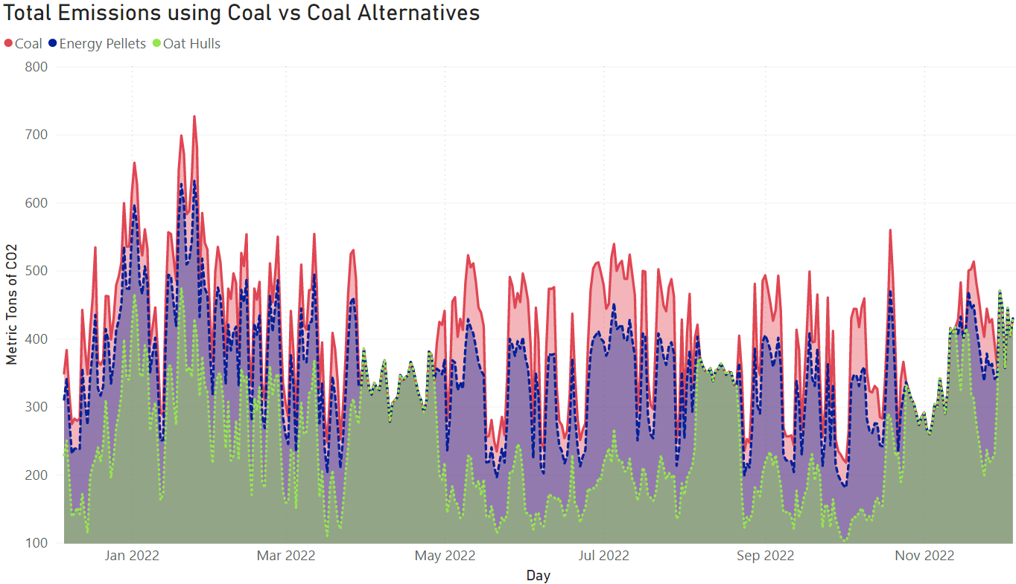

Figure 6: Graph showing the total CO2 emissions impact of UIowa replacing coal (red, solid top curve) with energy pellets (blue, dashed middle curve) or oat hulls (green, dotted bottom curve). Timeframe is from 12/6/2021 to 12/5/2022 rendered at a frequency of carbon emissions per day. The 3 curves converge on days where no coal is being burned.

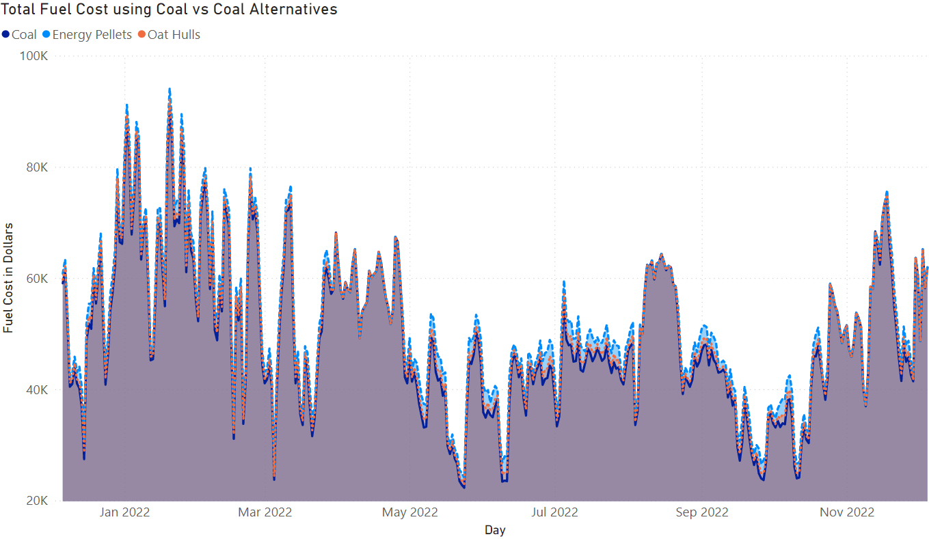

Figure 7: Graph showing the total fuel cost impact of UIowa replacing coal (purple, solid bottom curve) with energy pellets (blue, dashed top curve) or oat hulls (orange, dotted middle curve). Timeframe is from 12/6/2021 to 12/5/2022 rendered at a frequency of carbon emissions per day. The 3 curves converge on days where no coal is being burned.

While CO2 savings is a meaningful metric, it can also be important to consider the monetary cost of these CO2 savings. The three curves in figure 6 are almost indistinguishable, but adding up the difference in the curves results in the energy pellet replacement costing $827,549 (~4.4% increase) and the oat hull replacement costing $300,369 (~1.7% increase) over the course of the year. To be clear, these cost increases are based on the fuel cost only; it does not consider the cost of new equipment required or the cost of more regular maintenance.

The recently passed Inflation Reduction Act prices carbon at $85 per metric ton [18]. If we involve the externalities of carbon emissions in the above fuel cost estimations, we see that if carbon is priced at this rate, both of these fuel changes would actually save or earn the university money. Replacing coal with energy pellets would generate (18,220 tons CO2 prevented * $85) - $827,549 ≈ $721,151 of revenue and replacing coal with oat hulls would generate (57,180 tons CO2 prevented * $85) - $300,369 ≈ $4,559,931 of revenue. This potential source of income provides UIowa and ENGIE a fiscal incentive to support carbon pricing because they are in a position to profit from it, depending on policy implementation.

4.3 Electric vs Steam Chillers

The UIowa system contains electric and steam chillers for chilled water production. Using DEM we can evaluate the carbon and cost efficiency of each type of chiller. In particular UIowa recently installed a 5,000 cooling ton electric chiller, and we used DEM to evaluate how much carbon and cost was saved by choosing to install the electric chiller over the steam chiller.

We observed two 5,000 ton chillers, one steam and one electric, that were operating simultaneously on the energy system from 6/21/2022 to 7/18/2022. We tracked their energy resource inputs (electric and steam) and multiplied those inputs by their respective CO2 and cost factors that DEM generated daily to estimate a total carbon and fuel cost for each chiller. By dividing these totals by the total cooling energy each chiller generated (which were similar because they are both 5,000 ton chillers), we calculated the CO2 and cost efficiency of these chillers per cooling MMBTU. We reconfigure these results in terms of carbon and fuel cost per 5,000 cooling tons and display them in figures 8 and 9.

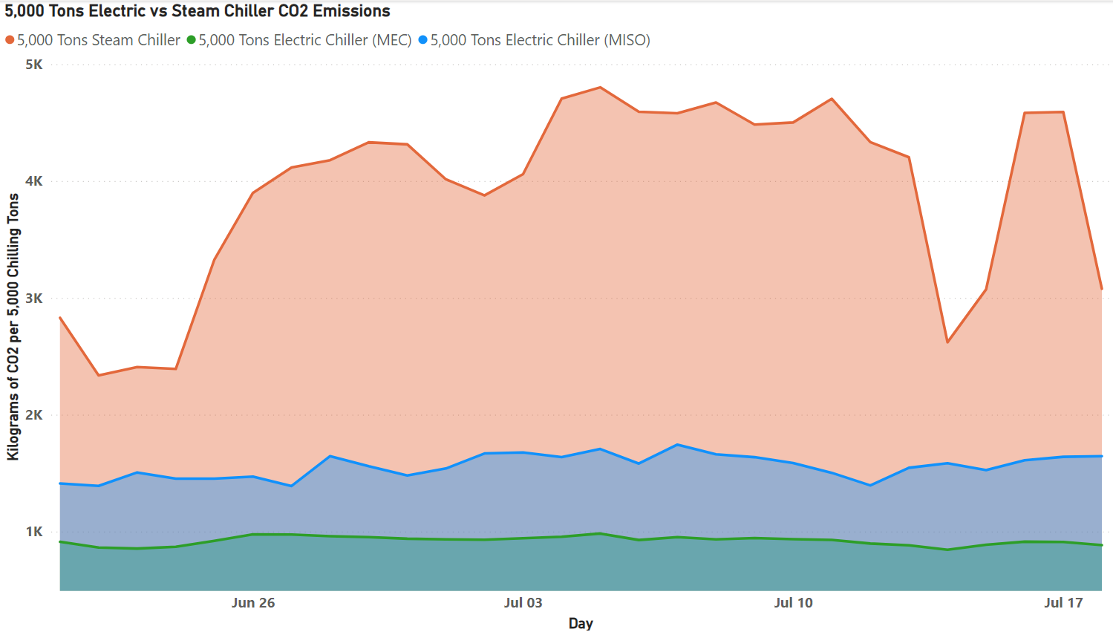

Figure 8: CO2 emissions per 5,000 cooling tons for a steam chiller versus an electric chiller running on the UIowa energy system. The bottom curve is an electric chiller assuming the MidAmerican Energy fuel mix [10] for purchased electricity, whereas the middle curve is an electric chiller assuming the MISO historical fuel mix provided by EIA [3] for purchased electricity.

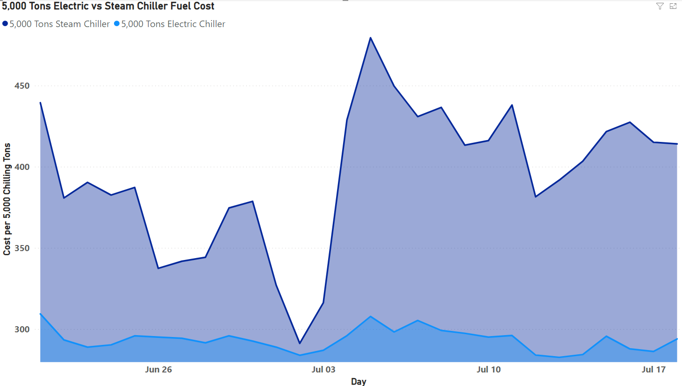

Figure 9: Energy resource cost per 5,000 cooling tons for a steam chiller versus an electric chiller running on the UIowa energy system. Note the dip in the cost of steam around July 2nd is attributed to a boiler that was temporarily burning energy pellets in place of natural gas.

Figure 8 highlights that because MISO and MidAmerican Energy have a significant amount of their energy coming from clean sources, namely wind power, the electric chiller becomes more carbon efficient. For the bottom curve, where we assume the MidAmerican Energy average fuel mix [10] for all purchased electricity, approximately 62% of the electric is from wind power. All fluctuations in the carbon efficiency curve come from the fluctuations of carbon intensity in campus generated electricity. MISO is a similar story except that **a)** wind power is a smaller percentage of the fuel mix, and **b)** EIA provides hourly fuel mix data [3] so the carbon intensity of purchased electricity also fluctuates, resulting in an undulating curve. Note: because we are using daily average data in this experiment, hourly wind fluctuation is leveled out. Had we ran the experiment with hourly granularity, one would expect the middle curve to have more peaks and valleys.

Figure 9 shows the cost efficiency between a chiller using steam as fuel and a chiller using electricity as fuel. This graph only has two curves because the utility provider averages fluctuations in energy prices, which is about 10.3 cents per kWh. The suspicious dip in the top curve is due to a temporary fuel substitution in the UIowa energy system, where the operators replaced a subset of its natural gas usage (roughly 75,000 square feet per hour) with energy pellets (roughly burning an additional 8,000 pounds per hour). This impacts price significantly because at the time the price of natural gas was significantly higher (between 8 and 10 dollars per 1,000 cubic feet [19]), and energy pellets assumed the constant price in table 3. Had the price of natural gas been lower (say, around 3 dollars per 1,000 cubic feet), this fuel change would have actually costed more.

5 CONCLUSIONS

We demonstrate that Dynamic Emissions Modeler (DEM) can be deployed and used to systematically ingest streams of data involved in an energy system to generate CO2 and other cost factors per unit of energy resource. These factors can be used for carbon-based demand-side optimizations [2, 5] and to understand the carbon and cost efficiency of energy resource consumers (buildings, chillers, etc.). In experimental results, we show that DEM can serve as a valuable planning tool to evaluate the impact of changes to an energy system. These changes can include fuel changes, equipment changes, and even the impacts of new generation sources being added to a system (e.g., installing a new solar farm). Our experimental results show that replacing coal with energy pellets could lower campus emissions by 12.5% and replacing coal with oat hulls by 39.2%. We also show that electrifying chillers can increase the carbon efficiency of chilled water production by upwards of 40%.

ACKNOWLEDGMENTS

We thank ENGIE North America for use of their systems and data and especially for the expertise their engineers; George Paterson, Melissa Gilmartin, and Rob Murray; contributed to this project. We could not have grasped many of the underlying system and institutional details without their help!

REFERENCES

[1] Blaine Hauglie. 2023. Xbox Is Now the First Carbon Aware Console, Update Rolling Out to Everyone Soon. <https://news.xbox.com/en-us/2023/01/11/xbox-carbon-aware-console-sustainability/>, 2023. Accessed: 2023-02-07

[2] Noman Bashir, Tian Guo, Mohammad Hajiesmaili, David Irwin, Prashant Shenoy, Ramesh Sitaraman, Abel Souza, and Adam Wierman. 2021. Enabling Sustainable Clouds: The Case for Virtualizing the Energy System. In Proceedings of the ACM Symposium on Cloud Computing (SoCC '21). Association for Computing Machinery, New York, NY, USA, 350–358. <https://doi.org/10.1145/3472883.3487009>

[3] EIA Open Data API. <https://www.eia.gov/opendata/>

[4] MISO RT Data APIs. <https://www.misoenergy.org/markets-and-operations/RTDataAPIs/>

[5] Rishikesh Jha, Stephen Lee, Srinivasan Iyengar, Mohammad H. Hajiesmaili,  
David Irwin, and Prashant Shenoy. 2020. Emission-aware Energy Storage  
Scheduling for a Greener Grid . In The Eleventh ACM International Conference  
on Future Energy Systems (e-Energy’20), June 22–26, 2020, Virtual Event,  
Australia. ACM, New York, NY, USA, 11 pages. https://doi.org/10.1145/  
3396851.3397755

[6] Diptyaroop Maji, Ramesh K. Sitaraman, and Prashant Shenoy. 2022. DACF:  
Day-ahead Carbon Intensity Forecasting of Power Grids using Machine  
Learning. In The Thirteenth ACM International Conference on Future Energy  
Systems (e-Energy ’22), June 28-July 1, 2022, Virtual Event, USA. ACM, New  
York, NY, USA, 5 pages. <https://doi.org/10.1145/3538637.3538849>

[7] District Energy Fact Sheet. <https://www.energy.gov/sites/default/files/2021/03/f83/District_Energy_Fact_Sheet.pdf>, 2018. Accessed: 2023-02-07

[8] EPA Emission Factors Hub. <https://www.epa.gov/system/files/documents/2022-04/ghg_emission_factors_hub.pdf>, 2022. Accessed 2023-12-01.

[9] Convergen Energy. <https://www.convergenenergy.com/>, 2023

[10] MidAmerican Energy Fuel Mix <https://www.midamericanenergy.com/energy-mix>, 2022. Accessed: 2023-12-01

[11] EIA Electric CO2 Factors. <https://www.eia.gov/tools/faqs/faq.php?id=74&t=11>, 2022. Accessed: 2023-12-01

[12] Aveva PI System. <https://www.aveva.com/en/products/aveva-pi-system/>, 2023

[13] N. Halbwachs, P. Caspi, P. Raymond and D. Pilaud, "The synchronous data flow programming language LUSTRE," in Proceedings of the IEEE, vol. 79, no. 9, pp. 1305-1320, Sept. 1991, doi: 10.1109/5.97300.

[14] Units.NET. Add strongly typed quantities to your code and get merrily on with your life. <https://github.com/angularsen/UnitsNet>, 2023

[15] Dynamic Emissions Modeler. A software tool built in collaboration with the University of Iowa and ENGIE to dynamically model energy systems. <https://github.com/ryan-policheri/DynamicEmissionsModeler>, 2023

[16] UI announces it will be coal-free by 2025. <https://now.uiowa.edu/2017/02/ui-announces-it-will-be-coal-free-2025>, 2017. Accessed: 2023-02-07

[17] EPA Greenhous Gas Equivalencies Calculator. <https://www.epa.gov/energy/greenhouse-gas-equivalencies-calculator>, 2022. Accessed 2022-12-01Conference Name:ACM Woodstock conference

[18] The Inflation Reduction Act Includes a Bonanza for the Carbon Capture Industry. [https://time.com/6205570/inflation-reduction-act-carbon-capture/](https://news.stanford.edu/2021/06/07/professors-explain-social-cost-carbon/), 2022. Access 2023-02-07 Conference Short Name:WOODSTOCK’18

[19] EIA Natural Gas Price. <https://www.eia.gov/dnav/ng/hist/n3035us3m.htm>, 2023

Conference Location:El Paso, Texas USA

ISBN:978-1-4503-0000-0/18/06

Year:2018

Date:June

Copyright Year:2018

Copyright Statement:rightsretained

DOI:10.1145/1234567890

RRH: F. Surname et al.

Price:$15.00]