ANA 515 - Week 5

Ryan

2022-06-27

#Graph 1 - Bar Chart  
ggplot(data = drug_use) + geom_bar(mapping = aes(x = `age`, y = `heroin-use`), stat = "identity")

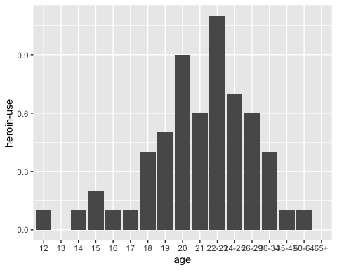

#Graph 2 - Scatter Plor Graph  
ggplot(data = drug_use) + geom_point(mapping = aes(x = `age`, y = `heroin-use`)) + geom_smooth(mapping = aes(x = `age`, y = `heroin-use`))

## `geom_smooth()` using method = 'loess' and formula 'y ~ x'

