**Database Design**

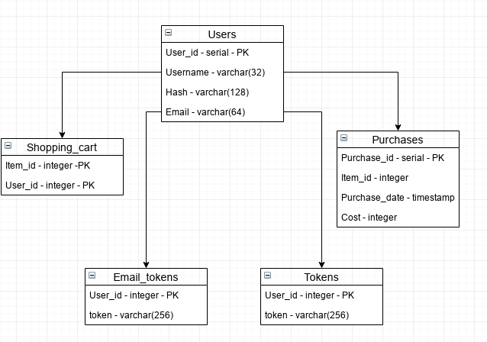

The database was designed to have a user table that provided the link between the other tables. There is no table for individual items as we are using an external API to get the movies for our application. The separation between email_tokens and the regular tokens table is that email tokens are one time use tokens used in the email password reset loop, and the tokens table contains all actively logged in users, and their auth token.

The database is only accessed via the Node.JS server API we are running on Heroku. An admin can still log onto the database manually through tools such as PGAdmin but general use is through AP. To ensure that non-users cannot access data/pages they shouldn't be able to, most endpoints require a token be provided, these tokens are strongly tied to individual users.