classify & Sample Meadows for Sourcewater Study

Ryan Peek

April 18, 2016

## Objective

* **Determine sourcewater relationship with HGM type and NDVI-NDWI**
* **Create/frame metrics that are quantifiable and stand alone**
* **Tie this to prioritization for restoration**
* Vulnerable vs. Resilient
* **VULNERABLE**: Incision, land use, climate
* **RESILIENT**: Sourcewater, more groundwater driven is more resilient, more surfacewater is less resilient

## Steps

* Pick 20-25 Meadows
* Conduct on the ground/remote HGM typing to get overall HGM proportions for meadows
* WQ sampling: minimum of 2 WQ sample times per meadow, (early summer/fall)
* Multilevel-bayesian mixed modeling

### Classification/Selection

Classify 120 by these factors and randomly pick from these, minimum of X for each type?

* HGM type (3 of each type, 7 types, exclude DRY)
* Elevation (>2000-2100: Snowline, or treeline)

Randomly select from these 14 bins, if holes talk with Dave and add meadows. NFWF meadows to this? Van Norden as well. Might need fewer meadows from Dave's set if we can fill bins with NFWF/Van Norden

* Latitude (Modoc/Lassen, Plumas/Tahoe/ED, Southern Central Sierra (Stan/Seq/Sierra/Inyo))

### Classifying & Binning Meadows

So first, a quick overview of the data. Across the **8** **HGM Source Types**, several types only have 2 meadows (type 6 and 8). Furthermore, those all fall into the same elevation bin (nothing above 2000 m in class 7 and 8). See below. If we want to select 3 per type, we'd need more meadows just to meet the minimum, and that would require selecting all available regardless.

|  |  |  |  |
| --- | --- | --- | --- |
| source_type | n() | mean(ELEV_MEAN) | max(ELEV_MEAN) |
| 1 | 4 | 2072.332 | 2682.74 |
| 2 | 8 | 1944.582 | 3136.71 |
| 3 | 14 | 1764.786 | 2633.97 |
| 4 | 32 | 2343.441 | 3059.42 |
| 5 | 47 | 2115.461 | 3055.97 |
| 6 | 2 | 2582.835 | 2659.28 |
| 7 | 5 | 1719.426 | 1921.14 |
| 8 | 2 | 1698.940 | 1698.94 |

It may make more sense to pick 2 per class/hgm type. If we drop HGM source_type 8 *(Dry)*, and combine classes 6 and 7, that leaves at least 2 meadows of each type and elevation class within each bin.

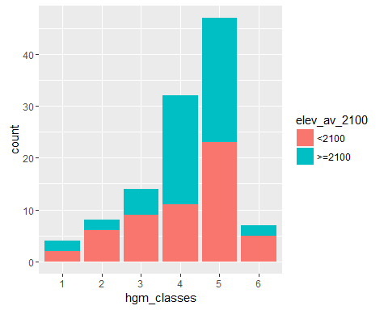

Assuming we select 2 meadows per bin to start, the easiest approach to randomly sample (from an already small sample), is to use the *sample* function in R, after grouping by *hgm class* & *elevation*.

|  |  |  |  |  |  |  |  |  |  |  |  |  |  |
| --- | --- | --- | --- | --- | --- | --- | --- | --- | --- | --- | --- | --- | --- |
| PLOT | METHOD | UCDavisObject_ID | elev | ELEV_MEAN | source_type | PLOTNAME2 | AREA_ACRE | HUC12 | LAT_DD | LONG_DD | Shape_Area | hgm_classes | elev_av_2100 |
| LAS0102 | frequency | UCDSNM016577 | 1640 | 1640.25 | 1 | LAS0102 -Big Jacks | 48.669765 | 180200030104 | 40.79434 | -120.9871 | 196960.340 | 1 | <2100 |
| LAS0119 | frequency | UCDSNM016562 | 1796 | 1796.03 | 1 | LAS0119 -Bear Valle Res. | 119.297481 | 180200030106 | 40.77553 | -121.1186 | 482781.709 | 1 | <2100 |
| STA0108 | frequency | UCDSNM011455 | 2685 | 2682.74 | 1 | STA0108 -Upper Relief Valley | 78.006463 | 180400100201 | 38.22224 | -119.7781 | 315682.218 | 1 | >=2100 |
| ELD0101 | frequency | UCDSNM012349 | 2170 | 2170.31 | 1 | ELD0101 -ONION VALLEY | 1.615009 | 180400120401 | 38.56506 | -120.1884 | 6535.737 | 1 | >=2100 |
| ELD0109 | frequency | UCDSNM012729 | 2044 | 2044.76 | 2 | ELD0109 -Shaw Flat | 4.341858 | 180201290103 | 38.65343 | -120.1904 | 17570.946 | 2 | <2100 |
| MOD0108 | cross section | UCDSNM016987 | 1417 | 1383.73 | 2 | MOD0108 -Boles Creek | 59.927791 | 180102040302 | 41.79951 | -121.0610 | 242520.137 | 2 | <2100 |
| TAH0123 | frequency | UCDSNM014209 | 2193 | 2222.11 | 2 | TAH0123 -BARKER MEADOW WEST | 7.353243 | 180201280203 | 39.05906 | -120.2492 | 29757.637 | 2 | >=2100 |
| INY0105 | frequency | UCDSNM005339 | 1607 | 3136.71 | 2 | INY0105 -UPPER BAKER | 61.008311 | 180901020708 | 37.16537 | -118.4780 | 246892.863 | 2 | >=2100 |
| ELD0104 | frequency | UCDSNM012306 | 1224 | 1224.98 | 3 | ELD0104 -BARNEY MEADOW | 3.704709 | 180400130403 | 38.55064 | -120.4627 | 14992.488 | 3 | <2100 |
| STA0104 | frequency | UCDSNM009725 | 1251 | 1242.27 | 3 | STA0104 -Indian Springs | 2.992495 | 180400090804 | 37.91545 | -120.0864 | 12110.245 | 3 | <2100 |
| STA0102 | frequency | UCDSNM011600 | 2389 | 2390.37 | 3 | STA0102 -KENNEDY LAKE | 206.489844 | 180400100202 | 38.26737 | -119.6663 | 835638.094 | 3 | >=2100 |
| STA0109 | frequency | UCDSNM011447 | 2630 | 2633.97 | 3 | STA0109 -Hay Meadow | 49.828319 | 180400100501 | 38.22312 | -119.8194 | 201648.858 | 3 | >=2100 |
| STA0111 | frequency | UCDSNM010679 | 1544 | 1549.44 | 4 | STA0111 -Sam Williams Spring | 2.623840 | 180400090901 | 38.08778 | -120.1036 | 10618.346 | 4 | <2100 |
| TAH0107 | greenline | UCDSNM014966 | 1512 | 1510.14 | 4 | TAH0107 -CARMEN VALLEY | 247.163951 | 180201230307 | 39.69690 | -120.4458 | 1000241.024 | 4 | <2100 |
| INY0102 | greenline | UCDSNM005877 | 2912 | 2911.63 | 4 | INY0102 -Coyote Cr West fork | 33.064568 | 180901020603 | 37.23991 | -118.4924 | 133808.094 | 4 | >=2100 |
| INY0131 | frequency | UCDSNM001115 | 3044 | 3044.22 | 4 | INY0131 -ROUND | 694.361214 | 180901030404 | 36.44410 | -118.1825 | 2809991.379 | 4 | >=2100 |
| LAS0108 | frequency | UCDSNM016618 | 1541 | 1541.30 | 5 | LAS0108 -Beaver Creek | 27.892184 | 180200030201 | 40.82496 | -121.2391 | 112876.115 | 5 | <2100 |
| PLU0110 | greenline | UCDSNM015480 | 1719 | 1724.12 | 5 | PLU0110 -Willow Creek II | 24.225694 | 180201220204 | 40.11149 | -120.3917 | 98038.298 | 5 | <2100 |
| SEQ0106 | greenline | UCDSNM000218 | 2361 | 2360.51 | 5 | SEQ0106 -Fish Creek | 218.921505 | 180300020203 | 36.07745 | -118.2441 | 885947.441 | 5 | >=2100 |
| INY0113 | frequency | UCDSNM000426 | 2405 | 2405.08 | 5 | INY0113 -Bakeoven Meadow | 4610.374391 | 180300020104 | 36.18739 | -118.1697 | 18657597.846 | 5 | >=2100 |
| ELD0107 | frequency | UCDSNM012847 | 1844 | 1844.05 | 7 | ELD0107 -JAKE SCHNEIDER MDW | 12.357351 | 180201290101 | 38.70297 | -120.1685 | 50008.627 | 6 | <2100 |
| LAS0114 | frequency | UCDSNM015786 | 1654 | 1654.27 | 7 | LAS0114 -Rice Creek Meadow | 67.942661 | 180201210102 | 40.35817 | -121.4573 | 274955.293 | 6 | <2100 |
| LTB0102 | frequency | UCDSNM012985 | 3141 | 2659.28 | 6 | LTB0102 -UPPER ANTONE | 5.910841 | 160501010301 | 38.74825 | -119.9900 | 23920.422 | 6 | >=2100 |
| LTB0103 | frequency | UCDSNM013064 | 2886 | 2506.39 | 6 | LTB0103 -ANTONE | 30.095128 | 160501010301 | 38.76029 | -119.9930 | 121791.149 | 6 | >=2100 |
| PLU0106 | frequency | UCDSNM015446 | 1710 | 1698.94 | 8 | PLU0106 -Poison Creek meadow | 9.081091 | 180201220206 | 40.09378 | -120.5247 | 36750.019 | NA | <2100 |
| PLU0107 | greenline | UCDSNM015446 | 1710 | 1698.94 | 8 | PLU0107 -Poison Creek | 9.081091 | 180201220206 | 40.09378 | -120.5247 | 36750.019 | NA | <2100 |

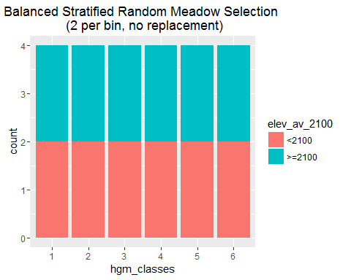

Haven't dealt with selecting across latitude yet, but I'll get a map into this sometime soon.