STAT200 – Elementary Statistics
Instructor: Larry Musolino, Email: lsm7@psu.edu

PLEASE READ THIS DOCUMENT CAREFULLY!

STAT200 Midterm Exam Info:

- STAT200 Midterm Exam will be taken on Weds July 27 at 1:00pm
At that time you will use your SMARTPHONE to login to this ZOOM Link:
Join URL: https://psu.zoom.us/j/91226124919

- This Exam will be taken within MyMathLab but in a proctored format (see below)
- Midterm Exam will cover material from Chapters 1 through 5.
- Midterm exam consists of 20 problems and you will have 2.5 hours to complete - note that problems on Midterm Exam will be similar to those from the MyMathLab HW assignments and MyMathLab Tests.
- For the midterm exam you will submit all questions at once when you are completed with the exam (you will not submit questions individually).
- To review past HWs or Tests in MyMathLab, click on GRADEBOOK in left hand menu in MyMathLab then click on REVIEW button for each assignment you want to review
- Midterm exam is Closed book and Closed Notes, use of Calculator OK.
- You will have access to StatCrunch for the Midterm Exam
- You can use copies of the Chapter Summaries from Chapter 1 to Chapter 5 for use as a reference while taking the Midterm Exam. In CANVAS, go to MODULES then go to MIDTERM EXAM INFO then download the file called “STAT200_Reference_Info_Midterm_Exam”. This file is a collection of the chapter summaries from Chapters 1 to 5. You can print out a copy of these sheets to use during the midterm, or you can bring this file up on your computer screen during the midterm exam.
- A practice Midterm test with solutions is posted in CANVAS for your review. Go to CANVAS then MODULES then Midterm Exam Info.
- Here is how PROCTORING will work for the MIDTERM EXAM:
On July 28 at 1:00pm you will use your SMARTPHONE to login to a ZOOM Meeting room as follows: Join URL: https://psu.zoom.us/j/91226124919

  - You can download a ZOOM app for your smartphone if you would like (this is optional).
  - You will enable video on your smartphone.
  - You will show a picture ID at the beginning of the meeting so the instructor can verify it is actually the student taking the midterm exam. Please have picture ID available.
  - Then, you will point your smartphone camera at your desktop and computer screen as shown in the image below and leave your smartphone in this position throughout the midterm exam testing process :
  - 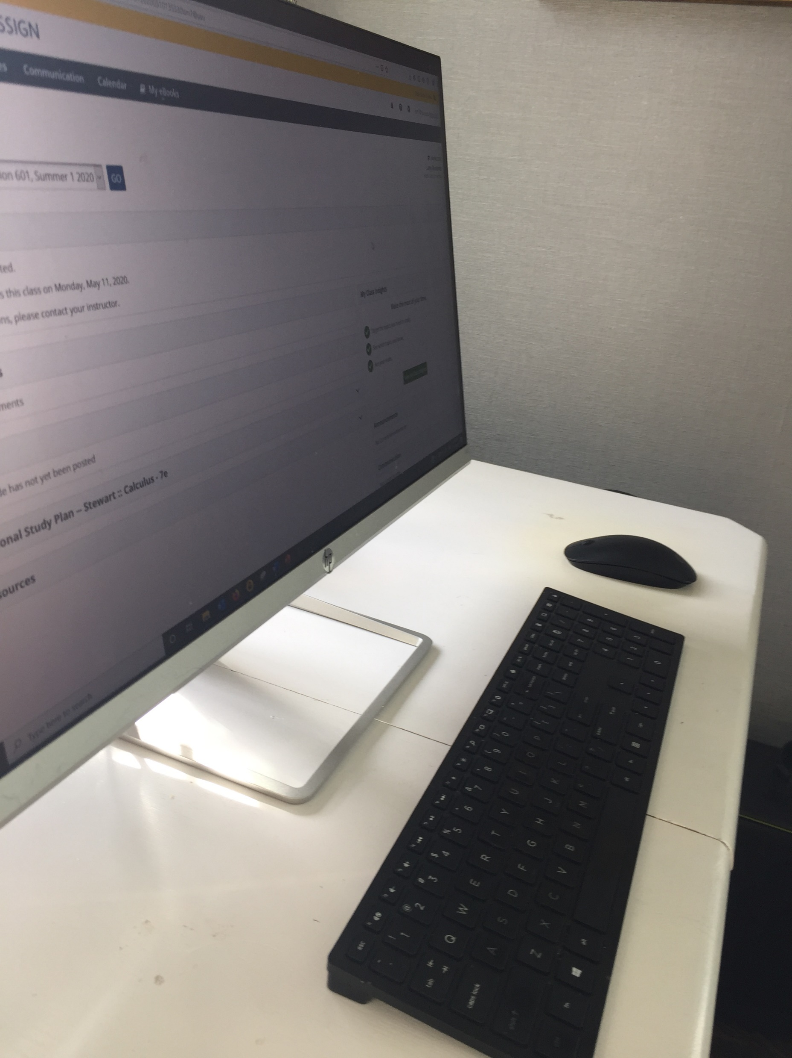
During the exam, point your smartphone camera at your desktop and computer screen as shown in this picture
  - Then you will use your laptop/desktop to access MyMathLab and click on the link for the Midterm exam
  - The Midterm exam is password protected and your instructor will provide you with the password at the beginning of the ZOOM meeting.
  - You will then complete the Midterm Exam within MyMathLab while your smartphone camera is pointed at your desktop/computer screen
  - Once you complete the Midterm Exam, you will submit the Exam within MyMathLab and then log out of the ZOOM meeting
  - Do not bring up any other websites on your computer except MyMathLab and StatCrunch while taking the Midterm exam (MyMathLab monitors your IP address and will alert the instructor if you navigate to another website)
  - Do not get any outside help from anyone else while taking the exam
  - During the midterm exam, you can use scrap paper. You can use calculator. You can use StatCrunch. You can use Chapter summaries
  - Please, have the charger for your phone and the charger for your laptop available !!

Key Concepts from STAT200 which will covered on Midterm Exam:
Concept | Section In Text
Determine if data is qualitative or quantitative | 1.2
Using a random number table to select random samples from population | 1.3
Construct a Frequency Distribution Table | 2.1
Finding sample mean, median and standard deviation from dataset (using StatCrunch) | 2.3, 2.4
Finding a weighted mean | 2.3
Finding quartiles Q1, Q2 and Q3, and Interquartile Range (IQR) for dataset | 2.5
Determining if there are outliers in dataset using lower threshold of Q1 – 1.5(IQR) and upper threshold of Q3 + 1.5(IQR) | 2.5
Finding and interpreting z-scores | 2.5
Using the Fundamental Counting Principle | 3.1
Multiplication Rule for Probability, P(A and B) | 3.2
Addition Rule for Probability, P(A or B) | 3.3
Determine if random variable is continuous or discrete, discrete probability distr | 4.1
Finding Binomial probabilities | 4.2
Finding Poisson probabilities | 4.3
Finding Probabilities for Standard Normal Distribution | 5.1
Finding Probabilities for Normal Distribution | 5.2
Finding z-scores and x-values given a Probability | 5.3
Sampling Distributions and the Central Limit Theorem | 5.4

