CMPEN 331 Lab 4
Shi Qiu

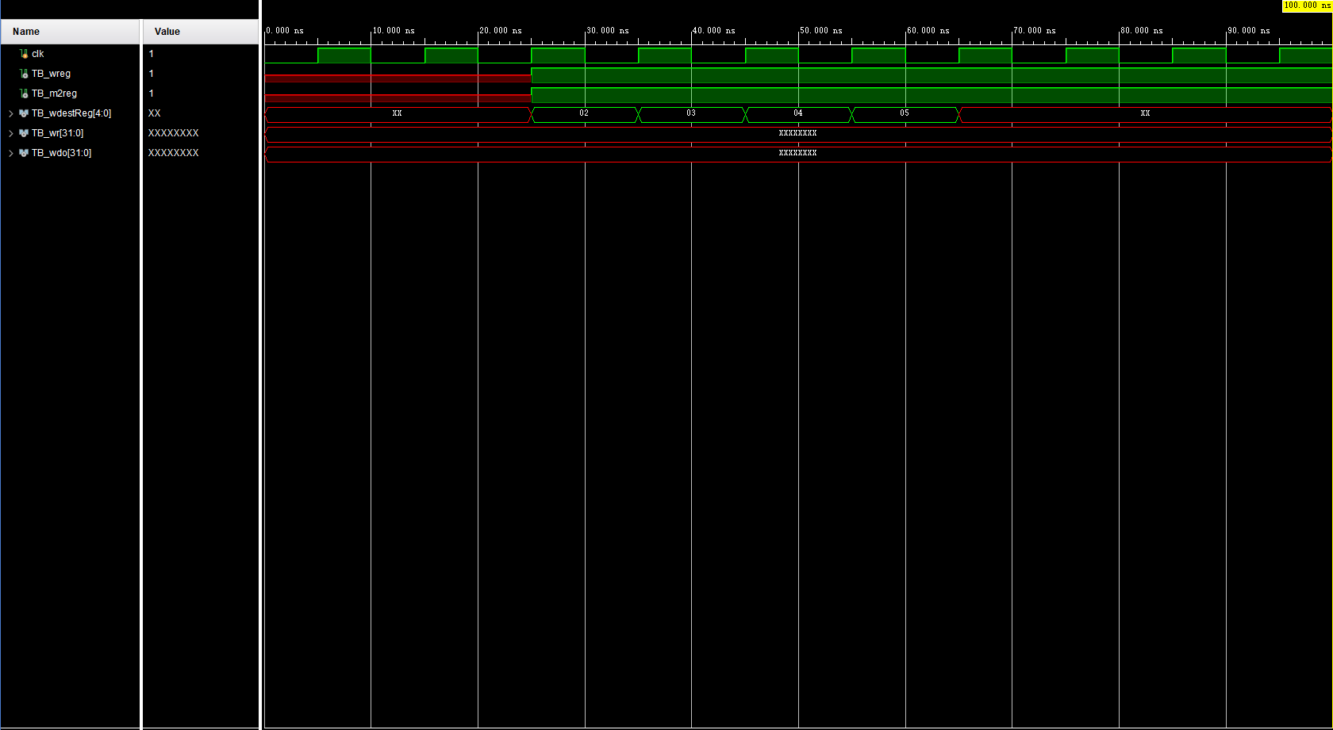

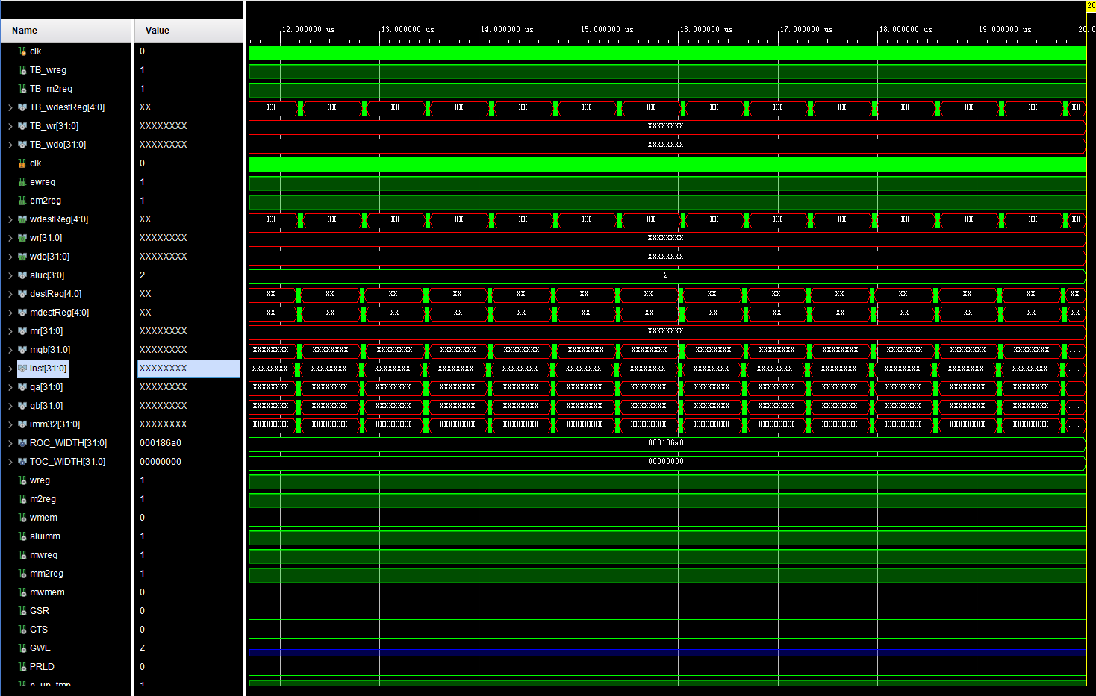
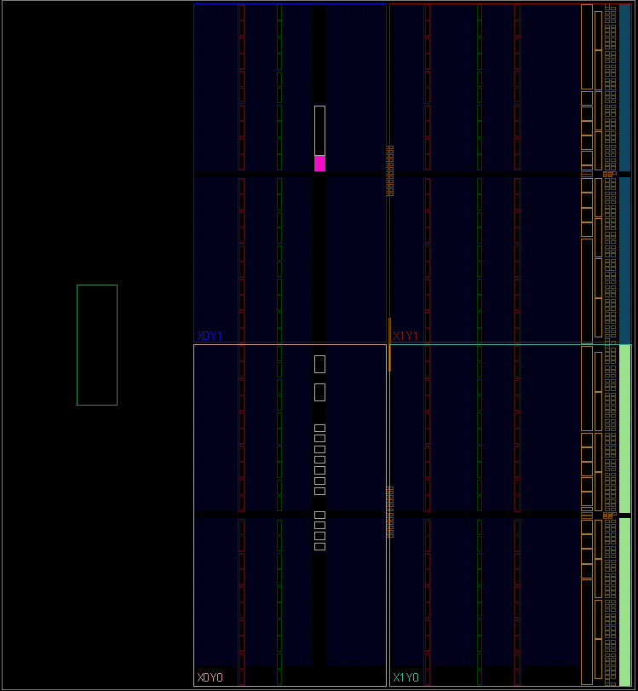

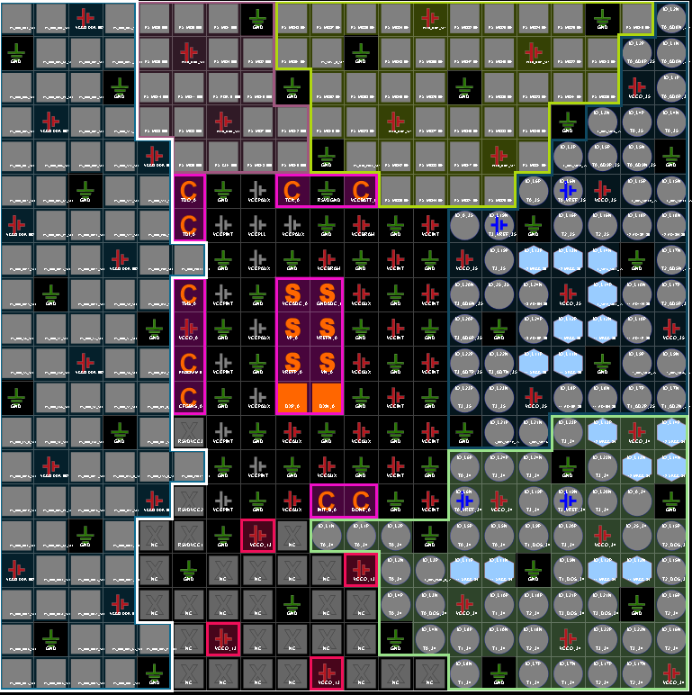
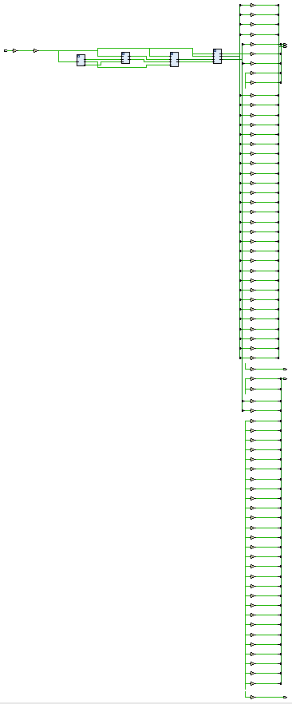

`timescale 1ns / 1ps
//////////////////////////////////////////////////////////////////////////////////
// Company:
// Engineer:
//
// Create I_Outte: 2022/04/10 13:18:23
// Design Name:
// Module Name:
// Project Name:
// Target Devices:
// Tool Versions:
// Description:
//
// Dependencies:
//
// Revision:
// Revision 0.01 - File Created
// Additional Comments:
//
//////////////////////////////////////////////////////////////////////////////////

module DataPath( //to all
input clk,
output ewreg,
output em2reg,
output [4:0] wdestReg,
output [31:0] wr,
output [31:0] wdo
);

wire [3:0] aluc;
wire [4:0] destReg;
wire [4:0] mdestReg;
wire [31:0] mr, mqb;
wire [31:0] inst;
wire [31:0] qa;
wire [31:0] qb;
wire [31:0] imm32;
wire wreg;
wire m2reg;
wire wmem;
wire aluimm;
wire mwreg;
wire mm2reg;
wire mwmem;

InstFetch if1(clk, inst);
InstDecode id(inst, clk, wreg, m2reg, wmem, aluc, aluimm, destReg, qa, qb, imm32);
Exe ex(wreg, m2reg, wmem, aluc, aluimm, destReg, qa, qb, imm32, clk, mwreg, mm2reg, mwmem, mdestReg, mr, mqb);
Mem me(mwreg, mm2reg, mwmem, mdestReg, mr, mqb, clk, ewreg, em2reg, wdestReg, wr, wdo);

Endmodule

`timescale 1ns / 1ps
//////////////////////////////////////////////////////////////////////////////////
// Company:
// Engineer:
//
// Create I_Outte: 2022/04/10 13:18:23
// Design Name:
// Module Name:
// Project Name:
// Target Devices:
// Tool Versions:
// Description:
//
// Dependencies:
//
// Revision:
// Revision 0.01 - File Created
// Additional Comments:
//
//////////////////////////////////////////////////////////////////////////////////

module TestBench();//迷茫

reg clk;

wire TB_wreg;
wire TB_m2reg;
wire [4:0] TB_wdestReg;
wire [31:0] TB_wr;
wire [31:0] TB_wdo;

DataPath dp (clk, TB_wreg, TB_m2reg, TB_wdestReg, TB_wr, TB_wdo);

initial begin
clk = 0;

#100 $finish;
end

always begin
#5;
clk = ~clk;
end

endmodule

`timescale 1ns/1ps
//////////////////////////////////////////////////////////////////////////////////
// Company:
// Engineer:
//
// Create I_Outte: 2022/04/10 13:18:23
// Design Name:
// Module Name:
// Project Name:
// Target Devices:
// Tool Versions:
// Description:
//
// Dependencies:
//
// Revision:
// Revision 0.01 - File Created
// Additional Comments:
//
//////////////////////////////////////////////////////////////////////////////////

module pc(
input [31:0] nextPC ,
input clk,
output reg [31:0] pc
); initial pc = 100;
always @(posedge clk) begin
pc <= nextPC;
end
endmodule

module instMem(
input [31:0] pc,

output reg [31:0] I_Out
);

reg [31:0] mem [0:63];

initial begin
mem[25] = {
6'b100011,
5'b00001,
5'b00010,
5'b00000,
5'b00000,
6'b000000
};
mem[26] = {
6'b100011,
5'b00001,
5'b00011,
5'b00000,
5'b00000,
6'b000100
};
mem[27] = {
6'b100011,
5'b00001,
5'b00100,
5'b00000,
5'b00000,
6'b001000
};
mem[28] = {
6'b100011,
5'b00001,
5'b00101,
5'b00000,
5'b00000,
6'b001100
};
end

always @ (*) begin
I_Out <= mem[pc[7:2]];
end
endmodule

module pcAdder(//next
input [31:0] pc,
output reg [31:0] nextPC
);
always @ (*) begin
nextPC <= pc + 4;
end
endmodule

module IFIDreg(
input [31:0] I_Out,
input clk,

output reg [31:0] dI_Out,
output reg [5:0] op,
output reg [5:0] func,
output reg [4:0] rd,
output reg [4:0] rt,
output reg [4:0] rs,
output reg [15:0] imm
);

always @ (*) begin
dI_Out <= I_Out;
op = I_Out[31:26];
func = I_Out[5:0];
rd = I_Out[15:11];
rt = I_Out[20:16];
rs = I_Out[25:21];
imm = I_Out[15:0];
end
endmodule

module InstFetch(
input clk,
output [31:0] dI_Out
);

wire [31:0] wpc;
wire [31:0] wnextPC;
wire [31:0] wI_Out;

pc pc1(wnextPC, clk, wpc);
pcAdder pcadd(wpc, wnextPC);
instMem inmem(wpc, wI_Out);
IFIDreg IFID(wI_Out, clk, dI_Out);

endmodule

module Control(
input [5:0] op,
input [5:0] func,

output reg wreg,
output reg m2reg,
output reg wmem,
output reg [3:0] aluc,
output reg aluImm,
output reg regrt
);

always @(*) begin
case (op)
6'b000000: //r-type
begin
case (func)
6'b100000: //Add
begin
wreg <= 1;
m2reg <= 0;
wmem <= 0;
aluc <= 4'b0010;
aluImm <= 0;
regrt <= 0;
end

endcase
end
6'b100011:
begin
wreg <= 1;
m2reg <= 1;
wmem <= 0;
aluc <= 4'b0010;
aluImm <= 1;
regrt <= 1;
end
endcase
end

endmodule

module regRTMux(
input [4:0] rt,
input [4:0] rd,
input regrt,
output reg [4:0] destReg
);

always @ (*) begin
if (~regrt) destReg <= rd;
else if (regrt) destReg <= rt;
end
endmodule

module regFile(
input [4:0] rs,
input [4:0] rt,

output reg [31:0] qa,
output reg [31:0] qb
);

reg [31:0] registers [0:31];

initial
begin
registers[0] = 32'd0;
registers[1] = 32'd0;
registers[2] = 32'd0;
registers[3] = 32'd0;
registers[4] = 32'd0;
registers[5] = 32'd0;
registers[6] = 32'd0;
registers[7] = 32'd0;
registers[8] = 32'd0;
registers[9] = 32'd0;
registers[10] = 32'd0;
registers[11] = 32'd0;
registers[12] = 32'd0;
registers[13] = 32'd0;
registers[14] = 32'd0;
registers[15] = 32'd0;
registers[16] = 32'd0;
registers[17] = 32'd0;
registers[18] = 32'd0;
registers[19] = 32'd0;
registers[20] = 32'd0;
registers[21] = 32'd0;
registers[22] = 32'd0;
registers[23] = 32'd0;
registers[24] = 32'd0;
registers[25] = 32'd0;
registers[26] = 32'd0;
registers[27] = 32'd0;
registers[28] = 32'd0;
registers[29] = 32'd0;
registers[30] = 32'd0;
registers[31] = 32'd0;

end

always @ (*) begin
qa = registers[rs];
qb = registers[rt];
end
endmodule

module ImmExt(
input [15:0] imm,

output reg [31:0] imm32
);

always @ (*) begin
imm32 <= {{17{imm[15]}}, imm[14:0]};
end
endmodule

module IDEXEreg(
input wreg,
input m2reg,
input wmem,
input [3:0] aluc,
input aluimm,
input [4:0] destReg,
input [31:0] qa,
input [31:0] qb,
input [31:0] imm32,
input clk,

output reg owreg,
output reg om2reg,
output reg owmem,
output reg [3:0] oaluc,
output reg oaluimm,
output reg [4:0] odestReg,
output reg [31:0] oqa,
output reg [31:0] oqb,
output reg [31:0] oimm32
);

always @ (posedge clk) begin
owreg <= wreg;
om2reg <= m2reg;
owmem <= wmem;
oaluc <= aluc;
oaluimm <= aluimm;
odestReg <= destReg;
oqa <= qa;
oqb <= qb;
oimm32 <= imm32;
end
endmodule

module InstDecode(
input [31:0] dinstOut,
input clk,

output owreg,
output om2reg,
output owmem,
output [3:0] oaluc,
output oaluimm,
output [4:0] odestReg,
output [31:0] oqa,
output [31:0] oqb,
output [31:0] oimm32
);

wire wwreg;
wire wm2reg;
wire wwmem;
wire [3:0] waluc;
wire waluimm;
wire [4:0] wdestReg;
wire [31:0] wqa;
wire [31:0] wqb;
wire [31:0] wimm32;

wire wrtMUX;

Control c(dinstOut[31:26], dinstOut[5:0], wwreg, wm2reg, wwmem, waluc, waluimm, wrtMUX);
regRTMux rtMux(dinstOut[20:16], dinstOut[15:11], wrtMUX, wdestReg);
regFile rf(dinstOut[25:21], dinstOut[20:16], wqa, wqb);
ImmExt extend(dinstOut[15:0], wimm32);
IDEXEreg idexe1(wwreg, wm2reg, wwmem, waluc, waluimm, wdestReg, wqa, wqb, wimm32, clk, owreg, om2reg, owmem, oaluc, oaluimm, odestReg, oqa, oqb, oimm32);

Endmodule

`timescale 1ns / 1ps
//////////////////////////////////////////////////////////////////////////////////
// Company:
// Engineer:
//
// Create I_Outte: 2022/04/10 13:18:23
// Design Name:
// Module Name:
// Project Name:
// Target Devices:
// Tool Versions:
// Description:
//
// Dependencies:
//
// Revision:
// Revision 0.01 - File Created
// Additional Comments:
//
//////////////////////////////////////////////////////////////////////////////////

module Main_Mem(
input [31:0] mr,
input [31:0] mqb,
input mwmem,
input clk,

output reg [31:0] mdo
);

reg [31:0] mem [0:63];

initial begin
mem[0] = 32'h00000000;
mem[1] = 32'h10000011;
mem[2] = 32'h20000022;
mem[3] = 32'h30000033;
mem[4] = 32'h40000044;
mem[5] = 32'h50000055;
mem[6] = 32'h60000066;
mem[7] = 32'h70000077;
mem[8] = 32'h80000088;
mem[9] = 32'h90000099;
end
always @ (*) begin
mdo <= mem[mr[7:2]];
end
always @ (negedge clk) begin
if (mwmem) begin
mem[mr[7:2]] <= mqb;
end
end
endmodule

module memwb(
input mwreg,
input mm2reg,
input [4:0] mdestReg,
input [31:0] mr,
input [31:0] mdo,
input clk,

output reg wwreg,
output reg wm2reg,
output reg [4:0] wdestReg,
output reg [31:0] wr,
output reg [31:0] wdo
);

always @ (posedge clk) begin
wwreg <= mwreg;
wm2reg <= mm2reg;
wdestReg <= mdestReg;
wr <= mr;
wdo <= mdo;
end
endmodule

module Mem(
input mwreg,
input mm2reg,
input mwmem,
input [4:0] mdestReg,
input [31:0] mr,
input [31:0] mqb,
input clk,

output wwreg,
output wm2reg,
output [4:0] wdestReg,
output [31:0] wr,
output [31:0] wdo
);

wire [31:0] doWire;

Main_Mem m(mr, mqb, mwmem, clk, doWire);
memwb mw(mwreg, mm2reg, mdestReg, mr, doWire, clk, wwreg, wm2reg, wdestReg, wr, wdo);

endmodule

