姓名:朱家顺 学号:55210425

1
% 一阶微分方程的解和积分曲线
% y'= y/x + sec(y/x)
clear,clc,close all
syms y(x)
dsolve(diff(y)==y/x+sec(y/x)); %先求通解
x=2:0.01:10;
for C=-5:0.5:-1
y=x.*asin(C+log(x)); %带入通解
plot(x,y)
%plot(x,abs(y)) 九条曲线
hold on
end

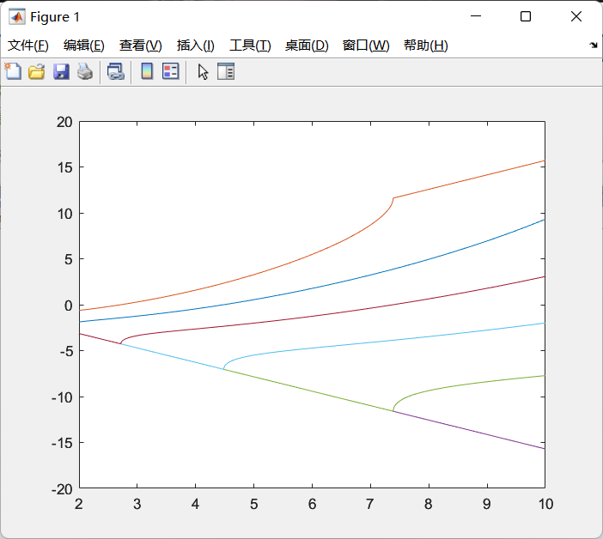

2
% 二阶微分方程的解和积分曲线
% y''-2y'-3y=0
clear,clc,close all
syms y(x)
dsolve(diff(2,y)-2*diff(y)-3*y==0); %求通解
x = -5:0.01:5;
for C1 = -5:1:5
for C2 = -6:2:6
y = C1*exp(-x)+C2*exp(3*x); %带入通解
plot(x,y)
axis([-5 5 -1000 1000])
hold on
end
end

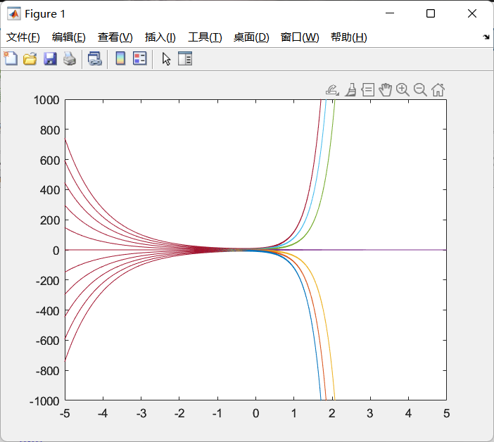

3
% 微分方程数值解法
% 先求解析解
% s= dsolve('Dy = -y+t+1','y(0)=1','t')
syms y(t)
eqn = diff(y)==-y+t+1;
cond = y(0)==1;
ySol(t) = dsolve(eqn,cond)
t = 0:0.1:1;
y = t +exp(-t); %求出来的解析解
plot(t,y);
hold on;
[t,y]=ode45('fun1',[0,1],1); % 求出来的数值解

plot(t,y,'ro');
xlabel('t')
ylabel('y')

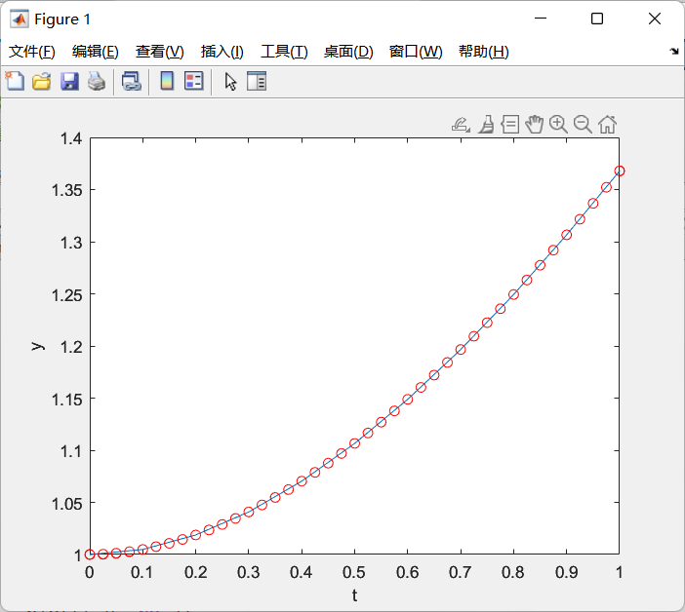
4
% 第一型曲面积分计算
clear,clc,close all
[x,y,z] = sphere(200);
i = find(x.^2+y.^2-x>=0);
z(i) = NaN;
mesh(x,y,z)
hold on
fimplicit(@(x,y) x.^2+y.^2-x)
title('')
syms x y r t
z = sqrt(1-x.^2-y.^2);
dzx = diff(z,x);
dzy = diff(z,y);
sxy = sqrt(1-x.^2-y.^2)*sqrt(1+dzx.^2+dzy.^2);
u = r*cos(t);
v = r*sin(t);
%subs(sxy,[x y],[u v])
int(int(subs(sxy,[x y],[u v])*r,r,0,cos(t)),t,-pi/2,pi/2)
int(int(subs(sxy,[x y],[u v])*r,r,0,1),t,0,pi*2)
%手动解方程
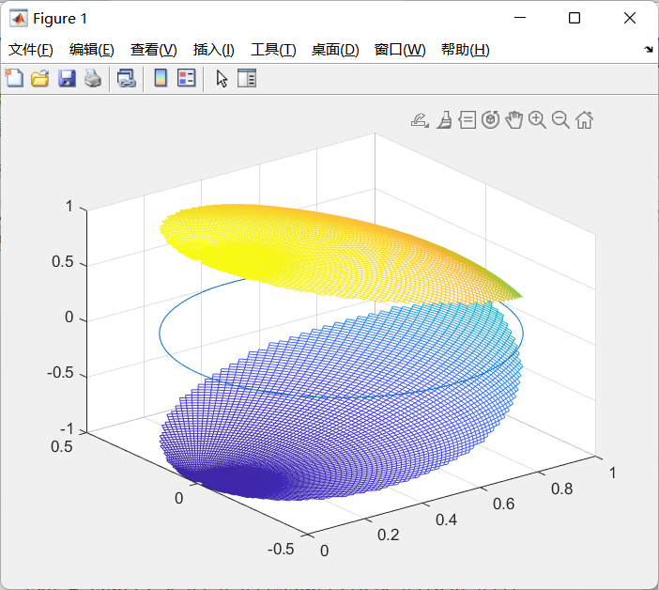
5
% 第二型曲面积分计算
clear,clc,close all
syms x y z t u v a
p = x*z.^2;
q = x.^2*y-z*3;
r = 2*x*y+y.^2*z;
dpx = diff(p,x);
dpy = diff(q,y);
drz = diff(r,z);
f = dpx+dpy+drz;
m = t*sin(u)*cos(v);
n = t*sin(u)*sin(v);
l = t*cos(u);
g = subs(f,[x y z],[m n l]);
int(int(int(g*t.^2*sin(u),u,0,pi/2),v,0,2*pi),t,0,a)

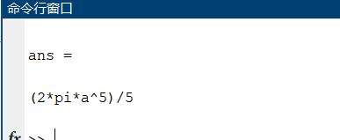

6
% 函数幂级数展开
clear,clc,close all
syms x
fl = sqrt(x.^3);
ty = taylor(fl,x,1,'Order',6)

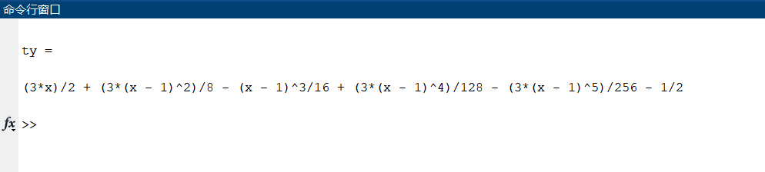

7
% 级数的和函数
clear,clc,close all
syms x n
f = x.^(2*n)/factorial(2*n);
s = symsum(f,n,1,Inf);
s1 = simplify(s,'IgnoreAnalyticConstraints',true)
s2 = simplify(s,'IgnoreAnalyticConstraints',false)
