# Reference

1.Downs, A. (1992) Stuck in traffic: coping with peak-hour traffic congestion, Washington, D.C.: The Brookings Institution.

2.Downs, A. (2004) Still stuck in traffic: coping with peak-hour traffic congestion, Washington, D.C.: The Brookings Institution.

3.Litman, T. (2004) Congestion costs, Transportation cost and benefit Analysis; techniques, estimates and implications, Victoria, British Columbia: Victoria Transport Policy Institute.

4.Lomax, T., Turner, S., Shunk, G., Levinson, H.S., Pratt, R.H., Bay, P.N. and Douglas, G.B. (1997) Quantifying congestion, volume 1 & 2, NCHRP Report 398, Washington, DC: Transportation Research Board.

5.Rothenberg, M.J. (1985) Urban congestion in the United States-what does the future hold, ITE Journal, 55(7), 22-39.

6.M Aftabuzzaman. (2007) Measuring Traffic Congestion- a Critical Review, institute of Transport Studies, Monash University, Melbourne, Victoria, Australia

# An abstract node graph of Subiaco in different levels

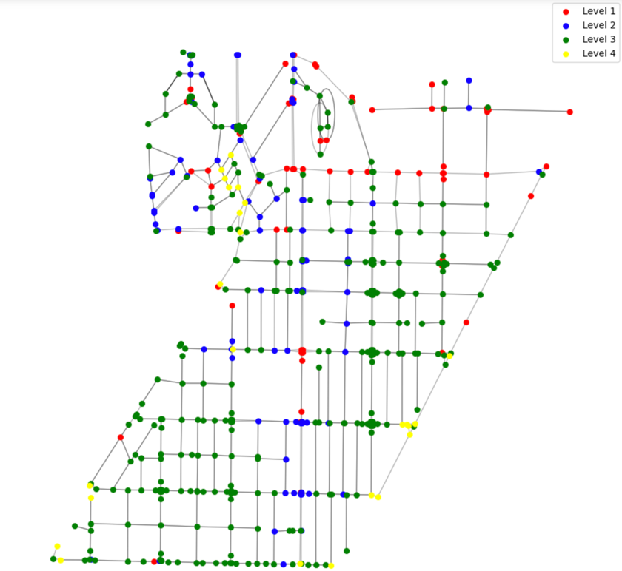

# Vehicles density map changing in different time step

We can easily see that during the changing in different time step, there will be a couple of grids in the completely same longitude (like a straight line) becoming darker. This straight line is Rokeby Road, and most of vehicles need to pass through the Rokeby Road in Subiaco, which force the grids to become darker.

