**1、Background**

**A. Problem statement**

As the capital of Western Australia, Perth has experienced a rapid population growth in these four years after Covid-19, leading to a period of urban management challenges, among which traffic congestion stands out as a particularly prominent issue. This problem not only adversely affects the daily commuting convenience of citizens but also poses significant hindrances to socio-economic development. Especially across varying time frames—such as peak time and normal time—the congestion issue manifests complex characteristics due to different travel purposes and traffic patterns. Therefore, this study aims to construct a traffic network model for one of suburbs in Perth, the Subiaco, focusing on simulating the daily traffic situation under different time periods.

**B. importance Discussion**

Traffic congestion is a major urban transportation problem (Downs, 1992; Litman, 2004). Different researchers have provided alternative definitions of traffic congestion. There is no universally accepted definition of traffic congestion (Downs, 2004). Many measures have been developed to represent the magnitude of traffic congestion on roadways in urban areas. But there is a debate about what is the most appropriate measure of traffic congestion (Lomax et al, 1997).

While there are many definitions in traffic congestion, we consider traffic congestion in this study is a condition in which the number of vehicles attempting to use a roadway at any time exceeds the ability of the roadway to carry the load at generally acceptable service levels (Rothenberg, 1985) and the speed of vehicles which make influence to each other.

This study focuses on the Subiaco district in Perth as a case example. Through detailed simulation and analysis of various traffic flow scenarios, the research aims to offer actionable insights and solutions that could significantly improve the current state of traffic in Perth. These insights and solutions may also provide valuable references for other rapidly growing cities facing similar traffic challenges.

**C. Overview**

In this study, a model based on geographic information and traffic flow was used to simulate and analyze traffic conditions in the Subiaco area. A detailed overview of the model is given below:

**a. Data loading and processing**

We Use the ‘networkx’ tool to load geographic data for the Subiaco area, which included intersections, roads, and other key locations. This data provided us with a basis for a real-world transportation network. To more accurately model traffic flow, we categorized each node into four classes based on its expected traffic volume. This helps us differentiate between areas with different traffic densities to more accurately simulate traffic flow during peak and off-peak hours.

**b. Construction of Traffic Flow Model**

The Class of ‘traffic_flow_map’ is the core of our model and is responsible for simulating traffic flow throughout the Subiaco region. This class can simulate different traffic flow patterns based on different time step and date, such as weekday morning and evening peaks and normal time.

For the Vehicle Class, we simulate the behaviour of each vehicle on the road. This class considers the vehicle's speed, direction, destination, and interaction with transportation devices.

The Class of ‘Traffic_light’ simulates how traffic signals work, including the timing of traffic light switching and interaction with moving vehicles.

**c. Simulation and Analysis**

In order to monitor the simulated traffic flow in real-time, we deployed an external server which provides a dynamic traffic flow visualization interface. This interface helps us visualize changes in traffic flow and possible congestion points.

Through multiple simulations, we can collect traffic data at different times and scenarios, and also we can set different parameters to control the number of vehicles and traffic lights in the beginning on the road. Based on these kinds of data, we will conduct an in-depth analysis to identify the main causes of traffic congestion.

**2、Model Description**

**A. Suitability of the choice of model**

The choice of a network-based traffic flow model to study traffic conditions in Subiaco is closely tied to the complexity of urban traffic flows. Such models excel at replicating the complex interactions in urban roadway networks, capturing the nature of intersections and variable traffic loads.

In our study we specifically reviewed Md Aftabuzzaman (2007) from Monash University in Measuring Traffic Congestion- a Critical Review, which emphasized that there is still no definitive definition of traffic congestion around the world, and that, there are so many traffic network models developed based on different definitions of traffic congestion that provide new perspectives on urban traffic congestion problems. These models can macroscopically mimic real-world traffic systems and provide valuable insights for traffic analysis, prediction, and optimization in different regions. Therefore, when our research focuses on the traffic congestion problem in Subiaco, the traffic network model remains the most appropriate choice. Some details of reference are listed as follow at the final part of this research.

**B. Assumptions and rules of model**

**Homogenized Vehicle Types**: For simplicity, we assume that all vehicles in the simulation are of uniform type and size. **Dynamic Traffic Lights**: Traffic lights work at predetermined times during different periods of time and at different times on different roadway types. **Nodes Classification**: Nodes are categorized into four levels based on expected traffic volumes, and a point assigned to a particular level does not update the level, but always remains in the level in which it is located. **Uniform Speed**: The vehicle maintains a constant speed during each individual time step and does not behave as if it were accelerating and decelerating at every instant in real life. **Trunk Road Priority**: In our model, vehicles tend to firstly find the primary road to move during the simulations. **Nodes setting**: Nodes at level 1 indicate the most trafficked areas such as schools, companies, hospitals, restaurants, etc. Level 2 indicates roadways that are close to entering level 1. Level 3 indicates residential areas. Level 4 indicates more remote roadways.

**C. Initial configuration and parameter selection of model**

**a. Vehicle Class**

Speed Limit: The speed limit of the vehicle is set based on the type of road (e.g., 'primary', 'primary link', 'secondary'). Non-primary roads have a speed limit of 5, while primary roads have a speed limit of 10. If there is no explicit speed limit information for a specific road, the default speed limit is set to 60.

Number of Vehicles and Traffic Flow: The speed of a vehicle is affected by the number of other vehicles on the same road. The higher the traffic flow, the lower the speed of the vehicle.

Path Selection: The vehicle considers road type ('primary', 'secondary', …) and distance factors to decide edge weights and calculate the shortest path from start to end point.

**b. Traffic light Class**

Positions: The position of the traffic light is randomly initialized at a point whose degree is greater than or equal to 3.

Time Pattern: The time pattern is determined by the current time step, including "morning peak"(200-300 time step), "evening peak"(700-800 time step) or "normal”.

Light duration: Each road type (e.g., 'primary', 'secondary', 'tertiary', 'residential', 'unclassified' and 'unknown') has a pre-set light duration. These durations may increase during peak hours.

Total traffic light cycle: determined by the sum of the light-on durations of all connecting roads.

**c. Traffic flow map Class**

Number of vehicles: in normal time mode, the upper limit of the number of vehicles is “normal_vehicles_num + 5”, and the lower limit is “normal_vehicles_num – 5”. During peak hours, these two values will increase accordingly.

Number and location of traffic lights: The number of traffic lights is determined by the “traffic_light_num” parameter. If a list of nodes is provided and these nodes fulfill the condition (connected to more than two roads), traffic lights are placed on these nodes. Otherwise, they are randomly placed on nodes that fulfill the condition.

**d. Other parameter**

Road choice priority: When the rules of vehicles moving in the model is “Trunk Road Priority”, the vehicles intend to choose primary road, and have lower weight to choose secondary road; When the rules of vehicles moving in the model is “Equal Weight”, which means the vehicles have the same weight to choose primary road or secondary road(both 1); When the rules of vehicles moving in the model is “Secondary Road Priority”, the vehicles have lower weight to choose primary road, and have higher weight to choose secondary road.

Primary Road: 'primary', 'primary_link', 'secondary'

Secondary Road: 'tertiary', 'residential', 'unclassified'

**3、Results**

Based on our model, we use 1000 time steps to simulate 24 hours in a day, and we set morning peak and evening peak in our traffic flow, which includes changes in the number and destinations of vehicles. We set 400 vehicles and 40 traffic lights in the model and their positions are initialized randomly.

As the time step climbs to 200, which indicates that we are currently in the morning peak, we can clearly see that the number of vehicles on the map in figure 3.1 has increased significantly, while the red and blue circle have increased significantly, which indicates that a lot of vehicles choose the nodes in level 2 and level 1 as their destinations. Therefore, our model simulates people traveling from their residences to these areas to go to work, school, and restaurants during the morning peak.

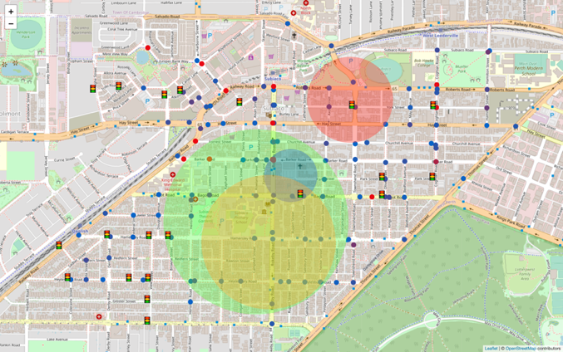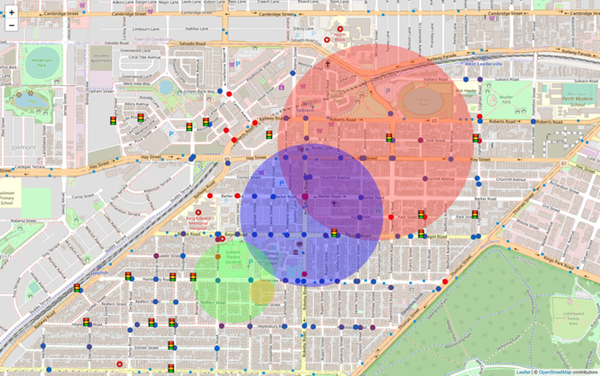When the time step is 700-800, we consider this to be the evening peak time. At the time step of 700, which indicates that we are in the evening peak hour, we can clearly see that the green and yellow circle on the map in figure 3.2 are starting to increase in size, and the red and blue circle are decreasing in size, which indicates that there are many vehicles moving to level 3 and level 4, which indicates that people are traveling from their places of work or school to their homes.

**Figure 3.1 Time Step 200 Map**

**Figure 3.2 Time Step 700 Map**

In addition, we also found that no matter how the time changes, there is always a large number of vehicles on Rokeby Road (Refer to the vehicle density map in appendix). We created Figure 3.3 to show how the number of vehicles on Rokeby Road varies over time steps, and Figure 3.4 to show the overall number of traffic congestions over time steps. We find out that at any time of the day, about 1/4 of the vehicles will be located on this road, so we have good reason to think that road congestion in the Subiaco area has a lot to do with traffic flow on Rokeby Road.

We can also see from the figure that the evening peak is more congested than the morning peak in Subiaco, and the congestion number of 580 time step is 0, which means that the congestion in the evening peak is not affected by morning peak.

**Figure 3.3 Vehicles numbers versus time step on Rokeby Road**

**Figure 3.4 Congestions number versus time step**

In order to further explore this phenomenon, we changed the weights of the car's choice of road and simulated vehicles over time step with Equal Weight and Secondary Road Priority and find that the number of vehicles on the Rokeby Road is decreasing (Figure 3.6). Then, the difference in the number of congestions over time step is reduced between morning peak and evening peak. (Figure 3.7)

Based on our observations we conclude:

1. Rokeby Road is an important north-south transportation hub in the Subiaco area, it contains about 1/4 of the traffic flow in our model.
2. The difference in the number of congestions between morning and evening peak is related to the number of vehicles on Rokeby Road.

This phenomenon indicates that the reason why the evening peak is more congested than the morning peak is that in the morning peak vehicles move from level 3 level 4, to level 1 and level 2, and it is opposite in the evening peak. (Refer to the node graph in appendix). the road types in level 1 area are more oriented towards the trunk roads, and as vehicles prefer the trunk roads, they will direct all the traffic from Roberts Road, Hay Street and other main roads to Rokeby Road because they need to move from work areas (level 1, level 2) to residential areas (level 3, level 4), while in the residential area, there are many secondary roads, and the main roads are only Rokeby Road and Nicholson, which makes it costly for the vehicles to enter the main roads from the residential areas in the morning peak, and some of them will go to level 1 directly along the secondary roads, which will reduce the traffic flow in Rokeby and reduce congestion in the morning.

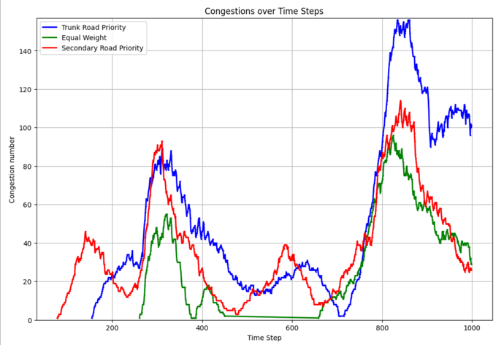

**Figure 3.6 Vehicles on Rokeby Road**

**Figure 3.5 Congestions over TS**

**4、Conclusion**

Our research unveiled the intricacies of daily traffic patterns under varying time frames, such as peak time and normal time. The results highlighted the distinct characteristics of congestion due to differing travel motives and traffic behaviors. As Perth continues to grapple with urban management challenges post-Covid-19, our findings offer valuable insights that can inform strategies to alleviate the pronounced issue of traffic congestion, ensuring smoother socio-economic development in the region. Our model simulates traffic flow in the Subiaco area over a day. Through our model, we simulated the morning and evening peak hours of traffic flow within a day, as well as changes in the number of vehicles and destination selection range. According to the results obtained from our simulation, we can find that Rokeby Road is an important north-south transportation hub in the Subiaco area. In addition to this, we can see that too many Trunk roads are not entirely beneficial to the transportation system. Even if they can carry more vehicles, the role of secondary roads is equally important, especially in places with a lot of trunk roads. Besides, we infer that if a new Trunk Road were added to the east side of Rokeby Road to share the traffic flowing into Rokeby Road by Hay Street and Roberts Road, it would greatly reduce traffic congestions.

Some limitations of our model are listed as follows:

1. In our model, due to the lack of data sources, the location of traffic lights is simulated randomly, which is different from the reality.
2. We just randomly selected the carrying capacity of different roads. In reality, the carrying capacity of Trunk Road will be higher, and the congestion problem may not be as serious as shown in the model.
3. We found some actual traffic flow data (traffic_flow_data.csv) and compared it with the traffic flow on a certain section of road simulated by the model. The correlation obtained was not high.
4. We have not simulated the traffic congestion problems that may be caused by some emergencies (traffic accidents, road maintenance, etc.)
5. A congestion elimination mechanism is artificially added to the model in order to prevent congestion at a certain point (especially the point in the Rokeby Road section) from causing most vehicles to jam at that point and thus affecting the simulation process. This may be different from the way congestion is handled in reality.

For future work, it is possible to consider solving these problems and adding more macroscopic real data into the model, not only limited to Subiaco, but also adding some factors such as population distribution, workplace distribution, etc., to simulate more accurately the changes of traffic flow in different hours. Within our model, new elements can also be introduced in future work, such as public transportation elements, if traffic congestion occurs during the morning peak hours, when a public transportation point is set on a particular blocked road, can this road's traffic congestion problem be significantly optimized in the next round of simulation. This is a further way we can sharpen our model performance.