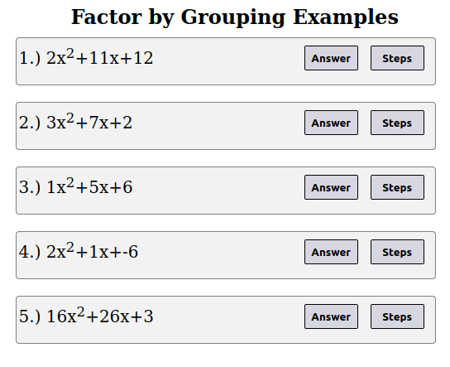
Summary

This project was the first in a series of applications intended to explore web development using HTML, CSS & JavaScript. The purpose of this application was to automate the creation of a Factor by Grouping Problem Set. That is, I did not want to write any HTML code to create each problem. This may not seem important now, but I feel that it may be useful later when I start the development of a larger Factor by Grouping website. The specifications of this application are as follows: a series of factor by grouping expressions should be shown, for each problem there should be a button that shows the answer to user and another button that gives a step by step solution.

Figure 1: Description of web page compoents

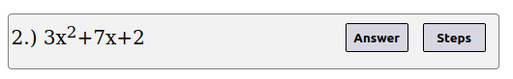

Figure 2: Result if the Answer Button is Pressed
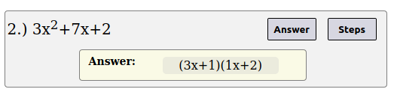

Figure 3: Result if he Answer Button is Pressed, then the Steps Button is Pressed
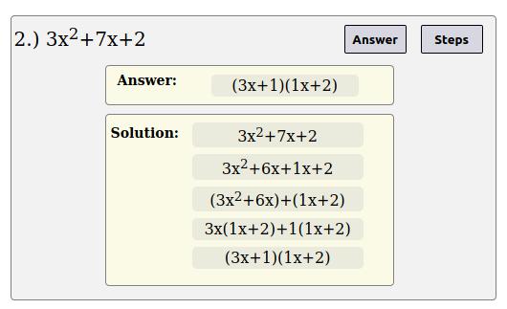

Figure 4: Result if just the Steps Button is Pressed

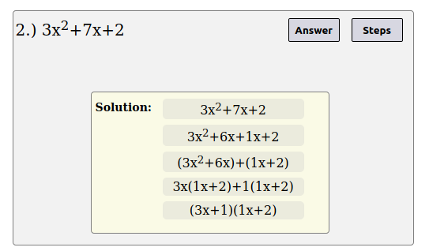

Figure 5: Showing that the Problems Resize and move when the Answers are Shown

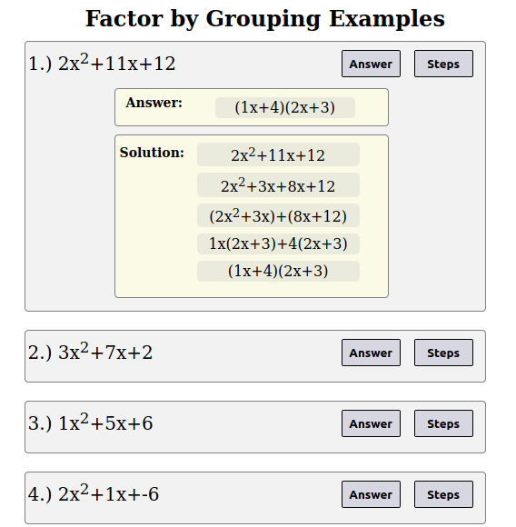

Web Application Code and Other Links

Hmtl: https://github.com/ryanA998/Factor-By-Grouping-Examples/blob/masterFactor_by_Grouping_Examples_Homepage.html

JavaScript:
https://github.com/ryanA998/Factor-By-Grouping-Examples/blob/master/Factor_by_Grouping_Examples_Script.js

Github:
https://github.com/ryanA998/Factor-By-Grouping-Examples

