Appendix A – Consultations with Client

Initial Consultation With Client – Transcript
The following is a transcript from a conversation between me and the client.
Me: Hello [client], I noticed that our academic decathlon team has like a ton of these focused quizzes and such from DemiDec and we never seem to use them., so I was thinking about how I could help with this problem. I was planning on creating a feature that you could import the quizzes and being able to test on them. Do you think that would be helpful? And also do you have any other features that you would like to be included in the program?
Client: I would love that! That would be so helpful. I would want to have a feature that could help others to review their missed questions and tracking the amount of time someone takes to do a test. That would help a lot with retaining the information and identifying places where people need improvement on. Also if possible, I think that adding in a feature to help me create Kahoots. Although I haven’t used it myself, Kahoot has this function to import question from spreadsheets. Do you think you can do something in code to create that automatically?
Me: I think most of those things are very doable. I would have to get back to you on that Kahoot import thing though.
Client: Got it! Again, thank you so much for offering to do this!
Me: Of course, [client]! I will get started on the features that we have discussed and will get back to you about that Kahoot thing!

Short Email Exchange with Client
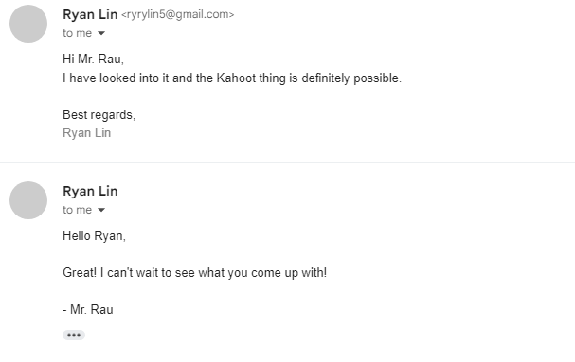

Second Consultation with Client
The following is a transcript from a conversation between me and the client.
Me: Hi [client]! I have done some planning and have made a preliminary design of the program! Would you like to look at it just to see if you would like the design?
Client: Of course!
Me: So here is the basic design behind this idea. Sorry for the roughness of this design, but the ending one will probably be much more refined and polished.
Client: No worries! I understand completely.
Me: So you start here at this home page where you see this statistics portion, the dropdowns to select the subject and test. Here is the main buttons that will accomplish everything that the program does. So basically, if you just select a subject it will pop up with all the tests pertaining to that subject. Then you click a test. Then you can either click the quiz button or the review missed questions button. Either of these will just bring you to this quiz menu. This quiz menu will present the question like this, and then make the correct answer green. Then it pops up with the next button.
Client: That looks great! That would definitely help with allowing the other students to quiz themselves quickly instead of having to print out those quizzes of Demidec.

Me: Yep! The import menu just looks like this. The export button just exports the current test. There is also a questions page that just views all the questions in the test. What do you think?
Client: That looks almost perfect! One small question: Would I have to click the export button each time I wanted to export a test? Or will it just be able to export the entire subject’s test all at once?
Me: That’s a great point! This draft was intending you to press it every time you needed to export a test. But I shall add a feature to make it so that you can just choose!
Client: Alright. Also, I feel like that the questions page would be a bit counterintuitive and not really add to the functionality of the program, because why would you need to check the questions when this is just a quizzing program?
Me: I see your point. I will remove that in the next draft! Is there anything else you would want included in this program?
Client: Nope I think you have basically everything I would like! I am so excited for the final product!
Me: Thank you! I will start programming now.

Sketch referenced in this conversation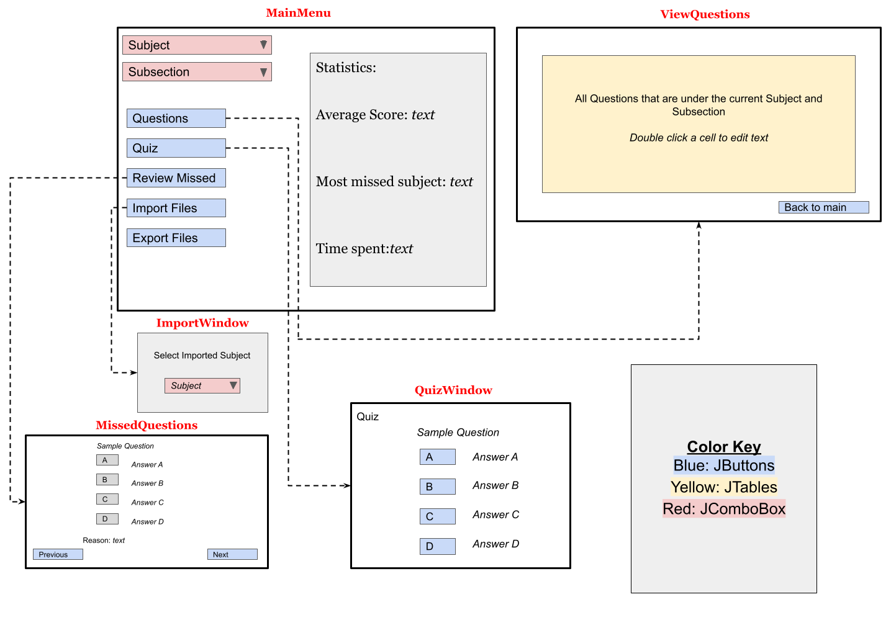

Final Meeting – Transcript
Me: Hello [Client]! I have finished the program!
Client: Hi [me]! That’s great! I am so excited to see it!
Me: Me too! I really hope you like it!
[The program opens, and I tell and show the client how to use the various features]
Me: So when you import something like this, it just loads it into these two dropdowns so that you can choose which test you want to quiz on. Then when you hit this quiz menu it brings you to this. You click an option, then it shows you which one is correct, and why its correct. Then you click the next button, and it shows you the next question. At the end of course, you will get your score.
Client: Woah. That is so cool! This is going to be such a great resource for everyone. I really love it how intuitive you made the import menu. Even someone like me that not so tech-savvy could reasonably figure out how to use it! I love the giant “Wooo” when you complete a test. Really gives a sense of pride. Although that dropdown seems a bit cluttered. It would be difficult to find one specific test that someone is looking for. Maybe a search bar would help? I also really like it how you made these statistics so large over here. It really gives the sense that you are improving or that you really need to study more haha.
Me: Yes that is true, it is a bit hard to find things. That is a great suggestion. Thank you! Of course, for the statistics, if someone wanted a fresh start they could just press this button here.
Client: I really like that. I think it might be bad if someone had to stay with their bad statistics forever if they start off with a few bad tests.
Client: I also really like it how you made choosing the tests so easily! I see you also made that improvement that I suggested last meeting about that export function.
Me: Yes of course!
[Client starts using the program themselves]
Client: What I am most curious about is if this export button works. If it actually imports into Kahoot that would actually save me so so so so so many hours.
[Spreadsheet is imported into Kahoot]
Client: Oh, my goodness! It worked! Thank you so much [me]! This will be such a tremendous help to the preparation I do every day. It will also keep Mrs. [Client] happy because I will be able to have more time to myself now! It really feels like all of that work is just gone with a click of a button!
Me: hahaha Thank you so much!
Client: Lets also check out this quiz menu now.
Me: Yes, so what I did for this is that whenever you get a question wrong, the program stores it behind the scenes. So, like every single question has its own scores. So when you go through the review mode, every question with a negative score will be presented.
Client: That’s great. I like that.
Me: And the great part is, when you close the program, it also saves everything. That means that you don’t have to reimport everything when you start it up again.
Client: I was just about to ask about that. That’s great that you thought about that! That will be a massive timesaver.
Me: Thank you! So yeah, that’s basically the whole program. Any thoughts?
Client: Wow [me], you really don’t know the amount of time this will save me. I also think that the quizzing part of the program will also help your fellow students to do better on their decathlon studying. Thank you so much for making this program!
Me: No problem! I had so much fun making it! Are there any improvements that you might want to add in the future?
Client: Um, If you have time, I know you are doing so much already, do you think you can also add in some way to import the USAD tests into this program? Also, do you think you could also create a review mode that encompasses a whole subject?
Me: So basically you want both types of tests imported. Hm that might be hard since it is in an entirely different format. But that’s a great idea! I will think about that. That review mode is also a great idea! Is there anything else?
Client: No! The program is so amazing! Thank you!
Me: No problem!

