Criterion B: Design

Table of Contents
Complete Diagram: 2
MainMenu diagram: 3
QuizMenu Diagram: 4
QuizMenu Flowchart: 5
ImportMenu Diagram: 6
ImportMenu Flowchart: 7
UML Diagram 8
Test Plan 9

Complete Diagram:

MainMenu diagram:

QuizMenu Diagram:

QuizMenu Flowchart:
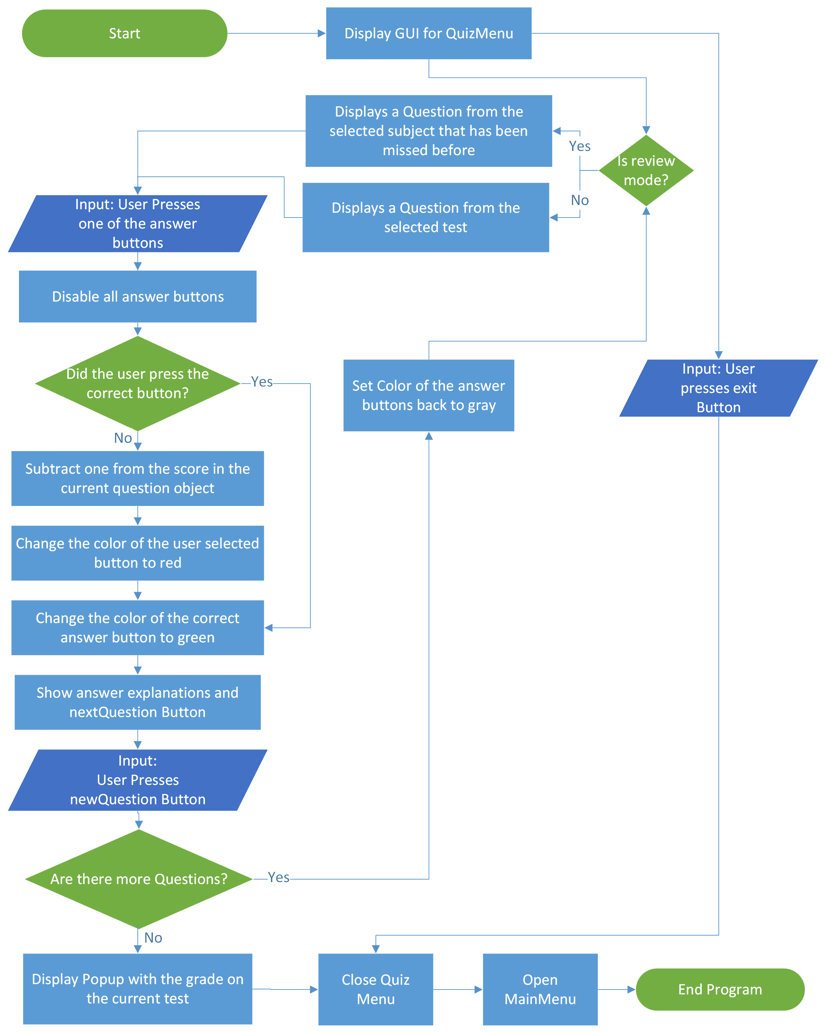

ImportMenu Diagram:

ImportMenu Flowchart:
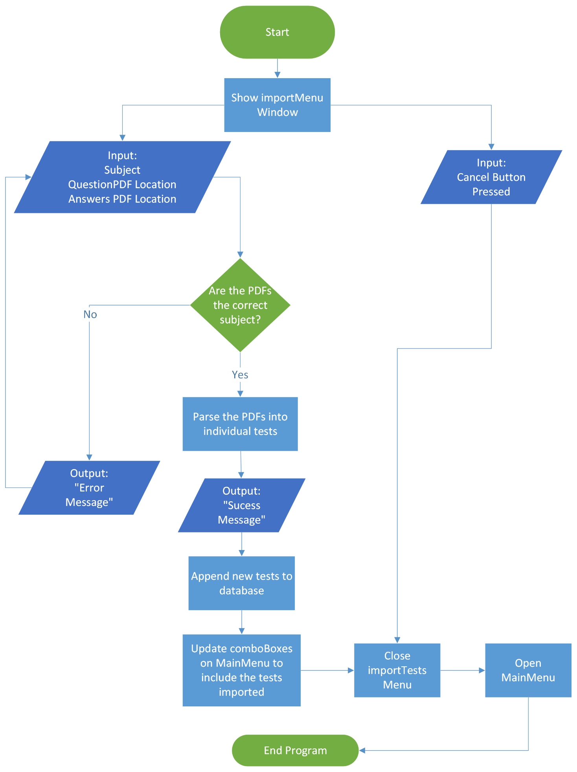

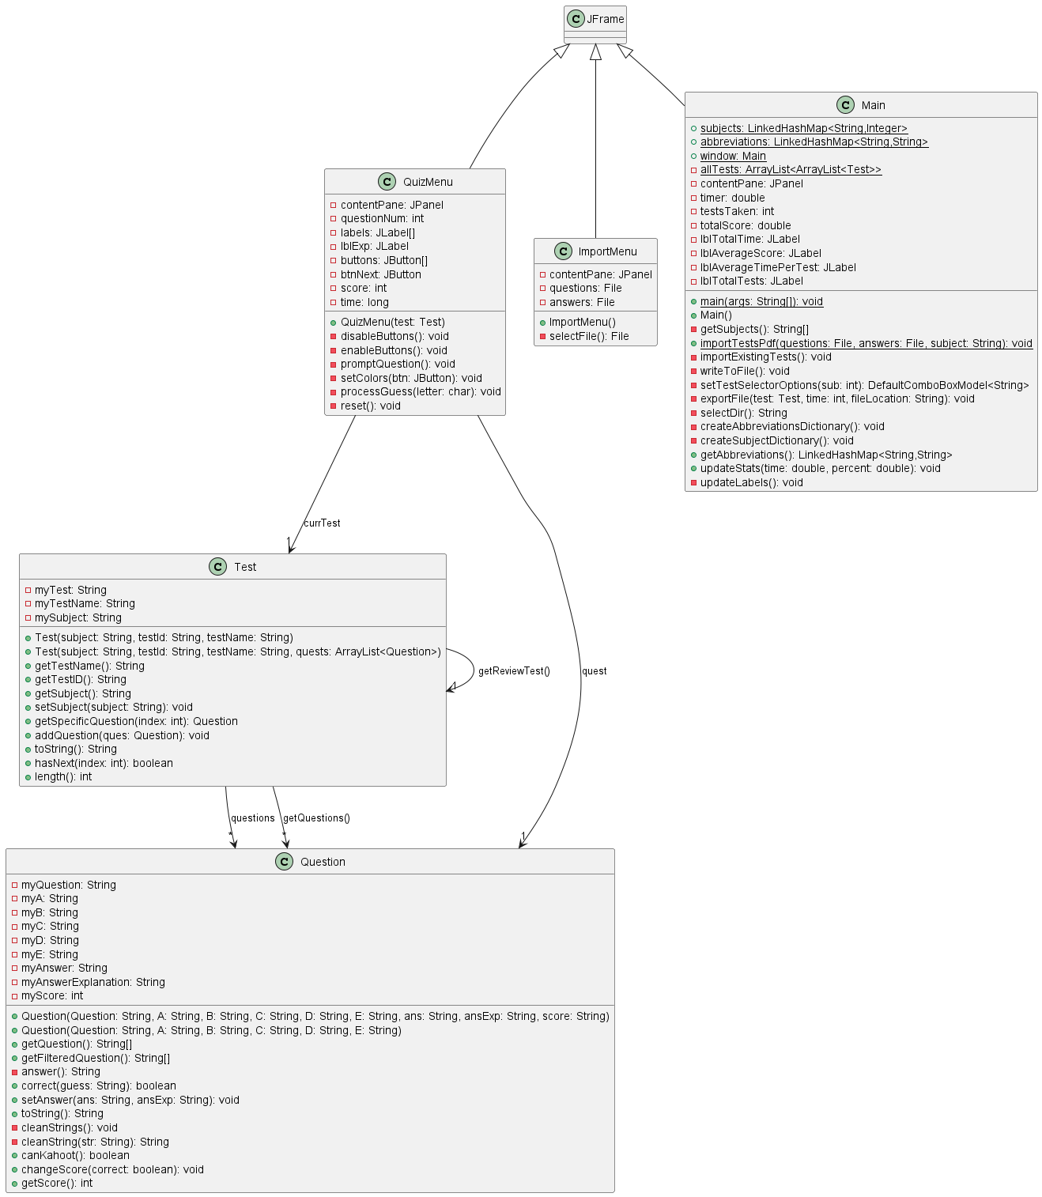
UML Diagram

Test Plan
Action to Test | Test Procedure | Success Criteria
The program should be able to retain all data upon opening and closing the program | Open and close the program. Make sure that all the data are listed in the dropdowns. Go to quiz menu and ensure that questions are displayed. | All data is retained
The program should be able to import and parse files correctly | Import pdfs, and then make sure the dropdowns have the correct test titles and see if the correct questions are prompted for tests. | The test titles are correctly displayed under each subject. Each test contains the correct questions
The program should be able to prompt the correct questions based on the selected tests and have the correct answers | Import a test set, then close the program. Then check the saved data file to compare it to the original pdf that was imported. | The appropriate test is shown and the program displays the correct answers
The program should be able to prompt questions that have been missed before | Purposefully miss a few questions on one test while in the regular quizzing mode. Select the same test again and press “Review Missed Questions” and ensure the same missed questions are prompted | The appropriate questions are shown.
The program should be able to export specific tests to excel spreadsheet files to a desired directory. | Select a test and click export. Ensure that the file is saved in the correct location and contains correct data | The data is correctly exported.
Statistics should not be modified until a test is completed | Quit a quiz prematurely and ensure none of the statistics have been updated | Nothing is updated
The correct statistics should be shown on the MainMenu | Use the program and measure the time spent and questions missed | Correct statistics are displayed
The program should be able to reset the statistics | Complete a Quiz, then press the “Reset Statistics” Button | Statistics are reset

