**CS3219 Task A Report**

**Name:** Ryan Tan Yu

**Matric**: A0183320R

**Email:** [e0310115@u.nus.edu](mailto:e0310115@u.nus.edu)

**Repo Link:** <https://github.com/ryanYtan/cs3219-A-reverse-proxy>

# Running the Docker container

* Clone or download the repo and cd into the project directory
* Build the images by running docker-compose build
* To start the server, run docker-compose up
* Access the server at http://localhost:80
* To stop the server, run docker-compose down

# Screenshots

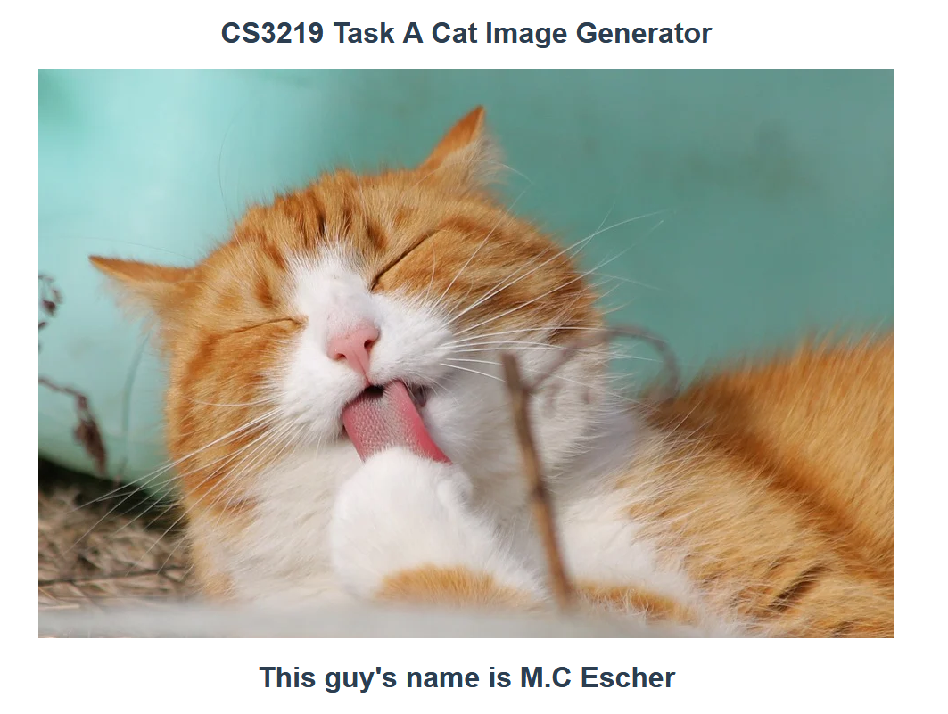

Figure 1: localhost:80

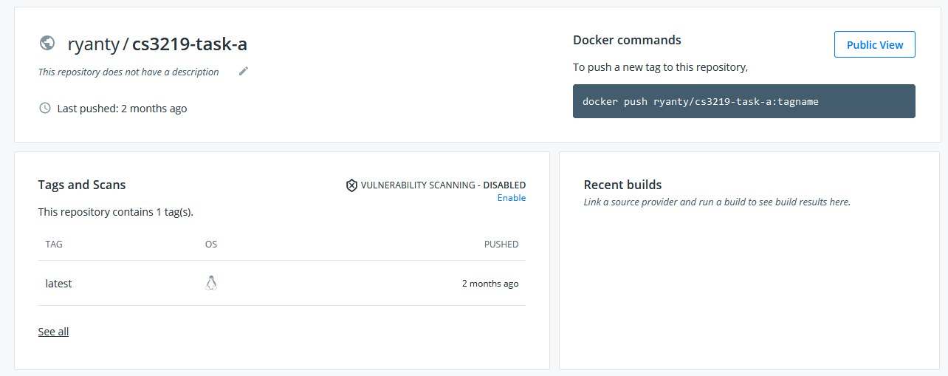

Figure 2: Docker Hub Registry