Documentation for Hotel reservation system software.

**1.Source code file:**

WindowsApplication2.rar

1. Unzip the rar file.
2. Set up the database path in App.config file under “WindowsApplication2\WindowsApplication2\App.config”

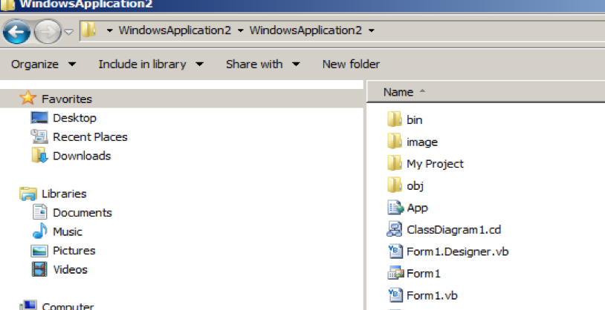

1. Change the path for database location in connectionString after “Data source=”:

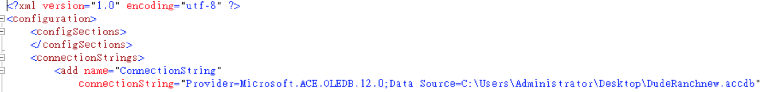

For example:

Data source=C:\Users\Desktop\DudeRanchnew.accbd

1. Open windowsApplication2.sln file in runnable environment.
2. Good to go!

**2.For install this software:**

1. Unzip Hotel.rar file
2. Change the database path under \HOTEL\Application Files\WindowsApplication2_1_0_0_10\WindowsApplication2.exe.config



Change the connectionString after “Data source=” to the location of the database in local computer.

1. Press setup to install the software and press all next buttons.
2. Good to go!