FUEL PRICE PREDICTION SYSTEM USING MACHINE LEARNING
RYAN ALFRED NYAMBATI
SCT222-0195/2021
Department of Information Technology
Jomo Kenyatta University of Agriculture and Technology
Supervisor: ________________________________
A research project submitted to the Department of Information Technology in partial fulfillment of the requirement for the award of the degree of Bachelor of Science in Information Technology at Jomo Kenyatta University of Agriculture and Technology.
2026

DECLARATION
This research project is my original work and has not been presented for the award of a degree in any other university.
Student Name: Ryan Alfred Nyambati
Signature: ________________________________ Date: __________________
This research project has been submitted for examination with my approval as the University Supervisor.
Supervisor Name: ________________________________
Signature: ________________________________ Date: __________________

ABSTRACT
Fuel prices in Kenya change regularly due to movements in international crude oil prices, exchange rates, and domestic pricing decisions. These changes affect transport costs, household budgets, and business planning. This project developed a simple Fuel Price Prediction System Using Machine Learning to estimate next-month prices for Super Petrol, Diesel, and Kerosene. The system was implemented as a Streamlit web application that loads a verified CSV dataset, converts the date field to datetime format, sorts the records chronologically, generates Month_num, Lag_1, and Lag_2 features, and trains a Linear Regression model for the selected fuel type. The dataset used in the project contains 52 monthly observations covering January 2022 to April 2026 with the variables Date, USD_KES, Crude_Oil, Super_Petrol, Diesel, and Kerosene. The application accepts expected USD/KES and crude oil values from the user, predicts the next-month fuel price in Kenya shillings, and displays MAE, MSE, R² Score, a trend chart, and expandable dataset views. The live system was tested using smoke, unit, functional, integration, GUI, performance, compatibility, regression, and acceptance tests. The results show that the system works correctly as a school project prototype, although the model accuracy remains limited because of the small dataset and the simple linear approach. The project therefore demonstrates a working machine learning application for fuel price forecasting while also showing the need for broader data coverage and additional models in future work.

TABLE OF CONTENTS
DECLARATION 1
ABSTRACT 2
TABLE OF CONTENTS 3
LIST OF TABLES 5
LIST OF FIGURES 6
ACRONYMS 7
DEFINITION OF TERMS 8
CHAPTER 1: INTRODUCTION 9
1.1 Background 9
1.2 Project Overview 9
1.3 Statement of the Problem 10
1.4 Proposed Solution 10
1.5 Objectives 11
1.6 Research Questions 11
1.7 Justification 11
1.8 Proposed Research and System Methodologies 12
1.9 Scope 12
CHAPTER 2: LITERATURE REVIEW 14
2.1 Introduction 14
2.2 Theoretical Review 14
2.3 Case Study Review 15
2.4 Integration and Architecture 15
2.5 Summary 16
2.6 Research Gaps 16
CHAPTER 3: SYSTEM ANALYSIS AND DESIGN 17
3.1 Introduction 17
3.2 System Development Methodology 17
3.3 Feasibility Study 17
3.4 Requirements Elicitation 18
3.5 Data Analysis 18
3.6 System Specification 22
3.7 Requirements Analysis and Modeling 23
3.8 Logical Design 24
3.8.1 System Architecture 24
3.8.2 Control Flow and Process Design 25
3.8.3 Design for Non-Functional Requirements 26
3.9 Physical Design 26
3.9.1 Database Design 27
3.9.2 User Interface Design 27
CHAPTER 4: SYSTEM IMPLEMENTATION AND TESTING, CONCLUSIONS AND RECOMMENDATIONS 29
4.1 Introduction 29
4.2 Environment and Tools 29
4.3 System Code Generation 29
4.4 Testing 30
4.5 User Guide 38
4.6 Conclusions 38
4.7 Recommendations 39
REFERENCES 40
APPENDICES 42
Appendix A: Data Extraction Sheet 42
Appendix B: Sample Dataset 42
Appendix C: Source Code 42
Appendix D: Testing Screenshots 44
Appendix E: Project Schedule 44
Appendix F: Budget 44
Appendix G: GitHub Repository Link 44
Appendix H: Jupyter Notebook Reference 44

LIST OF TABLES
Table 3.1: Feasibility Study Summary 17
Table 3.2: Requirements Elicitation Summary 18
Table 3.3: Descriptive Statistics of Project Variables 18
Table 3.4: Functional Requirements 22
Table 3.5: Non-Functional Requirements 23
Table 3.6: CSV Dataset Design 27
Table 4.1: Environment and Tools 29
Table 4.2: Model Evaluation Results by Fuel Type 30
Table 4.3: Test Cases and Results (Part 1) 32
Table 4.3: Test Cases and Results (Part 2) 33
Table 4.3: Test Cases and Results (Part 3) 34
Table 4.3: Test Cases and Results (Part 4) 35

LIST OF FIGURES
Figure 3.1: Fuel Price Trends for Super Petrol, Diesel, and Kerosene 19
Figure 3.2: USD/KES Exchange Rate Trend 20
Figure 3.3: Global Crude Oil Price Trend 21
Figure 3.4: Average Fuel Price Comparison 22
Figure 3.5: Use Case Diagram for the Fuel Price Prediction System 23
Figure 3.6: Level 0 Data Flow Diagram 24
Figure 3.7: System Architecture Diagram 25
Figure 3.8: Control Flow Diagram 26
Figure 3.9: Input Form Wireframe 28
Figure 3.10: Output Interface Wireframe 28
Figure 4.1: Application Input Form 36
Figure 4.2: Super Petrol Prediction Output 36
Figure 4.3: Diesel Prediction Output 36
Figure 4.4: Kerosene Prediction Output 36
Figure 4.5: Model Evaluation Section 36
Figure 4.6: Fuel Price Trend Chart 37
Figure 4.7: Historical Dataset Display 37
Figure 4.8: Lagged Dataset Display 38

ACRONYMS
API - Application Programming Interface
CBK - Central Bank of Kenya
CSV - Comma-Separated Values
EPRA - Energy and Petroleum Regulatory Authority
GUI - Graphical User Interface
KES - Kenya Shilling
MAE - Mean Absolute Error
ML - Machine Learning
MSE - Mean Squared Error
R² - Coefficient of Determination
USD - United States Dollar

DEFINITION OF TERMS
Crude oil price: The monthly global benchmark oil price used as one of the independent variables in the model.
Fuel price forecasting: The process of estimating future prices of fuel products using historical data and analytical methods.
Lagged variable: A previous value of the target variable used to help explain the current or future value.
Linear regression: A supervised learning method that models the relationship between input variables and a continuous target value.
Month_num: A sequential month counter created from the ordered dataset to represent the time position of each record.
Prediction accuracy metrics: Numerical measures such as MAE, MSE, and R² used to assess model performance.

CHAPTER 1: INTRODUCTION

1.1 Background
Fuel pricing remains an important economic issue because petroleum products directly affect transport, production, and household expenditure. Across the world, fuel prices respond to movements in crude oil markets, exchange rates, regulatory decisions, and supply chain conditions. When these drivers change, consumers and businesses experience immediate cost adjustments, making fuel price forecasting a useful planning tool (Hyndman & Athanasopoulos, 2021; World Bank, 2026).
In Kenya, maximum retail prices for Super Petrol, Diesel, and Kerosene are published by the Energy and Petroleum Regulatory Authority (EPRA) on a regular cycle. At the same time, the Kenya shilling to United States dollar exchange rate influences the local cost of imported petroleum products, while international crude oil prices signal global market pressure (Central Bank of Kenya, 2025; Energy and Petroleum Regulatory Authority, n.d.). These linked factors provide a strong basis for building a simple prediction model using public monthly data.

1.2 Project Overview
This project focuses on the design and implementation of a Fuel Price Prediction System Using Machine Learning. The system was developed as a Streamlit web application that predicts the next-month price of Super Petrol, Diesel, or Kerosene after the user selects a fuel type and enters expected USD/KES and crude oil values.
The project uses a verified monthly dataset stored in CSV format and applies a linear regression model trained on five input features: Month_num, USD_KES, Crude_Oil, Lag_1, and Lag_2. The system also displays model evaluation metrics, a fuel trend chart, and both the historical dataset and lagged dataset so that the output is easy to explain during project defense.

1.3 Statement of the Problem
Fuel prices in Kenya are important to households, transport operators, and small businesses, yet monthly price movements are difficult to estimate using observation alone. Users who need to plan transport budgets or compare fuel trends often depend on manual guesswork, scattered public notices, or simple spreadsheet checks that do not combine exchange rate data, crude oil prices, and previous fuel price patterns in one system.
Although machine learning can support structured prediction, many existing examples are either too advanced, too data-heavy, or not localized for a small academic project. There was therefore a need for a simple and functional system that could use verified monthly public data to predict next-month Kenyan fuel prices in a way that is easy to implement, test, and explain.

1.4 Proposed Solution
This research proposes the development of a Fuel Price Prediction System Using Machine Learning that predicts next-month prices for Super Petrol, Diesel, and Kerosene. The system uses a verified CSV dataset and a Linear Regression model trained on Month_num, USD_KES, Crude_Oil, Lag_1, and Lag_2.
The solution is implemented as a Streamlit application so that the user can select a fuel type, enter expected exchange rate and crude oil values, and receive a price estimate in Kenya shillings together with model accuracy metrics and trend visualization. The system therefore combines data preparation, prediction, evaluation, and presentation in one simple interface.

1.5 Objectives
General Objective: To design and implement a machine learning system for predicting next-month fuel prices in Kenya.
Specific Objectives:
1. To analyze verified monthly fuel price, exchange rate, and crude oil data relevant to the project.
2. To design a fuel price prediction system that uses lagged variables and linear regression.
3. To implement the designed system using Streamlit, Pandas, and Scikit-learn.
4. To test and evaluate the developed system using functional, model, and interface-based tests.

1.6 Research Questions
1. Which monthly variables are most appropriate for a simple fuel price prediction model in this project?
2. How can lagged fuel price variables be combined with exchange rate and crude oil data in a beginner-friendly machine learning system?
3. How can a Streamlit application be used to present next-month fuel price predictions clearly to a user?
4. How well does the developed system perform when evaluated using standard regression metrics and software testing procedures?

1.7 Justification
The project is justified because fuel price changes affect planning and decision-making at both individual and organizational levels. A simple forecasting tool can help users understand the relationship between historical prices, crude oil prices, and exchange rate changes without requiring advanced data science knowledge.
The project is also academically relevant because it demonstrates how a small, publicly sourced dataset can be prepared, modeled, and presented using a practical machine learning workflow. For the student researcher, the project provides experience in data preparation, feature engineering, user interface design, testing, and documentation.

1.8 Proposed Research and System Methodologies
The research component of the project followed an applied and quantitative approach. Public monthly data on fuel prices, exchange rates, and crude oil prices were compiled through document review and captured using a data extraction sheet. The resulting dataset was then cleaned, checked, summarized, and analyzed using Python tools.
The system component followed an iterative prototyping methodology. This approach was suitable because the application was small in scope and benefited from repeated improvement of the dataset workflow, user interface, and prediction logic. The method allowed the system to be developed in manageable stages from data loading to model training, interface design, testing, and documentation.

1.9 Scope
The project is limited to monthly fuel price prediction for Kenya using three target variables: Super Petrol, Diesel, and Kerosene. The implemented system uses a verified CSV dataset with records from January 2022 to April 2026 and predicts one month ahead using Month_num, USD_KES, Crude_Oil, Lag_1, and Lag_2.
The project does not include real-time data integration, mobile deployment, or advanced forecasting algorithms beyond Linear Regression. Its purpose is to provide a functional undergraduate prototype that is easy to understand, defend, and improve in future work.

CHAPTER 2: LITERATURE REVIEW

2.1 Introduction
This chapter reviews the literature related to fuel price forecasting, machine learning, time-based feature engineering, and simple software architecture choices for predictive systems. The review supports the selection of the variables, model, and implementation approach used in this project.

2.2 Theoretical Review
Machine learning is commonly defined as the development of models that learn patterns from data and use those patterns to make predictions on unseen cases. In supervised learning, the model is trained using input variables and known target values. For this project, the targets are the monthly prices of Super Petrol, Diesel, and Kerosene, while the predictors are Month_num, USD_KES, Crude_Oil, Lag_1, and Lag_2 (Géron, 2022; James et al., 2021).
Linear regression remains one of the most interpretable approaches for continuous prediction problems because it estimates how changes in predictor variables relate to changes in the target value. It is therefore suitable for an undergraduate project where transparency and ease of explanation are important. Scikit-learn documents LinearRegression as an ordinary least squares method that minimizes the residual sum of squares between observed and predicted values (scikit-learn developers, n.d.).
Time-dependent problems also benefit from lagged variables because previous values often carry information about the next observation. Forecasting literature emphasizes that recent historical behavior is useful in short-term prediction, especially when the dataset is ordered in time and when future values are estimated from past trends rather than from random samples (Hyndman & Athanasopoulos, 2021; Montgomery et al., 2024). In this project, Lag_1 and Lag_2 were introduced to capture the most recent month-to-month behavior of the selected fuel.

2.3 Case Study Review
Kenya offers a useful local application context because monthly petroleum prices are formally published by EPRA and are influenced by both international and domestic factors. EPRA's monthly price publications and pump price formula show that fuel prices are linked to regulated pricing decisions, while the Central Bank of Kenya publishes exchange rate information that reflects currency conditions relevant to import costs (Energy and Petroleum Regulatory Authority, n.d.; Central Bank of Kenya, 2025).
Recent studies also show continued interest in forecasting fuel-related prices using data-driven methods. Alwadi (2025) applied time series, machine learning, and deep learning models to fuel sales price forecasting and found that data-driven models can support operational decisions. Cohen (2025) compared econometric and machine learning techniques for short-term oil price forecasting and showed that lagged behavior and multiple external factors remain important when modeling energy price movements. These studies support the decision to use a data-based forecasting approach, although they are more advanced than the scope of this project.

2.4 Integration and Architecture
Several implementation choices are possible for a forecasting system. A spreadsheet-only approach is simple but limited in repeatability and interface quality. A database-backed enterprise application may be powerful but would add unnecessary complexity for an undergraduate prototype. A lightweight web-based interface with a flat CSV dataset and a simple model provides a better balance between usability and implementation effort.
For this reason, the project adopted a small layered architecture. The data layer stores verified monthly records in CSV format, the processing layer handles cleaning and feature generation with Pandas, the model layer trains Linear Regression using Scikit-learn, and the presentation layer uses Streamlit to display predictions, charts, and datasets (pandas developers, n.d.; Streamlit, n.d.). This structure is appropriate for a school project because it is functional, minimal, and easy to defend.

2.5 Summary
The reviewed literature shows that fuel and oil price forecasting can be approached using both statistical and machine learning methods. It also confirms the value of time ordering, lagged variables, and transparent evaluation metrics in short-term prediction tasks.

2.6 Research Gaps
Many published studies focus on large datasets, advanced hybrid models, or specialized forecasting environments. Fewer examples address a small, transparent, Kenya-focused academic system that can be implemented with public monthly data and explained easily in an undergraduate defense. This project addresses that gap by providing a localized, beginner-friendly web application that uses interpretable features and a simple regression workflow.

CHAPTER 3: SYSTEM ANALYSIS AND DESIGN

3.1 Introduction
This chapter presents the analysis and design of the Fuel Price Prediction System. It explains the development methodology, feasibility study, requirements elicitation process, data analysis, system specification, logical design, and physical design that guided the final implementation.

3.2 System Development Methodology
The project used an iterative prototyping methodology. The work began with identifying the required dataset structure and core prediction workflow, followed by repeated refinement of the preprocessing logic, user interface, and output presentation. This methodology was suitable because the project requirements became clearer as the prototype was tested using real data and screenshots.
The main stages were problem definition, data preparation, model design, interface implementation, testing, and documentation. The iterative approach allowed simple feedback loops without over-engineering the system.

3.3 Feasibility Study
Table 3.1: Feasibility Study Summary
Aspect | Observation | Conclusion
Technical feasibility | Python, Streamlit, Pandas, and Scikit-learn are readily available and were sufficient for data preparation, model training, and interface development. | Feasible
Economic feasibility | The project used open-source tools and a lightweight CSV dataset, reducing development cost to normal academic expenses such as internet, printing, and consultation. | Feasible
Operational feasibility | The system workflow is simple: choose a fuel type, enter expected values, and read the predicted price and metrics. | Feasible
Schedule feasibility | The project scope was limited to a small forecasting prototype, which made it manageable within the academic project period. | Feasible

3.4 Requirements Elicitation
Requirements were elicited through document review, observation, and the preparation of a data extraction sheet. Public monthly records were gathered from EPRA pump price releases, Central Bank of Kenya exchange rate publications, and World Bank commodity price resources. Because the project uses monthly public data rather than survey responses, the data extraction sheet served as the main collection instrument.
For the dataset period used in the final system, the project considered all 52 monthly records from January 2022 to April 2026. This amounted to a census of the selected period rather than a sampled subset.
Table 3.2: Requirements Elicitation Summary
Technique | Purpose | Outcome
Document review | To identify verified monthly values for fuel prices, exchange rates, and crude oil prices. | Provided the core numeric dataset.
Observation | To understand what the user needs from the app interface and outputs. | Guided the interface and visualization requirements.
Data extraction sheet | To record the exact fields collected for the CSV dataset. | Ensured consistency of variables and units.

3.5 Data Analysis
The final verified dataset contains 52 monthly records running from January 2022 to April 2026. No missing values were found during checking, which means the dataset was complete for the selected variables. Month_num was then created after sorting the data chronologically.
Table 3.3: Descriptive Statistics of Project Variables
Variable | Minimum | Maximum | Mean | Standard Deviation
USD_KES | 113.38 | 159.69 | 130.35 | 10.49
Crude_Oil | 62.54 | 122.71 | 83.71 | 14.71
Super_Petrol | 129.72 | 217.36 | 180.6 | 19.05
Diesel | 110.6 | 205.47 | 166.7 | 21.38
Kerosene | 103.54 | 205.06 | 154.17 | 23.4

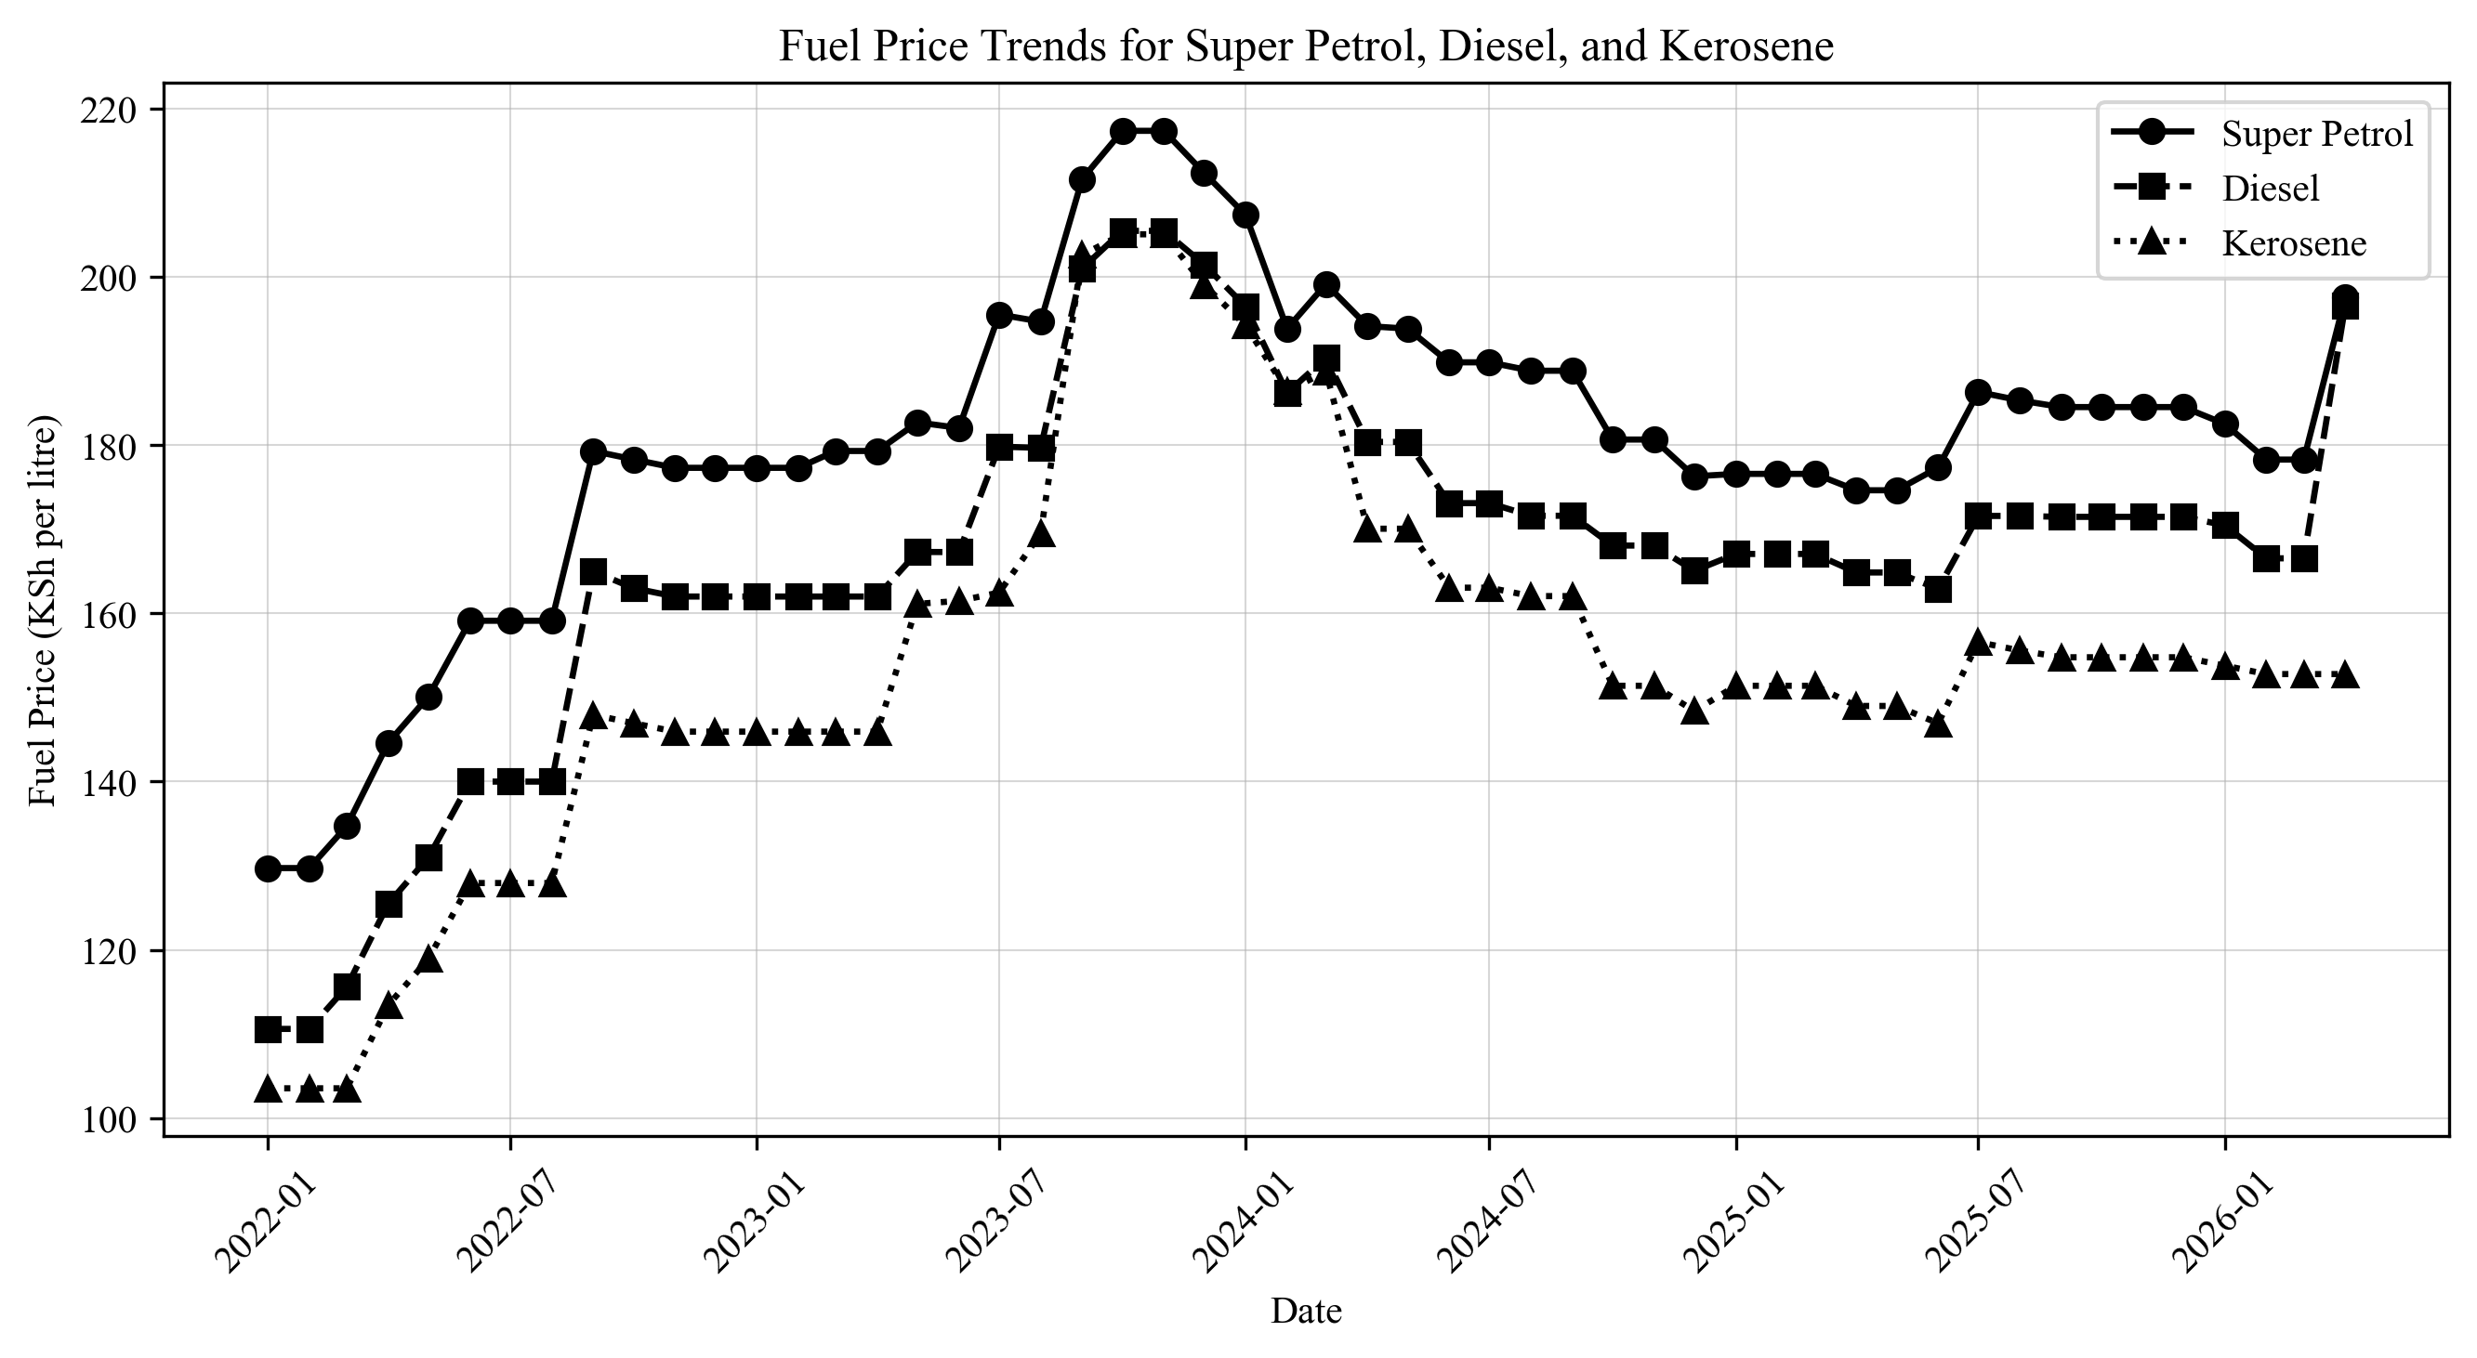
Figure 3.1: Fuel Price Trends for Super Petrol, Diesel, and Kerosene
Figure 3.1 shows that all three fuel prices generally moved upward from 2022, reached high levels around late 2023, and then moderated before rising again in selected months of 2025 and 2026. Super Petrol remained the highest-priced product for most of the period.
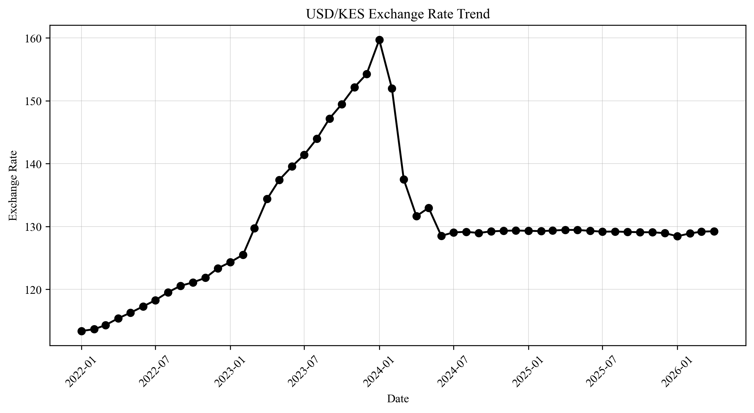
Figure 3.2: USD/KES Exchange Rate Trend
Figure 3.2 indicates that the exchange rate generally increased across the study period, showing depreciation of the Kenya shilling against the US dollar. This trend supports the inclusion of USD/KES as an explanatory variable.
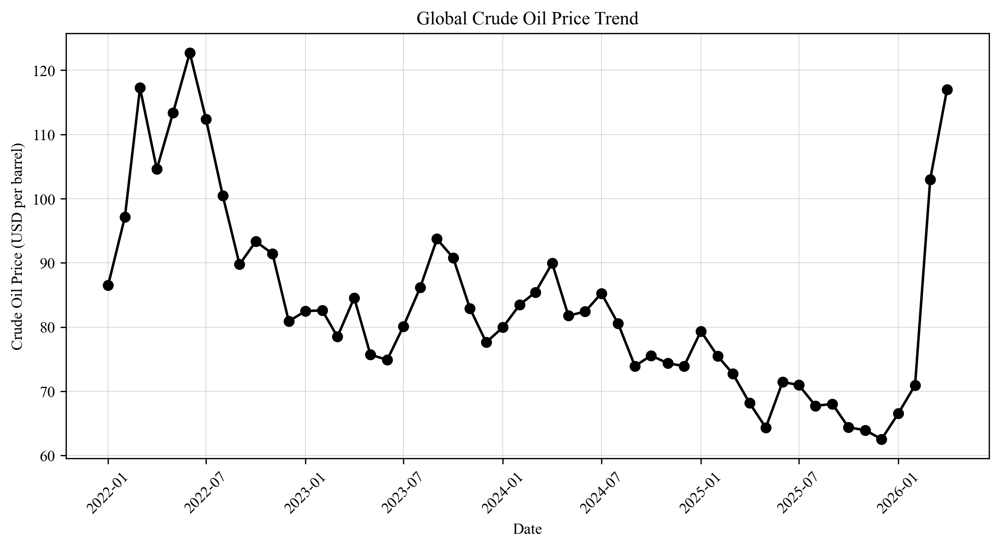
Figure 3.3: Global Crude Oil Price Trend
Figure 3.3 shows that crude oil prices were volatile, with a stronger spike in 2022 followed by lower levels in later periods. This variation provides a useful external price signal for the prediction model.
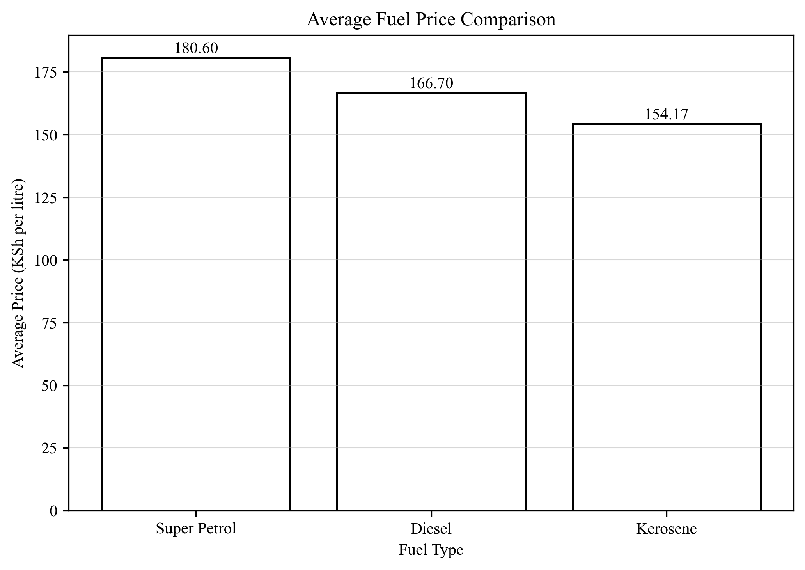
Figure 3.4: Average Fuel Price Comparison
Figure 3.4 compares the average prices of the three fuel products. Super Petrol recorded the highest average price, followed by Diesel, while Kerosene had the lowest average price in the dataset.

3.6 System Specification
The system requirements were grouped into functional and non-functional categories. Functional requirements describe what the system must do, while non-functional requirements describe how well it should do it.
Table 3.4: Functional Requirements
Requirement ID | Functional Requirement
FR1 | Load the verified CSV dataset from the project directory.
FR2 | Convert the Date field to datetime format and sort records chronologically.
FR3 | Create Month_num, Lag_1, and Lag_2 for the selected fuel type.
FR4 | Train a Linear Regression model for the selected target fuel.
FR5 | Accept expected USD/KES and crude oil values from the user.
FR6 | Predict the next-month price and display it in Kenya shillings.
FR7 | Display MAE, MSE, and R² Score for the selected model.
FR8 | Display a trend chart plus expandable historical and lagged datasets.

Table 3.5: Non-Functional Requirements
Requirement ID | Category | Non-Functional Requirement
NFR1 | Usability | The interface should be simple and easy to understand.
NFR2 | Performance | The local app should load and respond quickly for a small dataset.
NFR3 | Maintainability | The code should remain short, readable, and beginner-friendly.
NFR4 | Reliability | The system should handle the available dataset consistently without crashing.
NFR5 | Portability | The project should run through `streamlit run app.py` on a standard Python environment.

3.7 Requirements Analysis and Modeling
The analysis of the gathered requirements showed that the system needed a simple user role, a small set of verified input variables, and direct visibility of both prediction results and supporting data. These needs were modeled through the use case and data flow diagrams below.
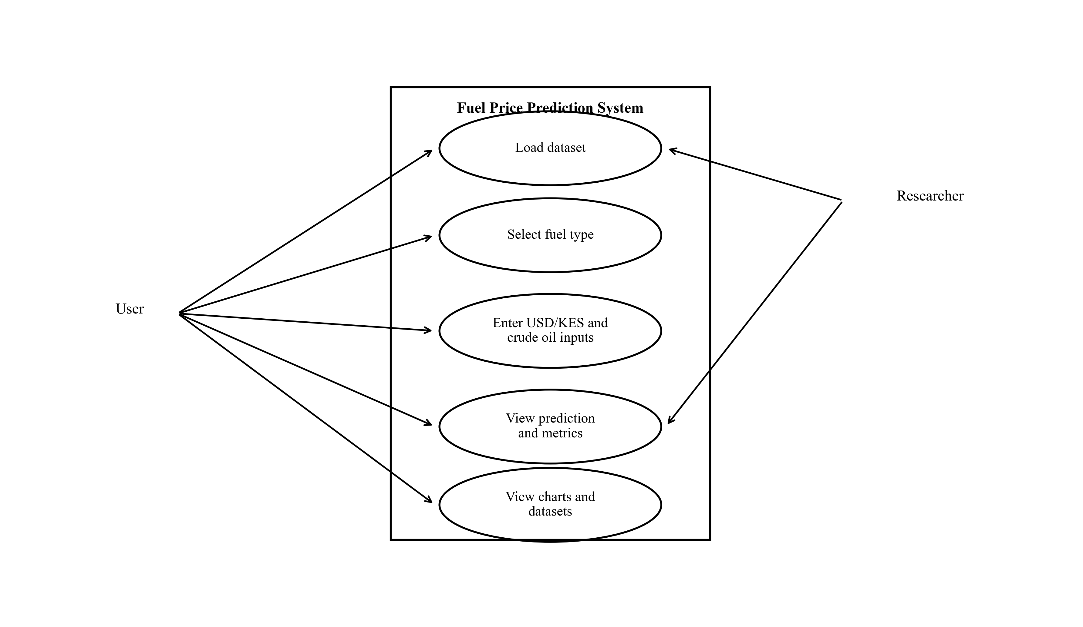
Figure 3.5: Use Case Diagram for the Fuel Price Prediction System
The use case diagram identifies the main actions performed by the user and the researcher in relation to the prediction system.
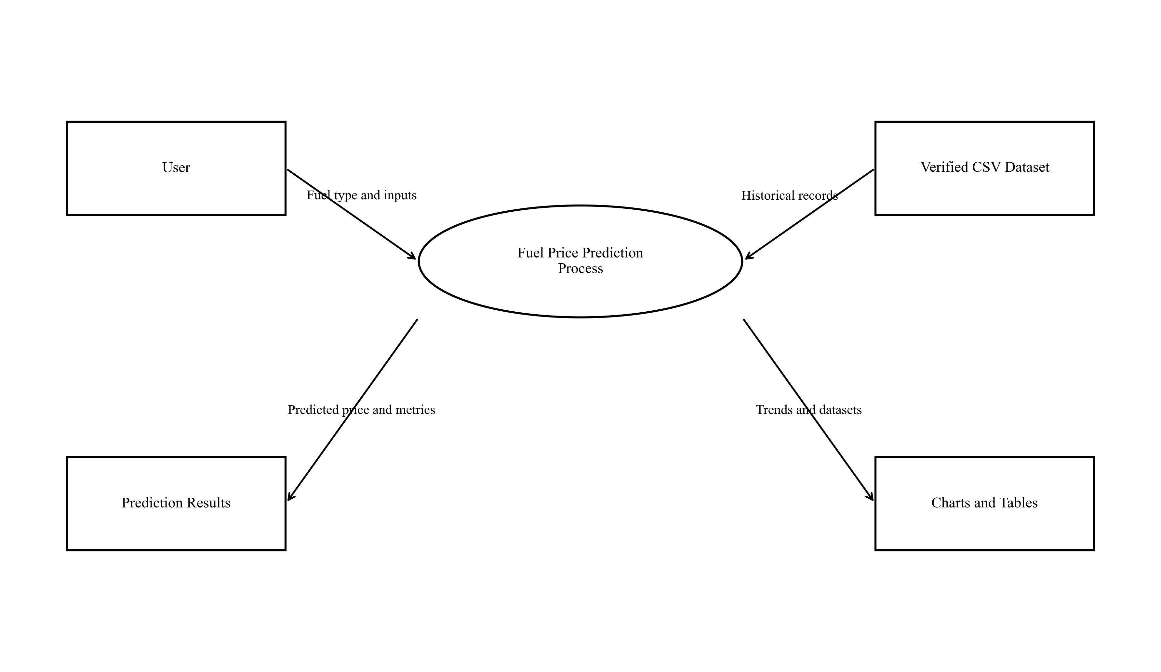
Figure 3.6: Level 0 Data Flow Diagram
The level 0 DFD shows how user inputs and the verified CSV dataset move through the prediction process to produce charts, tables, and price estimates.

3.8 Logical Design
The logical design describes how the application components interact before actual deployment details are considered.

3.8.1 System Architecture
The chosen architecture follows a simple layered pattern. The dataset layer stores monthly records in CSV form, the processing layer prepares the dataset and lagged features, the model layer trains and applies linear regression, and the interface layer presents the outputs through Streamlit.
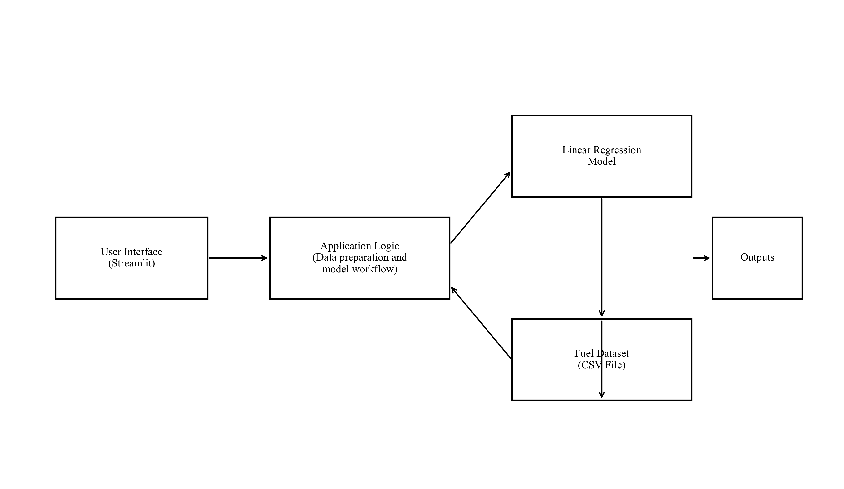
Figure 3.7: System Architecture Diagram

3.8.2 Control Flow and Process Design
At runtime, the system loads the dataset, prepares the time-based features, trains the model for the currently selected fuel type, accepts user inputs, predicts the next-month price, and then renders the outputs.
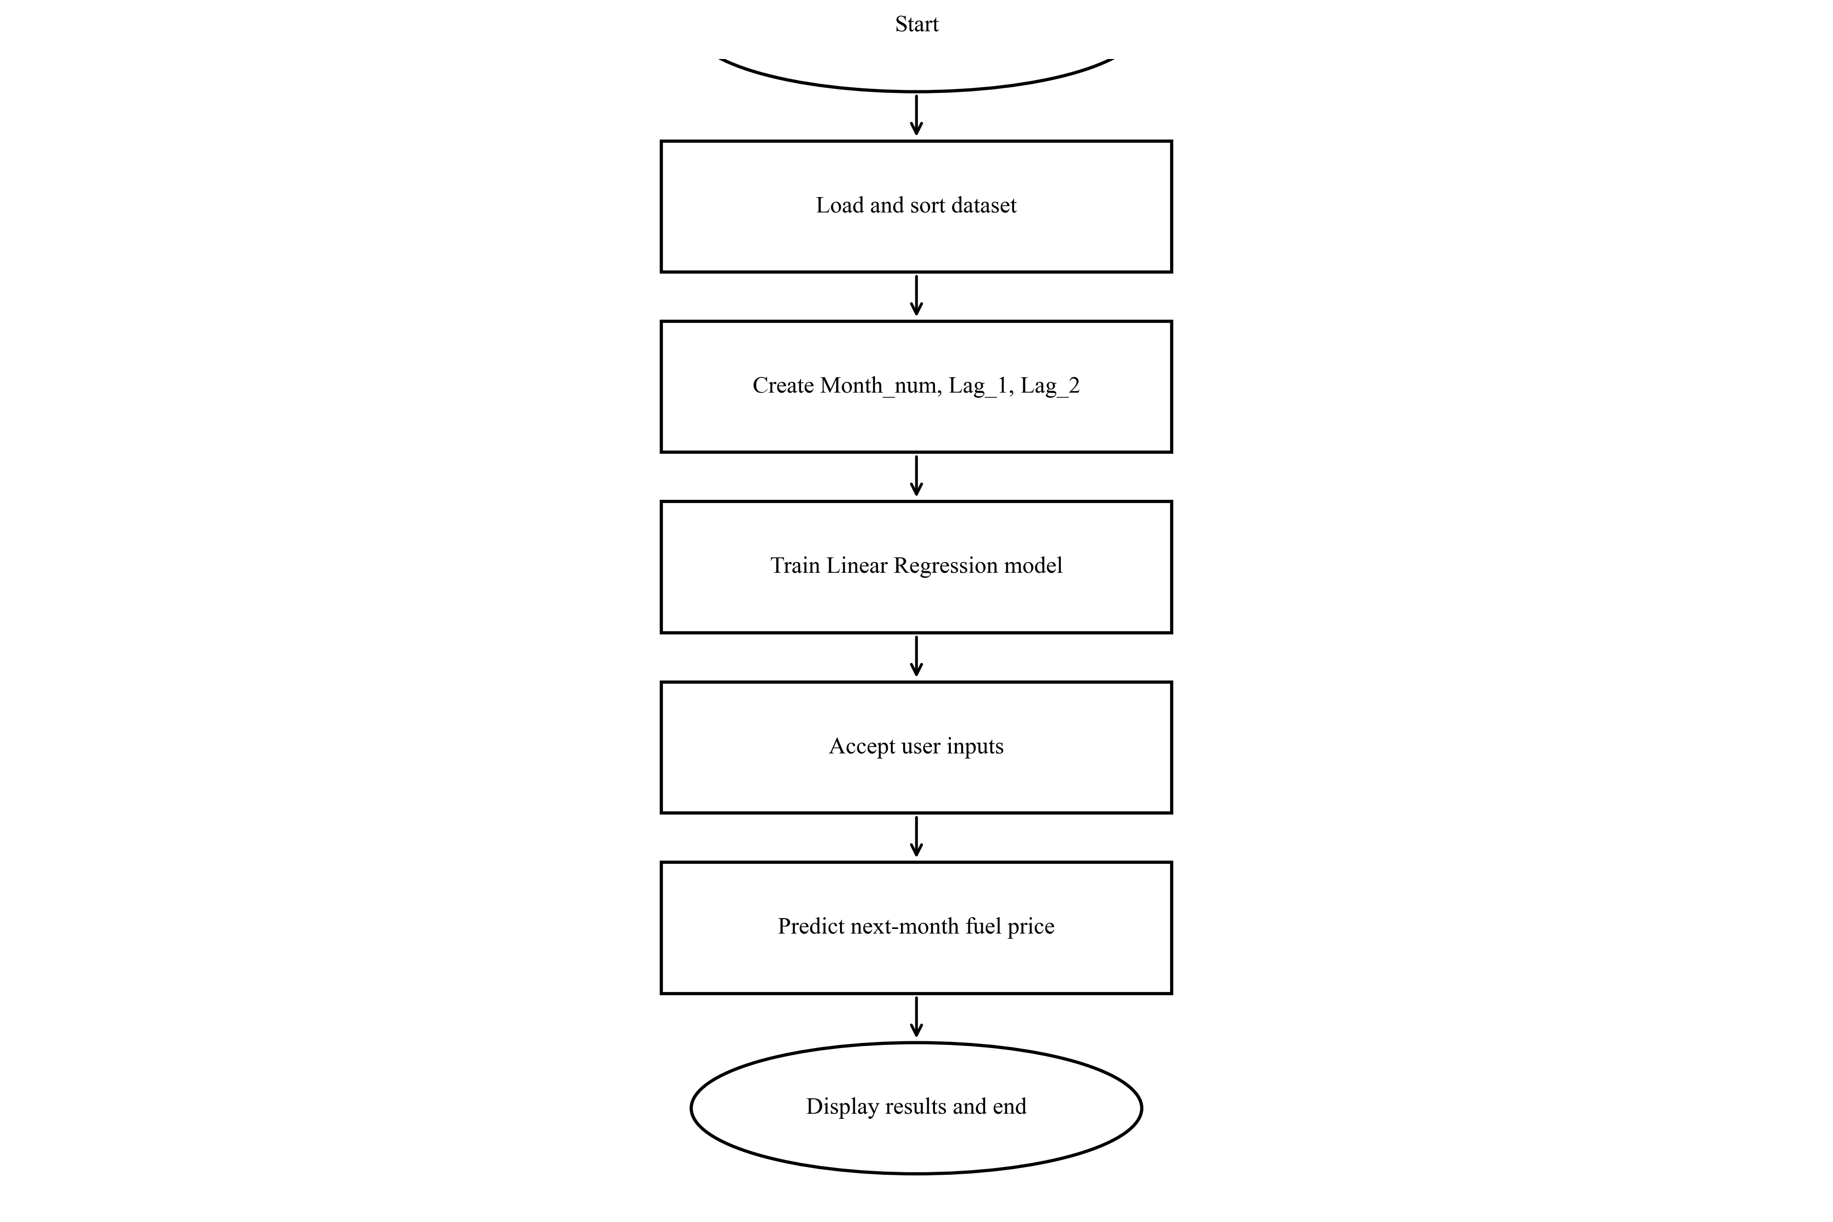
Figure 3.8: Control Flow Diagram
The sequence in Figure 3.8 matches the implementation in app.py and reflects the order in which prediction tasks are executed.

3.8.3 Design for Non-Functional Requirements
Usability was addressed by keeping the interface small and by presenting only one fuel selection, two numeric inputs, a prediction output, metric cards, and expandable dataset views. Maintainability was improved by separating the code into small helper functions for loading data, creating lagged features, training the model, and preparing the future input frame.
Basic reliability was supported through dataset column validation and chronological sorting before training. Performance needs were modest because the project uses a small CSV dataset and a light regression model, making local execution fast enough for classroom demonstration.

3.9 Physical Design
The physical design defines the concrete storage structure and user interface used in the final implementation.

3.9.1 Database Design
The system uses a flat CSV file rather than a relational database. This choice was intentional because the project dataset is small, static, and easy to distribute within the repository. The physical design therefore focuses on field structure, data types, and the way the file is read into Pandas.
Table 3.6: CSV Dataset Design
Field | Data Type | Description
Date | Text converted to datetime | Month and year of the observation.
USD_KES | Float | Expected or observed exchange rate.
Crude_Oil | Float | Observed global crude oil price in USD per barrel.
Super_Petrol | Float | Monthly fuel price target for Super Petrol.
Diesel | Float | Monthly fuel price target for Diesel.
Kerosene | Float | Monthly fuel price target for Kerosene.

3.9.2 User Interface Design
The interface design was kept deliberately minimal so that the application remains easy to explain during project defense. The input screen uses a fuel selector and two numeric fields, while the output screen shows prediction, model evaluation metrics, a chart, and expandable tables.
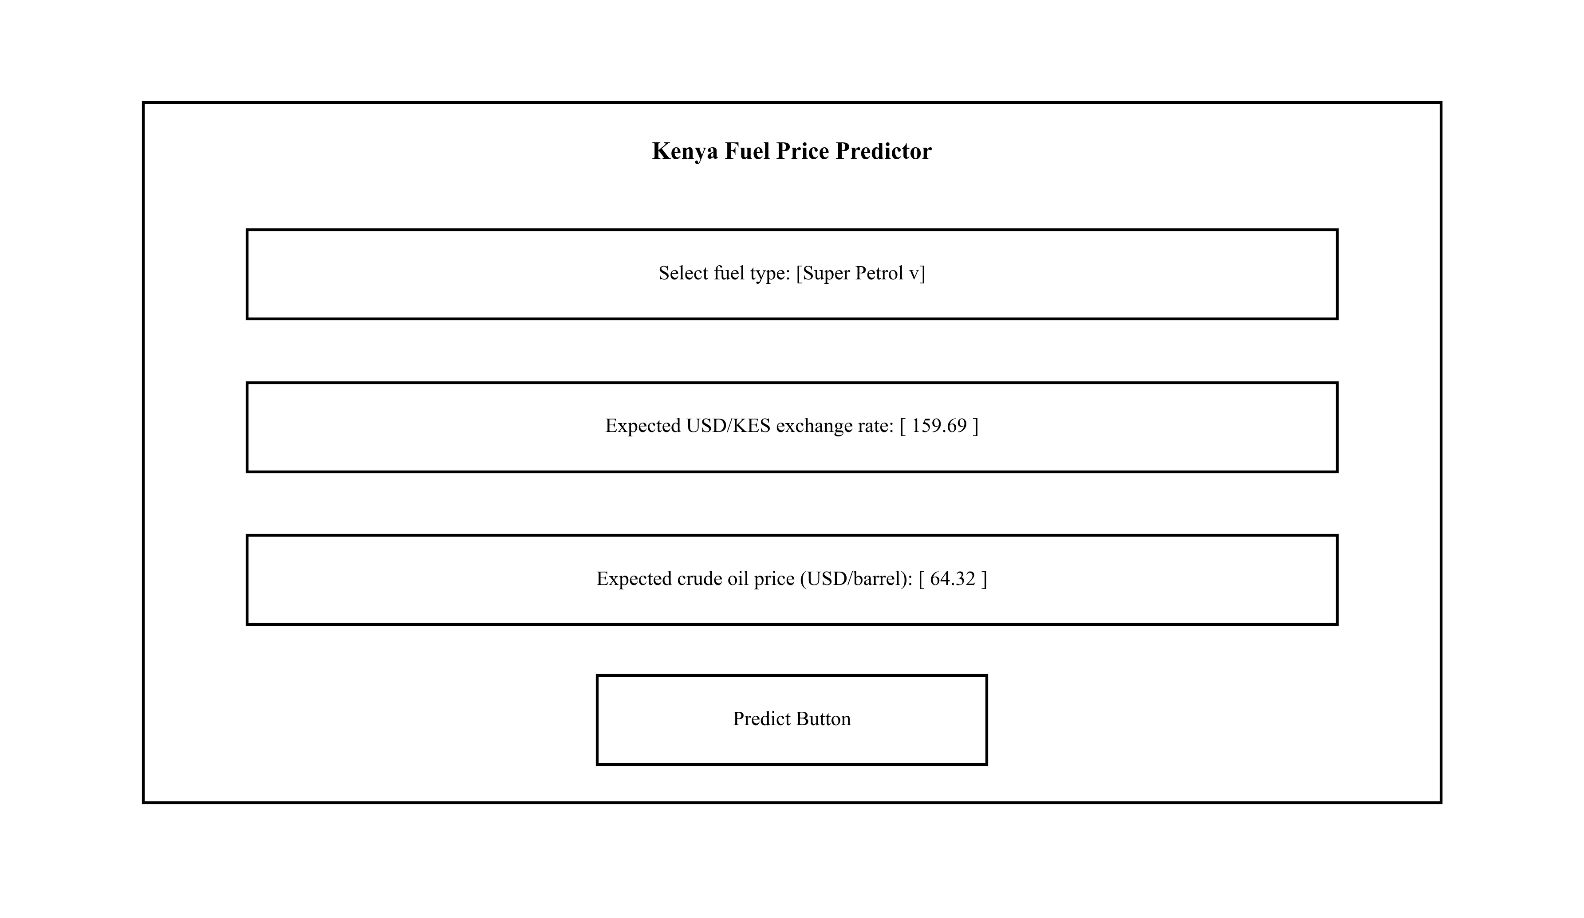
Figure 3.9: Input Form Wireframe
Figure 3.9 shows the input controls required before a prediction is made.
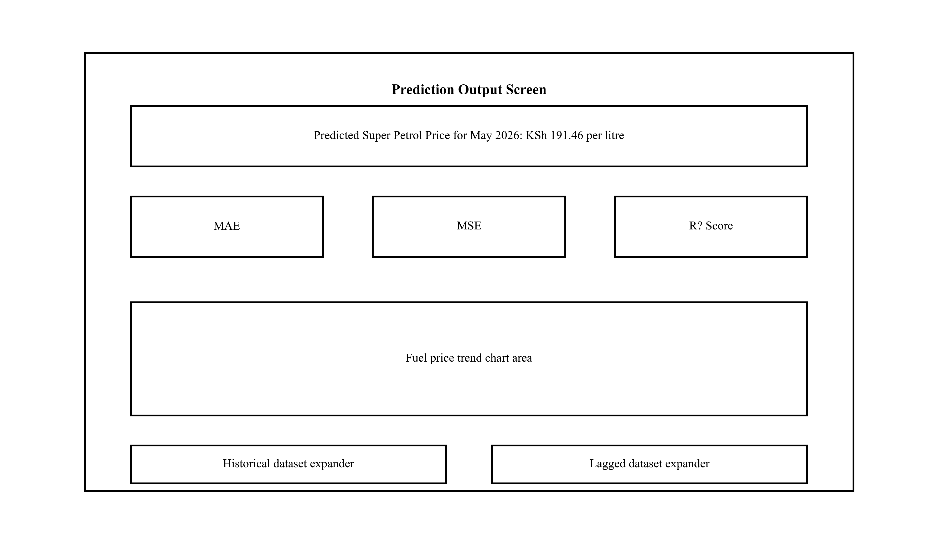
Figure 3.10: Output Interface Wireframe
Figure 3.10 shows the prediction, metrics, chart, and dataset expanders.

CHAPTER 4: SYSTEM IMPLEMENTATION AND TESTING, CONCLUSIONS AND RECOMMENDATIONS

4.1 Introduction
This chapter explains the implementation environment, the system code generation process, the tests applied to the working application, the user guide, the main conclusions, and the recommendations for future improvement.

4.2 Environment and Tools
Table 4.1: Environment and Tools
Component | Tool | Purpose
Programming language | Python 3.12 | Used for data processing, model training, and app logic.
Frontend and presentation | Streamlit 1.56.0 | Used to build the web interface.
Data handling | Pandas | Used for CSV loading, sorting, and feature creation.
Machine learning | Scikit-learn | Used for Linear Regression and evaluation metrics.
Visualization | Streamlit charts and Matplotlib | Used for the live chart and report figures.
Notebook environment | Jupyter Notebook | Used for exploratory data analysis and chart generation.

4.3 System Code Generation
The final source code was simplified so that the main workflow could be explained clearly. The code first loads the verified CSV file, validates the expected schema, converts the Date field to datetime format, sorts the records, and creates Month_num.
data = pd.read_csv(DATA_PATH)
validate_dataset(data)
data["Date"] = pd.to_datetime(data["Date"], format="%b-%Y")
data = data.sort_values("Date").reset_index(drop=True)
data["Month_num"] = range(1, len(data) + 1)
After the dataset is prepared, the application creates the lagged variables for the selected fuel type. Lag_1 stores the previous month price and Lag_2 stores the price from two months earlier.
lagged_data["Lag_1"] = lagged_data[fuel_column].shift(1)
lagged_data["Lag_2"] = lagged_data[fuel_column].shift(2)
lagged_data = lagged_data.dropna().reset_index(drop=True)
The model is then trained using Month_num, USD_KES, Crude_Oil, Lag_1, and Lag_2. A future input frame is created from the user's expected values and the most recent historical lagged prices.
model = LinearRegression()
model.fit(x_train, y_train)
future_input = pd.DataFrame({
"Month_num": [next_month_num],
"USD_KES": [usd_kes],
"Crude_Oil": [crude_oil],
"Lag_1": [last_price],
"Lag_2": [second_last_price],
})
prediction = model.predict(future_input)[0]
Finally, the system displays the predicted price, evaluation metrics, a trend chart, and the historical and lagged datasets in expandable sections. This design keeps the implementation short while still covering the full project requirement.

4.4 Testing
Testing was carried out to confirm that the application could load the dataset, create lag features, train the model, display the interface correctly, and respond to the required user actions. The project used a combination of smoke, unit, functional, integration, GUI, input validation, model, performance, compatibility, regression, and acceptance testing.
Table 4.2: Model Evaluation Results by Fuel Type
Fuel Type | MAE | MSE | R2 Score
Super Petrol | 4.73 | 55.46 | -1.16
Diesel | 5.88 | 115.34 | -0.74
Kerosene | 2.16 | 9.75 | -5.52

Table 4.3: Test Cases and Results (Part 1)
Test ID | Testing Type | Test Area | Test Input/Condition | Expected Result | Actual Result | Status
TC01 | Smoke Testing | Application startup | Run `streamlit run app.py`. | The application should start without errors. | Application started successfully at http://localhost:8501. | Pass
TC02 | Unit Testing | Dataset availability | Check for `fuel_prices.csv` in the project root. | The verified CSV file should exist. | The dataset file was found in the project root. | Pass
TC03 | Unit Testing | Dataset schema | Load the CSV and inspect column names. | Columns should match the required project schema. | Columns matched: Date, USD_KES, Crude_Oil, Super_Petrol, Diesel, Kerosene. | Pass
TC04 | Functional Testing | Date conversion | Convert `Date` from text to datetime. | All dates should convert successfully. | All 52 records converted successfully to datetime values. | Pass
TC05 | Functional Testing | Chronological sorting | Sort the dataset by `Date`. | Records should be in ascending month order. | Dataset sorted from Jan-2022 to Apr-2026. | Pass
TC06 | Functional Testing | Month numbering | Create `Month_num` after sorting the dataset. | Month numbers should run sequentially. | Month_num was created from 1 to 52. | Pass
TC07 | Unit Testing | Lag feature creation | Create lagged data for Super Petrol. | Lagged data should contain `Lag_1` and `Lag_2` and drop the first two rows. | Lagged Super Petrol dataset was created with 50 rows; first row is Mar-2022. | Pass

Table 4.3: Test Cases and Results (Part 2)
Test ID | Testing Type | Test Area | Test Input/Condition | Expected Result | Actual Result | Status
TC08 | Unit Testing | Lag feature creation | Create lagged data for Diesel. | Diesel lagged data should contain `Lag_1` and `Lag_2`. | Lagged Diesel dataset was created successfully. | Pass
TC09 | Unit Testing | Lag feature creation | Create lagged data for Kerosene. | Kerosene lagged data should contain `Lag_1` and `Lag_2`. | Lagged Kerosene dataset was created successfully. | Pass
TC10 | Model Testing | Super Petrol model | Train the linear regression model for Super Petrol. | The model should train and return evaluation metrics. | Model trained successfully. MAE=4.73, MSE=55.46, R?=-1.16. | Pass
TC11 | Model Testing | Diesel model | Train the linear regression model for Diesel. | The model should train and return evaluation metrics. | Model trained successfully. MAE=5.88, MSE=115.34, R?=-0.74. | Pass
TC12 | Model Testing | Kerosene model | Train the linear regression model for Kerosene. | The model should train and return evaluation metrics. | Model trained successfully. MAE=2.16, MSE=9.75, R?=-5.52. | Pass
TC13 | GUI Testing | Fuel selector | Change the selected fuel type from Super Petrol to Diesel and Kerosene. | The page headings and prediction output should update to the selected fuel type. | The interface updated to show Diesel and Kerosene prediction headings correctly. | Pass
TC14 | Input Validation Testing | USD/KES input field | Inspect the USD/KES widget in the app. | The widget should accept numeric values only. | The field rendered as a numeric spinbutton and accepted 129.24. | Pass

Table 4.3: Test Cases and Results (Part 3)
Test ID | Testing Type | Test Area | Test Input/Condition | Expected Result | Actual Result | Status
TC15 | Input Validation Testing | Crude oil input field | Inspect the crude oil widget in the app. | The widget should accept numeric values only. | The field rendered as a numeric spinbutton and accepted 117.00. | Pass
TC16 | Functional Testing | Super Petrol prediction output | Use default values with Super Petrol selected. | The app should show next-month prediction in Kenya shillings. | The app displayed KSh 191.46 per litre for May 2026. | Pass
TC17 | Functional Testing | Diesel prediction output | Use default values with Diesel selected. | The app should show next-month prediction in Kenya shillings. | The app displayed KSh 184.96 per litre for May 2026. | Pass
TC18 | Functional Testing | Kerosene prediction output | Use default values with Kerosene selected. | The app should show next-month prediction in Kenya shillings. | The app displayed KSh 154.00 per litre for May 2026. | Pass
TC19 | GUI Testing | Model evaluation section | View the metric cards after prediction. | The app should display MAE, MSE, and R? Score. | All three metrics were displayed in the interface. | Pass
TC20 | GUI Testing | Fuel price trend chart | Scroll to the trend chart area. | A line chart should display the selected fuel trend and predicted point. | The chart rendered successfully for the selected fuel. | Pass
TC21 | Integration Testing | Historical dataset display | Open the historical dataset expander. | The verified dataset should be displayed in a table. | The expander opened and displayed historical fuel records. | Pass

Table 4.3: Test Cases and Results (Part 4)
Test ID | Testing Type | Test Area | Test Input/Condition | Expected Result | Actual Result | Status
TC22 | Integration Testing | Lagged dataset display | Open the lagged dataset expander. | The lagged dataset should be displayed with Lag_1 and Lag_2. | The expander opened and displayed lagged values for Super Petrol. | Pass
TC23 | Performance Testing | Response time | Request the running local app URL once after startup. | The application should respond quickly in the browser. | The local response time measured about 250 ms. | Pass
TC24 | Compatibility Testing | Browser rendering | Open the app in Chromium through Playwright. | The interface should render correctly in a desktop browser. | The app rendered correctly in Chromium during screenshot capture. | Pass
TC25 | Regression Testing | Model feature check | Inspect `app.py` feature columns. | Only Month_num, USD_KES, Crude_Oil, Lag_1, and Lag_2 should be used. | The implemented feature list matched the required lag-variable model. | Pass
TC26 | Acceptance Testing | Minimum project requirements | Check the running app against the stated project features. | The app should load data, predict next-month fuel price, show metrics, show chart, and show both dataset sections. | All required project features were confirmed in the live application. | Pass

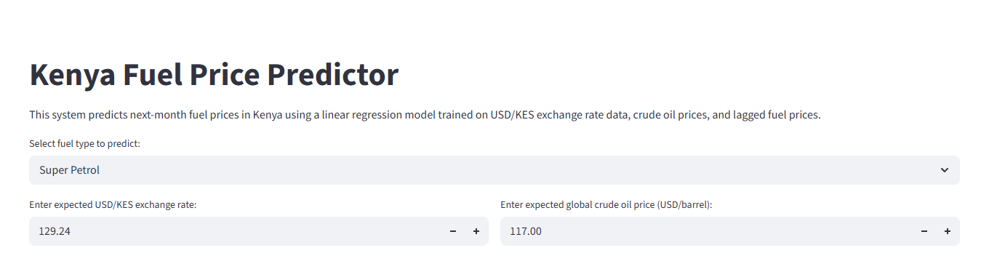
Figure 4.1: Application Input Form
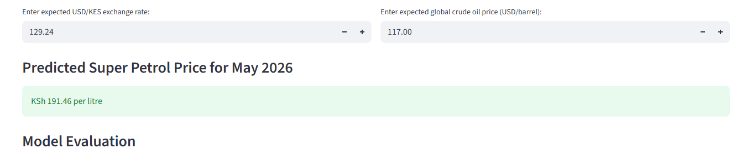
Figure 4.2: Super Petrol Prediction Output
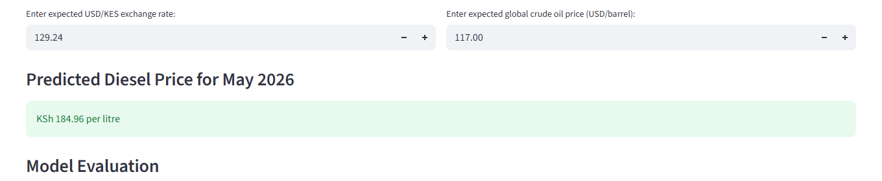
Figure 4.3: Diesel Prediction Output
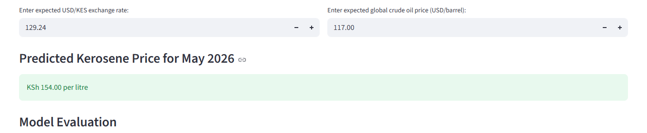
Figure 4.4: Kerosene Prediction Output
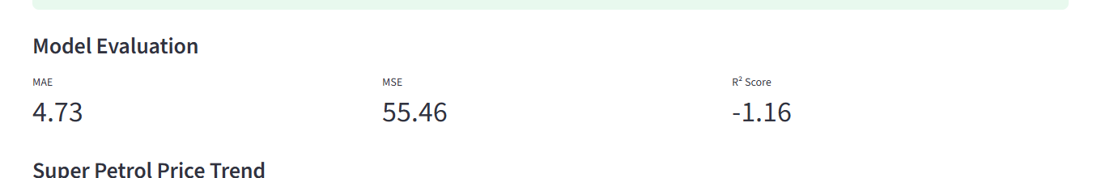
Figure 4.5: Model Evaluation Section
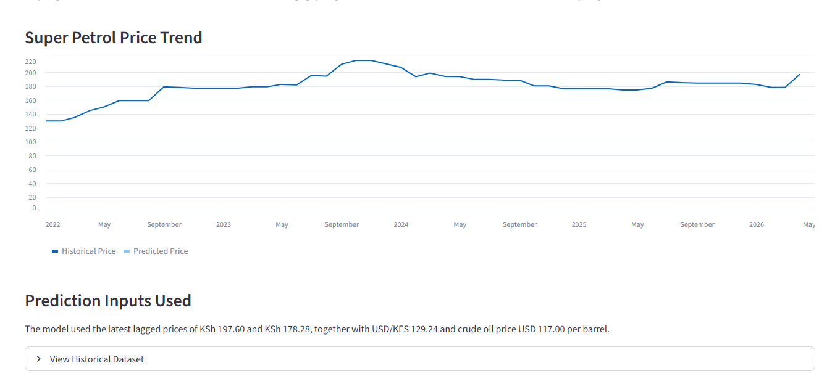
Figure 4.6: Fuel Price Trend Chart
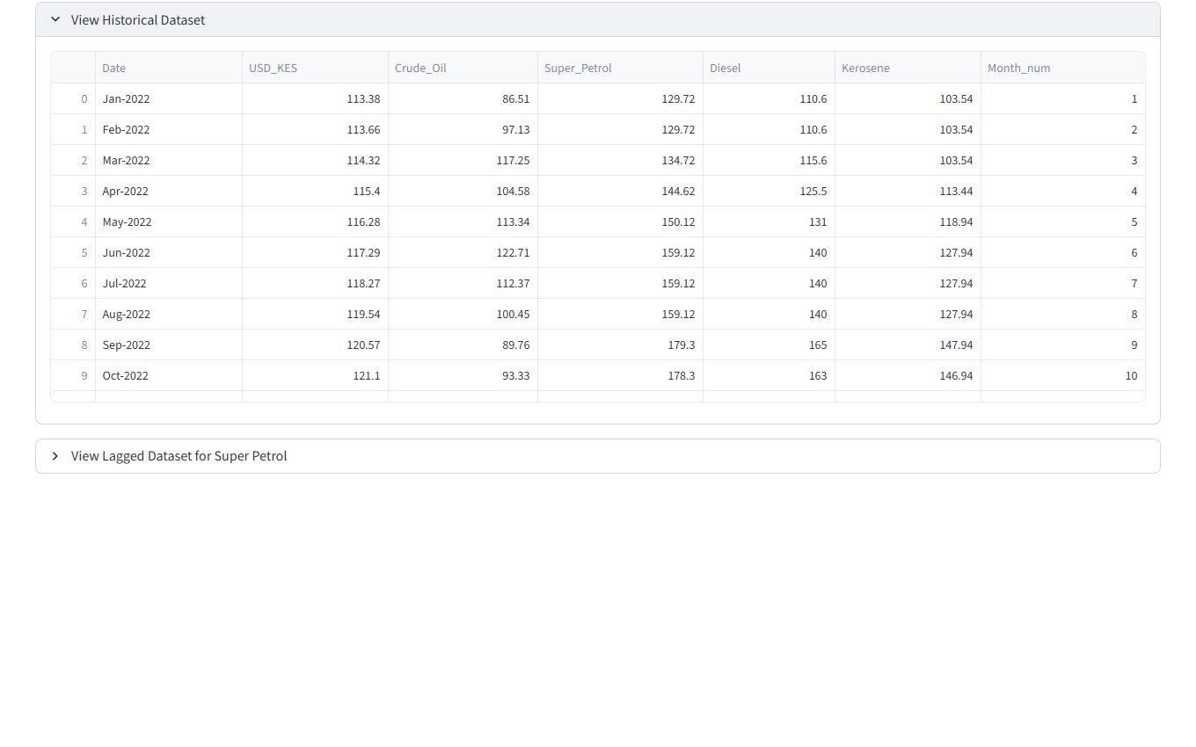
Figure 4.7: Historical Dataset Display
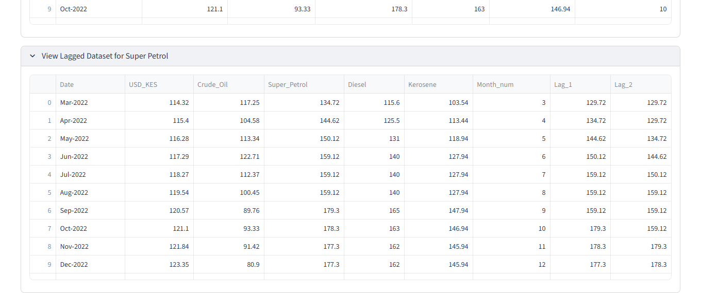
Figure 4.8: Lagged Dataset Display

4.5 User Guide
The system can be used through the following simple steps:
1. Install the project dependencies using `pip install -r requirements.txt`.
2. Start the application using `streamlit run app.py`.
3. Open the local Streamlit URL shown in the terminal.
4. Select the fuel type to predict: Super Petrol, Diesel, or Kerosene.
5. Enter the expected USD/KES exchange rate and crude oil price for the next month.
6. Read the predicted fuel price in Kenya shillings.
7. Review the displayed MAE, MSE, and R² Score values.
8. View the line chart, historical dataset, and lagged dataset for additional context.

4.6 Conclusions
The project achieved its main objective by developing a functional Fuel Price Prediction System Using Machine Learning. The final system loads a verified dataset, prepares lagged variables, trains a Linear Regression model, predicts next-month fuel prices, and displays the required supporting outputs in a simple web interface.
The most significant accomplishment is that the project integrates data preparation, model training, evaluation, visualization, and user interaction in one beginner-friendly application. However, the evaluation results also show a limitation: the small dataset and simple model reduce generalization performance, as indicated by low or negative R² values. This means the system is best presented as an academic prototype rather than a production forecasting tool.

4.7 Recommendations
Future work should extend the dataset to cover more years and possibly more explanatory variables, such as inflation, transport cost indicators, or international petroleum product benchmarks where appropriate and verified.
The project can also be improved by comparing Linear Regression with other forecasting models such as Random Forest, ARIMA, or gradient boosting. In addition, future versions could store data in a database, automate data updates, and provide a downloadable prediction report for users.

REFERENCES
Alwadi, M. A. (2025). Fuel sales price forecasting using time series, machine learning, and deep learning models. Engineering, Technology & Applied Science Research, 15(3), 22360-22366. https://doi.org/10.48084/etasr.10348
Central Bank of Kenya. (2025, April 2). Commercial banks' average exchange rates for major currencies / KES (closing of market) [PDF]. https://www.centralbank.go.ke/uploads/cbk_indicative_rates/620318092_CBK%20INDICATIVE%20RATES%203.4.2025.pdf
Cohen, G. (2025). A comprehensive study on short-term oil price forecasting using econometric and machine learning techniques. Machine Learning and Knowledge Extraction, 7(4), 127. https://doi.org/10.3390/make7040127
Energy and Petroleum Regulatory Authority. (n.d.). EPRA pump prices. Retrieved April 29, 2026, from https://www.epra.go.ke/EPRA%20Pump%20Prices
Energy and Petroleum Regulatory Authority. (n.d.). Pump price formulae. Retrieved April 29, 2026, from https://www.epra.go.ke/pump-price-formulae
Géron, A. (2022). Hands-on machine learning with Scikit-learn, Keras, and TensorFlow (3rd ed.). O'Reilly Media.
Hyndman, R. J., & Athanasopoulos, G. (2021). Forecasting: Principles and practice (3rd ed.). OTexts. https://otexts.com/fpp3/
James, G., Witten, D., Hastie, T., & Tibshirani, R. (2021). An introduction to statistical learning: With applications in R (2nd ed.). Springer. https://www.statlearning.com/
Montgomery, D. C., Jennings, C. L., & Kulahci, M. (2024). Introduction to time series analysis and forecasting (3rd ed.). Wiley.
pandas developers. (n.d.). pandas.read_csv. Retrieved April 29, 2026, from https://pandas.pydata.org/docs/reference/api/pandas.read_csv.html
scikit-learn developers. (n.d.). LinearRegression. Retrieved April 29, 2026, from https://scikit-learn.org/stable/modules/generated/sklearn.linear_model.LinearRegression.html
Streamlit. (n.d.). API reference. Retrieved April 29, 2026, from https://docs.streamlit.io/develop/api-reference
World Bank. (2026). Commodity markets. https://www.worldbank.org/en/research/commodity-markets
World Bank Prospects Group. (2026). World Bank commodities price data (The Pink Sheet). https://thedocs.worldbank.org/en/doc/74e8be41ceb20fa0da750cda2f6b9e4e-0050012026/world-bank-commodities-price-data-the-pink-sheet

APPENDICES

Appendix A: Data Extraction Sheet
Appendix Table A.1: Data Extraction Sheet
Field | Source | Frequency | Unit | Notes
Date | Project verified CSV dataset | Monthly | Month-Year | Used for chronological ordering and month numbering.
USD_KES | Central Bank of Kenya exchange rate publications | Monthly | KES per USD | Represents the exchange rate factor in the model.
Crude_Oil | World Bank commodity price data | Monthly | USD per barrel | Represents global crude oil price movement.
Super_Petrol | EPRA maximum retail pump prices | Monthly | KSh per litre | Target variable for super petrol forecasting.
Diesel | EPRA maximum retail pump prices | Monthly | KSh per litre | Target variable for diesel forecasting.
Kerosene | EPRA maximum retail pump prices | Monthly | KSh per litre | Target variable for kerosene forecasting.

Appendix B: Sample Dataset
Appendix Table B.1: Sample Dataset
Date | USD_KES | Crude_Oil | Super_Petrol | Diesel | Kerosene | Month_num
Jan-2022 | 113.38 | 86.51 | 129.72 | 110.6 | 103.54 | 1
Feb-2022 | 113.66 | 97.13 | 129.72 | 110.6 | 103.54 | 2
Mar-2022 | 114.32 | 117.25 | 134.72 | 115.6 | 103.54 | 3
Apr-2022 | 115.4 | 104.58 | 144.62 | 125.5 | 113.44 | 4
May-2022 | 116.28 | 113.34 | 150.12 | 131.0 | 118.94 | 5
Jun-2022 | 117.29 | 122.71 | 159.12 | 140.0 | 127.94 | 6
Jul-2022 | 118.27 | 112.37 | 159.12 | 140.0 | 127.94 | 7
Aug-2022 | 119.54 | 100.45 | 159.12 | 140.0 | 127.94 | 8
Sep-2022 | 120.57 | 89.76 | 179.3 | 165.0 | 147.94 | 9
Oct-2022 | 121.1 | 93.33 | 178.3 | 163.0 | 146.94 | 10

Appendix C: Source Code
The full application source code is provided in the repository file `app.py` and duplicated in `appendices/App_Source_Code.py`. A short excerpt of the main workflow is shown below.
def main() -> None:
data = load_data()
selected_fuel = st.selectbox("Select fuel type to predict:", list(FUEL_OPTIONS.keys()))
fuel_column = FUEL_OPTIONS[selected_fuel]
model_data = create_lagged_data(data, fuel_column)
model, metrics = train_model(model_data, fuel_column)
future_input = build_future_input(data, fuel_column, usd_kes, crude_oil)
prediction = float(model.predict(future_input)[0])

Appendix D: Testing Screenshots
The testing screenshots used in Chapter 4 are stored in the `outputs/screenshots/` folder of the repository. These include the application input form, prediction outputs for each fuel type, the model evaluation section, the trend chart, and dataset views.

Appendix E: Project Schedule
Appendix Table E.1: Project Schedule
Activity | Start Period | End Period
Problem definition and proposal alignment | September 2025 | October 2025
Data collection and verification | November 2025 | January 2026
Data analysis and model development | February 2026 | March 2026
Streamlit system implementation | March 2026 | April 2026
Testing, documentation, and final report writing | April 2026 | May 2026

Appendix F: Budget
Appendix Table F.1: Project Budget
Item | Estimated Cost (KSh)
Internet and data bundles | 4000
Printing and binding | 3500
Transport for consultations | 5000
Contingency | 2500
Total | 15000

Appendix G: GitHub Repository Link
Repository URL: https://github.com/ryanair000/fuel-price-predictor

Appendix H: Jupyter Notebook Reference
Notebook file: notebooks/FuelPriceAnalysis.ipynb

