Git Guide

Table of Contents
Open Command prompt 1
Download gitlab to your computer 1
Update gitlab with new files 2
Clone my github on my computer 2
Upload my code to git lab 3
Create a new git branch 3
Change branches 3
Git Status 4
I changed a file and I want the original 5
How do I remove a file from my repo 5
I tried to push my changes but it was rejected 5
I got a merge error trying to pull from github 6

Open Command prompt
- Windows
  - Open Git Bash
- Mac
  - Open a terminal

Download gitlab to your computer
- Open Command prompt
- Enter the below command and press enter, it may take several minutes to download
  - git clone https://ua.bootcampcontent.com/UA-Coding-Bootcamp/UAPHX201905DATA4.git
- You will be prompted to login to your gitlab account

Update gitlab with new files
- Open Command prompt
- Navigate to your UAPHX201905DATA4 folder
  - Use the cd command to navigate through directories
  - Ex: cd UAPHX201905DATA4
- Type the below command
  - git pull

Clone my github on my computer
- Open github
- From the root of your repository click the green button that says download
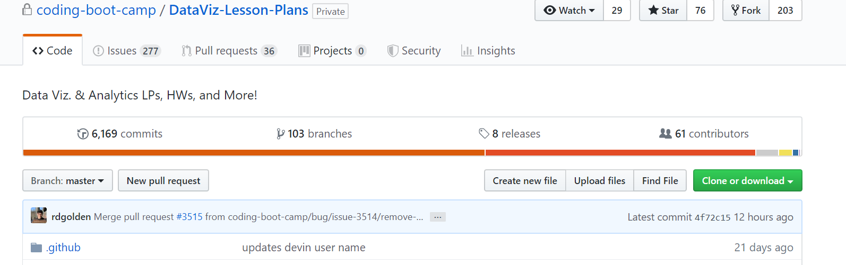
- A box will popup, click the clipboard at the end of the URL. This will copy the URL which you will paste in step 5.
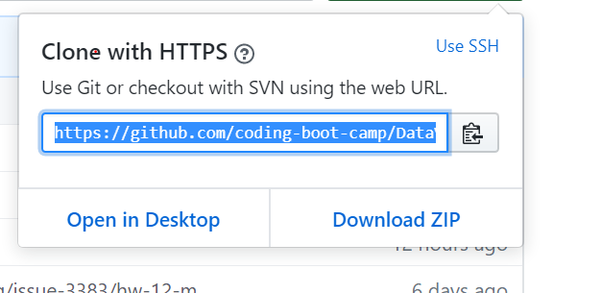
- Open Command prompt
  - Windows: Open Git Bash
  - Mac: Open a terminal
- Type git clone then right click and click paste
  - Ex: git clone https://ua.bootcampcontent.com/UA-Coding-Bootcamp/UAPHX201905DATA4.git

Upload my code to git lab
- Open Command prompt
- Navigate to where your file is by using the cd command
  - cd <path to folder name>
  - Ex: cd homework/python/pybank
- git add <filename>
  - Ex: git add pybank.py
- git commit -m “uploading homework”
  - The message can say whatever you want it to, its a message about what you are committing to the repository
- git push

Create a new git branch
- Open Command prompt
- Navigate to where your file is by using the cd command
  - cd <path to folder name>
  - Ex: cd homework/python/pybank
- Type git checkout -b <branchName>
  - Ex: git checkout -b myNewBranch

Change branches
- Open Command prompt
- Navigate to where your file is by using the cd command
  - cd <path to folder name>
  - Ex: cd homework/python/pybank
- Type: git checkout <branchname>
  - Ex: git checkout master

Git Status
- Git status can be used to determine the status of your files. There are 3 sections for git status.
  - Changes to be committed:
    - These will be highlighted in green
    - There are changed files you have added but not yet pushed
  - Changes not staged for commit:
    - These files will be highlighted in red
    - These files are changed from what was in the repository but not yet added to the commit
  - Untracked Files:
    - These files will be highlighted in red
    - These are files in your repository which have never been committed to your repo.
    - These could be new files for your repo or something you downloaded but never need to commit.
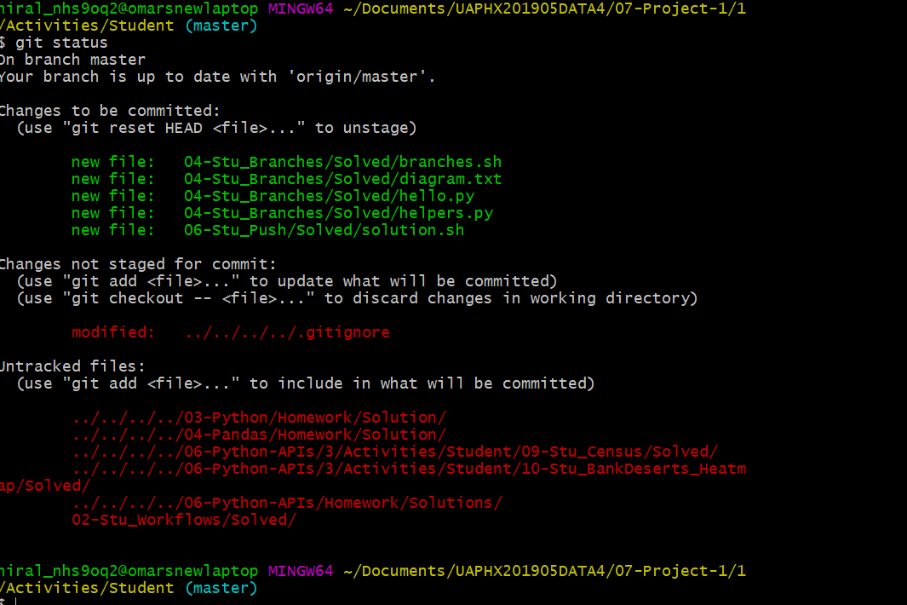

I changed a file and I want the original
- For example from the image above I made changes to ../../../../.gitignore but I want the file I currently have committed in the repo and would like to throw out the change.
- I type git checkout -- ../../../../.gitignore
- If I type git status again I will see that, that file no longer shows up in Changes not staged for commit: and I will have my same file from the repo.

How do I remove a file from my repo
- Type git rm <filename>
- Ex: git rm myfile.py
- NOTE: This will delete it from your computer as well so only do this if you mean it.

I tried to push my changes but it was rejected
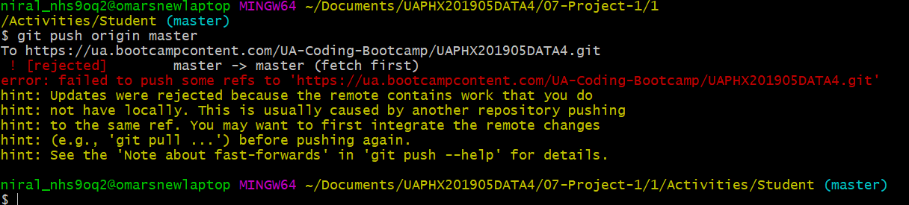
- If you see the above error that means there was a change on the repo which you have not “pull”ed before trying to push
- You can try doing a git pull if that is successful you can run git push again and it should work.
- If you get a merge conflict see the next section

I got a merge error trying to pull from github
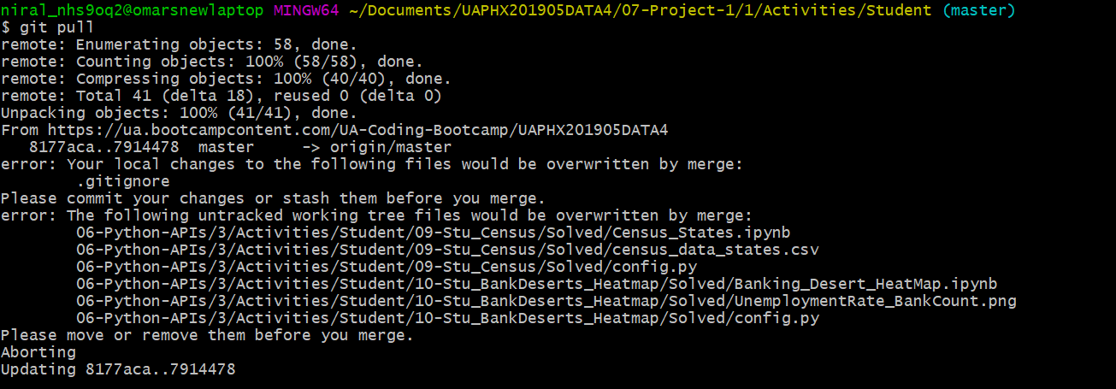
- This happens when you have a file that is changed in the repository and different on your computer. There are a few ways you can resolve this.
  - Temporarily move the affected file(s) to a new directory outside of your repo.
    - In the example above there are 6 files.
    - I can type mv 06-Python-APIs/3/Activities/Student/09-Stu_Census/Solved/Census_States.ipynb /tmp
      - NOTE: it is mv <source> <destination>
    - This will move the targeted file to my /tmp folder.
    - Then I can run the pull again, and determine which files I want to keep.
      - If I want the files I moved i can use the mv command to move the file back
      - Ex: mv /tmp/Census_States.ipynb 06-Python-APIs/3/Activities/Student/09-Stu_Census/Solved/
  - Use the git stash option
    - Typing git stash will stash all uncommited changes
    - This will add your changes onto a stack that you can pop them back off of later
    - So if i wanted to stash my changes pull from the repository then restore my files I would do the following commands
      - I type git stash
      - I type git pull to get all the committed changes to the repo.
      - I type git stash list to show me the list of stashed items the one I just did should be on top. stash@{0}
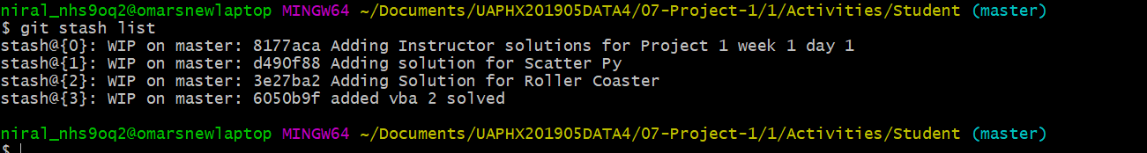
      - I type git stash apply stash@{0} and I will see that all my uncommitted files from before I pulled are back.
