API Login – Bad Request

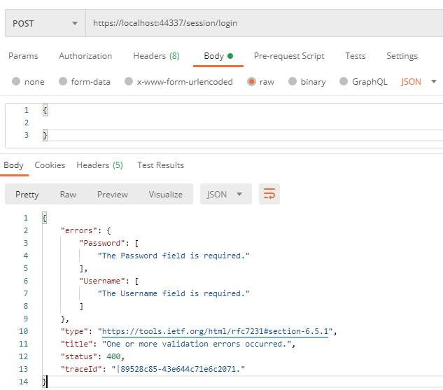

API Login – (this will Registers User if none are in the in-memory DB)

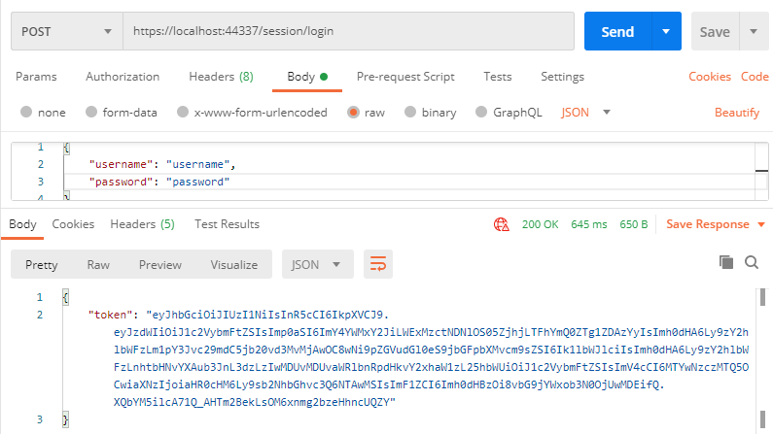

API Covid results – No Authorization

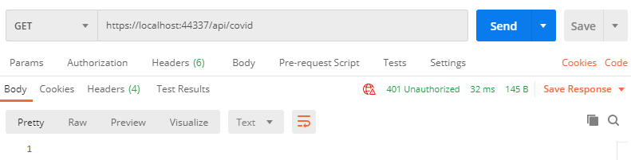

API Covid results – With Authorization

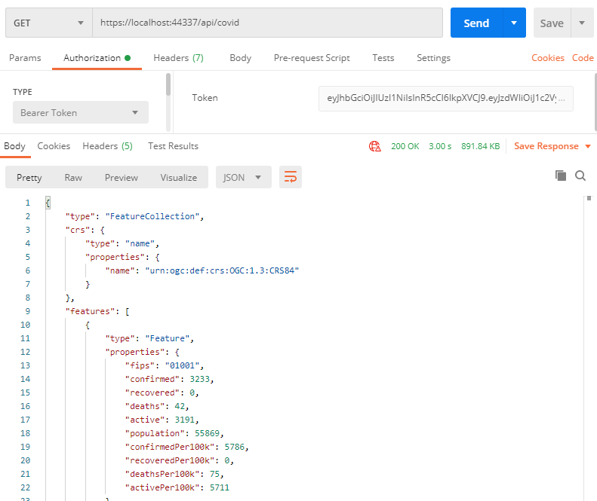

Browser – Returns a Guest cookie that allows the browser to retrieve data from Covid API.

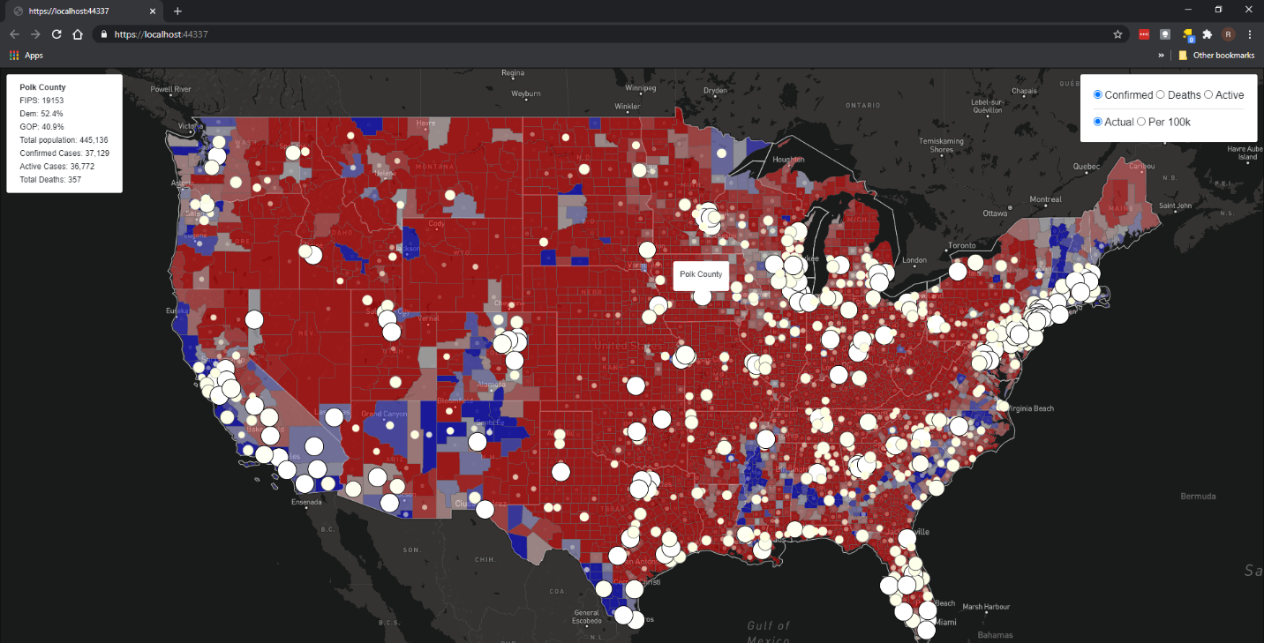

External APIs used:  
 **Mapbox – within the View**  
 <https://api.mapbox.com/mapbox-gl-js/v1.12.0/mapbox-gl.js>

**Population API** – returns population amounts for the covid per 100k results  
 <https://opendata.arcgis.com/datasets/628578697fb24d8ea4c32fa0c5ae1843_0.geojson>

**Covid API** – returns an up to date Geojson used for the Mapbox API  
 [https://api.census.gov/data/2019/pep/population?get=POP&for=county:*](https://api.census.gov/data/2019/pep/population?get=POP&for=county:*)