**The system metaphor**

***Overview***

The system works like **Voyage.**  Departing from the **Starting point** given by the **Sailor** or **Captain,** it **Explores** the world within certain **Scope**. During the **Voyage**, The system collects and **Save** the data which will be **Analyzed** and used to **Make a Map**

***Key words***

**Starting point:** the original source where we start with. It usually comes from user’s input (typically the article URL)

**Explore:** the process that the system searches and collects data among online news sources that which link to, quote, and mention the **Starting point.**



**Save:** store collected data for further use (eg. To **Make a Map, Convert** and **Analyze**)

**Map**: an interactive visualization. Each **point** represents one specific news source, and the other points linking to that point are other online sources (English-languge news sources and twitter users) which link to, quote, and mention that original source.

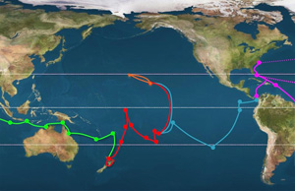 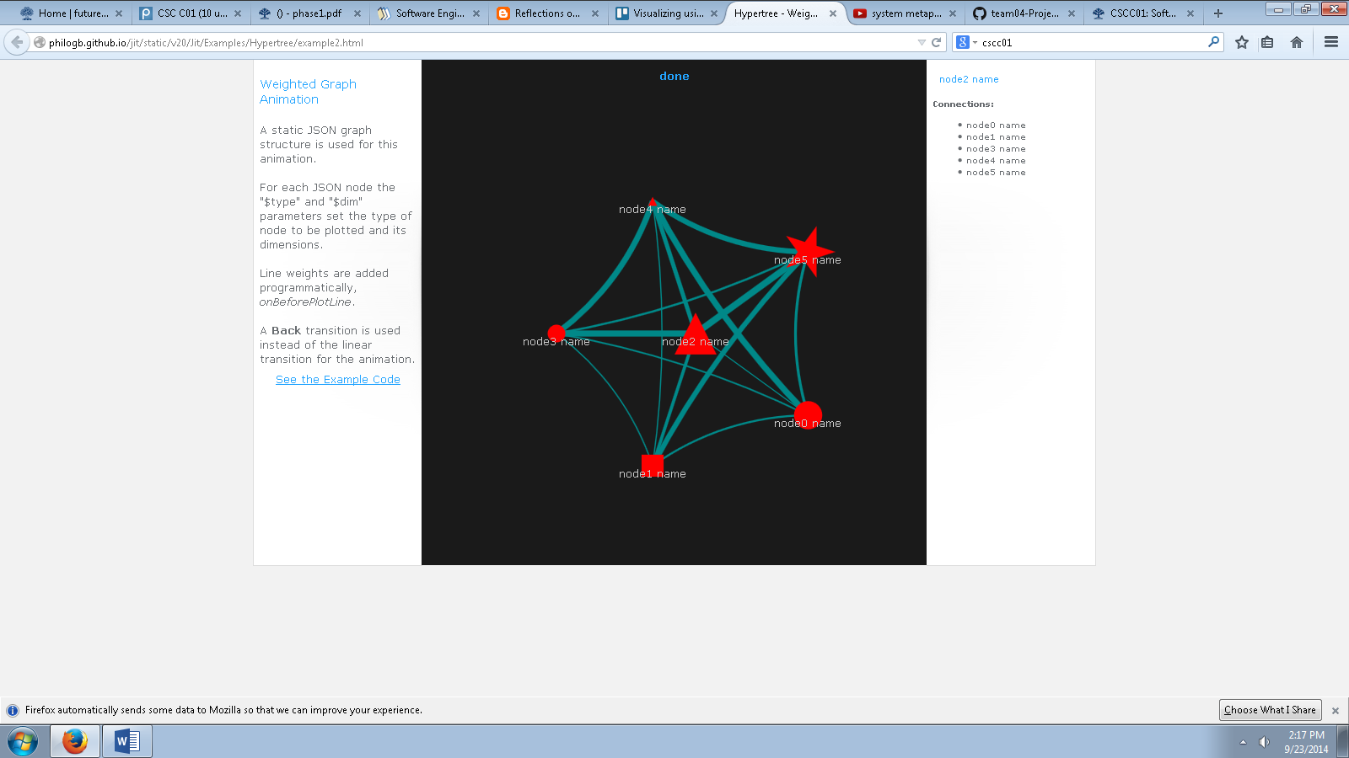

**Make a Map:** makinga **Map** (an interactive visualization like the upper-right picture) by using data collected through **Explore.**

**Scope**: a list of global English-language news sources that are monitored. **Explore** cannot be operated outside the **Scope**.

Also, users can set the Scope to define a list of global English-language news sources to monitor.

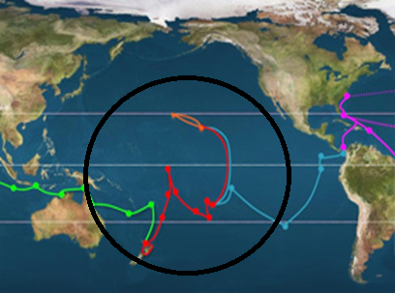

**Convert:** retrieve particular stored data in other formatssuch as XML, JSON or Web ARChive (WARC).

**Analyze**: get statistics based on the collected data, or sort data by some features.

**Sailor:** a kind of users with restricted permissions. They can only perform normal operations such as **Explore, Save,** and **Make a Map.** (Usually for researchers)

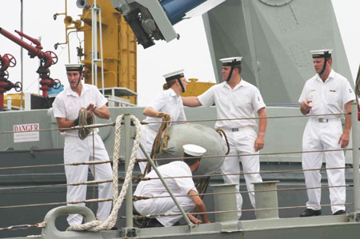

**Captain:** a kind of users with all permissions, they take control of all **Sailor** users. In addition to the **Sailor**’s permissions, they can change edit the configuration file, use terminal and so on. (Usually for Librarians)

