Ryan Berger
CS665

1. I used the Strategy pattern, which uses delegates in a class determined by interfaces or abstract classes. By doing this, different algorithms can be invoked from the same class. I only needed a single interface for my Employee design, but it did force each class that implemented it to use specific functions (which all had to be separately defined). If I had used abstract classes instead, I might have been able to inherit some of the code in the Pay subclasses. This differs from homework 1 and 2 where it does not directly use inheritance, but uses interfaces and delegation instead.

2. For employees, I did not use inheritance. Instead, I used behavior interfaces which are delegated in the Employee class. By using interfaces, I was able to define how each type of employee could behave. The downside of using this strategy instead of abstract classes is that I could have included functions in the abstract class for possible re-usability via inheritance.

3. public void setMonthlyData(Allocation all)
{
payBehavior.setMonthlyData(all);
}
The type of Allocation is not selected until Employee is invoked in the Firm class.

public double getCost(int projectNumber)
{
return payBehavior.getCost(projectNumber);
}
The type of payBehavior is not determined until Employee is invoked in the Firm class.

4. I insulated the details of computing pay from the Employee, Firm, and Allocation classes. If another kind of employee was added, then a new Pay class and Allocation class would need to be created to implement PayBehavior. In the last assignment, the same amount of work was needed.

5.
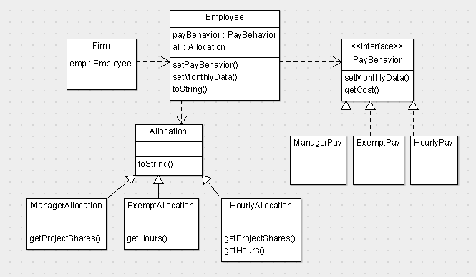

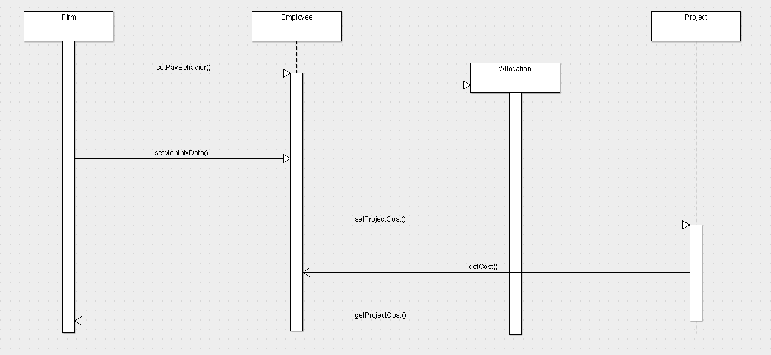

package cs665hw3;

import java.util.ArrayList;
import java.util.List;

/**
*
* @author Ryan
*/
public class Firm {

private double utilities;
private double rent;
private double equipment;

public Firm(double utilities,
double rent,
double equipment)
{
this.utilities = utilities;
this.rent = rent;
this.equipment = equipment;
}

public static void main(String[] args) {

List<Project> projectList = new ArrayList();
List<Employee> employeeList = new ArrayList();
String firmData = "2000.0:10000.0:3000.0";
String projectData = "April:Rose:0.2:0.4:0.6;"
+ "April:Jasmine:0.8:0.6:0.4";
String employeeData = "Green:Manager:90000.0:0.2,0.8;"
+ "Black:Hourly:20.0:0.5,0.5:50.0;"
+ "Brown:Hourly:10.0:0.4,0.6:30.0;"
+ "Jones:Exempt:60000.0:80.0,80.0;"
+ "Smith:Exempt:48000.0:40.0,120.0";

String[] firms = firmData.split(":");

Firm firm = new Firm(Double.parseDouble(firms[0]),
Double.parseDouble(firms[1]),
Double.parseDouble(firms[2]));

String[] employees = employeeData.split(";");

for (String e: employees)
{
Employee emp = null;
double[] projectShares = null;
double[] totalHours = null;
String[] employeeGroup = e.split(":");
String employeeType = employeeGroup[1];

projectShares = getProjectInfo(employeeGroup, projectShares, 3);
totalHours = getProjectInfo(employeeGroup, projectShares, 4);

if (employeeType.equals("Manager"))
{
emp = new Employee();
emp.setPayBehavior(new ManagerPay(employeeGroup[0],
employeeType,
Double.parseDouble(employeeGroup[2])));
emp.setMonthlyData(new ManagerAllocation(projectShares));
}
else if(employeeType.equals("Hourly"))
{
emp = new Employee();
emp.setPayBehavior(new HourlyPay(employeeGroup[0],
employeeType, Double.parseDouble(employeeGroup[2])));
emp.setMonthlyData(new
HourlyEmployeeAllocation(projectShares, totalHours));
}
else if(employeeType.equals("Exempt"))
{
emp = new Employee();
emp.setPayBehavior(new ExemptPay(employeeGroup[0],
employeeType,
Double.parseDouble(employeeGroup[2])));
emp.setMonthlyData(new
ExemptEmployeeAllocation(projectShares));
}
employeeList.add(emp);
}

int projectNumber = 0;
String[] projects = projectData.split(";");
for (String p: projects)
{
String[] projectGroup = p.split(":");
Project tempProj = new Project(projectGroup[0],
projectGroup[1],
Double.parseDouble(projectGroup[2]),
Double.parseDouble(projectGroup[3]),
Double.parseDouble(projectGroup[4]),
employeeList,
firm,
projectNumber);
tempProj.setProjectCost();
projectList.add(tempProj);
projectNumber++;
}

printReport(employeeList, projectList, firm);

}

/**
* Extracts projectInfo from input string
* @param employeeGroup
* @param projectShares
* @param index
* @return projectShares
* @throws NumberFormatException
*/
private static double[] getProjectInfo(String[] employeeGroup,
double[] projectShares,
int index) throws NumberFormatException {
if (employeeGroup.length > index)
{
int i = 0;
String[] projectTemp = (employeeGroup[index]).split(",");
projectShares = new double[projectTemp.length];
for (String h : projectTemp) {
projectShares[i] = Double.parseDouble(h);
i++;
}
}
return projectShares;
}

/**
* Prints report of employee and project data
* @param empList
* @param projList
*/
private static void printReport(List<Employee> empList,
List<Project> projList,
Firm firm)
{
for (Employee emp: empList)
{
System.out.println(emp.toString());
}
System.out.println(firm.toString());

for (Project proj: projList)
{
System.out.println(proj.toString());
}
}

public double getUtilities()
{
return utilities;
}

public double getRent()
{
return rent;
}

public double getEquipment()
{
return equipment;
}

@Override
public String toString()
{
return "Utilities, Rent, Equipment: "
+ utilities + " " + rent + " " + equipment;
}

}

package cs665hw3;

/**
*
* @author Ryan
*/
public class Employee {

private Allocation all;
private PayBehavior payBehavior;

public Employee()
{
}

public void setPayBehavior(PayBehavior pb)
{
payBehavior = pb;
}

public void setMonthlyData(Allocation all)
{
payBehavior.setMonthlyData(all);
}

public Allocation getMonthlyData()
{
return all;
}

public double getCost(int projectNumber)
{
return payBehavior.getCost(projectNumber);
}

@Override
public String toString()
{
return payBehavior.toString();
}

}

package cs665hw3;

/**
*
* @author Ryan
*/
public interface PayBehavior {

public void setMonthlyData(Allocation all);

public double getCost(int projectNumber);

}

package cs665hw3;

/**
*
* @author Ryan
*/
public class ManagerPay implements PayBehavior {

private ManagerAllocation all;
private String name;
private String status;
private double salary;

public ManagerPay(String name,
String status,
double salary)
{
this.name = name;
this.status = status;
this.salary = salary;
}

public void setMonthlyData(Allocation all)
{
this.all = (ManagerAllocation)all;
}

public double getProjectShare(int projectNumber)
{
return all.getProjectShares()[projectNumber];
}

public double getCost(int projectNumber)
{
double percentWorked = getProjectShare(projectNumber);
return salary / 12 * percentWorked;
}

@Override
public String toString()
{
return name + " "
+ status
+ " Salary: " + salary
+ " " + all.toString();
}

}

package cs665hw3;

/**
*
* @author Ryan
*/
public class ExemptPay implements PayBehavior {

private ExemptEmployeeAllocation all;
private String name;
private String status;
private double salary;

public ExemptPay(String name,
String status,
double salary)
{
this.name = name;
this.status = status;
this.salary = salary;
}

public void setMonthlyData(Allocation all)
{
this.all = (ExemptEmployeeAllocation)all;
}

public double getHours(int projectNumber)
{
return all.getHours()[projectNumber];
}

public double getCost(int projectNumber)
{
double hoursWorked = getHours(projectNumber);
return salary * hoursWorked / 12 / 160;
}

@Override
public String toString()
{
return name + " "
+ status + " Salary: " + salary
+ " " + all.toString();
}

}

package cs665hw3;

/**
*
* @author Ryan
*/
public class HourlyPay implements PayBehavior {

private HourlyEmployeeAllocation all;
private String name;
private String status;
private double hourlyRate;

public HourlyPay(String name,
String status,
double hourlyRate)
{
this.name = name;
this.status = status;
this.hourlyRate = hourlyRate;
}

public void setMonthlyData(Allocation all)
{
this.all = (HourlyEmployeeAllocation)all;
}

public double[] getHours()
{
return all.getHours();
}

public double getProjectShare(int projectNumber)
{
return all.getProjectShares()[projectNumber];
}

public double getCost(int projectNumber)
{
double hoursWorked = getHours()[0];
double percentWorked = getProjectShare(projectNumber);
double cost = 0.0;

if (hoursWorked > 40)
{
cost = hourlyRate * 40 * percentWorked;
cost += (hourlyRate * percentWorked * (hoursWorked - 40)) * 1.5;
}
else
{
cost = hourlyRate * percentWorked * hoursWorked;
}

return cost;
}

@Override
public String toString()
{
return name + " "
+ status + " Hourly Rate: " + hourlyRate
+ " " + all.toString();
}

}

package cs665hw3;

/**
*
* @author Ryan
*/
public abstract class Allocation {

@Override
public abstract String toString();
}

package cs665hw3;

/**
*
* @author Ryan
*/
public class ManagerAllocation extends Allocation {

private double[] projectShares;

public ManagerAllocation(double[] projectShares)
{
this.projectShares = projectShares;
}

public double[] getProjectShares()
{
return projectShares;
}

@Override
public String toString()
{
String output = "Project shares:";
for (double s: projectShares)
{
output += " " + s;
}
return output;
}
}

package cs665hw3;

/**
*
* @author Ryan
*/
public class ExemptEmployeeAllocation extends Allocation {

private double[] projectHours;

public ExemptEmployeeAllocation(double[] projectHours)
{
this.projectHours = projectHours;
}

public double[] getHours()
{
return projectHours;
}

@Override
public String toString()
{
String output = "Project hours:";
for (double h: projectHours)
{
output += " " + h;
}
return output;
}

}

package cs665hw3;

/**
*
* @author Ryan
*/
public class HourlyEmployeeAllocation extends Allocation {

private double[] projectShares;
private double[] totalHours;

public HourlyEmployeeAllocation(double[] projectShares,
double[] totalHours)
{
this.projectShares = projectShares;
this.totalHours = totalHours;
}

public double[] getProjectShares()
{
return projectShares;
}

public double[] getHours()
{
return totalHours;
}

@Override
public String toString()
{
String output = "Project shares:";
for (double s: projectShares)
{
output += " " + s;
}

output += " Total hours:";
for (double h: totalHours)
{
output += " " + h;
}

return output;
}
}

package cs665hw3;

import java.util.List;

/**
*
* @author Ryan
*/
public class Project {

private String month;
private String name;
private double percentUtilities;
private double percentRent;
private double percentEquipment;
private List<Employee> employees;
private Firm firm;
private int projectNumber;
private double cost = 0.0;

public Project(String month,
String name,
double percentUtilities,
double percentRent,
double percentEquipment,
List<Employee> employees,
Firm firm,
int projectNumber)
{
this.month = month;
this.name = name;
this.percentUtilities = percentUtilities;
this.percentRent = percentRent;
this.percentEquipment = percentEquipment;
this.employees = employees;
this.firm = firm;
this.projectNumber = projectNumber;
}

public void setProjectCost()
{
for (Employee emp: employees)
{
cost += emp.getCost(projectNumber);
}
}

public double getProjectCost()
{
return cost;
}

@Override
public String toString()
{
double utilities = (firm.getUtilities() * percentUtilities);
double rent = (firm.getRent() * percentRent);
double equipment = (firm.getEquipment() * percentEquipment);
double total = utilities + rent + equipment + cost;

return "Month of "
+ month + " Project " + name + ": "
+ utilities + " "
+ rent + " "
+ equipment + " "
+ cost + " "
+ total;
}

}

Green Manager Salary: 90000.0 Project shares: 0.2 0.8
Black Hourly Hourly Rate: 20.0 Project shares: 0.5 0.5 Total hours: 50.0
Brown Hourly Hourly Rate: 10.0 Project shares: 0.4 0.6 Total hours: 30.0
Jones Exempt Salary: 60000.0 Project hours: 80.0 80.0
Smith Exempt Salary: 48000.0 Project hours: 40.0 120.0
Utilities, Rent, Equipment: 2000.0 10000.0 3000.0
Month of April Project Rose: 400.0 4000.0 1800.0 5670.0 11870.0
Month of April Project Jasmine: 1600.0 6000.0 1200.0 12230.0 21030.0

