Ryan Berger
CS665

Prof Shtern, thank you for the extension. Due to my inexperience with Java GUIs, I was not able to finish all of the assignment (it took me awhile to get what I have working). As you will see, I was able to pass the data to the GUI, but could not figure out how to properly draw on the canvas. As a result, the data is printed in the title bar of the window and the graph functionality is not implemented. There are also no checkboxes.

1. My program is not complete, but uses two observer patterns. One is used to control the retrieval of data from the Firm class to the Display class. I used the built-in Java class to achieve this since only a simple implementation with little customization was needed. I considered this to be an advantage over the traditional implementation since the built-in Java class required fewer lines of code. The second use of the observer pattern was for the button click. I used a scaled-down version of the observer pattern which simply created a listener on the button.

2. My program did not use any inheritance (although I suspect it would have been useful to create an abstract base class for the graph and table classes since they both use the same input data; an interface would not have been appropriate since data is involved).

3. display.update(observable, comboBox.getSelectedItem()); Substitution is possible here since update method casts the second parameter to a String.

4. I did not implement the graph, but for the text neither of the classes seem to be fully insulated. The Observer and Observable classes are mediating between them, but there still seems to be some dependencies between them. If drawing types were added, they should be able to use the same Observable as the text.

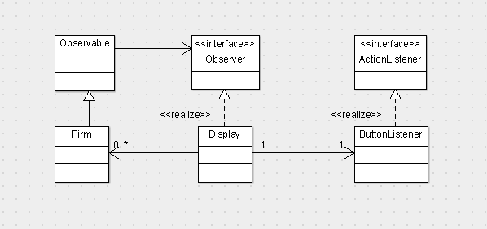

I'm not sure what you mean by Instance Diagram. I cannot find any examples in the book or lecture notes.
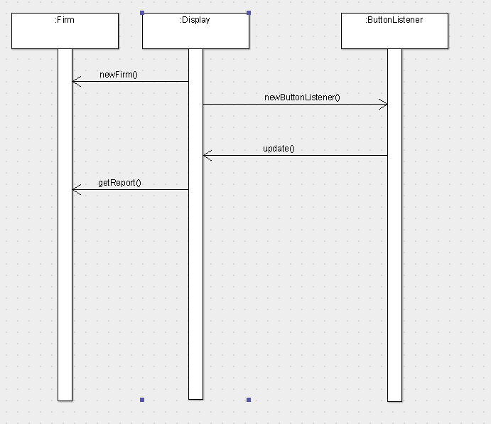

package cs665hw4;

import java.util.HashMap;
import java.util.Observable;

/**
*
* @author Ryan
*/
public class Firm extends Observable {

private HashMap firstQ;
private double firstQuarter;
private HashMap secondQ;
private double secondQuarter;
private HashMap thirdQ;
private double thirdQuarter;
private HashMap fourthQ;
private double fourthQuarter;

public void Firm()
{ }

public void firmChanged()
{
setChanged();
notifyObservers();
}

public void setFirm(String year)
{
setFirm(firstQ, secondQ, thirdQ, fourthQ, year);
}

public void setFirm(HashMap firstQ, HashMap secondQ,
HashMap thirdQ, HashMap fourthQ, String year)
{
this.firstQuarter = ((Double)firstQ.get(year)).doubleValue();
this.secondQuarter = ((Double)secondQ.get(year)).doubleValue();
this.thirdQuarter = ((Double)thirdQ.get(year)).doubleValue();
this.fourthQuarter = ((Double)fourthQ.get(year)).doubleValue();
firmChanged();
}

public void initialize()
{
firstQ = new HashMap();
firstQ.put("2008", 1000.0);
firstQ.put("2009", 2000.0);
secondQ = new HashMap();
secondQ.put("2008", 2300.0);
secondQ.put("2009", 3000.0);
thirdQ = new HashMap();
thirdQ.put("2008", 1000.0);
thirdQ.put("2009", 4500.0);
fourthQ = new HashMap();
fourthQ.put("2008", 1000.0);
fourthQ.put("2009", 3000.0);

}

public String getReport()
{
return toString();
}

public double getFirstQuarter()
{
return firstQuarter;
}

public double getSecondQuarter()
{
return secondQuarter;
}

public double getThirdQuarter()
{
return thirdQuarter;
}

public double getFourthQuarter()
{
return fourthQuarter;
}

@Override
public String toString()
{
return firstQuarter + " " + secondQuarter
+ " " + thirdQuarter + " " + fourthQuarter;
}

}

package cs665hw4;

import java.awt.BorderLayout;
import javax.swing.JButton;
import javax.swing.JFrame;
import java.util.Observable;
import java.util.Observer;
import javax.swing.JComboBox;

/**
*
* @author Ryan
*/
public class Display implements Observer {

Observable observable;
JFrame frame;
String data;

public Display(Observable observable)
{
this.observable = observable;
}

public void update(Observable obs, Object arg)
{
if (obs instanceof Firm)
{
Firm firm = (Firm)obs;
firm.initialize();
firm.setFirm((String) arg);
this.data = firm.getReport();
frame.setTitle(data);
}
}

public static void main(String[] args)
{
Firm firm = new Firm();
Display display = new Display(firm);

display.go();
}

public void go()
{
frame = new JFrame();
JButton button = new JButton("Show Data");
final JComboBox comboBox = new JComboBox();
comboBox.addItem("2008");
comboBox.addItem("2009");
frame.getContentPane().add(BorderLayout.BEFORE_FIRST_LINE, comboBox);
frame.getContentPane().add(BorderLayout.LINE_START, button);
frame.setDefaultCloseOperation(JFrame.EXIT_ON_CLOSE);
frame.setSize(400, 450);
frame.show();

button.addActionListener(new ButtonListener(this,
observable, comboBox));
}

}

package cs665hw4;

import java.awt.event.ActionEvent;
import java.awt.event.ActionListener;
import java.util.Observable;
import javax.swing.JComboBox;

/**
*
* @author Ryan
*/
public class ButtonListener implements ActionListener {

private Display display;
private Observable observable;
private JComboBox comboBox;

public ButtonListener(Display display, Observable observable,
JComboBox comboBox)
{
this.display = display;
this.observable = observable;
this.comboBox = comboBox;
}

public void actionPerformed(ActionEvent e) {
// Type of reference is different here,
// but is cast as a String in update method
display.update(observable, comboBox.getSelectedItem());
}
}

