Ryan Berger
CS665 HW 5

1. The decorator pattern I used involved several filters being applied to the input movie list and adding the accepted movies to a final list. In general, the more filters that were applied, the smaller the final list would be. The Movie class holds all of the descriptive details of each movie that is contained in the “database”. The Filter superclass is abstract and cannot be directly invoked. It contains an abstract method acceptMovie() which is implemented in each subclass to determine if a movie fits the input criteria. The Filter class also has a method getMovies() which applies an individual filter depending on its type at run-time. Finally, the Main class creates each filter and invokes the getMovies() method and keeps track of the final movie list for each set of commands.

2. I used inheritance with an abstract class for the different filters. The Filter superclass has a getMovies() method which calls the abstract method acceptMovie(). Depending on which type of filter was instantiated, a different instance of acceptMovie() is invoked at runtime.

3. finalList = filter.getMovies(finalList); - The type of filter could belong to any subclass of Filter.
if (acceptMovie(movie)) – The method acceptMovie could belong to any subclass of Filter.

4. I insulated the Movie class from all details of filtering. I also insulated the Filter superclass from any detail of filtering other than the action of adding the accepted movies to the final list. My Main class was insulated from all of the filtering other than creating the filter objects and invoking their methods. If I wanted to add a filter for number of stars or movie title, I would simply just need to add new Filter subclasses and then create them in my Main class.

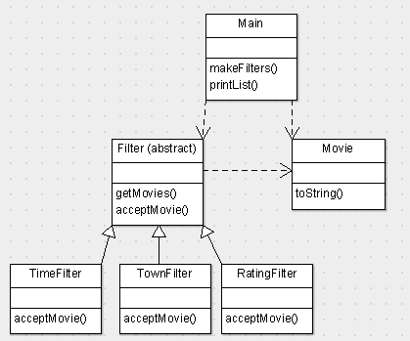
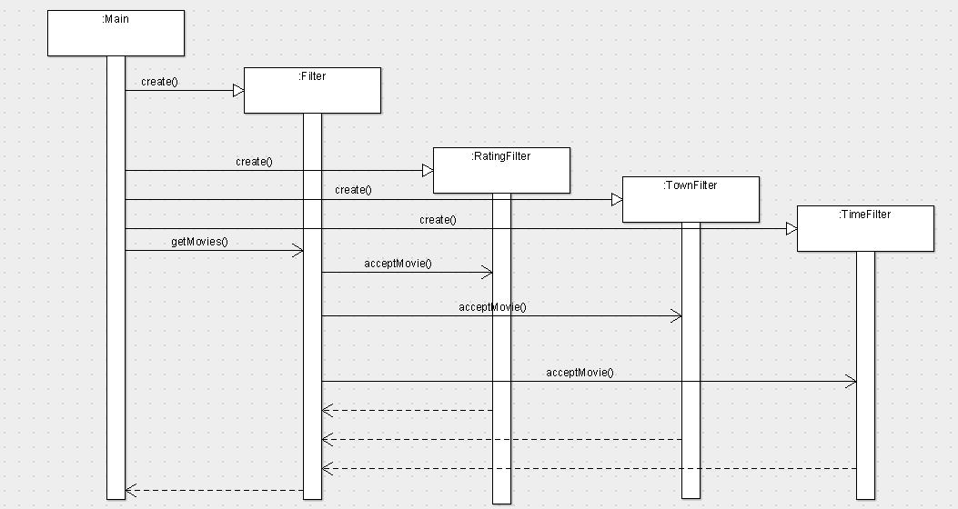
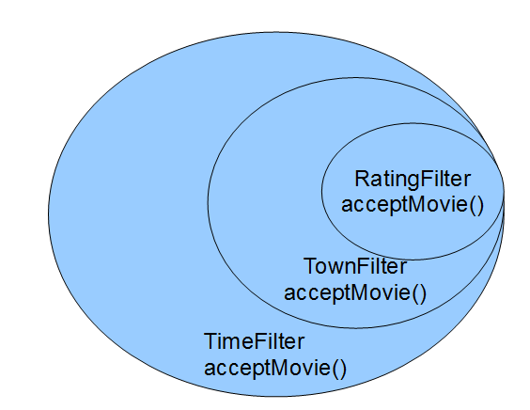

package cs665hw5;

import java.text.ParseException;

/**
*
* @author Ryan
*/
public class Main {

private Movie movies[] = {
new Movie("War and Peace", "Boston", "PG", 2,
new String[] {"2:15 pm", "5:20 pm", "7:50 pm", "10:15 pm"}),
new Movie("Splash", "Boston", "G", 3,
new String[] {"1:55 pm", "4:05 pm", "7:35 pm", "10:10 pm"}),
new Movie("Birds", "Waltham", "PG-13", 4,
new String[] {"4:30 pm", "9:00 pm"}),
new Movie("Gone with the Wind", "Cambridge", "NC-17", 3,
new String[] {"11:10 am", "12:45 pm", "1:45 pm", "3:30 pm",
"4:30 pm", "6:20 pm","7:20 pm", "9:20 pm", "10:20 pm","11:50 pm"}),
}; // end of movies[]

private static final String testCommands[][] = {
{"town=cam, wal"}, // first test run
{"earliest=4:30 pm", "latest=8:00 pm", "maxRating=pg-13"}, // second run
}; // end of testCommands[]

private static Filter filter;
private static Movie[] finalList;

/**
* @param args the command line arguments
*/
public static void main(String[] args) throws ParseException {

Main main = new Main();
for (String[] commands: testCommands)
{
main.makeFilters(commands);
main.printList(finalList);
}
}

private void makeFilters(String[] commands) throws ParseException
{
String[] input;
String param;
String value;

// Initialize finalList of movies
finalList = movies;

for (String command: commands)
{
System.out.println("Processing command: " + command);
input = command.split("=");
param = input[0];
value = input[1];

if (param.equals("town"))
{
filter = new TownFilter(value);
}
else if (param.equals("maxRating"))
{
filter = new RatingFilter(value);
}
else if (param.equals("earliest"))
{
filter = new TimeFilter(value, true);
}
else if (param.equals("latest"))
{
filter = new TimeFilter(value, false);
}
finalList = filter.getMovies(finalList);
}
}

private void printList(Movie[] movies)
{
if (movies.length > 0)
{
for (Movie m: movies)
{
System.out.println(m.toString());
}
}
else
{
System.out.println("Sorry, no movies match the search criteria.");
}
}

}

package cs665hw5;

/**
*
* @author Ryan
*/
public class Movie {

private String title;
private String town;
private String rating;
private int numStars;
private String[] times;

public Movie(String title, String town, String rating,
int numStars, String[] times)
{
this.title = title;
this.town = town;
this.rating = rating;
this.numStars = numStars;
this.times = times;
}

@Override
public String toString()
{
String desc;

desc = title;

switch (numStars)
{
case 1:
desc += " *,";
break;
case 2:
desc += " **,";
break;
case 3:
desc += " ***,";
break;
case 4:
desc += " ****,";
break;
case 0:
default:
break;
}

desc += " rated " + rating + " now playing in " + town + " at ";

for (String time: times)
{
if (time != null)
{
desc += time + ", ";
}
}

// Trim trailing comma
desc = desc.substring(0, desc.length() - 2);

return desc;
}

public String getTitle()
{
return title;
}

public String getTown()
{
return town;
}

public String getRating()
{
return rating;
}

public int getNumStars()
{
return numStars;
}

public String[] getTimes()
{
return times;
}

public void setTimes(String[] times)
{
this.times = times;
}

}

package cs665hw5;

import java.text.ParseException;
import java.util.ArrayList;
import java.util.List;

/**
*
* @author Ryan
*/
public abstract class Filter {

public Movie[] getMovies(Movie[] movies) throws ParseException
{
List<Movie> finalList = new ArrayList<Movie>();

for (Movie movie: movies)
{
if (acceptMovie(movie))
{
finalList.add(movie);
}
}

// Convert List back to Array
movies = new Movie[finalList.size()];
for (int i=0; i<finalList.size(); i++)
{
movies[i] = finalList.get(i);
}

return movies;
}

public abstract Boolean acceptMovie(Movie movie) throws ParseException;

}

package cs665hw5;

import java.text.DateFormat;
import java.text.ParseException;
import java.util.Date;

/**
*
* @author Ryan
*/
public class TimeFilter extends Filter {

private Date requestedTime;
private Boolean isEarliest;

public TimeFilter(String requestedTime,
Boolean isEarliest) throws ParseException
{
if (requestedTime != null)
{
this.requestedTime = DateFormat
.getTimeInstance(DateFormat.SHORT)
.parse(requestedTime);
}
this.isEarliest = isEarliest;
}

public Boolean acceptMovie(Movie movie) throws ParseException
{
String[] times = movie.getTimes();
String[] tempTimes = new String[times.length];
Date tempTime;
int index = 0;
int result;

for(String time: times)
{
if (time != null)
{
tempTime = DateFormat
.getTimeInstance(DateFormat.SHORT)
.parse(time);
result = requestedTime.compareTo(tempTime);

if (isEarliest)
{
if (result <= 0)
{
tempTimes[index] = time;
}
}
else
{
if (result >= 0)
{
tempTimes[index] = time;
}
}
}
index++;
}

if (tempTimes.length > 0)
{
movie.setTimes(tempTimes);
return true;
}
else
{
return false;
}
}

}

package cs665hw5;

/**
*
* @author Ryan
*/
public class RatingFilter extends Filter {

private String[] ratings = new String[] {"G", "PG", "PG-13", "R", "NC-17"};
private String maxRating;

public RatingFilter(String maxRating)
{
this.maxRating = maxRating;
}

public Boolean acceptMovie(Movie movie)
{
int movieRatingIndex = 0;
int maxRatingIndex = 0;

for(int i = 0; i < ratings.length; i++){
// Get rating index of movie
if (ratings[i].equals(movie.getRating()))
{
movieRatingIndex = i;
}
// Now, get max rating index
if (ratings[i].equals(maxRating.toUpperCase()))
{
maxRatingIndex = i;
}
}

if (movieRatingIndex <= maxRatingIndex)
{
return true;
}
else
{
return false;
}
}

}

package cs665hw5;

/**
*
* @author Ryan
*/
public class TownFilter extends Filter {

private String[] townNames;

public TownFilter(String townNames)
{
this.townNames = townNames.split(",");
}

public Boolean acceptMovie(Movie movie)
{
String movieTown;
String inputTown;

for (String town: townNames)
{
movieTown = movie.getTown().toUpperCase();
inputTown = town.trim().toUpperCase();

if (movieTown.startsWith(inputTown))
{
return true;
}
}

return false;
}

}

Processing command: town=cam, wal
Birds ****, rated PG-13 now playing in Waltham at 4:30 pm, 9:00 pm
Gone with the Wind ***, rated NC-17 now playing in Cambridge at 11:10 am, 12:45 pm, 1:45 pm, 3:30 pm, 4:30 pm, 6:20 pm, 7:20 pm, 9:20 pm, 10:20 pm, 11:50 pm
Processing command: earliest=4:30 pm
Processing command: latest=8:00 pm
Processing command: maxRating=pg-13
War and Peace **, rated PG now playing in Boston at 5:20 pm, 7:50 pm
Splash ***, rated G now playing in Boston at 7:35 pm
Birds ****, rated PG-13 now playing in Waltham at 4:30 pm

