Ryan Berger
CS665

1. The Singleton pattern was used to ensure that only one instance of certain objects were created. In this case, it was desirable for only one copy of Queue, Statistics, Entrance objects to be created. I also only wanted a single instance of the SimulatorFacade class in order to ensure simplicity in my object creation during run-time. The Singleton pattern needed to be utilized since there are cases in the program run where one of these objects would be referenced in a loop, but a single instance needed to be guaranteed.

2. When setting up my Singleton patterns, I chose to use the default constructors for each object instead of passing in parameters since none of these objects required parameters on creation. If parameters had been necessary, then I would have passed parameters from the the GetInstance() method to the class constructor. The exception is the SimulatorFacade class which had parameters to pass to its local variables. I used eager instantiation since I knew that each object would definitely be used during run-time, so performing lazy instantiation would have resulted in unnecessary null checks.

3. If I needed to build a histogram of queue length distribution, I would need to change the Statistics class by adding a new method AddToQueueLengthDist() along with modifying the Print() method to print the new information. I would also need to modify the SimulationFacade class to invoke this new method. If I were to keep track of the idle time of cashiers, I would need to modify the Server class to add a method IncrementIdle(). I would also need to modify the SimulationFacade class to invoke and finally the Statistics class to print the new information.

4. The SimulationFacade class knows about all of the underlying classes in the program and invokes each of them. The Simulation class knows nothing about the underlying classes. It only knows about the SimulationFacade class and tells it to Run().

5. The adapter pattern was not used in this solution. I did not have any classes which had the same function names (or ones that would make sense to be called the same name). Also, none of my classes had the same number of functions with the same return type. Therefore, use of the adapter pattern did not make sense for me to use in this exercise.

6. The results are not correct. I cannot figure out why I am receiving such large values (and sometimes negative values). I suspect that I may be receiving default integer values, but the initialization to zero in the Statistics class seems to dismiss this theory. It's possible that the error may be in my SimulationFacade class, but even after stepping through the code with the debugger it's not clear where these value changes are happening. Because of this, I cannot give an accurate answer on the optimal number of cashiers needed to reduce the customer waiting time.

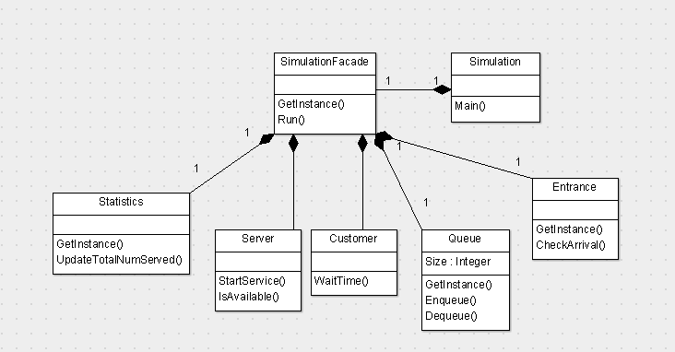
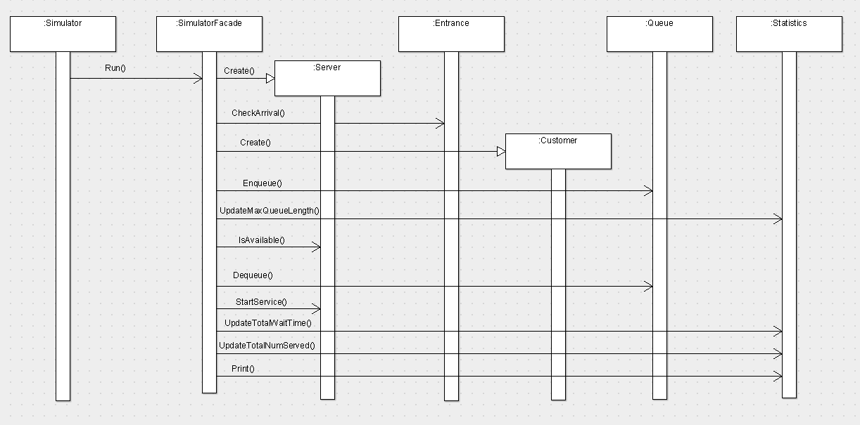
using System;
using System.Collections.Generic;

namespace CS665Hw7
{
public class Simulation
{
static void Main(string[] args)
{
SimulationFacade sim;

sim = SimulationFacade.GetInstance(28800, 120, 10, 5);
sim.Run();

sim = SimulationFacade.GetInstance(28800, 120, 5, 5);
sim.Run();

sim = SimulationFacade.GetInstance(28800, 120, 6, 5);
sim.Run();
}

}
}

using System;
using System.Collections.Generic;
using System.Text;

namespace CS665Hw7
{
class SimulationFacade
{
private static int _simLength, _avgServiceTime, _avgArrivalTime, _maxNumServers;
private static SimulationFacade _uniqueInstance = new SimulationFacade();

private SimulationFacade()
{ }

public static SimulationFacade GetInstance(int simLength, int avgSeviceTime, int avgArrivalTime, int maxNumServers)
{
_simLength = simLength;
_avgServiceTime = avgSeviceTime;
_avgArrivalTime = avgArrivalTime;
_maxNumServers = maxNumServers;
return _uniqueInstance;
}

public void Run()
{
List<Server> serverList = new List<Server>();

PrintHeader();

for (int i = 1; i <= _maxNumServers; i++)
{
serverList.Add(new Server(_avgServiceTime));
Statistics stats = Statistics.GetInstance();

for (int currentTime = 1; currentTime <= _simLength; currentTime++)
{
Entrance entrance = Entrance.GetInstance();
Queue queue = Queue.GetInstance();

// Check to see if new customer has arrived
if (entrance.CheckArrival(_avgArrivalTime))
{
queue.Enqueue(new Customer(currentTime));
stats.UpdateMaxQueueLength(queue.Size);

foreach (Server s in serverList)
{
// Check to see if server is available
if (s.IsAvailable(currentTime))
{
Customer removedCust = queue.Dequeue();

if (removedCust != null)
{
// Serve customer and update statistics
s.StartService(currentTime);
stats.UpdateTotalWaitTime(removedCust.WaitTime(currentTime));
stats.UpdateTotalNumServed();
}
}
}
}
}
stats.Print(i);
stats.Clear();
}
}

private void PrintHeader()
{
Console.WriteLine(string.Format("Simulation length: {0} sec", _simLength));
Console.WriteLine(string.Format("Average service time: {0} sec", _avgServiceTime));
Console.WriteLine(string.Format("Average arrival time: {0} sec", _avgArrivalTime));
}
}
}

namespace CS665Hw7
{
public class Server
{
private int _startTime = -1;
private readonly int _serviceTime;

public Server(int serviceTime)
{
_serviceTime = serviceTime;
}

public void StartService(int currentTime)
{
_startTime = currentTime;
}

public bool IsAvailable(int currentTime)
{
return _startTime + _serviceTime < currentTime;
}

}
}

using System.Collections.Generic;

namespace CS665Hw7
{
public class Queue
{
private static readonly List<Customer> _customerList = new List<Customer>();
private static readonly Queue _uniqueInstance = new Queue();

private Queue()
{ }

public static Queue GetInstance()
{
return _uniqueInstance;
}

public void Enqueue(Customer cust)
{
_customerList.Add(cust);
}

public Customer Dequeue()
{
Customer removedCust = null;

if (_customerList.Count > 0)
{
removedCust = _customerList[0];
_customerList.RemoveAt(0);
}

return removedCust;
}

public int Size
{
get { return _customerList.Count; }
}
}
}

using System;

namespace CS665Hw7
{
public class Entrance
{
private static readonly Entrance _uniqueInstance = new Entrance();

private Entrance()
{ }

public static Entrance GetInstance()
{
return _uniqueInstance;
}

public bool CheckArrival(double interval)
{
double num = 0.0;
double probability = 1 / interval;
Random rand = new Random();

// Returns a number between 0.0 and 1.0
num = rand.NextDouble();

if (num < probability)
{
return true;
}
return false;
}
}
}

namespace CS665Hw7
{
public class Customer
{
private readonly int _arrivalTime;

public Customer(int arrivalTime)
{
_arrivalTime = arrivalTime;
}

public int WaitTime(int currentTime)
{
return currentTime - _arrivalTime;
}

}
}

using System;

namespace CS665Hw7
{
public class Statistics
{
private int _totalNumServed = 0;
private int _totalWaitTime = 0;
private int _maxQueueLength = 0;
private static readonly Statistics _uniqueInstance = new Statistics();

private Statistics()
{ }

public static Statistics GetInstance()
{
return _uniqueInstance;
}

public void UpdateTotalNumServed()
{
_totalNumServed++;
}

public void UpdateTotalWaitTime(int waitTime)
{
_totalWaitTime += waitTime;
}

public void UpdateMaxQueueLength(int queueLength)
{
if (queueLength > _maxQueueLength)
{
_maxQueueLength = queueLength;
}
}

public void Print(int numServers)
{
if (_totalNumServed > 0)
{
string output = string.Format("Number of cashiers: {0}\n", numServers);
output += string.Format("Served {0} customers\n", _totalNumServed);
output += string.Format("Average wait time: {0} sec\n", _totalWaitTime / _totalNumServed);
output += string.Format("Longest queue: {0} customers\n", _maxQueueLength);

Console.Write(output);
}
}

public void Clear()
{
_totalNumServed = 0;
_totalWaitTime = 0;
_maxQueueLength = 0;
}
}
}

Simulation length: 28800 sec
Average service time: 120 sec
Average arrival time: 10 sec
Number of cashiers: 1
Served 30 customers
Average wait time: 1740 sec
Longest queue: 3540 customers
Number of cashiers: 3
Served 186 customers
Average wait time: 16365 sec
Longest queue: 10715 customers
Number of cashiers: 5
Served 64 customers
Average wait time: 15491 sec
Longest queue: 14412 customers

Simulation length: 28800 sec
Average service time: 120 sec
Average arrival time: 5 sec
Number of cashiers: 1
Served 31 customers
Average wait time: 1800 sec
Longest queue: 3654 customers
Number of cashiers: 2
Served 62 customers
Average wait time: 8435 sec
Longest queue: 7251 customers
Number of cashiers: 3
Served 61 customers
Average wait time: 885 sec
Longest queue: 14538 customers
Number of cashiers: 4
Served 27 customers
Average wait time: -7437 sec
Longest queue: 17724 customers
Number of cashiers: 5
Served 170 customers
Average wait time: 7385 sec
Longest queue: 24398 customers

Simulation length: 28800 sec
Average service time: 120 sec
Average arrival time: 6 sec
Number of cashiers: 1
Served 46 customers
Average wait time: 14434 sec
Longest queue: 5497 customers
Number of cashiers: 2
Served 38 customers
Average wait time: 17741 sec
Longest queue: 10075 customers
Number of cashiers: 3
Served 27 customers
Average wait time: 20912 sec
Longest queue: 13242 customers
Number of cashiers: 4
Served 32 customers
Average wait time: 17872 sec
Longest queue: 17006 customers
Number of cashiers: 5
Served 51 customers
Average wait time: 21769 sec
Longest queue: 19760 customers

Simulation length: 28800 sec
Average service time: 120 sec
Average arrival time: 10 sec
Number of cashiers: 2
Served 114 customers
Average wait time: 7461 sec
Longest queue: 6599 customers
Number of cashiers: 4
Served 124 customers
Average wait time: 21200 sec
Longest queue: 10191 customers
Number of cashiers: 5
Served 30 customers
Average wait time: 2281 sec
Longest queue: 13787 customers

Simulation length: 28800 sec
Average service time: 120 sec
Average arrival time: 5 sec
Number of cashiers: 1
Served 29 customers
Average wait time: 20999 sec
Longest queue: 17212 customers
Number of cashiers: 2
Served 54 customers
Average wait time: 12495 sec
Longest queue: 23561 customers
Number of cashiers: 3
Served 24 customers
Average wait time: 10481 sec
Longest queue: 26376 customers
Number of cashiers: 4
Served 96 customers
Average wait time: 18360 sec
Longest queue: 31915 customers
Number of cashiers: 5
Served 117 customers
Average wait time: 20044 sec
Longest queue: 37154 customers

Simulation length: 28800 sec
Average service time: 120 sec
Average arrival time: 6 sec
Number of cashiers: 1
Served 26 customers
Average wait time: 21520 sec
Longest queue: 40246 customers
Number of cashiers: 2
Served 55 customers
Average wait time: 12848 sec
Longest queue: 46736 customers
Number of cashiers: 3
Served 26 customers
Average wait time: 12792 sec
Longest queue: 49784 customers
Number of cashiers: 4
Served 88 customers
Average wait time: 19280 sec
Longest queue: 54687 customers
Number of cashiers: 5
Served 90 customers
Average wait time: 19682 sec
Longest queue: 59108 customers

