Ryan Berger
CS665

1. This program used both the template design pattern and the iterator design pattern. The template design pattern was implemented in the Analyze superclass. It uses a call sequence in performAnalysis() where it initializes the counter, tests the string, prints the input string (only if using the AnalyzeWhiteSpace subclass), and prints the report. The subclasses define specific behavior for the testString() and printReport() methods. In the case of AnalyzeWhiteSpace, it also defines special behavior for isWhiteSpaceTest(). The iterator pattern was used in two places. First, it was used as an external iterator in the Analyze classes. The iterator was implemented in the testString() method of each Analyze subclass. This was an external iterator since I had to create my own for loop whenever I needed to iterate. Second, it was used as an internal iterator in the Request classes. The iterator is internal since I only need to send a Request object to the internalIterator() method in order to perform iterations.

2. In the external iterator, the container has no knowledge of the iterator and is not used at all. For the internal iterator, the internalIterator() method has knowledge of the iterator through the Request abstract class. The method itself does not do any iterating, it only class the method apply() which triggers each iterator to run.

3. The superclass Analyze contains most of the logic to run the steps needed in the correct order. The subclasses define specifically what each step should do and in the case of AnalyzeWhiteSpace, it tells the superclass to perform an additional step with a hook. For the Request superclass, it knows nothing except for the apply() method signature. The subclasses contain all of the logic.

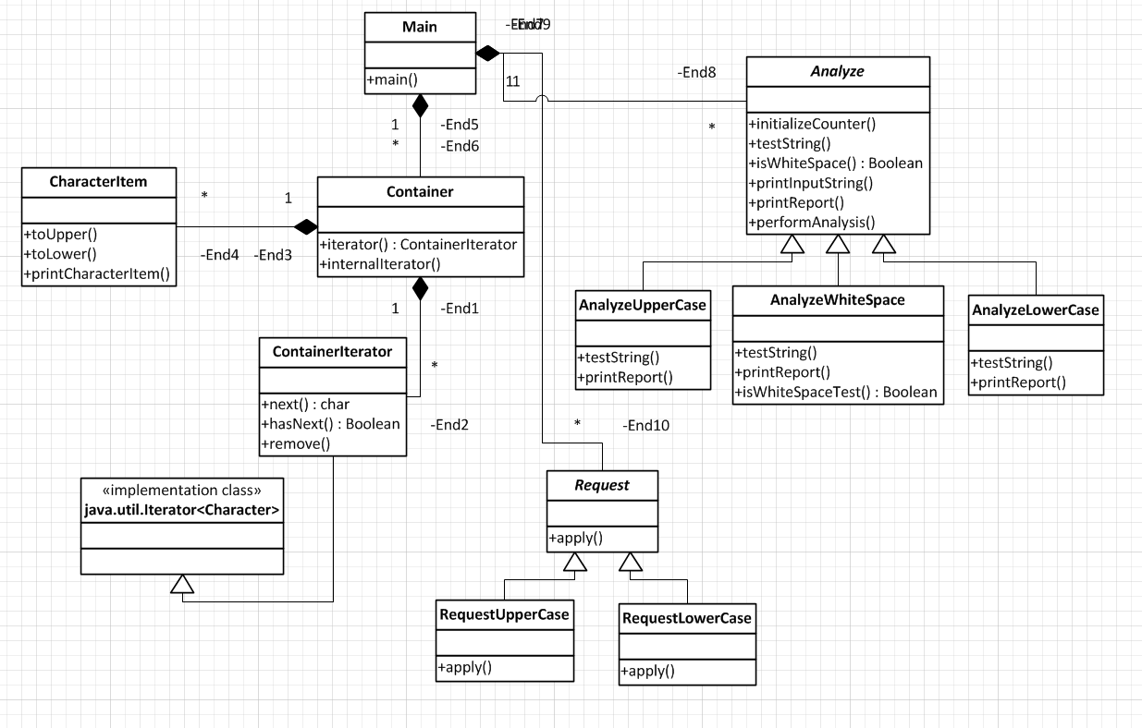

package cs665hw8;

/**
*
* @author Ryan
*/
public class Main {

/**
* @param args the command line arguments
*/
public static void main(String[] args) {
String test1 = "\"TEST\"";
String test2 = "A test";
String test3 = "This Is Another Test";

Analyze analyze = new AnalyzeWhiteSpace(test1);
analyze.performAnalysis();
analyze = new AnalyzeUpperCase(test1);
analyze.performAnalysis();
analyze = new AnalyzeLowerCase(test1);
analyze.performAnalysis();

System.out.println();

analyze = new AnalyzeWhiteSpace(test2);
analyze.performAnalysis();
analyze = new AnalyzeUpperCase(test2);
analyze.performAnalysis();
analyze = new AnalyzeLowerCase(test2);
analyze.performAnalysis();

System.out.println();

analyze = new AnalyzeWhiteSpace(test3);
analyze.performAnalysis();
analyze = new AnalyzeUpperCase(test3);
analyze.performAnalysis();
analyze = new AnalyzeLowerCase(test3);
analyze.performAnalysis();

System.out.println("\nContainer data in the upper case:");
Request ruc = new RequestUpperCase();
Container cont = new Container(test1);
cont.internalIterator(ruc);
cont = new Container(test2);
cont.internalIterator(ruc);
cont = new Container(test3);
cont.internalIterator(ruc);

System.out.println("\nContainer data in the upper case:");
Request rlc = new RequestLowerCase();
cont = new Container(test1);
cont.internalIterator(rlc);
cont = new Container(test2);
cont.internalIterator(rlc);
cont = new Container(test3);
cont.internalIterator(rlc);

}
}

package cs665hw8;

/**
*
* @author Ryan
*/
public class Container {

private String inputString = "";
private ContainerIterator cont;

public Container(String inputString)
{
this.inputString = inputString;
}

public ContainerIterator iterator(String inputString)
{
if (cont == null)
{
cont = new ContainerIterator(inputString);
}

return cont;
}

public void internalIterator(Request request)
{
CharacterItem c;
for (int i = 0; i < inputString.length(); i++)
{
c = new CharacterItem(iterator(inputString).next());
request.apply(c);
}
System.out.println();

}
}

package cs665hw8;

import java.util.Iterator;

/**
*
* @author Ryan
*/
public class ContainerIterator implements Iterator<Character> {

private char[] items;
private int position;

public ContainerIterator(String items)
{
this.items = items.toCharArray();
}

public Character next()
{
return items[position++];
}

public boolean hasNext()
{
return (position + 1 <= items.length && items[position] != '\0');
}

public void remove()
{
throw new UnsupportedOperationException();
}
}

package cs665hw8;

/**
*
* @author Ryan
*/
public class CharacterItem {

private char c;

public CharacterItem(char c)
{
this.c = c;
}

public void toLower()
{
c = Character.toLowerCase(c);
}

public void toUpper()
{
c = Character.toUpperCase(c);
}

public void printCharacterItem()
{
System.out.print(c);
}
}

package cs665hw8;

/**
*
* @author Ryan
*/
public abstract class Analyze {

protected int counter = 0;
protected String inputString = "";

public void initializeCounter()
{
counter = 0;
}

public abstract void testString();

public boolean isWhiteSpaceTest()
{
return false;
}

public void printInputString()
{
System.out.println("String: " + inputString);
}

public abstract void printReport();

public final void performAnalysis()
{
initializeCounter();
testString();
if (isWhiteSpaceTest())
{
printInputString();
}
printReport();
}
}

package cs665hw8;

/**
*
* @author Ryan
*/
public class AnalyzeWhiteSpace extends Analyze {

public AnalyzeWhiteSpace(String inputString)
{
this.inputString = inputString;
}

public void testString()
{
ContainerIterator iter = new ContainerIterator(inputString);

while (iter.hasNext())
{
char a = iter.next();

if (!Character.isSpaceChar(a))
{
counter++;
}
}
}

@Override
public boolean isWhiteSpaceTest()
{
return true;
}

public void printReport()
{
String outputString = counter + " non-white symbol";

if (counter > 1)
{
outputString += "s";
}

System.out.println(outputString);
}
}

package cs665hw8;

/**
*
* @author Ryan
*/
public class AnalyzeUpperCase extends Analyze {

public AnalyzeUpperCase(String inputString)
{
this.inputString = inputString;
}

public void testString()
{
ContainerIterator iter = new ContainerIterator(inputString);

while (iter.hasNext())
{
char a = iter.next();

if (Character.isUpperCase(a))
{
counter++;
}
}
}

public void printReport()
{
String outputString = counter + " upper case character";

if (counter > 1)
{
outputString += "s";
}

System.out.println(outputString);
}
}

package cs665hw8;

/**
*
* @author Ryan
*/
public class AnalyzeLowerCase extends Analyze {

public AnalyzeLowerCase(String inputString)
{
this.inputString = inputString;
}

public void testString()
{
ContainerIterator iter = new ContainerIterator(inputString);

while (iter.hasNext())
{
char a = iter.next();

if (Character.isLowerCase(a))
{
counter++;
}
}
}

public void printReport()
{
String outputString = counter + " lower case character";

if (counter > 1)
{
outputString += "s";
}

System.out.println(outputString);
}
}

package cs665hw8;

/**
*
* @author Ryan
*/
public abstract class Request {

public abstract void apply(CharacterItem c);

}

package cs665hw8;

/**
*
* @author Ryan
*/
public class RequestUpperCase extends Request {

public void apply(CharacterItem c)
{
c.toUpper();
c.printCharacterItem();
}
}

package cs665hw8;

/**
*
* @author Ryan
*/
public class RequestLowerCase extends Request {

public void apply(CharacterItem c)
{
c.toLower();
c.printCharacterItem();
}
}

