Ryan Berger
CS665

1. The abstract factory pattern used here had two IngredientFactory subclasses: PlainIngredientFactory and OfficialIngredientFactory. Both create specific dish subclasses when called. Each factory keeps track of the total cost of its dishes in the PlaceOrder() function.

2. New subclasses would be added under the Dish superclass. Also, the PlainIngredientFactory class and OfficialIngredientFactory class would be affected in the PlaceOrder() function along with the ToString() function to print them out.

3. I have insulated the Dish superclass along with its subclasses if a new dinner is added. The only change might be some new subclasses added to construct the dinner. If applicable, a new factory class may be needed to accommodate the new type of dinner.

4. The Dish superclass along with the appropriate subclasses would be affected by the addition of carbs, proteins and fats in order to add the fields and set their values. The PlainIngredientFactory class and the OfficialIngredientFactory class would also be affected in order to print this information in the ToString() method.
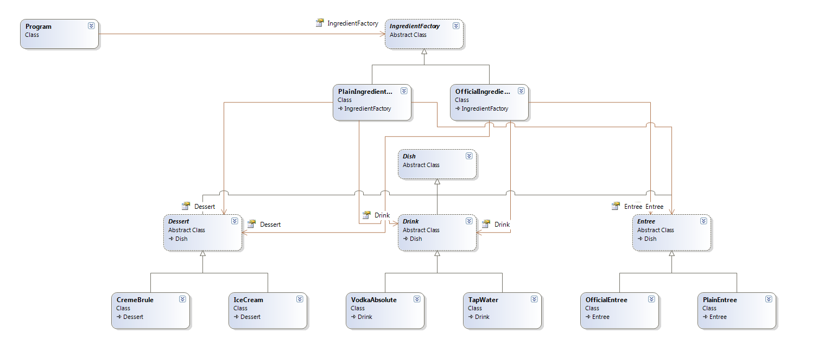
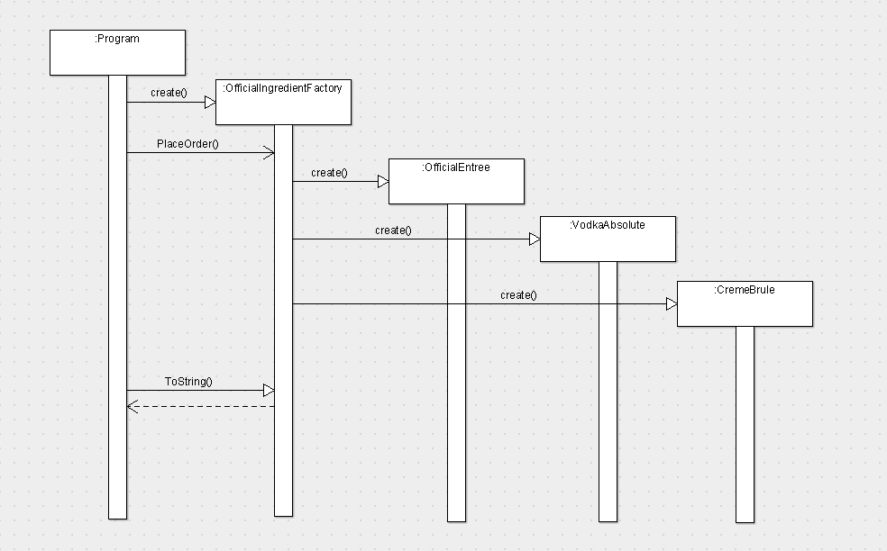
Note: this code was written with C#.NET

using System;
using System.Collections.Generic;
using System.Text;

namespace CS665Hw6
{
class Program
{
static void Main(string[] args)
{
int numOfficial, numPlain;

Console.Write("Enter the number of official dinners to prepare: ");
int.TryParse(Console.ReadLine(), out numOfficial);
Console.Write("Enter the number of plain dinners to prepare: ");
int.TryParse(Console.ReadLine(), out numPlain);

IngredientFactory officialFactory = new OfficialIngredientFactory();
IngredientFactory plainFactory = new PlainIngredientFactory();

for (int i = 0; i < numOfficial; i++)
{
officialFactory.PlaceOrder();
}
for (int j = 0; j < numPlain; j++)
{
plainFactory.PlaceOrder();
}

Print(officialFactory, plainFactory, numOfficial, numPlain);
}

private static void Print(IngredientFactory officialFactory,
IngredientFactory plainFactory, int numOfficial, int numPlain)
{
Console.WriteLine();

if (numOfficial > 0)
Console.WriteLine(officialFactory.ToString());
if (numPlain > 0)
Console.WriteLine(plainFactory.ToString());

Console.WriteLine(string.Format("Total order (no taxes): ${0:0.00}",
officialFactory.GetTotalPrice() + plainFactory.GetTotalPrice()));
}
}
}

using System;
using System.Collections.Generic;
using System.Text;

namespace CS665Hw6
{
public abstract class IngredientFactory
{
protected Entree entree;

protected Drink drink;

protected Dessert dessert;

protected double totalPrice = 0.0;

public abstract void PlaceOrder();

public abstract override string ToString();

public double GetTotalPrice()
{
return totalPrice;
}
}
}

using System;
using System.Collections.Generic;
using System.Text;

namespace CS665Hw6
{
public class OfficialIngredientFactory : IngredientFactory
{
public override void PlaceOrder()
{
entree = new OfficialEntree();
drink = new VodkaAbsolute();
dessert = new CremeBrule();
totalPrice += entree.GetPrice() + drink.GetPrice() + dessert.GetPrice();
}

public override string ToString()
{
string output = "---- Official Style Dinner ----\n";
output += string.Format("{0}: {1:0.0} calories, ${2:0.00}\n", entree.GetName(), entree.GetCalories(), entree.GetPrice());
output += string.Format("{0}: {1:0.0} calories, ${2:0.00}\n", drink.GetName(), drink.GetCalories(), drink.GetPrice());
output += string.Format("{0}: {1:0.0} calories, ${2:0.00}\n", dessert.GetName(), dessert.GetCalories(), dessert.GetPrice());
output += string.Format("Dinner price: ${0:0.00}\t Total calories: {1:0.0}\n",
entree.GetPrice() + drink.GetPrice() + dessert.GetPrice(),
entree.GetCalories() + drink.GetCalories() + dessert.GetCalories());
output += string.Format("Total price of official dinners: ${0:0.00}\n", totalPrice);
return output;
}
}
}

using System;
using System.Collections.Generic;
using System.Text;

namespace CS665Hw6
{
public class PlainIngredientFactory : IngredientFactory
{
public override void PlaceOrder()
{
entree = new PlainEntree();
drink = new TapWater();
dessert = new IceCream();
totalPrice += entree.GetPrice() + drink.GetPrice() + dessert.GetPrice();
}

public override string ToString()
{
string output = "---- Plain Style Dinner ----\n";
output += string.Format("{0}: ${1:0.00}\n", entree.GetName(), entree.GetPrice());
output += string.Format("{0}: ${1:0.00}\n", drink.GetName(), drink.GetPrice());
output += string.Format("{0}: ${1:0.00}\n", dessert.GetName(), dessert.GetPrice());
output += string.Format("Dinner price: ${0:0.00}\n",
entree.GetPrice() + drink.GetPrice() + dessert.GetPrice());
output += string.Format("Total price of plain dinners: ${0:0.00}\n", totalPrice);
return output;
}
}
}

using System;
using System.Collections.Generic;
using System.Text;

namespace CS665Hw6
{
public abstract class Dish
{
protected string name = "";
protected double price = 0.0;
protected double calories = 0.0;

public string GetName()
{
return name;
}

public double GetPrice()
{
return price;
}

public double GetCalories()
{
return calories;
}
}
}

using System;
using System.Collections.Generic;
using System.Text;

namespace CS665Hw6
{
public abstract class Entree : Dish
{
}

public class OfficialEntree : Entree
{
public OfficialEntree()
{
name = "Official Entry";
price = 6.50;
calories = 1500.0;
}
}

public class PlainEntree : Entree
{
public PlainEntree()
{
name = "Plain Entry";
price = 12.00;
}
}
}

using System;
using System.Collections.Generic;
using System.Text;

namespace CS665Hw6
{
public abstract class Drink : Dish
{
}

public class VodkaAbsolute : Drink
{
public VodkaAbsolute()
{
name = "Vodka Absolute";
price = 2.50;
calories = 300.0;
}
}

public class TapWater : Drink
{
public TapWater()
{
name = "Tap Water";
price = 0.50;
}
}
}

using System;
using System.Collections.Generic;
using System.Text;

namespace CS665Hw6
{
public abstract class Dessert : Dish
{
}

public class CremeBrule : Dessert
{
public CremeBrule()
{
name = "Creme Brule";
price = 1.20;
calories = 200.0;
}
}

public class IceCream : Dessert
{
public IceCream()
{
name = "Ice Cream";
price = 1.50;
}
}
}

Enter the number of official dinners to prepare: 12
Enter the number of plain dinners to prepare: 22

---- Official Style Dinner ----
Official Entry: 1500.0 calories, $6.50
Vodka Absolute: 300.0 calories, $2.50
Creme Brule: 200.0 calories, $1.20
Dinner price: $10.20 Total calories: 2000.0
Total price of official dinners: $122.40

---- Plain Style Dinner ----
Plain Entry: $12.00
Tap Water: $0.50
Ice Cream: $1.50
Dinner price: $14.00
Total price of plain dinners: $308.00

Total order (no taxes): $430.40

Enter the number of official dinners to prepare: 134
Enter the number of plain dinners to prepare: 500

---- Official Style Dinner ----
Official Entry: 1500.0 calories, $6.50
Vodka Absolute: 300.0 calories, $2.50
Creme Brule: 200.0 calories, $1.20
Dinner price: $10.20 Total calories: 2000.0
Total price of official dinners: $1366.80

---- Plain Style Dinner ----
Plain Entry: $12.00
Tap Water: $0.50
Ice Cream: $1.50
Dinner price: $14.00
Total price of plain dinners: $7000.00

Total order (no taxes): $8366.80

Enter the number of official dinners to prepare: 1
Enter the number of plain dinners to prepare: 0

---- Official Style Dinner ----
Official Entry: 1500.0 calories, $6.50
Vodka Absolute: 300.0 calories, $2.50
Creme Brule: 200.0 calories, $1.20
Dinner price: $10.20 Total calories: 2000.0
Total price of official dinners: $10.20

Total order (no taxes): $10.20

Enter the number of official dinners to prepare: 0
Enter the number of plain dinners to prepare: 0

Total order (no taxes): $0.00

