**Training Guide: Understanding and Utilizing Data Models**

How do you make decisions? Are you aware of the process that you use to make your choices?

This guide provides an overview of common data analysis models, their applications, and how to interpret their results. The information is designed for executives and laypersons to understand three things:

1. How to ask better questions
2. How to make better decisions
3. How humans use HEURISTICS, scientific generalizations, to make decisions, solve problems, and form judgments quickly. They are simple strategies that can be used by humans, animals, organizations, and machines.

**HEURISTIX** and **HEURISTIX ANALYTIX** gives you the power of these mental models.

**1. Exploratory Data Analysis (EDA)**

**How It Works:** EDA is the process of analyzing data sets to summarize their main characteristics. It often uses visual methods such as histograms, scatter plots, and box plots.

**How to Use:**

* Identify patterns and trends.
* Spot anomalies or outliers.
* Assess data distributions.

**Interpretation:**

* Look for clusters, outliers, or gaps in data.
* Use visuals to make informed decisions about data preprocessing.

*Importance: pattern recognition*.

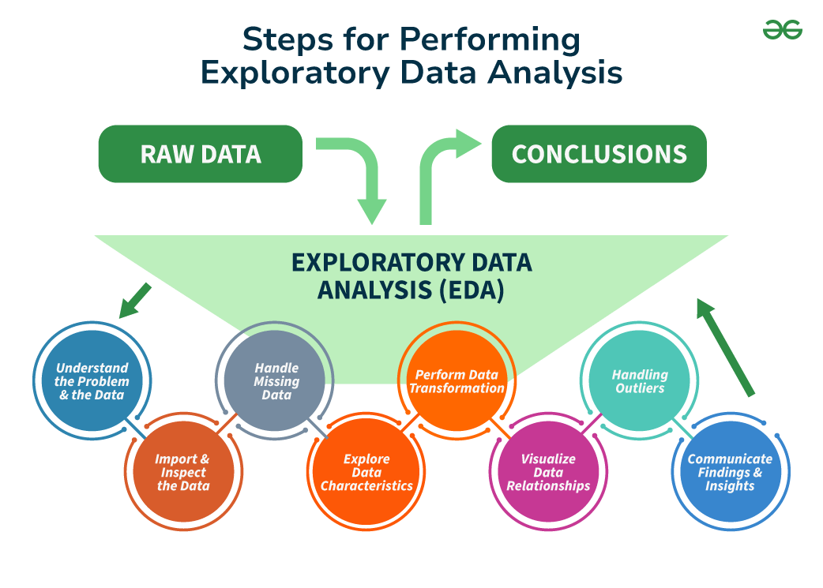

**2. Correlation Analysis**

**How It Works:** Measures the strength and direction of relationships between variables using metrics like Pearson’s correlation coefficient.

**How to Use:**

* Determine if variables are positively or negatively correlated.
* Prioritize features in predictive models.

**Interpretation:**

* Values near +1 indicate strong positive correlation; values near -1 indicate strong negative correlation.

*Importance: identifying* *variable relationships*.

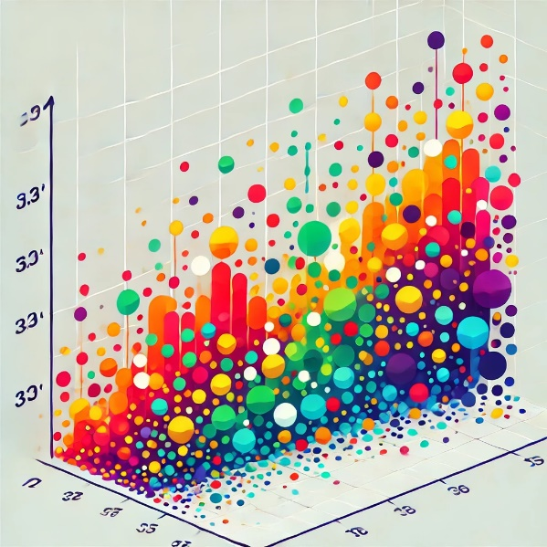

**3. Hypothesis Testing**

**How It Works:** Statistical tests (e.g., t-tests, chi-square tests) evaluate assumptions about a population based on sample data.

**How to Use:**

* Define null and alternative hypotheses.
* Use p-values to decide whether to reject the null hypothesis.

**Interpretation:**

* P-value < 0.05: Evidence against the null hypothesis.
* P-value ≥ 0.05: Fail to reject the null hypothesis.

*Importance:* *validating ideas.*



**4. Dimension Reduction (Random Forest Ensemble)**

**How It Works:** Random forests rank features by importance, helping reduce the dataset's dimensions while preserving predictive power.

**How to Use:**

* Identify less significant variables to remove.
* Use top features for modeling.

**Interpretation:**

* Feature importance scores indicate each variable’s contribution to predictions.

*Importance:* *making analysis manageable.*



**5. ANOVA Analysis**

**How It Works:** ANOVA (Analysis of Variance) compares means across multiple groups to find significant differences.

**How to Use:**

* Test whether group means differ significantly.
* Use for comparing more than two groups.

**Interpretation:**

* F-statistic and p-value indicate whether group differences are statistically significant.

*Importance:* *deciding what variables to keep.*

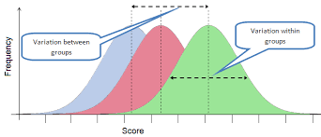

**Are different groups behaving differently?**

**6. Linear Regression**

**How It Works:** Models the relationship between independent and dependent variables by fitting a line through the data.

**How to Use:**

* Predict outcomes based on input features.
* Assess relationships between variables.

**Interpretation:**

* Coefficients show how much the dependent variable changes per unit increase in an independent variable.

*Importance:* *identifying causality, attribution, and contribution.*



**7. Cluster Analysis (K-means)**

**How It Works:** Divides data into k clusters based on similarity, minimizing within-cluster variance.

**How to Use:**

* Identify natural groupings in data.
* Segment customers or markets.

**Interpretation:**

* Centroids represent cluster centers.
* Visualize clusters to interpret group characteristics.

*Importance: groupings and categorizations.*

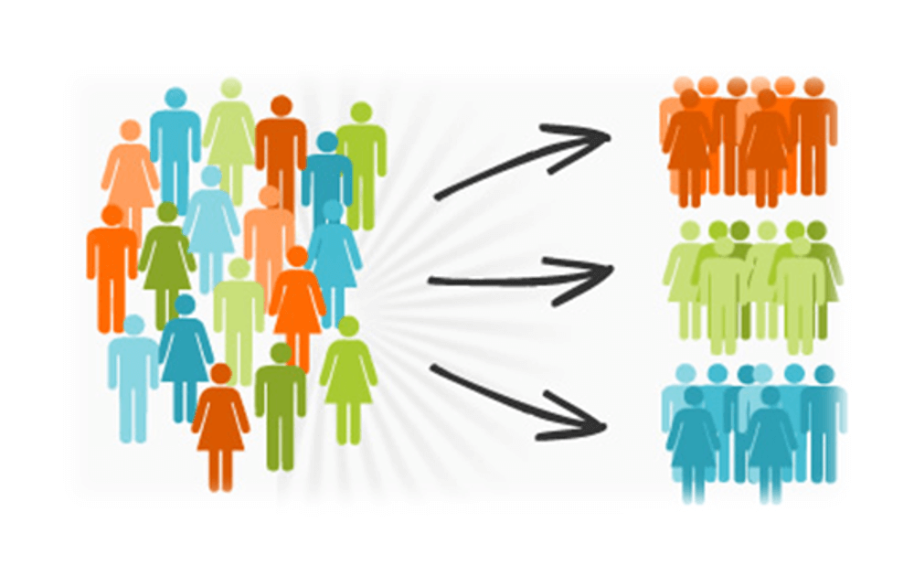

**8. Conjoint Analysis**

**How It Works:** Assesses individuals’ preferences by analyzing trade-offs among product attributes.

**How to Use:**

* Analyze what factors are most important in determining an individual's outcomes related to a chosen variable with hypothetical product combinations.
* Estimate utility scores for attributes.

**Interpretation:**

* Higher utility scores indicate preferred attributes.

*Importance:* *influences on decisions.*



**KNOWLEDGE**

**9. Neural Networks**

**How It Works:** Mimic the human brain by using layers of interconnected nodes (neurons) to learn complex patterns in data.

**How to Use:**

* Use for tasks like image recognition or natural language processing.
* Train the network on labeled data.

**Interpretation:**

* Monitor accuracy and loss metrics to evaluate performance.

*Importance:* *uncovering hidden patterns using artificial cognition.*

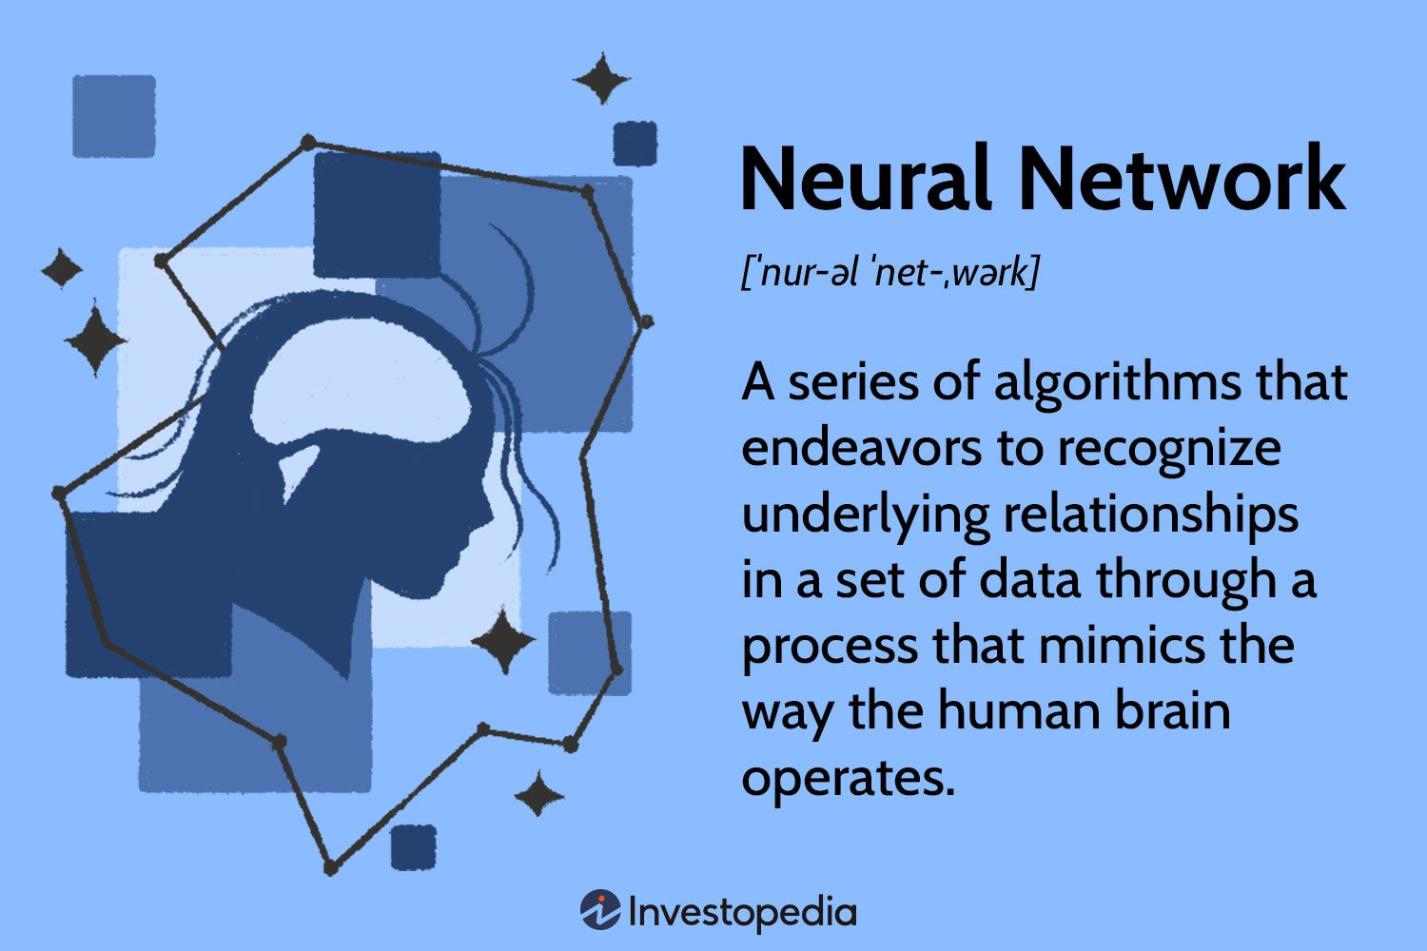

**10. Decision Trees**

**How It Works:** Splits data into branches based on feature values, leading to decision outcomes.

**How to Use:**

* Interpret tree diagrams to understand decision rules.
* Use for classification or regression tasks.

**Interpretation:**

* Each branch represents a decision path; leaves indicate outcomes.

*Importance:* *charting the path to decisions.*

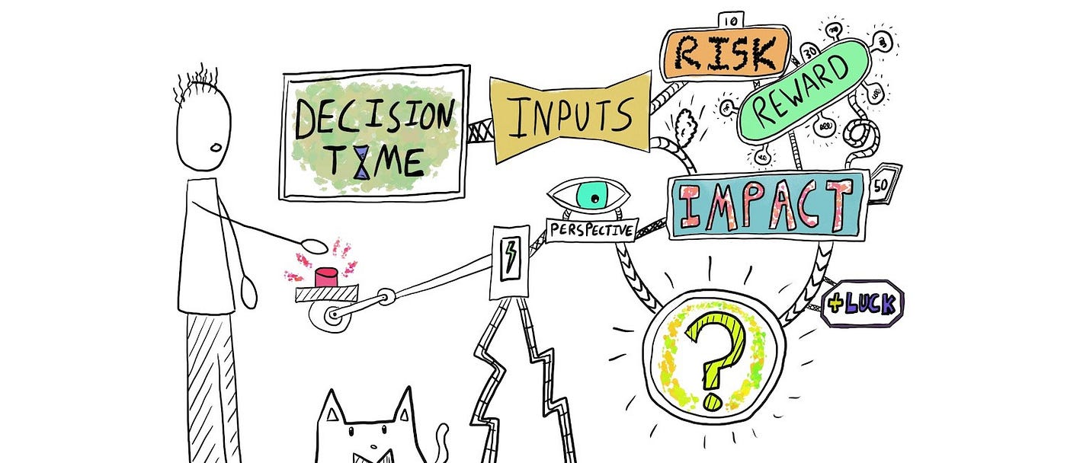

**11. Predictive Analytics and Generative AI**

**How It Works:** Predictive analytics forecasts future outcomes using statistical models, while generative AI creates new content (e.g., text, images) based on learned patterns.

**How to Use:**

* Predict customer behaviour, market trends, or risk.
* Use generative AI for automating creative tasks.

**Interpretation:**

* Assess predictions with metrics like RMSE (Root Mean Square Error).
* For generative AI, evaluate the quality of generated outputs.

*Importance:* *predicting the future and telling you how to react.*



This guide offers foundational knowledge to empower informed decisions about employing these models in various business scenarios.

© Heuristix 2024