**Getting a Service Account Key from the Google Cloud Platform, or:  
Getting your Key for the Transmogrifier Program  
  
by Ryan L. Boyd -- Updated on 2018-07-08**

If you’ve never worked with the Google Cloud Platform, setting up an account/project might seem complicated, or even just completely unintuitive. I’ve written this little guide as a walk-through for getting from Point A (starting with nothing) to Point B (getting your service account key file).

1. Go to <https://console.cloud.google.com/apis/api/translate.googleapis.com>. This will bring you to your Google Cloud dashboard  
   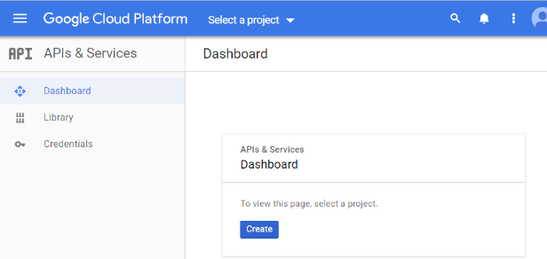
2. Click "Create" to make a new project.
3. You can name your project anything that you want – it doesn't really matter. Suggested name: TranslateProject. You'll also likely have to set up your billing info at this point as well. Remember, the Google Translate API is not free. Using the API will cost money.  
   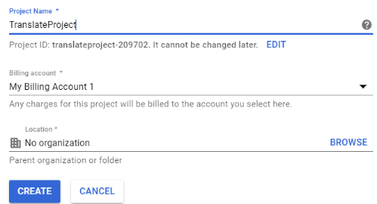
4. It might look like nothing is happening for a few seconds, but Google is setting up your "project". It should be ready in less than a minute, and you'll probably see your little "notification" logo spinning:  
   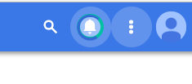
5. Go to "Select a Project"  
   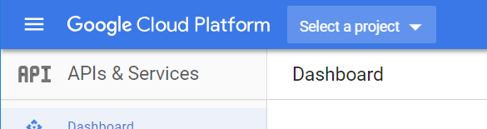
6. Click on the project that you just created. You'll see the little blue checkmark show up *after* you've selected your project.  
   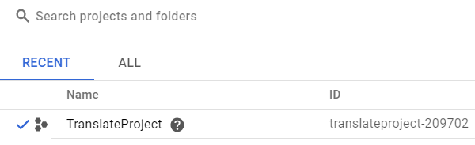
7. Now it's time to link your project to the Google Translate API. You can either scroll through the list that Google gives you, or just search for "translate" to make it easier to find. Once you've found it, click on the box that says "Cloud Translation API"  
   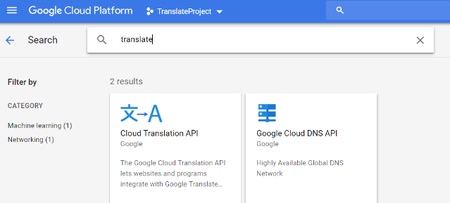
8. Click the blue "Enable" button.  
   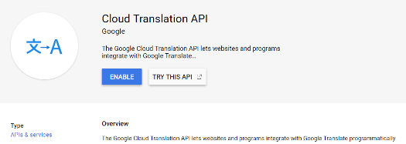
9. Now that the API is linked to your project, you need to create/download your credentials file. Click on "Credentials", located in the left panel:  
   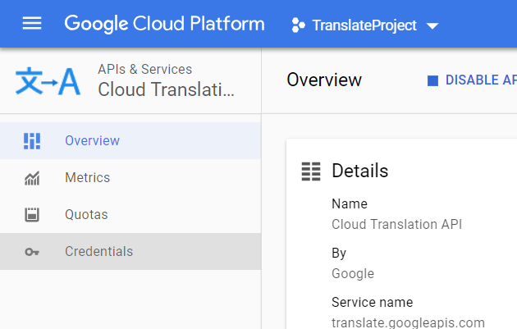
10. It will tell you that you need to visit the "Credentials in APIs & Services" page. Go ahead and click on this link.  
    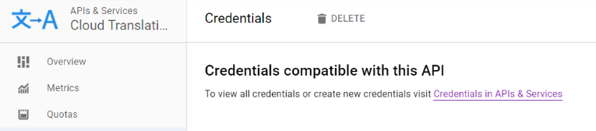
11. Click on the blue "Create Credentials" button, and select "Service account key" from the dropdown menu.  
    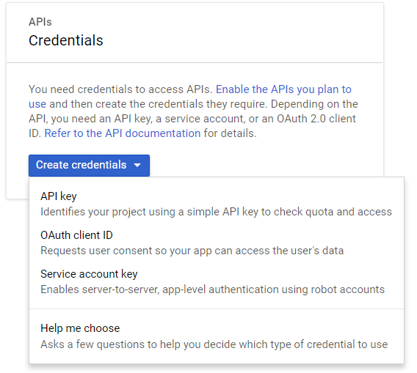
12. Fill in the information for a new service account. For all of our purposes, you basically just want to make a single "master" account. The other "roles" are for if you are doing this as an organization and want to set up lower-level users, managers, etc. to control access to the project. This doesn't really matter for us. You'll typically want to use the following settings:
    * New Service Account
    * Service Account Name: (Your name)
    * Role: Project 🡪 Owner
    * Key type: JSON

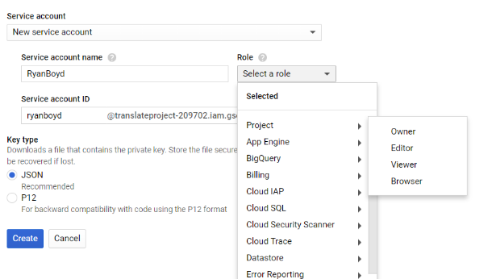

1. Click the blue "Create" button. You will then be prompted to download your service account key.  
     
   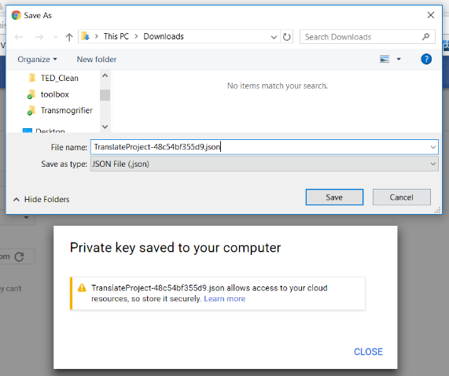
2. That's it! This json file that you download will be the Service Account Key that you use when you start up the Transmogrifier.

And there you have it – the 14 simplest steps in the world :)

If you need to delete your project for any reason, you can do a Google search for how to “shut down” a project, or check the following URL:

<https://cloud.google.com/resource-manager/docs/creating-managing-projects#shutting_down_projects>