Ryan Brosnahan

Homework 3

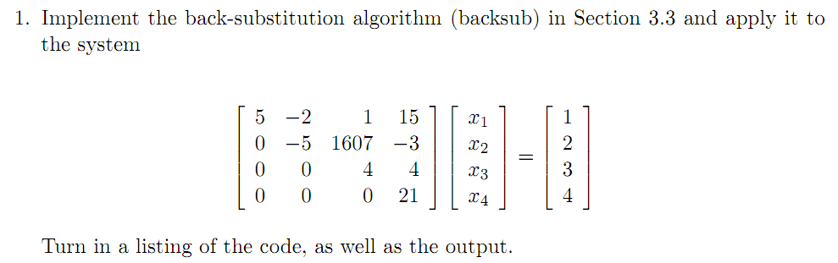

%backsub.m

function x = backsub(U, Y)

%Y=UX U:NxN Y:Nx1

N = length(Y);

x = zeros(N,1);

x(N) = Y(N)/U(N,N);

for k=N-1:-1:1

x(k) = (Y(k)-U(k,k+1:N)*x(k+1:N))/U(k,k);

end

>> U=[5 -2 1 15; 0 -5 1607 -3; 0 0 4 4; 0 0 0 21]

>> Y = [1; 2; 3; 4]

>> backsub(U, Y)

ans =

7.124333333333334e+01

1.793166666666667e+02

5.595238095238095e-01

1.904761904761905e-01

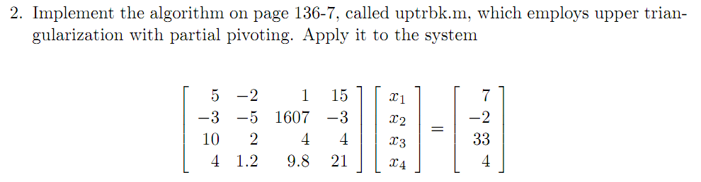

From your website:

%uptrbk.m

function X = uptrbk(A,B)

%Ax=B; N is NxN; B is Nx1

[N,N] = size(A);

X = zeros(N,1);

C=zeros(1,N+1);

Aug = [A B];

for p=1:N-1

[Y,j] = max(abs(Aug(p:N,p)));

C = Aug(p,:);

Aug(p,:) = Aug(j+p-1,:);

Aug(j+p-1,:) = C;

if Aug(p,p)==0

'A was singular. No unique solution'

break

end

for k=p+1:N

m = Aug(k,p)/Aug(p,p);

Aug(k,p:N+1) = Aug(k,p:N+1)-m*Aug(p,p:N+1);

end

end

X = backsub(Aug(1:N,1:N),Aug(1:N,N+1));

>> A = [5 -2 1 15; -3 -5 1607 -3; 10 2 4 4; 4 1.2 9.8 21]

>> B = [7; -2; 33; 4]

>> uptrbk(A, B)

ans =

3.295073687199341e+00

1.006377669420495e+00

7.108379037624037e-03

-4.979814317462225e-01

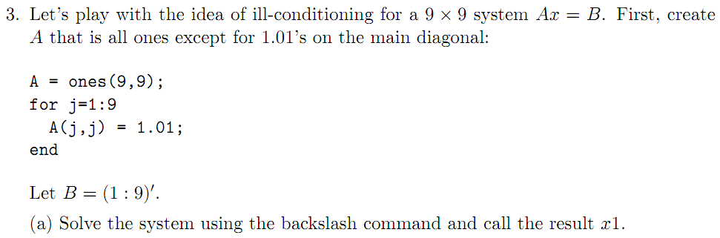

>> x1 = A\B

x1 =

-3.994450610432928e+02

-2.994450610432837e+02

-1.994450610432854e+02

-9.944506104328704e+01

5.549389567171661e-01

1.005549389567171e+02

2.005549389567170e+02

3.005549389567170e+02

4.005549389567133e+02

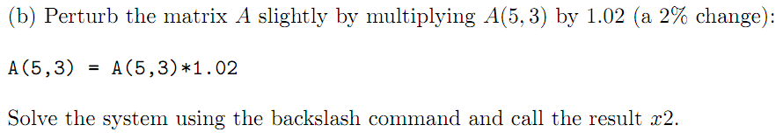

>> x2 = A\B

x2 =

-4.563480741797438e+02

-3.563480741797438e+02

-2.563480741797447e+02

-1.563480741797431e+02

4.563480741797473e+02

4.365192582025690e+01

1.436519258202578e+02

2.436519258202556e+02

3.436519258202554e+02

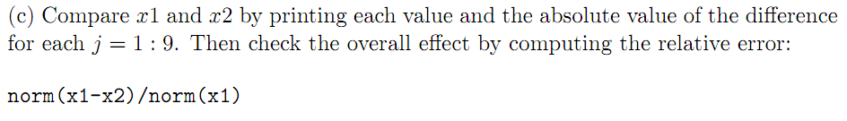

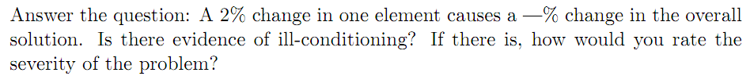

for j=1:9

disp('x1 at ')

j

disp(' ')

x1(j)

disp('x2 at ')

j

x2(j)

disp('abs err: ')

abs(x1(j)-x2(j))

end

Condensed to a table:

|  |  |  |  |
| --- | --- | --- | --- |
| x1 | x2 | abs(x1 - x2) | abs(x1-x2)/abs(x1) |
| -3.99445061043E+02 | -4.5634807418E+02 | 5.69030131365E+01 | 1.42455167646E-01 |
| -2.99445061043E+02 | -3.5634807418E+02 | 5.69030131365E+01 | 1.90028224003E-01 |
| -1.99445061043E+02 | -2.5634807418E+02 | 5.69030131365E+01 | 2.85306704708E-01 |
| -9.94450610433E+01 | -1.5634807418E+02 | 5.69030131365E+01 | 5.72205522723E-01 |
| 5.54938956717E-01 | 4.5634807418E+02 | 4.55793135223E+02 | 8.21339229668E+02 |
| 1.00554938957E+02 | 4.3651925820E+01 | 5.69030131365E+01 | 5.65889788476E-01 |
| 2.00554938957E+02 | 1.4365192582E+02 | 5.69030131365E+01 | 2.83727807615E-01 |
| 3.00554938957E+02 | 2.4365192582E+02 | 5.69030131365E+01 | 1.89326494963E-01 |
| 4.00554938957E+02 | 3.4365192582E+02 | 5.69030131365E+01 | 1.42060445652E-01 |

There is evidence of extreme ill-conditioning. Just a 2% change in one parameter propagated into error of massive proportions for all parameters (>14%).

>> norm(x1-x2)/norm(x1)

ans =

6.240324858473382e-01

>> norm(x1-x2)

ans =

4.833746014722979e+02

These are pretty big which suggests ill-conditioning.



>> y1 = C\B

y1 =

-1.666666666666667e-01

-5.555555555555555e-02

5.555555555555550e-02

1.666666666666666e-01

2.777777777777778e-01

3.888888888888890e-01

5.000000000000000e-01

6.111111111111114e-01

7.222222222222221e-01



>> y2 = C\B

y2 =

-1.666598071092453e-01

-5.554869599813423e-02

5.556241511297687e-02

1.666735262240880e-01

2.776611653016147e-01

3.888957484463103e-01

5.000068595574214e-01

6.111179706685326e-01

7.222290817796437e-01

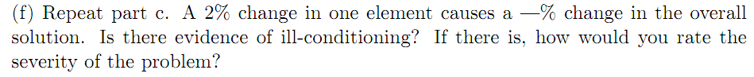

|  |  |  |  |
| --- | --- | --- | --- |
| y1 | y2 | abs(y1 - y2) | abs(y1-y2)/abs(y1) |
| -1.6666666667E-01 | -1.6665980711E-01 | 6.85955742100E-06 | 4.11573445260E-05 |
| -5.5555555556E-02 | -5.5548695998E-02 | 6.85955742129E-06 | 1.23472033583E-04 |
| 5.5555555556E-02 | 5.5562415113E-02 | 6.85955742130E-06 | 1.23472033583E-04 |
| 1.6666666667E-01 | 1.6667352622E-01 | 6.85955742200E-06 | 4.11573445320E-05 |
| 2.7777777778E-01 | 2.7766116530E-01 | 1.16612476163E-04 | 4.19804914187E-04 |
| 3.8888888889E-01 | 3.8889574845E-01 | 6.85955742097E-06 | 1.76388619396E-05 |
| 5.0000000000E-01 | 5.0000685956E-01 | 6.85955742097E-06 | 1.37191148419E-05 |
| 6.1111111111E-01 | 6.1111797067E-01 | 6.85955742097E-06 | 1.12247303252E-05 |
| 7.2222222222E-01 | 7.2222908178E-01 | 6.85955742097E-06 | 9.49784873673E-06 |

There is no evidence of ill conditioning, the 2% change led to a <.014% change in the solutions. That’s pretty small!

>> norm(y1-y2)/norm(y1)

ans =

9.867800240768174e-05

>> norm(y1-y2)

ans =

1.182154720035904e-04

These are small. Although it isn’t a perfect measure, and ignoring all other evidence, it is likely based on the norm that these are not ill-conditioned.



>> norm(C)

ans =

18

>> norm(A)

ans =

9.01

These results are counter-intuitive considering C was less affected by perturbation than A.

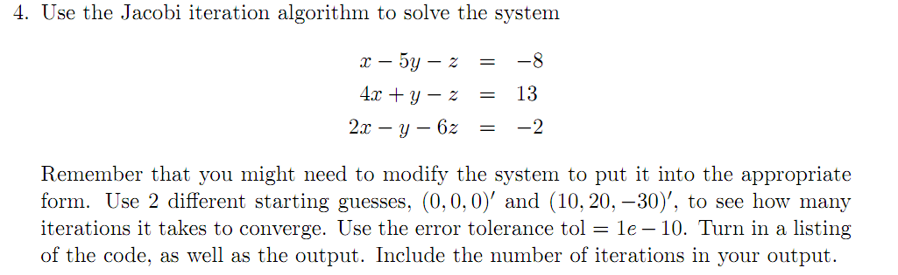

Just to check:

>> A\B

ans =

3.000000000000000e+00

2.000000000000000e+00

1.000000000000000e+00

From your website:

%jacobi.m

function [X,k] = jacobi(A,B,P,delta,max1)

N = length(B);

for k=1:max1

for j=1:N

X(j)=(B(j)-A(j,[1:j-1,j+1:N])*P([1:j-1,j+1:N]))/A(j,j);

end

err = norm(X'-P);

relerr = err/(norm(X)+eps);

P = X';

fprintf('%4g %20.15f %20.15f %20.15f\n',k,X(1),X(2),X(3))

if (err<delta)|(relerr<delta)

break

end

end

X = X';

First guess (0,0,0)’ takes 19 iterations:

>> jacobi(A, B, guess, 1e-10, 100)

ans =

2.999999999942206e+00

2.000000000005136e+00

9.999999999343087e-01

Second guess (10,20,-30)’ takes 23 iterations:

>> jacobi(A, B, guess2, 1e-10, 100)

ans =

2.999999999960004e+00

2.000000000003563e+00

9.999999999545466e-01

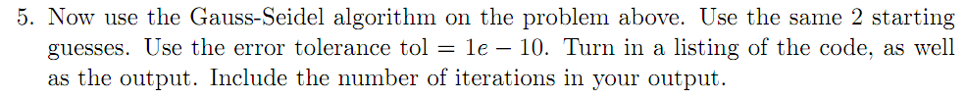

%gseid.m

function [X,k]=gseid(A,B,P,delta,max1)

N=length(B);

X=zeros(N,1);

for k=1:max1

for j=1:N

X(j) = (B(j)-A(j,1:j-1)*X(1:j-1) - A(j,j+1:N)*P(j+1:N))/A(j,j);

end

err = abs(norm(X-P));

relerr = err/(norm(X)+eps);

P = X;

fprintf('%4g %20.15f %20.15f %20.15f\n',k,X(1),X(2),X(3))

if (err<delta)|(relerr<delta)

break

end

end

X = X';

First guess (0,0,0)’ takes 13 iterations:

>> gseid(A, B, guess, 1e-10, 100)

ans =

2.999999999969199e+00 2.000000000008718e+00 9.999999999882799e-01

Second guess (10,20,-30)’ takes 16 iterations:

>> gseid(A, B, guess2, 1e-10, 100)

ans =

2.999999999983042e+00 2.000000000004545e+00 9.999999999935897e-01

6.

Consider tic toc functions