Ryan Brosnahan

HW 6

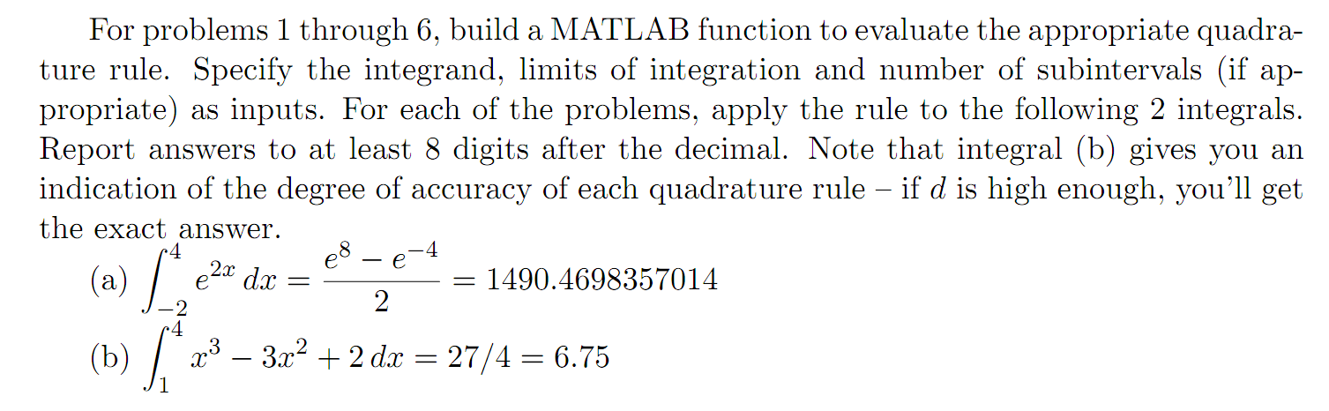

>> f = @(x) exp(2\*x);

>> g = @(x) x^3 - 3\*x^2 + 2;



function I = trapezoid(f, a, b)

%trapezoid quadrature integration of function f on [a, b]

I = (b - a)/2 \* (f(a) + f(b));

>> trapezoid(f, -2, 4)

ans = 8.942928908041851e+03

>> trapezoid(g, 1, 4)

ans = 27



function I = Simpson(f, a, b)

%Simpson's quadrature integration of function f on [a, b]

h = (b - a)/2;

I = h/3 \* (f(a) + 4 \* f( (a+b)/2 ) + f(b));

>> Simpson(f, -2, 4)

ans = 3.010532527076340e+03

>> Simpson(g, 1, 4)

ans = 6.500000000000000e-00



function I = boole(f, a, b)

%Boole's quadrature integration of function f on [a, b]

h = (b - a)/4;

I = 2\*h/45 \* (7\*f(a) + 32\*f(a+h) + 12\*f(a+2\*h) + 32\*f(a+3\*h) + 7\*f(b));

>> boole(f, -2, 4)

ans = 1.714433068356761e+03

>> boole(g, 1, 4)

ans = 6.500000000000000e-00



function I = cTrapezoid(f, a, b, n)

h = (b - a)/n;

I = 0;

for k=0:n-1

I = I + trapezoid(f, a + k\*h, a + k\*h + h);

end

>> cTrapezoid(f, -2, 4, 40)

ans = 1.501631627533835e+03

>> cTrapezoid(g, 1, 4, 40)

ans = 6.762656250000020e+00

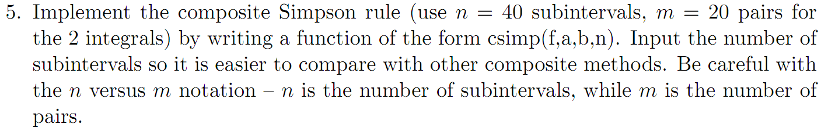

function I = cSimpson(f, a, b, n)

%source http://www.pcs.cnu.edu/~bbradie/matlab/quadrature/simp.m

%composite Simpson's rule

h = (b - a)/n;

x = linspace ( a, b, n+1 );

for i = 1:n+1

fx(i) = feval ( f, x(i) );

end

w = [ 1 zeros(1,n-1) 1 ];

w(2:2:n) = 4\*ones(1,n/2);

w(3:2:n-1) = 2\*ones(1,n/2-1);

I = (h/3) \* sum ( w .\* fx );

>> cSimpson(f, -2, 4, 40)

ans = 1.490536194953689e+03

>> cSimpson(g, 1, 4, 40)

ans = 6.749999999999999e+00

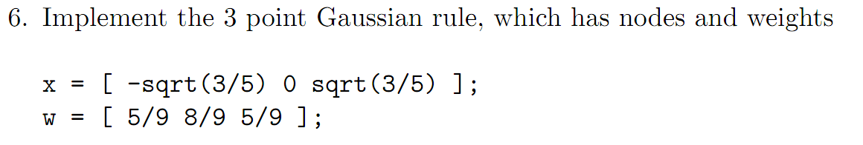

function I = gauss3(f, c, d)

a = -1;

b = 1;

x = [-sqrt(3/5) 0 sqrt(3/5)];

w = [5/9 8/9 5/9];

n = length(x);

t = c + (d-c)/(b-a) \* (x-a);

I = 0;

for k=1:n

I = I + w(k)\*f(t(k));

end

I = I \* (d-c)/(b-a);

>> gauss3(f, -2, 4)

ans = 1.304682954288653e+03

>> gauss3(g, 1, 4)

ans = 6.749999999999998e+00



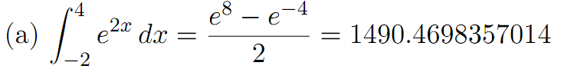

This is bad. Because the equation is positive (increasing) and concave up, we would expect the trapezoid rule to have a positive bias.

$$E_{S}\left[f\right]= -\frac{{\left(b-a\right)}^{5}}{180} f^{\left(4\right)}\left(μ\right)=O(h^{4})$$

$$Comp Simpson= 1490.53619495368$$

$$Actual=1490.4698357014$$

$$Abs Error=0.066359252289$$

This is may be acceptable depending on the application.