Ryan Brosnahan

Computing Assignment 3



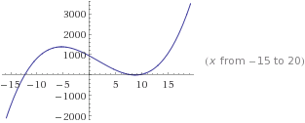

The positive roots are very close together which makes Regula-Falsi, Secant, and Bisection methods difficult because they require a guess interval. The equation is not in proper form to do Fixed Point easily. Finding the derivative is easy enough, so Newton’s it is!

>> NewtonsRoot(f, fp, -15, 10e-9, 50)

ans =

**-1.234567890100894e+01**

>> NewtonsRoot(f, fp,8 , 10e-9, 50)

ans =

**8.706454465547902e+00**

>> NewtonsRoot(f, fp,10 , 10e-9, 50)

ans =

**8.706595534278467e+00**

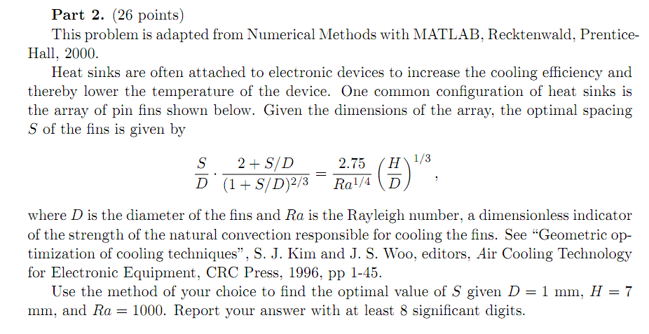

It is very easy to put the equation in the form s = g(s) so fixed point is a nice choice.

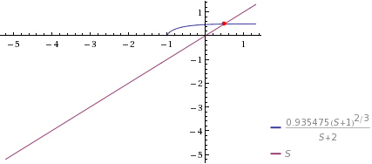

g =

@(S)((2.75/(R^(1/4)))*((H/D)^(1/3)))*(((1+S/D)^(2/3))/(2+S/D))*D

>> fixedPointRoot(g, 5, 1e-9, 50)

ans =

**4.901086499061800e-01**