Ryan Brosnahan

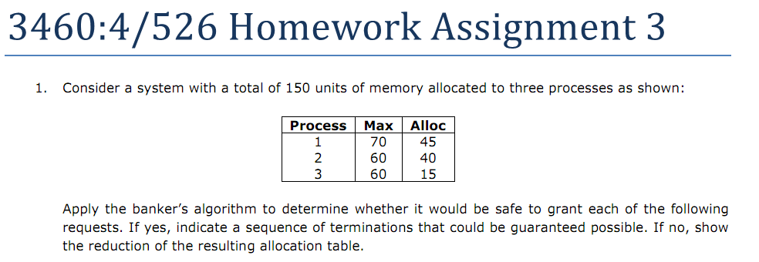







Internal fragmentation happens when the program is allocated more memory than it needs. This is a very typical scenario and it happens when there are no available blocks of memory that are the exact right size, but one that is larger than needed is available so the program gets put there.

External fragmentation happens when a program will not fit into one block, so it is *fragmented* and split into two or more blocks. This also implies that it does not completely fill the last block, leaving some space unused and wasted.

**In a paging system, the wasted space in the last page is lost to internal fragmentation. In a pure segmentation system, some space is invariably lost between the segments. This is due to external fragmentation. FROM THE INTERNET**



First fit:

   
Goes in the 20k

  
Goes in the 10k

  
Goes in the 18k

Best fit:

  
Goes in the 12k

  
Goes in the 10k

  
Goes in the 9k

Worst fit:

  
Goes in the 20k

  
Goes in the 18k

  
Goes in the 15k

Next fit:

  
Goes in the 20k

  
Goes in the 18k

  
Goes in the 9k



1k -> 10 bits



0|1110000011  
Page: 0  
Offset: 899



10110|1110100000  
Page: 22  
Offset: 928



11111100|1001000100  
Page: 252  
Offset: 580



0|0101111100  
Page: 0  
Offset: 380

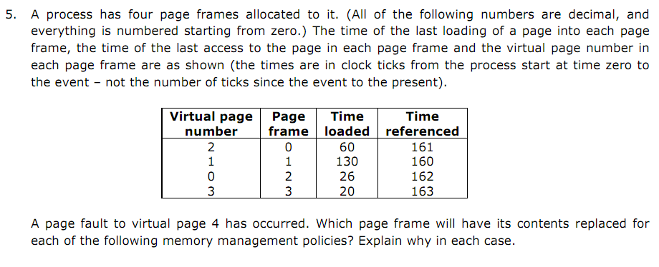



Page frame 3: Page 3 was loaded into frame 3 first (at time 20) so it will be the first out.



Page frame 1: The “current time” in our scenario is 164. At 163 frame 3 was used, at 162 frame 2 was used, and at 161 frame 0 was used. The lease recently used was frame 1 at 160.



Page frame 3: Page 3 will not be used for the longest time so the frame that holds it can be used.

