Ryan Sullivan

U73687595

21 November 2019

EC311

Lab 2

**Objective:**

Create a counter with both manual and automatic counting functions with a universal reset and a seven-segment display.

**Methodology:**

Create multiple submodules that could be put together to create the desired product:

Counter:

The first iteration of the counter module that could only store up to one byte (8-bits), it would add a single bit to the total stored value for every time an increment is registered at a clock positive edge and would reset on a positive reset.

Counter16:

A modified version of the first counter module the only difference being that it could now store up to two bytes (16-bits) of data.

Debouncer:

A module used to account for the inaccuracy of a button push, it would register a single button push only after adding up enough of its signals and would not continually send a positive signal to the counter, thus negating the problem with having such a fast clock with such slow button pushes.

Clock Divider:

There were two separate clock divider modules, one for a fast clock (1 kHz) which would be used to refresh the seven-segment display, and one slow clock (1 Hz) used for the input for the automatic counting function. Both the clock dividers would only change their signal (from 1 to 0 or vice versa) once a certain number of clock pulses from the onboard clock had been registered, this number varies from clock to clock.

Display Control:

This was very simply a 2-bit counter that fed into 2:4 decoder, wherein the counter would register every clock pulse from the fast clock (1kHz) and increment by 1 bit, then the 2:4 decoder was fed into the seven-segment display to select a digit anode, refreshing each digit in sequence at a refresh rate of 1 kHz.

Seven-Segment Decoder:

This was a 4:7 decoder that would take a 4-bit input and output a 7-bit bitstream that would be fed directly into the seven-segment display digits that would light up each segment in accordance with the 4-bit input (taken from the counter16 module in 4-bit chunks each corresponding to their own digit), which would translate the binary value into a more palatable hexadecimal value. The output is updated with every change to the input.

**Observation:**

Elaborated Design:

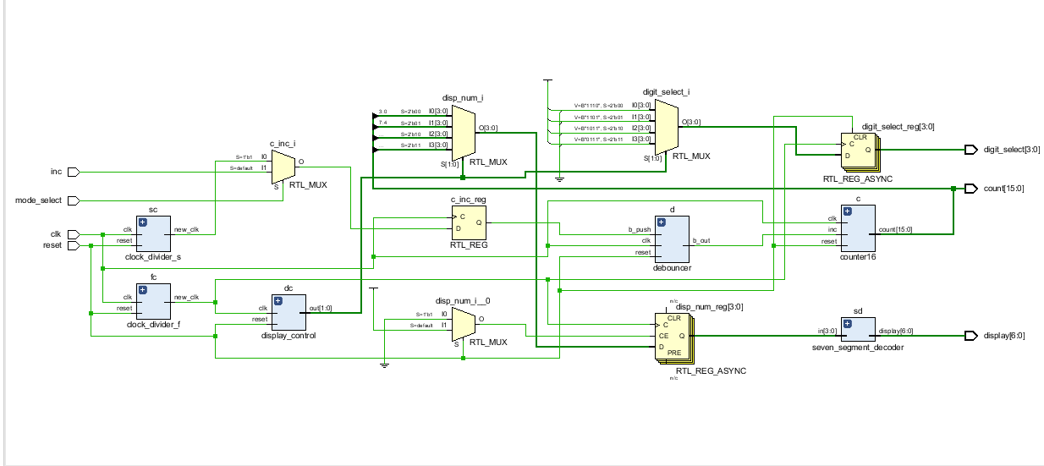

Counter Testbenches: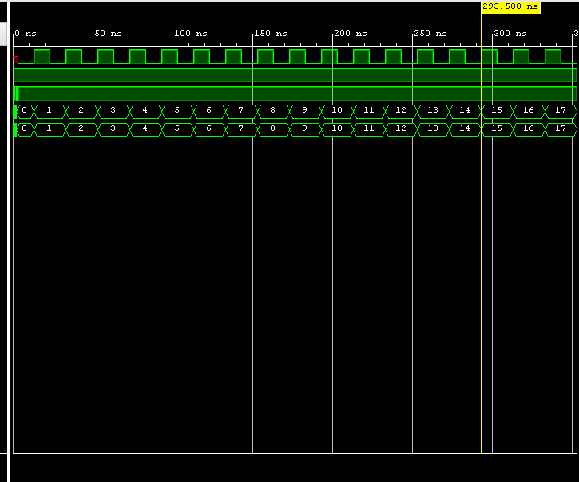

Display Control Testbench: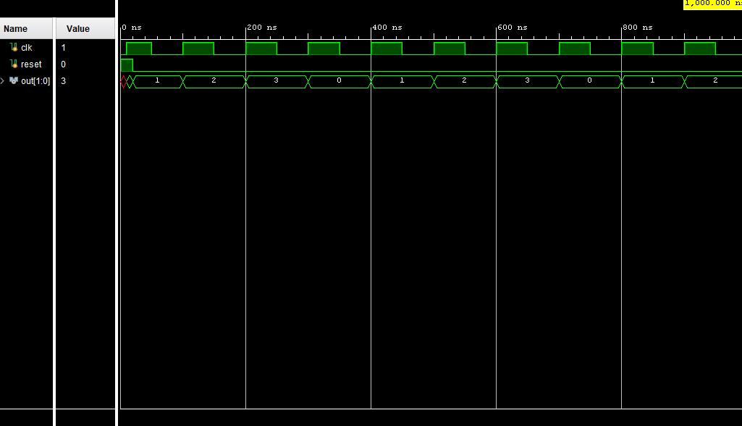

Debouncer Testbench: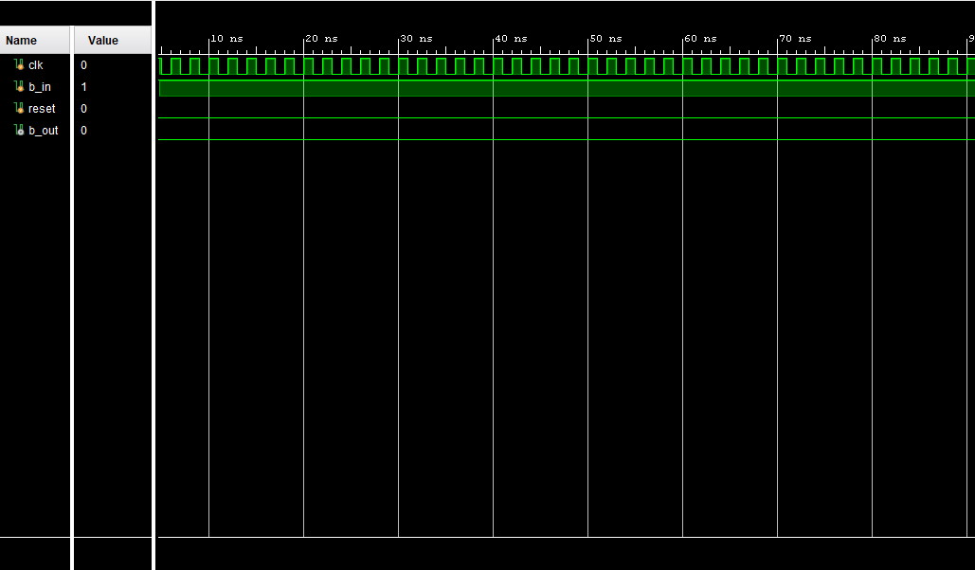

Seven-Segment Decoder Testbench: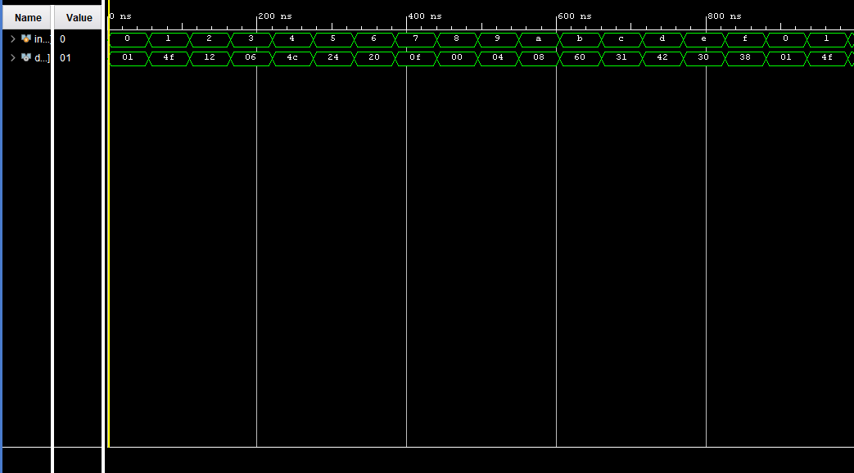

Constraints File: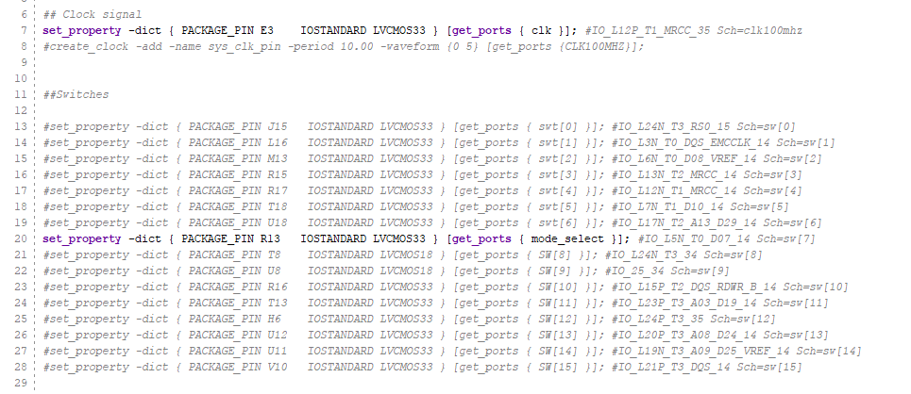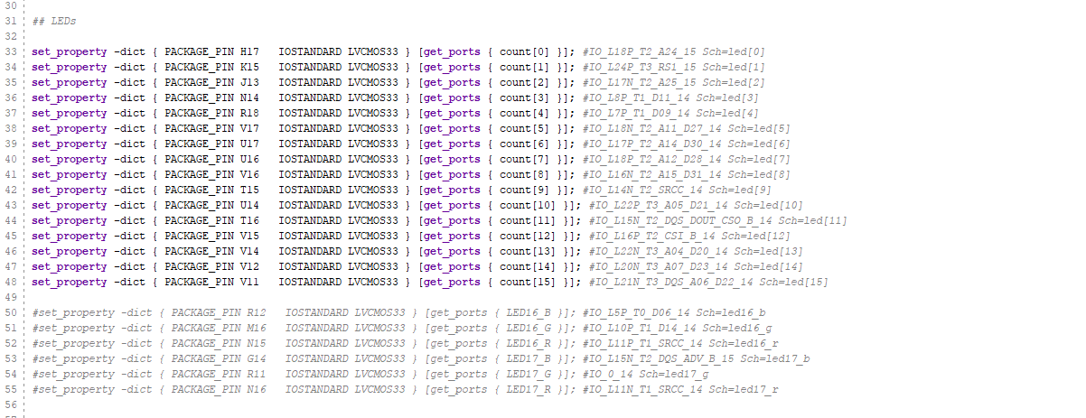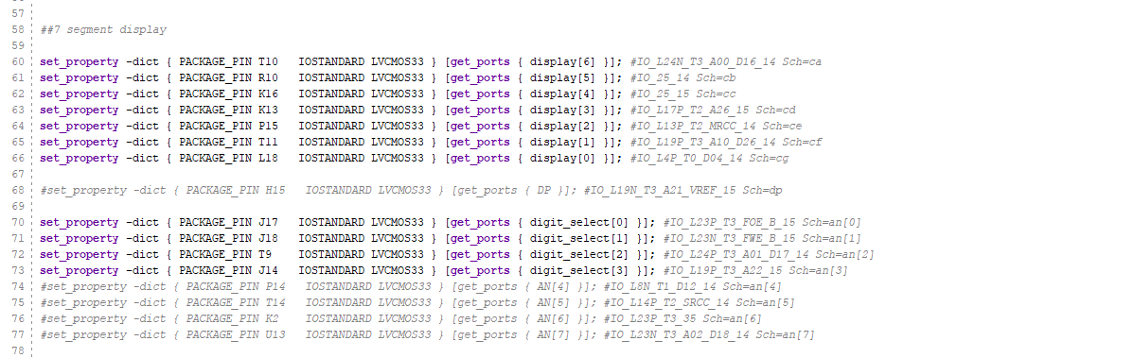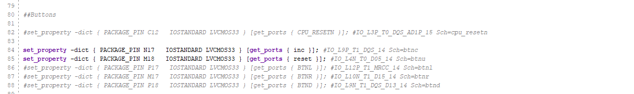

**Conclusion:**

This lab has helped immensely in improving my understanding of Verilog and the workings of an FPGA board. The lab also taught me that a modular design is extremely efficient and the best in terms of testing and fixing any bugs that arise in project creation. Finally working with a physical board has improved my overall coding skillset and has better prepared me for the professional landscape in the future.

**Code:**

module top(

input clk,

input reset,

input inc,

output [7:0] count

);

wire b_out;

debouncer d(

.clk(clk),

.reset(reset),

.b_push(inc),

.b_out(b_out)

);

counter c(

.clk(clk),

.reset(reset),

.inc(b_out),

.count(count)

);

endmodule

module top2(

input clk,

input reset,

input mode_select,

input inc,

output [15:0] count,

output reg [3:0] digit_select,

output [6:0] display

);

wire b_out, f_clk, s_clk;

wire [1:0] dig_sel;

reg [3:0] disp_num;

reg c_inc;

clock_divider_f fc(

.clk(clk),

.reset(reset),

.new_clk(f_clk)

);

clock_divider_s sc(

.clk(clk),

.reset(reset),

.new_clk(s_clk)

);

seven_segment_decoder sd(

.in(disp_num),

.display(display)

);

display_control dc(

.clk(f_clk),

.reset(reset),

.out(dig_sel)

);

debouncer d(

.clk(clk),

.reset(reset),

.b_push(c_inc),

.b_out(b_out)

);

counter16 c(

.clk(clk),

.reset(reset),

.inc(b_out),

.count(count)

);

always@(posedge clk) begin

if(mode_select) begin

c_inc = s_clk;

end else begin

c_inc = inc;

end

end

always@(posedge f_clk, negedge reset) begin

if(reset) begin

digit_select <= 4'b0000;

end else if(f_clk) begin

case(dig_sel)

2'b00: begin

digit_select <= 4'b1110;

disp_num <= count[3:0];

end

2'b01: begin

digit_select <= 4'b1101;

disp_num <= count[7:4];

end

2'b10: begin

digit_select <= 4'b1011;

disp_num <= count[11:8];

end

2'b11: begin

digit_select <= 4'b0111;

disp_num <= count[15:12];

end

endcase

end

end

endmodule

module counter(

input clk,

input reset,

input inc,

output reg [7:0] count

);

always @(posedge clk, negedge reset) begin

if(reset) begin

count <= 8'b00000000;

end else if(clk) begin

if(inc) begin

count <= count + 8'b00000001;

end

end

end

endmodule

module debouncer(

input clk,

input reset,

input b_push,

output reg b_out

);

parameter MAX = 1600000;

reg [31:0] count;

always @(posedge clk) begin

if(reset)

count <= 0;

else if(b_push)

count <= count +1;

else

count <= 0;

end

always @(posedge clk) begin

if(reset)

b_out <= 1'b0;

else if(count == MAX)

b_out <= 1'b1;

else

b_out <= 1'b0;

end

endmodule

module counter16(

input clk,

input reset,

input inc,

output reg [15:0] count

);

always @(posedge clk, negedge reset) begin

if(reset) begin

count <= 16'b000000000000000;

end else if(clk) begin

if(inc) begin

count <= count + 16'b000000000000001;

end

end

end

endmodule

module clock_divider_f(

input clk,

input reset,

output reg new_clk

);

reg [31:0] count;

parameter slow_clk = 50000000;

parameter fast_clk = 50000;

always @(posedge clk, negedge reset) begin

if(reset) begin

count <= 32'b0;

new_clk <= 1'b0;

end

else if(count == fast_clk -1)begin

count <= 32'b0;

new_clk <= ~new_clk;

end

else begin

count <= count + 32'b1;

new_clk <= new_clk;

end

end

endmodule

module clock_divider_s(

input clk,

input reset,

output reg new_clk

);

reg [31:0] count;

parameter slow_clk = 50000000;

parameter fast_clk = 50000;

always @(posedge clk, negedge reset) begin

if(reset) begin

count <= 32'b0;

new_clk <= 1'b0;

end

else if(count == slow_clk -1)begin

count <= 32'b0;

new_clk <= ~new_clk;

end

else begin

count <= count + 32'b1;

new_clk <= new_clk;

end

end

endmodule

module seven_segment_decoder(

input [3:0] in,

output reg [6:0] display

);

always @(in)begin

case(in)

4'b0000: display <= 7'b0000001;

4'b0001: display <= 7'b1001111;

4'b0010: display <= 7'b0010010;

4'b0011: display <= 7'b0000110;

4'b0100: display <= 7'b1001100;

4'b0101: display <= 7'b0100100;

4'b0110: display <= 7'b0100000;

4'b0111: display <= 7'b0001111;

4'b1000: display <= 7'b0000000;

4'b1001: display <= 7'b0000100;

4'b1010: display <= 7'b0001000;

4'b1011: display <= 7'b1100000;

4'b1100: display <= 7'b0110001;

4'b1101: display <= 7'b1000010;

4'b1110: display <= 7'b0110000;

4'b1111: display <= 7'b0111000;

endcase

end

endmodule

module display_control(

input clk,

input reset,

output reg [1:0] out

);

always @(posedge clk, negedge reset) begin

if(reset) begin

out <= 2'b00;

end else if(clk) begin

out <= out + 2'b01;

end

end

endmodule

**Testbenches:**

module seven_seg_test();

reg[3:0] in;

wire[6:0] display;

seven_segment_decoder s(

.in(in),

.display(display)

);

initial begin

in <= 4'b0000;

end

always begin

#55 in <= in + 4'b1;

end

endmodule

module deb_test();

reg clk, b_in, reset;

wire b_out;

debouncer d(

.clk(clk),

.b_push(b_in),

.reset(reset),

.b_out(b_out)

);

initial begin

b_in <= 1'b1;

reset <= 1'b1;

#1 reset = 1'b0;

clk <= 1'b0;

forever begin

#1 clk = ~clk;

end

#1;

end

endmodule

module count_test();

reg clk, inc, reset;

wire [7:0] count;

wire [15:0] count2;

counter c(

.clk(clk),

.inc(inc),

.reset(reset),

.count(count)

);

counter16 c2(

.clk(clk),

.inc(inc),

.reset(reset),

.count(count2)

);

initial begin

inc <= 1'b1;

#1 reset <= 1'b1;

#1 reset <= 1'b0;

#1 reset <= 1'b1;

clk <= 1'b0;

forever begin

#10 clk = ~clk;

end

end

endmodule

module display_control(

input clk,

input reset,

output reg [1:0] out

);

always @(posedge clk, negedge reset) begin

if(reset) begin

out <= 2'b00;

end else if(clk) begin

out <= out + 2'b01;

end

end

endmodule