American Baptists

Q75 Thank you for agreeing to take our survey. Please choose the options that best fit your experience or opinion.

Q2 In the past 12 months, has your church declined in total membership, increased in total membership, or remained the same?

* Declined in total membership (1)
* Increased in total membership (3)
* Remained the same (4)

Q3 Do you ever worry that other churches are trying to recruit your members?

* Yes (1)
* No (2)
* Haven't thought about it (3)

Q5 In the past year, in which of the following political activities have you engaged? Please check as many as apply.

* Voted in a national election (1)
* Contacted an elected official (2)
* Contributed money to a candidate, party, or political group (3)
* Volunteered for a campaign or party (4)
* Volunteered for an interest group (5)
* Urged my congregation to vote (6)
* Protested for a political cause (7)
* Attended a political rally or march (8)
* Formed a political study group in church (9)
* Registered voters in my church (10)

Q6 In the past 12 months, has your church done any of the following?

|  |  |  |
| --- | --- | --- |
|  | Yes (1) | No (2) |
| Sponsored an outreach event intended to bring people into your congregation (1) |  |  |
| Used different worship materials (e.g., music) to appeal to non-members (2) |  |  |
| Had a special committee to work on recruiting new members (3) |  |  |
| Mailed or distributed newsletters, letters, or flyers to recruit new members (4) |  |  |

Q78 Let's say you have a political view that you know would be very unpopular with others in your community. Would you be willing to do the following?

|  |  |  |
| --- | --- | --- |
|  | Yes, would be willing (1) | No, not willing (2) |
| Put a sign in front of your home (1) |  |  |
| Put a bumper sticker on your car (2) |  |  |
| Participate in a demonstration (3) |  |  |
| Wear a button in public (4) |  |  |
| Sign a petition for publication in the local paper (5) |  |  |
| Write a letter to your US representatives (6) |  |  |

Q4 In your view, should the ABC-USA do more or less of the following?

|  |  |  |  |  |  |  |  |
| --- | --- | --- | --- | --- | --- | --- | --- |
|  | Much more (1) | More (2) | Somewhat More (3) | The Same (4) | Somewhat Less (5) | Less (6) | Much Less (7) |
| Does the ABC-USA need to be more or less involved with social and political issues? (1) |  |  |  |  |  |  |  |
| Should the ABC-USA be more or less involved in debating social and political issues inside the religious body? (2) |  |  |  |  |  |  |  |
| Should the ABC-USA be more or less engaged in presenting its social and political views to government? (3) |  |  |  |  |  |  |  |

Q7 In the past 12 months, has your church declined in total membership, increased in total membership, or remained the same?

* Declined in total membership (1)
* Increased in total membership (3)
* Remained the same (4)

Q8 Do you ever worry that other churches from your denomination are trying to recruit your members?

* Yes (1)
* No (2)
* Haven't thought about it (3)

Q10 In the past year, which of the following political activities have you engaged? Please check as many as apply.

* Voted in a national election (1)
* Contacted an elected official (2)
* Contributed money to a candidate, party, or political group (3)
* Volunteered for a campaign or party (4)
* Volunteered for an interest group (5)
* Urged my congregation to vote (6)
* Protested for a political cause (7)
* Attended a political rally or march (8)
* Formed a political study group in church (9)
* Registered voters in my church (10)

Q11 In the past year, has your church done any of the following?

|  |  |  |
| --- | --- | --- |
|  | Yes (1) | No (2) |
| Sponsored an outreach event intended to bring people into your congregation (1) |  |  |
| Used different worship materials (e.g., music) to appeal to non-members (2) |  |  |
| Had a special committee to work on recruiting new members (3) |  |  |
| Mailed or distributed newsletters, letters, or flyers to recruit new members (4) |  |  |

Q77 Let's say you have a political view that you know would be very unpopular with others in your community. Would you be willing to do the following?

|  |  |  |
| --- | --- | --- |
|  | Yes, would be willing (1) | No, not willing (2) |
| Put a sign in front of your home (1) |  |  |
| Put a bumper sticker on your car (2) |  |  |
| Participate in a demonstration (3) |  |  |
| Wear a button in public (4) |  |  |
| Sign a petition for publication in the local paper (5) |  |  |
| Write a letter to your US representatives (6) |  |  |

Q9 In your view, should the ABC-USA do more or less of the following?

|  |  |  |  |  |  |  |  |
| --- | --- | --- | --- | --- | --- | --- | --- |
|  | Much more (1) | More (2) | Somewhat More (3) | The Same (4) | Somewhat Less (5) | Less (6) | Much Less (7) |
| Does the ABC-USA need to be more or less involved with social and political issues? (1) |  |  |  |  |  |  |  |
| Should the ABC-USA be more or less involved in debating social and political issues inside the religious body? (2) |  |  |  |  |  |  |  |
| Should the ABC-USA be more or less engaged in presenting its social and political views to government? (3) |  |  |  |  |  |  |  |

Q13 In the past year, which of the following political activities have you engaged? Please check as many as apply.

* Voted in a national election (1)
* Contacted an elected official (2)
* Contributed money to a candidate, party, or political group (3)
* Volunteered for a campaign or party (4)
* Volunteered for an interest group (5)
* Urged my congregation to vote (6)
* Protested for a political cause (7)
* Attended a political rally or march (8)
* Formed a political study group in church (9)
* Registered voters in my church (10)

Q14 In the past 12 months, has your church done any of the following?

|  |  |  |
| --- | --- | --- |
|  | Yes (1) | No (2) |
| Sponsored an outreach event intended to bring people into your congregation (1) |  |  |
| Used different worship materials (e.g., music) to appeal to non-members (2) |  |  |
| Had a special committee to work on recruiting new members (3) |  |  |
| Mailed or distributed newsletters, letters, or flyers to recruit new members (4) |  |  |

Q25 Let's say you have a political view that you know would be very unpopular with others in your community. Would you be willing to do the following?

|  |  |  |
| --- | --- | --- |
|  | Yes, would be willing (1) | No, not willing (2) |
| Put a sign in front of your home (1) |  |  |
| Put a bumper sticker on your car (2) |  |  |
| Participate in a demonstration (3) |  |  |
| Wear a button in public (4) |  |  |
| Sign a petition for publication in the local paper (5) |  |  |
| Write a letter to your US representatives (6) |  |  |

Q12 In your view, should the ABC-USA do more or less of the following?

|  |  |  |  |  |  |  |  |
| --- | --- | --- | --- | --- | --- | --- | --- |
|  | Much more (1) | More (2) | Somewhat More (3) | The Same (4) | Somewhat Less (5) | Less (6) | Much Less (7) |
| Does the ABC-USA need to be more or less involved with social and political issues? (1) |  |  |  |  |  |  |  |
| Should the ABC-USA be more or less involved in debating social and political issues inside the religious body? (2) |  |  |  |  |  |  |  |
| Should the ABC-USA be more or less engaged in presenting its social and political views to government? (3) |  |  |  |  |  |  |  |

Q73 In general, how satisfied or dissatisfied are you with the way things are going in the United States at this time?

* Very satisfied (1)
* Satisfied (4)
* Somewhat satisfied (5)
* Neither satisfied nor dissatisfied (6)
* Somewhat dissatisfied (7)
* Dissatisfied (8)
* Very dissatisfied (9)

Q74 How much do you trust the federal government to do what's right?

* Trust greatly (1)
* Trust (2)
* Trust somewhat (3)
* Neither trust nor distrust (4)
* Distrust somewhat (5)
* Distrust (6)
* Distrust greatly (7)

Q15 Have any of the following happened in the past year regarding any issue?

|  |  |  |
| --- | --- | --- |
|  | Yes (1) | No (2) |
| Congregation members contacted me with their political concerns (1) |  |  |
| I contacted government officials on behalf of members of my congregation (2) |  |  |
| I considered myself a representative of my congregation to the public and government officials. (3) |  |  |
| The congregation considered me to be one of their representatives to the public and government officials. (4) |  |  |
| I knew government officials personally. (5) |  |  |

Q18 Do you agree or disagree with the following statements?

|  |  |  |  |  |  |
| --- | --- | --- | --- | --- | --- |
|  | Strongly Agree (1) | Agree (2) | Neither Agree nor Disagree (3) | Disagree (4) | Strongly Disagree (5) |
| The more clergy can step out of the way of the congregation the better. (2) |  |  |  |  |  |
| It is important for the congregation to construct their own salvation. (3) |  |  |  |  |  |
| The Gospel is what the congregation makes of it. (5) |  |  |  |  |  |
| The church must adapt to a postmodern culture in order to spread the Gospel. (7) |  |  |  |  |  |
| I believe there are many valid interpretations of the Bible. (9) |  |  |  |  |  |

Q20 Now, on to a new topic. Please read each statement and then check whether you agree or disagree.

|  |  |  |  |  |  |
| --- | --- | --- | --- | --- | --- |
|  | Strongly Agree (1) | Agree (2) | Neither Agree nor Disagree (3) | Disagree (4) | Strongly Disagree (5) |
| It's very important that politicians air their differences of opinion publicly. (1) |  |  |  |  |  |
| The level of civility in society is important to address. (5) |  |  |  |  |  |
| You can't have democracy without political opposition. (2) |  |  |  |  |  |
| You can't be sure an opinion is correct unless people are free to argue against it. (3) |  |  |  |  |  |
| Unless many views are presented, there is little chance that the truth can ever be known. (4) |  |  |  |  |  |

Q21 If the election were to be held today, for which presidential candidate would you vote?

* Hillary Clinton (Democrat) (1)
* Donald Trump (Republican) (2)
* Gary Johnson (Libertarian) (5)
* Jill Stein (Green) (3)
* Other (4)
* I will not vote for President this year (6)

Q22 How about your congregation? Please estimate the proportion of adults that supports the two major party candidates.

______ Donald Trump (1)

______ Hillary Clinton (2)

Q67 In making your decision on how to cast your vote for President, what was the most important factor?

* Abortion stance (1)
* Immigration stance (2)
* Judicial appointments (3)
* Religious freedom stance (4)
* Hillary Clinton (5)
* Donald Trump (6)
* Treatment of women (7)
* Temperament for office (8)
* Something else (9)

Q63 How often have you discussed the presidential election this year with others?

* Never (1)
* Sometimes (2)
* About once a week (3)
* Several times a week (6)
* Daily (4)
* More than once a day (5)

Q64 With roughly how many people have you discussed the presidential election this year? Click in the slider space to record your answer. If the number is greater than 50, please just pick 50.

______ Number of people-> (1)

Q79 What is your view about the creation of the world and humanity? Where do you think most people in your congregation stand? How about your denomination? If you can, please use the following scale where 0 means that the world and humans were created by God; 100 means humans were created through evolutionary processes; and 50 would reflect a blended view that evolution of humans was guided by God.

______ Your position (1)

______ Your congregation (2)

______ Your denomination (3)

Q80 How will the world end? What are your views? Please use the following scale, if possible, where 0 means the world will be destroyed and select humans will join God in the afterlife; 100 means that there are natural cycles of destruction and rebirth; and 50 is a blended perspective where natural cycles are guided by God.

______ Your position (1)

______ Your congregation (2)

______ Your denomination (3)

Q81 Which of the following comes closest to your own position about global warming and climate change? Where would your congregation and denomination stand?

|  |  |  |  |
| --- | --- | --- | --- |
|  | Global warming is not happening (4) | Global warming is happening but it is part of a natural cycle which is not caused by humans (5) | Global warming is happening and it is primarily caused by human activity (6) |
| Your position (1) |  |  |  |
| Your congregation (2) |  |  |  |
| Your denomination (3) |  |  |  |

Q82 Do you agree or disagree with the following statements?

|  |  |  |  |  |  |
| --- | --- | --- | --- | --- | --- |
|  | Strongly agree (8) | Somewhat agree (9) | Neither agree nor disagree (10) | Somewhat disagree (11) | Strongly disagree (12) |
| Humans were meant to rule over nature (4) |  |  |  |  |  |
| When humans interfere with nature it often produces disastrous consequences (5) |  |  |  |  |  |
| The so-called ecological crisis facing humankind has been greatly exaggerated (6) |  |  |  |  |  |
| We are approaching the limit of the number of people the earth can support (7) |  |  |  |  |  |
| The balance of nature is strong enough to cope with the impacts of modern industrial nations (8) |  |  |  |  |  |
| Human are severely abusing the environment (9) |  |  |  |  |  |

Q157 Do you agree or disagree with the following statements?

|  |  |  |  |  |  |
| --- | --- | --- | --- | --- | --- |
|  | Strongly agree (8) | Somewhat agree (9) | Neither agree nor disagree (10) | Somewhat disagree (11) | Strongly disagree (12) |
| Humans were meant to rule over nature (4) |  |  |  |  |  |
| When humans interfere with nature it often produces disastrous consequences (5) |  |  |  |  |  |
| The so-called ecological crisis facing humankind has been greatly exaggerated (6) |  |  |  |  |  |
| We are approaching the limit of the number of people the earth can support (7) |  |  |  |  |  |
| The balance of nature is strong enough to cope with the impacts of modern industrial nations (8) |  |  |  |  |  |
| Human are severely abusing the environment (9) |  |  |  |  |  |

Q154 What is your view about the creation of the world and humanity? Where do you think most people in your congregation stand? How about your denomination? If you can, please use the following scale where 0 means that the world and humans were created by God; 100 means humans were created through evolutionary processes; and 50 would reflect a blended view that evolution of humans was guided by God.

______ Your position (1)

______ Your congregation (2)

______ Your denomination (3)

Q155 How will the world end? What are your views? Please use the following scale, if possible, where 0 means the world will be destroyed and select humans will join God in the afterlife; 100 means that there are natural cycles of destruction and rebirth; and 50 is a blended perspective where natural cycles are guided by God.

______ Your position (1)

______ Your congregation (2)

______ Your denomination (3)

Q156 Which of the following comes closest to your own position about global warming and climate change? Where would your congregation and denomination stand?

|  |  |  |  |
| --- | --- | --- | --- |
|  | Global warming is not happening (4) | Global warming is happening but it is part of a natural cycle which is not caused by humans (5) | Global warming is happening and it is primarily caused by human activity (6) |
| Your position (1) |  |  |  |
| Your congregation (2) |  |  |  |
| Your denomination (3) |  |  |  |

Q70 Please read the following story before proceeding to a final set of questions.

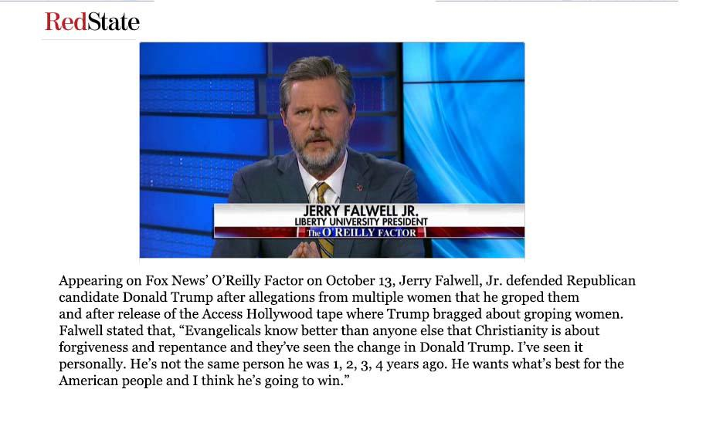

Q71 Please read the following story before proceeding to a final set of questions.

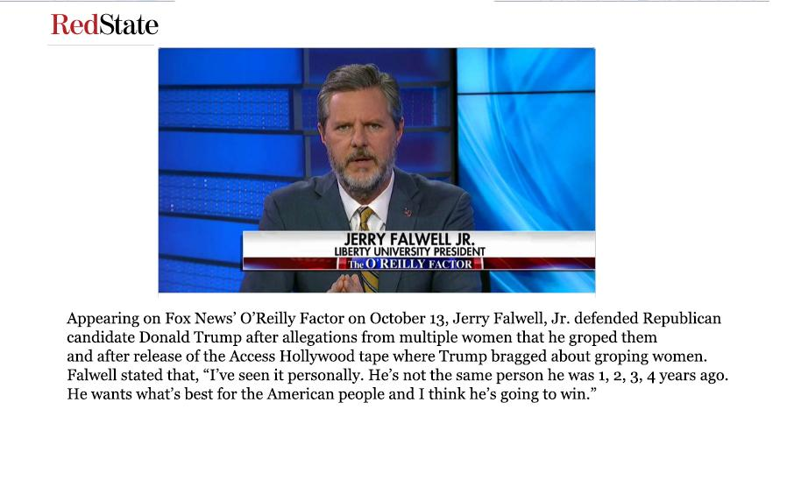

Q76 Please click next to continue to the following questions. Thank you.

Q66 Do you agree or disagree with the following statements?

|  |  |  |  |  |  |  |  |
| --- | --- | --- | --- | --- | --- | --- | --- |
|  | Strongly Agree (1) | Agree (2) | Somewhat agree (3) | Neither agree nor disagree (4) | Somewhat disagree (5) | Disagree (6) | Strongly disagree (7) |
| Public support for Donald Trump will hurt Christian witness. (1) |  |  |  |  |  |  |  |
| Moving a conservative agenda is worth any price of supporting Trump. (2) |  |  |  |  |  |  |  |
| I have expressed doubts to others about my candidate choice. (7) |  |  |  |  |  |  |  |
| Disagreement among Christians regarding Donald Trump is healthy. (3) |  |  |  |  |  |  |  |
| The Christian Right is dead after this election. (4) |  |  |  |  |  |  |  |
| The bond between evangelicals and the Republican Party is a healthy lasting one. (5) |  |  |  |  |  |  |  |
| Elected officials can still perform their public duties in an ethical manner even if they have committed immoral personal acts. (6) |  |  |  |  |  |  |  |

Q65 Off the top of your head (that is, without doing research), how do the following groups and individuals stand with respect to Republican nominee Donald Trump? If you don't know this person or don't know their stance, please just click "don't know."

|  |  |  |  |
| --- | --- | --- | --- |
|  | Endorses Trump (1) | Opposes Trump (2) | Don't know (3) |
| Russell Moore (1) |  |  |  |
| Christianity Today (2) |  |  |  |
| Jerry Falwell Jr. (3) |  |  |  |
| Mike Huckabee (4) |  |  |  |
| Dr. James Dobson (5) |  |  |  |
| Rick Warren (6) |  |  |  |
| Pat Robertson (7) |  |  |  |
| Michael Gerson (8) |  |  |  |
| Tony Perkins (9) |  |  |  |
| Beth Moore (11) |  |  |  |
| Jen Hatmaker (10) |  |  |  |

Q50 In the past 12 months, has your church declined in total membership, increased in total membership, or remained the same?

* Declined in total membership (1)
* Increased in total membership (3)
* Remained the same (4)

Q51 Do you ever worry that other churches from your denomination are trying to recruit your members?

* Yes (1)
* No (2)
* Haven't thought about it (3)

Q52 Do you ever worry that other churches are trying to recruit your members?

* Yes (1)
* No (2)
* Haven't thought about it (3)

Q27 These are some descriptors of your congregation.

Q28 About how many of the following does your church have? (just numbers please)

Adult members (1)

Average weekly attendance at all services (2)

The percentage of adult members who are active in the congregation beyond attending weekly services in any activity (governing board, small groups, programs etc.)? (3)

Q29 What kind of community is your church in?

* Rural or farm (1)
* Mill community (2)
* small city/town (under 50,000) (3)
* medium sized city (50-100,000) (4)
* large city (100-250,000) (5)
* suburb of large city (6)
* very large city (over 250,000) (7)
* suburb of very large city (8)

Q30 Would you say that members of your congregation are primarily of what class?

* Working/lower (1)
* Lower-Middle (2)
* Middle (3)
* Upper Middle (4)
* Upper (5)

Q31 On this page, we'd like to ask you about some comparisons of you, your congregation, and your community.

Q32 How would you compare your own views with congregation members’ views on the following items?

|  |  |  |  |  |  |
| --- | --- | --- | --- | --- | --- |
|  | Mine are much more liberal (1) | Mine are somewhat more liberal (2) | Mine are about the same (3) | Mine are somewhat more conservative (4) | Mine are much more conservative (5) |
| On social issues like abortion (1) |  |  |  |  |  |
| In terms of partisanship (2) |  |  |  |  |  |
| On theological issues (3) |  |  |  |  |  |
| On issues regarding immigration (4) |  |  |  |  |  |
| On government aid to the poor (5) |  |  |  |  |  |

Q26 Think about your community: Do you think that your opinions are generally in the majority (most people agree with you) or in the minority (where most people disagree with you)?

* Strongly in the minority (1)
* In the minority (2)
* Somewhat in the minority (3)
* Neither minority nor majority (4)
* Somewhat in the majority (5)
* In the majority (6)
* Strongly in the majority (7)

Q60 We would now like your perceptions of how your congregation differs from your local community.

|  |  |  |  |  |  |
| --- | --- | --- | --- | --- | --- |
|  | 1 (1) | 2 (2) | 3 (3) | 4 (4) | 5 (5) |
| Very politically similar:Very politically different (1) |  |  |  |  |  |
| Very racially similar:Very racially different (2) |  |  |  |  |  |
| Very economically similar:Very economically different (3) |  |  |  |  |  |
| Very similar religious involvement levels:Very different religious involvement levels (4) |  |  |  |  |  |
| Very similar community engagement levels:Very different community engagement levels (5) |  |  |  |  |  |

Q38 Now, we have several quick items about you. This is the second to last page.   What is your gender?

* Male (1)
* Female (2)

Q39 Generally speaking, which of the following political labels do you identify with?

* Strong Democrat (1)
* Democrat (2)
* Independent who leans Democratic (3)
* Independent (4)
* Independent who leans Republican (5)
* Republican (6)
* Strong Republican (7)
* Other party (8)

Q68 Which of the following ideological labels do you best identify with?

* Strong liberal (1)
* Liberal (2)
* Moderate (3)
* Conservative (4)
* Strong conservative (5)

Q41 What is your race? (check as many as apply)

* White (1)
* Black (2)
* Hispanic (3)
* Asian (4)
* Pacific Islander (5)
* Native American (6)
* Other (7)

Q42 Would you use any of the following to describe your religious faith? (check as many as apply)

* Evangelical (1)
* Fundamentalist (2)
* Liberal (3)
* Orthodox (4)
* Ecumenical (5)
* Pentecostal (6)
* Conservative (7)
* Emergent church (8)

Q43 This is the final page of questions!

Q24 How often do you present the following values about how to be a *good person of your faith* in your sermons and public speech?

|  |  |  |  |  |  |
| --- | --- | --- | --- | --- | --- |
|  | Very Often (1) | Often (2) | Sometimes (3) | Rarely (4) | Never (5) |
| It is important to “love the stranger as yourself." (1) |  |  |  |  |  |
| It is important to invite others to our house of worship even if it begins to change as a result. (2) |  |  |  |  |  |
| It is important to shop as much as possible at stores owned by people of our faith. (3) |  |  |  |  |  |
| It is important to keep company with other people of our faith. (4) |  |  |  |  |  |

Q44 Do you agree or disagree with the following statements?

|  |  |  |  |  |  |
| --- | --- | --- | --- | --- | --- |
|  | Strongly Agree (1) | Agree (2) | Neither Agree nor Disagree (3) | Disagree (4) | Strongly Disagree (5) |
| The devil exists. (1) |  |  |  |  |  |
| The Bible is literally true. (2) |  |  |  |  |  |
| Jesus will return to earth in bodily form. (3) |  |  |  |  |  |
| Jesus was born of a virgin. (4) |  |  |  |  |  |
| There is an objective standard of right and wrong established by God's Word. (5) |  |  |  |  |  |
| Men are given authority over women. (6) |  |  |  |  |  |

Q45 For how long have you been a clergyperson and how long serving this congregation? Please enter a number (rounding to the nearest year).

In the ministry (1)

This congregation (2)

Q46 In what year were you born?

______ Year born--> (1)

Q47 In what state is your congregation?

* Alabama (4)
* Alaska (5)
* Arizona (6)
* Arkansas (7)
* California (8)
* Colorado (9)
* Connecticut (10)
* Delaware (11)
* District of Columbia (12)
* Florida (13)
* Georgia (14)
* Hawaii (15)
* Idaho (16)
* Illinois (17)
* Indiana (18)
* Iowa (19)
* Kansas (20)
* Kentucky (21)
* Louisiana (22)
* Maine (23)
* Maryland (24)
* Massachusetts (25)
* Michigan (26)
* Minnesota (27)
* Mississippi (28)
* Missouri (29)
* Montana (30)
* Nebraska (31)
* Nevada (32)
* New Hampshire (33)
* New Jersey (34)
* New Mexico (35)
* New York (36)
* North Carolina (37)
* North Dakota (38)
* Ohio (39)
* Oklahoma (40)
* Oregon (41)
* Pennsylvania (42)
* Rhode Island (43)
* South Carolina (44)
* South Dakota (45)
* Tennessee (46)
* Texas (47)
* Utah (48)
* Vermont (49)
* Virginia (50)
* Washington (51)
* West Virginia (52)
* Wisconsin (53)
* Wyoming (54)

Q48 What is the highest level of education you have received?

* Less than a high school degree (1)
* High school/GED equivalent (2)
* Some college, but did not graduate (3)
* Graduated college/seminary (4)
* Master's degree or working toward a Master's. (5)
* Received a doctorate (6)

Q49 That concludes our survey! Please click the "Next >>" button to submit your results. If you wish to receive a summary of the results, please contact Dr. Paul A. Djupe (djupe@denison.edu) or Dr. Ryan Burge (rpburge@eiu.edu).  Thank you for sharing your opinions with us.