**Introduction**

The most important story in religious demography over the last few years is the meteoric and seemingly unending increase in the share of survey respondents who indicate that they do not affiliate with an organized religion. In March 2012, Time Magazine’s cover story was titled, “The Rise of the Nones,” and focused on a report from the Pew Research Center that those of no religious affiliation had moved past the twenty percent mark in the general population (Sullivan 2012). In much the same way, recent results from the 2018 wave of the General Social Survey indicate that those of no religious affiliation are the same share of the population as evangelical Protestants or Roman Catholics, a finding that was covered extensively by the media (Bump 2019; Monahan 2019). This finding was lauded by those who do not identify with a religious tradition (Pearce 2019) but drew a worried response from leaders of some of the largest Christian denominations in the United States (Mohler 2019). Yet, despite the media fervor that developed surrounding the latest wave of the GSS, an unmentioned issue was that the General Social Survey’s approach to measuring religious affiliation is but one of many approaches to classifying religion in the United States.

While the General Social Survey indicates that 23.3% of respondents have no religious affiliation, other surveys support estimates that are much higher. For instance, the 2018 wave of the Cooperative Congressional Election Study which contained a sample size of sixty thousand respondents indicates that 31.3% of the population of the United States has no religious affiliation. That difference in calculations, which is just over eight percentage points and is still growing, should raise concern for those who study American religion. What are the methodological choices that lead to these different results from the GSS and the CCES? And, does the population of the “nones” from one survey look similar demographically to the sample of the “nones” from the other?

This paper will begin by briefly examining the literature surrounding the measurement and growth of the religious nones, but then will transition to a rigorous empirical analysis of how surveys measure the religiously unaffiliated. This section will describe how survey wording can subtly encourage respondents to select different response options and therefore lead to samples that do not look alike on a number of other factors. Finally, practical advice will be offered on how social science can begin to rectify how to measure those who are religiously unaffiliated.

**Literature Review**

Social scientists who have studied religion have been writing about how and why societies have become more likely to shift away from religion over time since the seminal work by Weber (2002), that was advanced upon by his associate Ernst Troeltsch (1958). The reality that fewer individuals are associating with religion over time and the empirical analysis surrounding its meaning and progression have continued apace in the subfield for the last five decades (for a good overview of the scholarship see Swatos and Christiano 1999). Even very recent scholars have puzzled over how to accurately conceptualize what it means to be a “none.” Zuckerman et al (2016) spend an entire chapter on possible measurement approaches, to arrive at the conclusion that multiple approaches may be the most fruitful (11-29). This is buttressed by Silver et al (2014) who note that, “there is no essential way…with one must explore secular and nonbelieving peoples” (991). Excellent work by Baker and Smith (2015) have concluded that there are four types of secular people in the United States and Cragun (2019) has noted that many of the questions that are included on widely used survey instruments are problematic for the nonreligious to answer.

While these efforts are incredibly beneficial for social scientists in our efforts toward conceptualization of the religiously unaffiliated; this has all happened against a backdrop of the American public consistently seeking an answer to a central question: how many “nones” are there?

To that end, quantitative social science has been exploring what it means to have no religious affiliation on surveys for at least six decades. For instance, in 1957, the United States Census included a question regarding religious affiliation (Good 1959), which was also implemented among surveys distributed by social scientists (Svalastoga 1965). However, as early as 1968, the sociologist Glenn Vernon was noting that measuring religious disaffiliation was a “neglected category” (1968). Vernon wrote that “nones are a neglected category, included in research designs so that the percentages may total 100, rather than because it is a category worth of analysis.” (Vernon 1968, 220).

Since Vernon’s admonition over five decades ago, social scientists have begun to closely examine what it means to be religiously affiliated, struggling with the describing religiosity as a philosophical point of a few or a pattern of religious behavior. For instance, Robert Bellah’s path breaking *Habits of the Heart* vividly describe the reality that many people engaged in religious individualism - a type of belief in a higher power with any measurable religious affiliation (Bellah et al. 2007). The type of privatism that Bellah described has also been noted by other researchers who describe it as “invisible religion” (Machalek and Martin 1976) or “non-doctrinal religion” (Yinger 1969). Yet, despite the plethora of work in the area of non-traditional religiosity, social scientists have not seriously examined how people like the famous Sheila Larson in Bellah’s study would respond to a basic survey question regarding her religious affiliation.

Instead a great deal of important social science work on the intersections between politics, society, and religion have assumed that the way a survey presents options about religious affiliation are appropriate, without fully evaluating that claim. The General Social Survey’s questions about religious affiliation or disaffiliation have been employed in hundreds of papers as either key dependent or independent variables in foundational work regarding American religious life. For instance, Hout and Fischer provided some of the first empirical evidence that political partisanship was finding its way into religion. Their work with the GSS concluded that the political liberals were much more likely to disaffiliate from religious communities than those who place themselves on the right of the political spectrum (Hout and Fischer 2002).

However, what may be the most important methodological component to Hout and Fischer’s important findings is placed in an easily missed in a footnote. In footnote 22 the authors note that a 1996 Gallup report finds that a much smaller fraction of respondents in that survey indicated no religious affiliation than that of the GSS. The authors reason that this is because the Gallup approach does not mention the phrase, “no religion” specifically, while the GSS does. Volunteering that one is a “none” versus just choosing it from a list of options is asking respondents to overcome quite a bit of social desirability bias toward having a religious affiliation. They hypothesize that this should lead to a Gallup sample “probably composed of more ‘hard core’ skeptics than the GSS sample is” (Hout and Fischer 2002, 178). Yet, this intriguing finding has only been briefly addressed by other social science.

In a short note in 1998, Caplow notes that there is a strong likelihood of respondents stating that they have a religious affiliation when in actuality, many of them are completely detached from any identifiable religious community (Caplow 1998). Another brief mention occurs when Kohut et al. argue that those who indicate a religious affiliation but no religious behaviors or beliefs should be combined with those who have religious affiliation into a single “no preference” category (Kohut et al. 2001, 20). The only other sustained effort to discuss the approach to counting the “nones” comes from a report that tries to reconcile the differences in result from the General Social Survey and the Baylor Religion Survey (2005). While the Baylor Religion Survey reported a much lower share of “nones” in the sample (~4%), they write that, “this variation represents a small, but important, difference in measurement, but does not indicate that one approach is more adequate or accurate than the other” (Smith and Kim 2007, 10).

That is not to say that other social scientists studying religion have not struggled with how survey instruments posed questions to respondents. Smith and Kim took up a herculean task: trying to assess the share of Americans who are Protestant Christians. The research team used not just the GSS, but also the National Election Study (NES), alongside the American Religious Identification Studies (ARIS) to try and get an accurate count. The authors spend a great deal of time discussing the nuances of Protestant affiliation, noting the difficulty of sorting “Hebrew Christians” and people who are New Age into meaningful and consistent categories (Smith and Kim 2005, 212-213). They note that this task is difficult given that the approach employed by the GSS is fundamentally different than that used by the ARIS survey. For instance, the GSS asks: “What is your religious preference? Is it Protestant, Catholic, Jewish, some other religion, or no religion?” While the ARIS study merely asks: “What is your religion?” Previous scholarship has concluded that if a survey instrument mentions a number of world religions respondents are much more inclined to express a specific affiliation (Protestant, Catholic, Buddhist) than if they are asked a more open-ended question (Smith 1991).

Questioning individuals about their religious affiliation is obviously fraught with serious methodological pitfalls. Chief of which is a strong desire on the part of respondents to give answers that they believe will be perceived well by the person administering the survey. This “social desirability bias” has long been seen by survey methodologists as a serious concern (Nederhof and Zwier 1983). While especially acute in psychology research (Nederhof 1985), particularly work that focuses on self-assessment (McGuire 1968), it can also significantly impact work done in other social sciences (Karp and Brockington 2005; Streb et al. 2007). Obviously, areas of life that have a strong moral component are more likely to suffer from measurement error because of social desirability bias.

While there are many areas that can be sensitive to social desirability bias (sexual behavior and drug use), survey questions that center on religious themes are clearly vulnerable to the desire of respondents to look good in the eyes of the survey administrator by overstating their religious devotion. The most well-known example is the over reporting of church attendance by respondents. Surveys conducted between the 1940’s and 1970’s indicated a stable level of religious participation with approximately four in ten Americans describing their church attendance as weekly or more (Hout and Greeley 1987). This fell under suspicion when a research team went into every church in Ashtabula County, Ohio and counted the actual people in the pews. Their results were startling. While 36% of Protestant respondents to a phone survey indicated weekly church attendance, the actual headcount was closer to 20%. For Catholics, the discrepancy was at least twenty percentage points (Hadaway, Marler, and Chaves 1993, 1998). The apparent overestimation of church attendance is a phenomenon well covered by social science (Hout and Greeley 1998; Presser and Stinson 1998; Woodberry 1998). Yet, this line of inquiry has not extended into the consequences of offering different ways for respondents to indicate that they have no religious affiliation.

That’s not to say that social science has not considered the measurement religious nones, but many of the attempts have nibbled around the edges of the question. Most notably, a field of inquiry has sprung up around the term “liminal” to describe people who move in and out of religious affiliation over a period of time. The data that is necessary for this study comes from panel designs, where individuals’ whose religious affiliation changes over time is analyzed (Lim, MacGregor, and Putnam 2010; Hout 2017). However, while the authors note the discrepancies in question wording between surveys and the significantly diverging count of the religious “nones,” (Lim, MacGregor, and Putnam 2010, 600) they are not specifically focused on the implications of different measurement techniques in measuring religious affiliation.

The importance of understanding the trade-offs in different survey techniques is much more than explaining a discrepancy in a census of the “nones”. Those who study religious behavior need to understand if one approach to measuring religion disaffiliation may capture more people who do not claim a religious affiliation but may still be exposed to a religious community through sporadic church attendance. Or, as the connection between religion and politics has grown every closer, it may be possible that political liberals may be more apt to identify as a religious “none” even though they do feel a sense of religiosity given that they dislike how many forms of Christianity have become synonymous with Republican politics (Patrikios 2013). While a “one best way” of asking religious affiliation questions may be elusive, the academic community will be well served knowing how samples differ and how that may impact results.

**Two Approaches to Asking about Religion**

In order to assess how question wording impacts how the respondents given to survey administrators two different instruments will be assessed: the General Social Survey (GSS) and the Cooperative Congressional Election Study (CCES). The General Social Survey has been a mainstay of social science research on religion since its inception in 1972. It provides a tremendous service to the scholarly community because it has been asking a series of religion in questions in exactly the same way for over four decades. Its ability to provide longitudinal analysis of the changing religious landscape is second to none. Because of the consistency of question wording and variable labeling it has been possible to develop highly complex and nuanced classification schemes to divide respondents into different faith traditions (Steensland et al. 2000; Stetzer and Burge 2016; Shelton and Cobb 2017). The GSS has been conducted at least bi-annually since 1972 and each wave of the survey contains, on average, 2025 respondents.

The initial religion question asked to each respondent is as follows: “What is your religious preference? Is it Protestant, Catholic, Jewish, some other religion, or no religion?” In most cases, a follow up question is posed based on the initial response. For instance, if a respondent says that they are Protestant they will be asked what specific denomination they attend (Baptist, Methodist, etc.). If they state they that are “some other religion” then they are asked to be more specific with response options such as: Mormon, Muslim, or Buddhist. However, some response options end this section of the survey including Catholic and no religion. Therefore, if one was an atheist or agnostic the most likely outcome is the selection of “no religion,” thus ending the classification process.

The Cooperative Congressional Election Study takes an entirely different approach. The survey instrument adopts the approach utilized by the Pew Research Center (all the variable labels include Pew’s name: religpew, religpew_baptist, etc.) The initial question posed to respondents is: “What is your present religion, if any?”[1] Note that this query does not offer any response options to those taking the survey but instead presents them a list of possibilities as the delivery method is entirely through the Internet. The options include: Protestant, Roman Catholic, Mormon, Eastern or Greek Orthodox, Jewish, Muslim, Buddhist, Hindu, Atheist, Agnostic, Nothing in particular, or Something else. Almost all the response options lead to a branching structure in a similar fashion to the GSS. For instance, if a respondent indicates that they are a Muslim then they are asked what type of Muslim with options such as Sunni or Shiia presented. For those who choose atheist, agnostic, or nothing in particular this is the only religious affiliation question they are asked. A “something else” choice leads to a free response option.

Therefore, respondents who have no religious affiliation in the GSS have a different choice placed before them than those taking the CCES. While, the GSS is conducted through in person surveys and five response options are named including “no religion,” the CCES displays twelve possibilities with three options for the unaffiliated: atheist, agnostic, or nothing in particular. While there is no scholastically accepted definition of the “nones,” the most straightforward operationalization is that for the GSS it is those who choose “no religion,” while for the CCES it is a combination of atheists, agnostics, and nothing in particulars who could all be lumped together as “nones.”

Before moving on to the analysis section, it is important to note that for the purposes of this paper, a “none” will be defined strictly through the lens of religious affiliation. Obviously, there is considerable debate about classifying “nones” through religious behavior (those who never attend religious services) or belief (those who say that God doesn’t exist), the approach that seems to have the most salience to the general public is through a measure of belonging/affiliation. This is most notably a function of Pew Research Center’s widely cited figures related to America’s changing religious landscape, which are squarely focused on questions of affiliation (Pew Research Center 2019).

Using these two approaches to measuring the nones by affiliation yields different estimates based on which survey is employed. Figure 1 visualizes the share of each group that has no religious affiliation using the respective survey weights from the GSS and the CCES. This analysis is limited to just 2008 to 2018 because while the CCES began in 2006, it did not settle on a consistent set of religion questions until the 2008 wave. As previously described, the CCES estimate includes three populations: atheists, agnostics, and nothing in particulars, while the GSS is just those who say “no religion.”

INSERT FIGURE 1 ABOUT HERE

In 2008, the GSS indicates that 16.7% of Americans have no religious affiliation. The estimate from the CCES is higher at 22.3% - a difference of 5.6% percentage points. According to the United States Census Bureau, the adult population is approximately 250 million people, therefore this discrepancy represents nearly 15 million adult Americans. However, the discrepancies in estimates has only increased over the past decade. By 2014, the GSS result was 20.5% nones, while the CCES’s figure was 27.6%. In the most recent waves of the surveys available conducted in the fall of 2018, the GSS sample was 23.3% none, while the CCES was much higher at 31.4%. The gap between the two survey estimates has expanded to 8.2%, which is a 2.6 percentage point increase in the past ten years, which indicates that this discrepancy is getting even larger, necessitating some careful discussion of the implications of this difference. Obviously, these disparities cannot be chalked up to weighting or sampling errors, but must be something much more fundamental to the ways that these two instruments assess religious tradition.

To see how the GSS’s singular category for religious nones corresponds to the three different options given to those taking the CCES, Figure 2 displays how each of the four population groups have shifted over time. This calculation seems to indicate that the CCES “nothing in particular” category seems to closely resemble the GSS’s “no religion” option. In several instances, the differences in estimates are substantively small. In fact, the 2012 estimate for the CCES “nothing in particular” category is eight tenths of a percentage point higher than the GSS “no religion” group. Although, the gap has widened in the two categories in recent years. In 2016, the gap between the two lines was 2.9% and had increased to 3.2% to 2018. If this were the only option offered to those without a religious affiliation to those in the CCES, we could conclude that the samples collected are somewhat different, but not alarmingly so.

INSERT FIGURE 2 ABOUT HERE

However, on top of the “nothing in particular” category the CCES also specifically mentions atheists and agnostics. Beginning in 2010, the CCES sample is at least 5% agnostic, climbing to a peak of 5.7% in 2018. Atheists have seen a similar trajectory. They were 3.4% in 2008 but quickly rose to 4.4% by 2012. In 2018, they were 5.7% of the sample - the same share as were agnostics. In 2018, the CCES was 19.8% nothing in particular, 5.7% atheist, and 5.7% agnostic for a total of 31.4%, compared to 23.3% who identified as “no religion” in the GSS.

Could it be that the CCES category of “nothing in particular” serves as the functional equivalent of the GSS’s “no religion”? While the estimates derived from each category do look similar, that seems theoretically dubious. For instance, if an individual is surveyed that sees themselves as an atheist, they would obviously choose the atheist category in the CCES, but would have no other option than to choose the “no religion” category in the GSS. The same scenario is true for self-described agnostics. Together these two groups made up 11.4% of the sample in the 2018 CCES, compared to 23.3% of the GSS’s entire none sample. That would indicate that 11.7% of the CCES sample would be the equivalent of the GSS’s no religion category, when in fact the “nothing in particular” category is much higher at 19.9%. That is a discrepancy of 8.2%. Given that the academic literature indicates a great deal of discrimination that exists against atheists (Gervais, Shariff, and Norenzayan 2011; Cragun et al. 2012; Hammer et al. 2012), it would seem likely that those who chose to identify as an atheist (along with the agnostic option) on the CCES would be openly committed to the label. The net effect would be that the atheist/agnostic option would siphon people away from the “nothing in particular” response option, yet this category remains incredibly robust in the last decade of the CCES.

As religious demography is a zero-sum game, for every person that chose one of the “none” options in the GSS or CCES, there is one less respondent who identifies as Protestant, Catholic, Jewish, or some other faith group. As a way to understand how the GSS approaches to classification encourages a certain type of respondent to choose a religious affiliation compared to the CCES, Figure 3 is a histogram of religious groups distribution in the 2018 GSS and CCES, again with the appropriate survey weights. The GSS analysis in the bars to the left, and the CCES is the bars to the right.

INSERT FIGURE 3 HERE

As previously discussed, the discrepancy among the “nones” is apparent here with an 8.1% divergence in the two surveys. There are other notable differences. For instance, the GSS indicates that 45.8% of respondents were Protestant in 2018 vs. 39% for the CCES. The GSS also has a greater share of Catholics (23.2%) vs. the CCES’s count of 18.1%. Both differences are statistically significant (p < .05). Among the smaller religious groups, the disparity in samples is relatively small. For instance, there is no difference in the population share of Jews, Mormons, Buddhists, Muslims, Hindus, and Orthodox Christians. However, the CCES sample was twice as likely to choose the “something else” option (5.6% vs 2.8%). While it is plausible that some of these “something else” respondents were actually religiously unaffiliated, that would fail to explain a significant portion of the discrepancy. Instead it seems that nearly all of the differences in the size of the nones can be explained by respondents being more likely to choose Protestant or Catholic in the GSS versus the CCES.

If there are some respondents who are choosing the Protestant option at a higher rate than in the CCES, it seems most plausible that these individuals would be marginally attached to a faith tradition, as opposed to be a committed member of a church community. The most accessible way to measure that is through looking at the church attendance of the Protestant sample in the GSS against the Protestants in the CCES. Unfortunately, the two surveys offer respondents a completely different range of response options to the question regarding church attendance. The GSS offers nine ways to respond (other than “don’t know”) ranging from never (0) to more than once a week (8). On the other hand the CCES has just six options, which also range from never (1) to more than once a week (6). Normally, an analyst could collapse some of the categories in the GSS to try and emulate those in the CCES, however because of the specificity required for this analysis only two categories will be compared: those who never attend, and those who attend more than once a week. This provides an “apples to apples” comparison between the two survey samples as the question wording is identical in both instruments.

INSERT FIGURE 4 HERE

Clearly, the samples from the GSS do not like those drawn from the CCES, especially when it comes to the Protestant subsample. For instance, a Protestant in the GSS was nearly twice as likely to say that they never attended church than a Protestant in the CCES (7.8% vs. 15.8%). Therefore, we can conclude that the GSS sampling procedure seems to encourage very weakly attached Protestants to identify as Protestant instead of religiously unaffiliated. This could be one of the reasons that the GSS sample of nones is smaller than the comparative sample in the CCES. On the other hand, Protestants who attend church more than once a week were seven points more numerous in the CCES sample than in the GSS. If the share of never attending Protestants in the GSS mirrored that of the CCES, the share of more than weekly attenders would jump to 9.8%. So, while this does correct the discrepancy somewhat, there are other unexplained measurement issues at play.

The differences between the two Catholic samples is much smaller and much less worrisome. While 16.9% of the Catholic sample indicates that they never attend church in the GSS, the figure is 14.7% for Catholics in the CCES. However, it is crucial to note that for both Protestants and Catholics the share that never attends is higher in the GSS than in the CCES. At the top end of the attendance range, there are also small differences. Again, the share of the population that attends more than once a week is higher in the CCES than in the GSS, however the discrepancy for Catholics is much smaller (1.7%) than it was for the Protestant sample. Taken together, this seems to provide some support for the assertion that the GSS’s approach to religious classification seems to encourage never attending Protestants to select the Protestant option, when many of these same people in the CCES chose a religiously unaffiliated option (most likely the “nothing in particular” category). However, this does not seem to be as widespread among nominal Catholics.

Another way to assess the differences between the nones in the GSS and the CCES is to calculate the partisanship differences between the samples. Figure 5 visualizes the partisan means for each sample as the point estimate with 95% confidence intervals indicated by capped lines. Each survey contains a seven-point partisanship scale ranging from Strong Democrat to Strong Republican with Independent as the middle option. Anyone who responded “other” or “third party” was excluded from the analysis.

INSERT FIGURE 5 HERE

To get a sense of where each of the “none” groups in the CCES stand politically, estimates for atheists, agnostics, and nothing in particular were visualized separately then these three groups were combined to compare the “nones” in the CCES with those in the GSS. Atheists are a group whose politics lean the furthest to the left out of any of the none groups, followed by agnostics. The “nothing in particular “group is much more moderate, however. Once these three groups are combined and compared to the GSS’s “nones” it is apparent that the CCES nones are slightly to the left of those in the GSS, with the difference between the two samples being statistically significant. On the other hand, Protestants in the CCES are significantly more to the right of the partisan spectrum. In fact, it is the largest discrepancy between any of the religious groups in the CCES and GSS. For all other groups including Catholics, Jews, Mormons, Buddhists, Hindus, and Muslims the mean partisanship of those in the CCES is not statistically different than that in the GSS. It is also noteworthy that the point estimate for the “nones” in the GSS is very similar to the “nothing in particular” estimate for the CCES. This seems to support the idea that the GSS’s “no religion” is functioning in a similar way to “nothing in particular” for the CCES.

However, a larger issue looms: we must consider why the CCES nones are further to the left than those in the GSS and the CCES Protestants are further to the right. To return to the prior discussion regarding nominal Protestants, it may be that the size differences among never attending Protestants may be tilting the partisan scales. That’s not the case in the GSS. Protestants who never attend church are just 1% further to the left of the mean for Protestants overall in the GSS. So, if the share of never attending Protestants was halved to match the CCES, there would not be a significant change in the overall estimate. The difference is larger for nominal Protestants in the CCES, though. The mean for never attenders was 4.10, while it was 4.43 for Protestants as a whole. If one could increase the number of nominal Protestants in the CCES to match the level seen in the GSS by reducing the number of nones (assuming that their mean partisanship of this nominal group would stay stable) that would push the overall CCES Protestant sample to the left while moving the CCES “none” estimate to the right. This would mitigate some of the discrepancies between the samples. The measurement upshot is that the approach in the CCES seems to coax some Democrat leaning nominally affiliated individuals to choose a “none” option, when they would have been more apt to choose Protestant in the GSS.

**Multivariate Modeling**

To further elucidate some of the nuances that exist between the three types of nones in the CCES (atheist/agnostic/nothing in particular) and the GSS “no religion” group, I logit model was specified with each of the four identities. Dependent variables were chosen from the most common demographic characteristics that were found in both the CCES and the GSS datasets. In order to generate consistency between the two datasets, each variable was scaled from zero to one. The results are visualized in Figure 6. The coefficient plot has a straightforward interpretation: the coefficient is represented by each shape, with the standard errors are indicated by horizontal lines. The CCES sample is so large that the standard errors often do not extend past the point estimate shapes. If the estimate is to the right of zero and does not overlap with the vertical dashed line on zero, then the model predicts a greater likelihood of that religious identification, if it is to the left and not intercepting zero then it’s less likely.

Clearly higher levels of religious attendance predict a much lower likelihood of identifying with any of the “none” identities. However, this is especially true for atheists in the survey data. Note that a GSS “none” falls between the estimates for an agnostic and a “nothing in particular” in the CCES. However, there are times when the variables seem to work in opposite directions. For instance, higher levels of education drive up the likelihood of identifying as an atheist or agnostic, but make one less likely to identify “nothing in particular” – it’s not statistically significant for those in the GSS. This same general pattern emerges for race and gender. Being white or male drives up the likelihood of identifying as an atheist or agnostic, but makes one less likely to be a “nothing in particular.” It’s also noteworthy that partisanship is not statistically significant for identifying as a “nothing in particular,” but moving to the right side of political spectrum makes one less likely to identify as an atheist, agnostic, or a GSS “none”. Taken together, this model does not provide a clear picture for where the GSS “no religion” group fits among the three options included the CCES. It’s clear that atheists are not the same as a “none” in the GSS, but it’s not possible to draw additional conclusions.

**Conclusion**

Taken together, this paper has laid out an underreported problem in survey design: two of the most important survey datasets that measure American’s religious behavior and belief arrive at starkly different estimates of share of “nones.” The Cooperative Congressional Election Study’s combination of atheists, agnostics, and nothing in particulars pegs that figure at 31.4% in 2018, while the General Social Survey’s “no religion” group is 23.3%. This discrepancy represents twenty million adult Americans. How do these surveys arrive at such different estimates? The results presented here seem to indicate that the GSS approach to religious classification seems to encourage marginally attached Protestants to choose a Protestant affiliation, while many of these same individuals identify as a religious “none” in the CCES’s measurement approach. The end result is that the GSS sample of nones is more politically moderate than the nones in the CCES, while simultaneously the Protestant sample in the CCES is further to the right of the political spectrum.

Obviously, these are worrisome differences that can have a significant impact on social scientists studying religion. For instance, if a researcher is interested in understanding the political views of white Protestants, they could turn to either the GSS or the CCES. Depending on which data they chose, they would possibly arrive at completely different conclusions because the CCES sample of Protestants is much more politically conservative than the same sample in the GSS. In the same way, a research project that is interested in “nones” who attend church, may have a completely different sample in the CCES vs. the GSS and therefore estimating confidence intervals will be wildly different because of sample size.

To help remedy this situation a few suggestions are offered:

**Scholars need to understand how the survey they use may bias their results**

Researchers must make a measured and thoughtful decision when it comes to choosing which survey instrument that they will use when assessing issues regarding religious affiliation, especially when research questions are focused on the behaviors and beliefs of Protestants and religious nones. This becomes increasingly relevant if those questions are focused on measuring political affiliation, public opinion, or church attendance. In fact, if questions appear in both the GSS and CCES, it seems necessary to make sure that findings are replicated in both datasets.

**The GSS needs to explore how it encourages people to affiliate with religion**

The approach employed by the General Social Survey toward religious affiliation needs to be reconsidered, however that must be approached with extreme caution. One of the invaluable contributions made by the GSS is that it’s questions regarding religious affiliation have remained unchanged since its inception. To alter these core questions would mean that social scientists would have no consistent way to measure religious change dating back to 1972. Instead, it would be worthwhile to understand how the GSS’s approach to only giving respondents a few options leads respondents to be less inclined to pick “no religion.” A pilot survey that would possibly rotate the order in which response options are read may lead to more individuals not picking Protestant just because it was read first. Or including a follow up question to those who say that they are “no religion” with options like “atheist”, “agnostic”, “humanist” or “nothing in particular” may give scholars greater specificity when creating religious categories.

**The academic community needs to carefully consider how to classify religious “nones”**

There have been thousands of pages written about how to sort Protestant Christians into different traditions. Scholars have debated the right way to divide mainline and evangelical Protestants, as well as the creation and maintenance of the Black Protestant category. Yet religious nones are now as large as evangelical Protestants, over twice as numerous as mainline Protestants, and nearly triple the size of black Protestants. Coding the nones comes from one line of computer code. At minimum scholars need to take seriously the demographic and political differences between atheists, agnostics, and nothing in particulars. Are Protestants and Catholics who never attend church similar to one type of nones? Or are there nothing in particulars who attend church or pray? Do they look like low attending Christians? Do politically conservative nones look at religious institutions differently than nones who find themselves on the left of the political spectrum? And are there generational shifts in the beliefs and behaviors of nones? These are just a few of the questions that have not been taken up in earnest by scholars of American religion.

The preeminent scholar of American evangelical Lyman Kellstedt once wrote that, “measurement error is sin” (Green 1996, xix). While Kellstedt’s focus was how to measure different types of Protestants Christians, the same logic applies to the study of those without a religious affiliation. To begin to erect a measurement framework around those who eschew the trappings of religious will provide observers of American religion a much stronger footing to be able to make claims and the size, scope, and composition of the religious nones in the United States. We must begin this task quickly and in earnest.

**Figure 1**

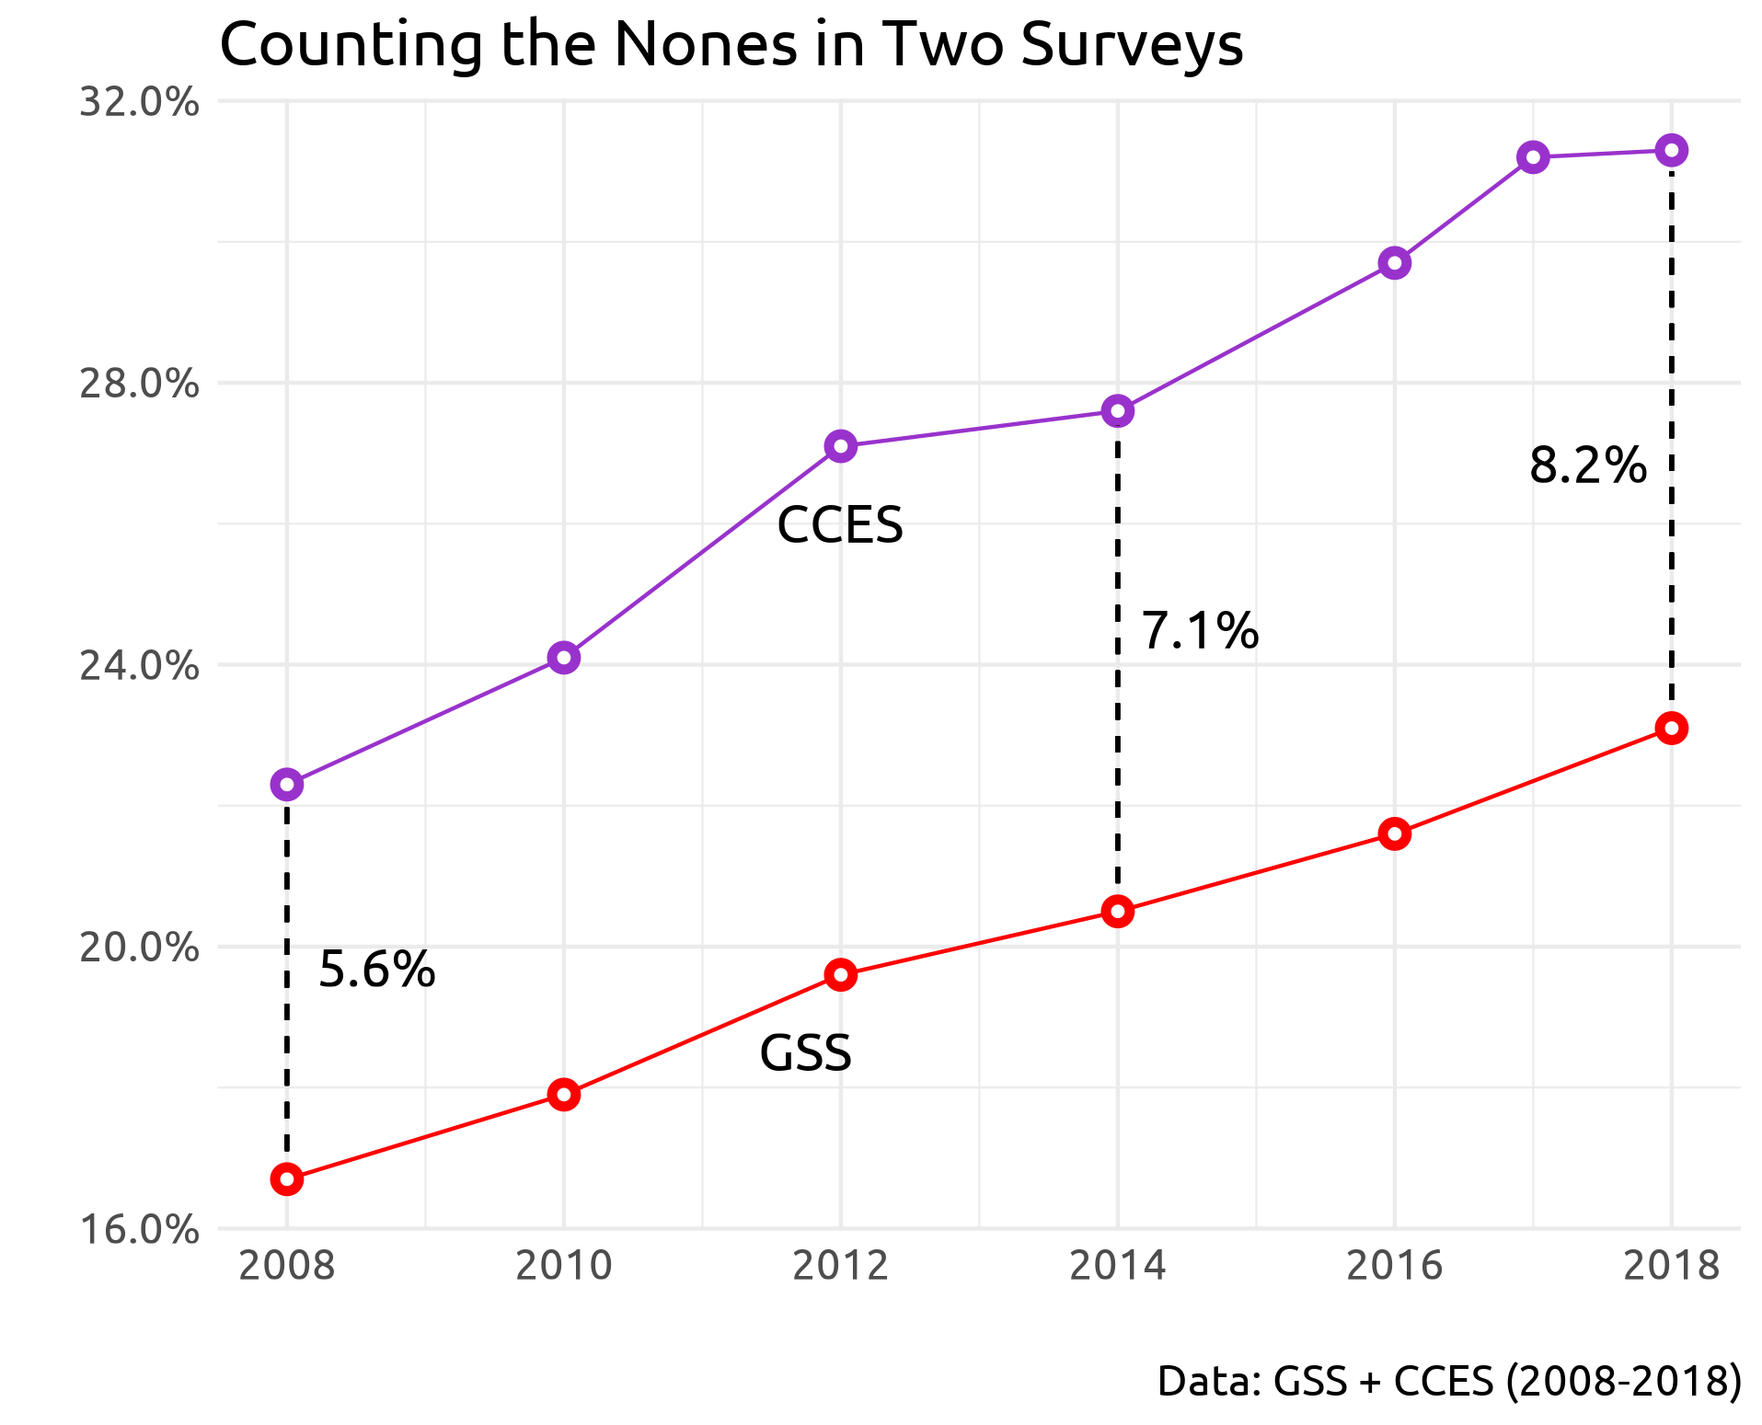

**Figure 2**

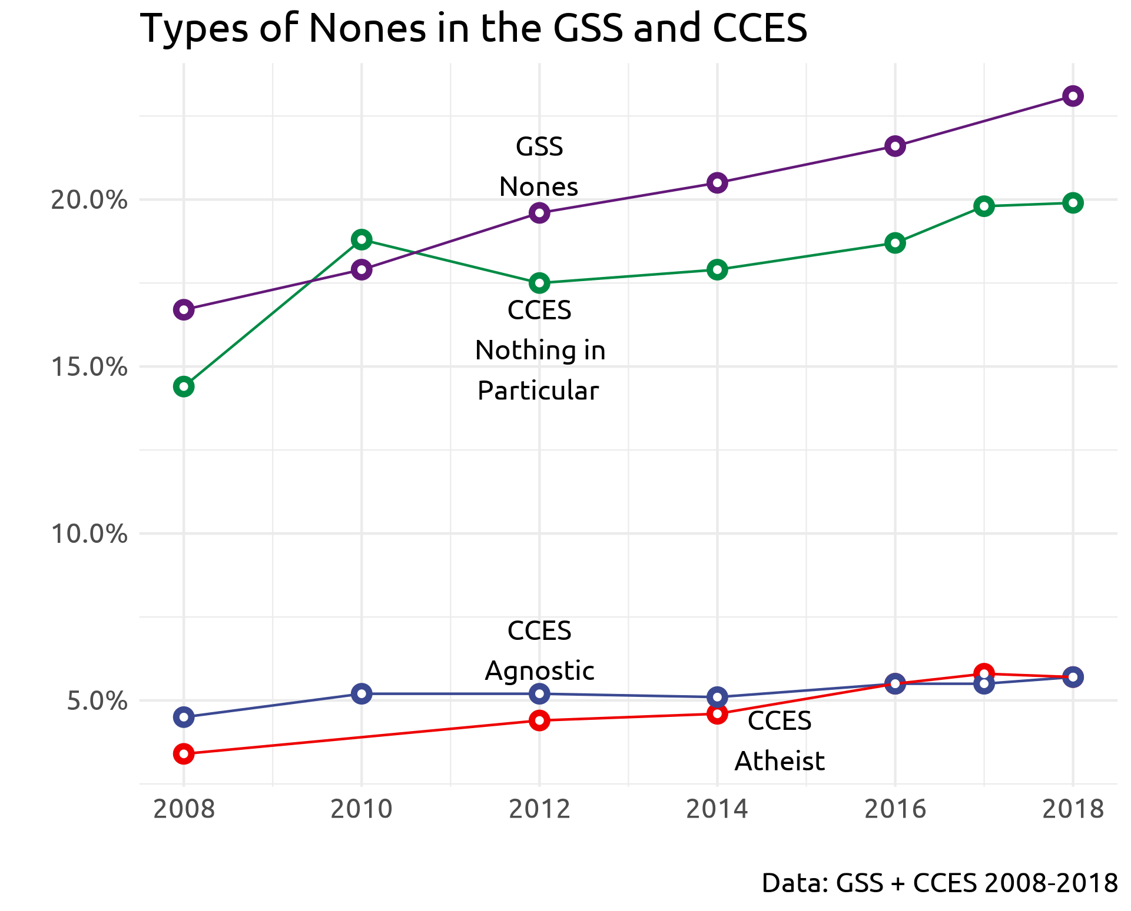

**Figure 3**

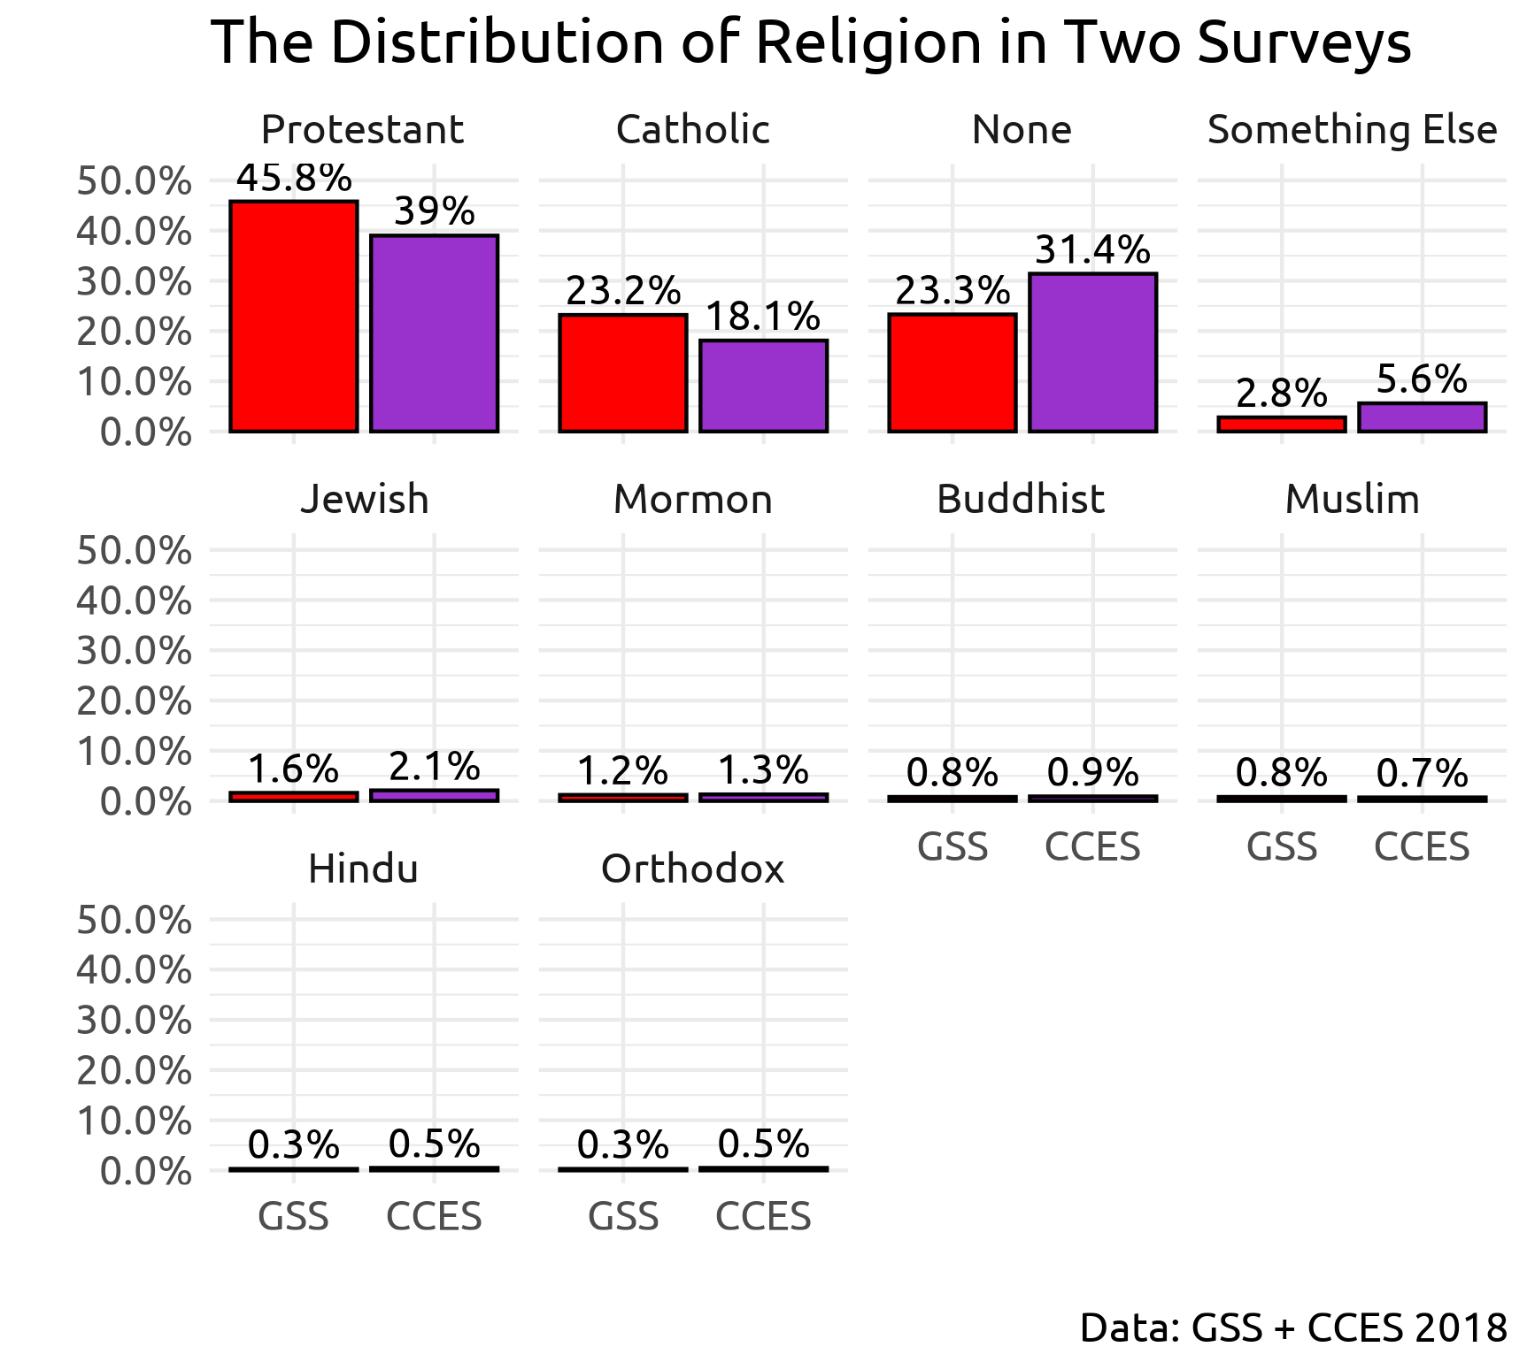

**Figure 4**

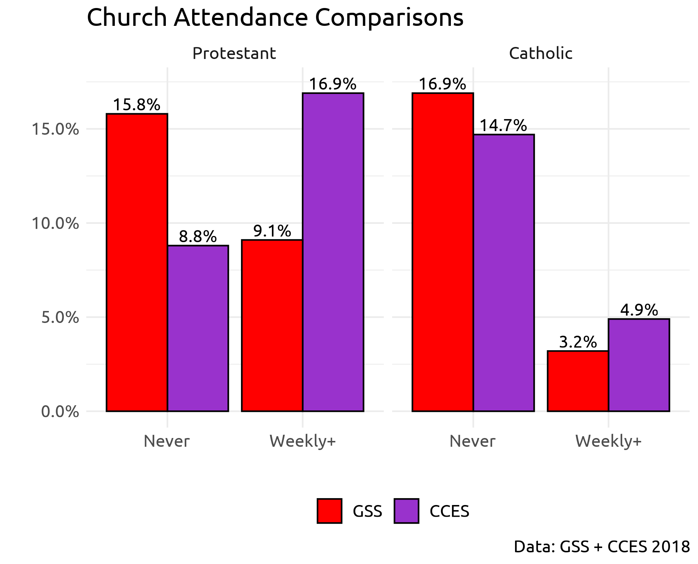

**Figure 5**

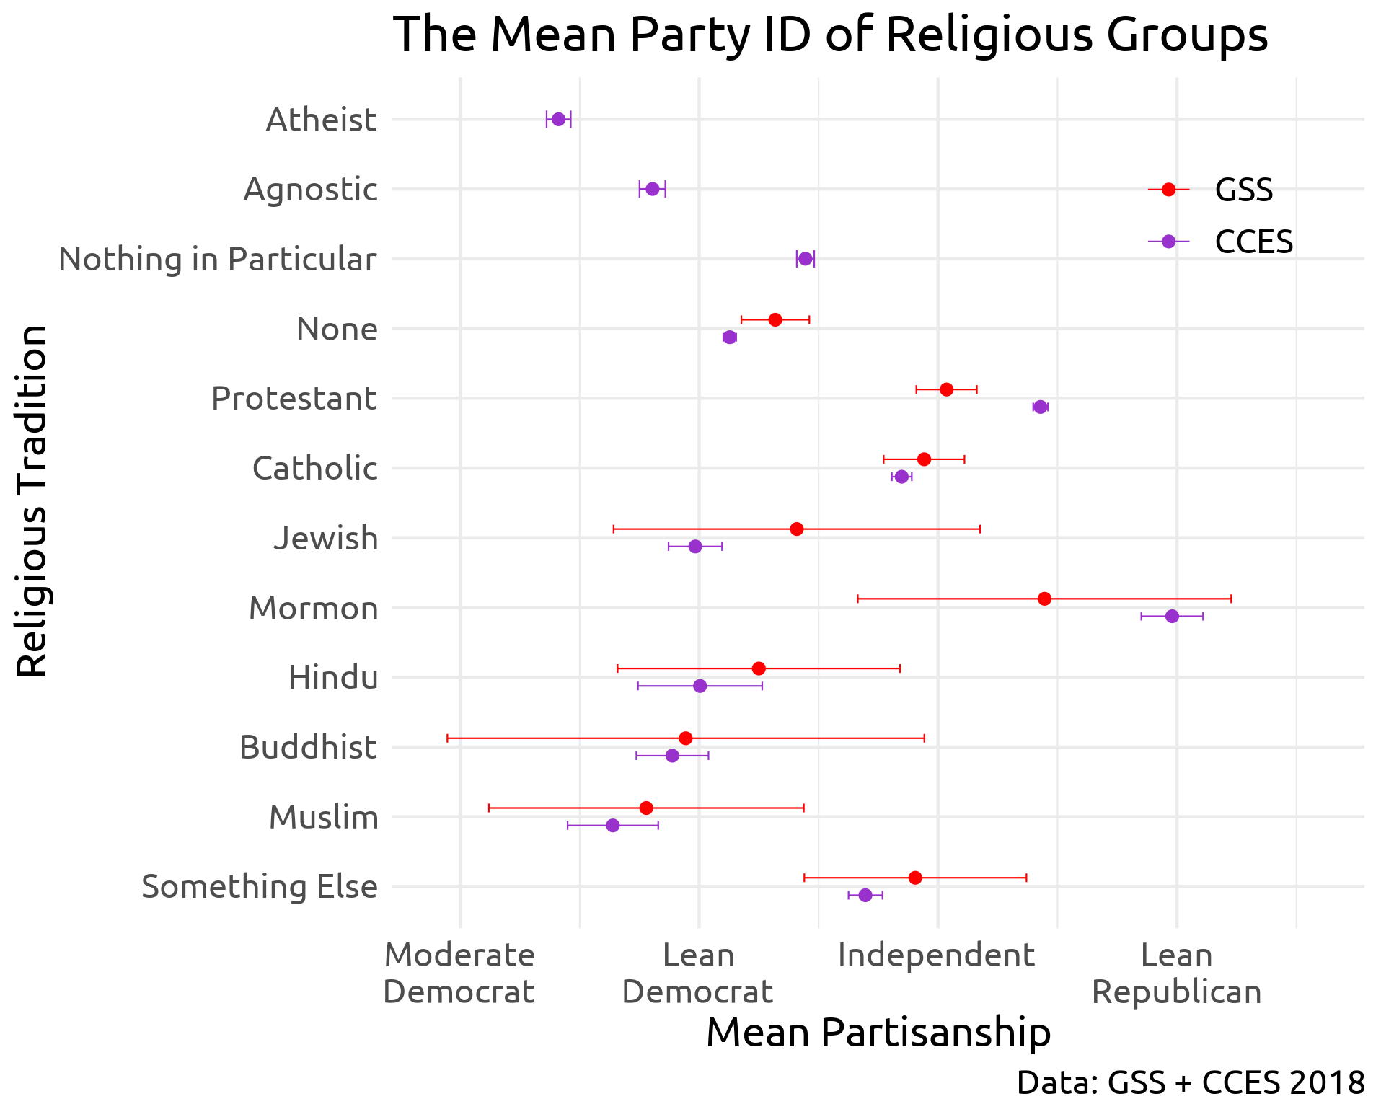

**Figure 6**

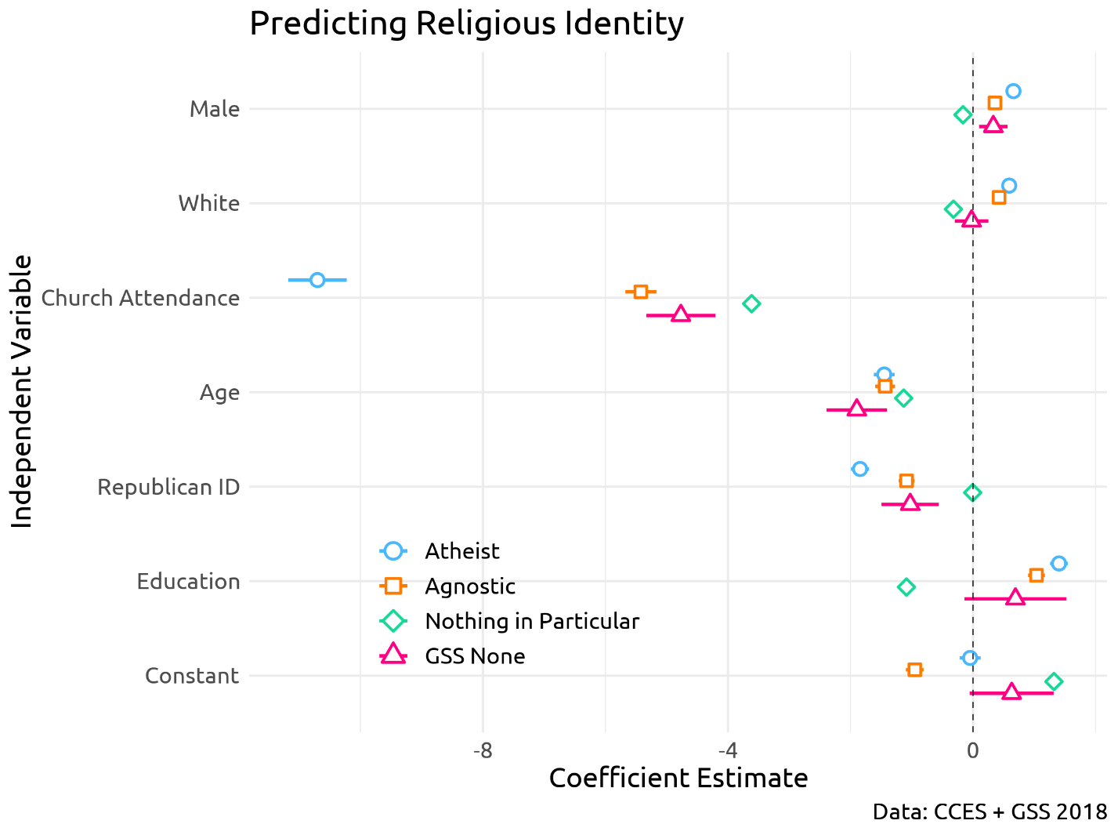

**Work Cited**

Bellah, Robert N. et al. 2007. *Habits of the Heart, With a New Preface: Individualism and Commitment in American Life*. First Edition, With a New Preface edition. Berkeley, Calif. Los Angeles, Calif. London: University of California Press.

Bump, Philip. 2019. “Analysis | Are Nonreligious Democrats Emerging as a Counterweight to the Evangelical Right?” *Washington Post*. https://www.washingtonpost.com/politics/2019/04/01/are-nonreligious-democrats-emerging-counterweight-evangelical-right/ (July 18, 2019).

Caplow, Theodore. 1998. “The Case of the Phantom Episcopalians.” *American Sociological Review* 63(1): 112–13.

Chaves, Mark. 1994. “Secularization as Declining Religious Authority.” *Social Forces* 72(3): 749–74.

Cragun, Ryan T et al. 2012. “On the Receiving End: Discrimination toward the Non-Religious in the United States.” *Journal of Contemporary Religion* 27(1): 105–27.

Cragun, Ryan T. 2019. “Questions You Should Never Ask an Atheist: Towards Better Measures of Nonreligion and Secularity.” Secularism and Nonreligion 8:1-6.

Gervais, Will M, Azim F Shariff, and Ara Norenzayan. 2011. “Do You Believe in Atheists? Distrust Is Central to Anti-Atheist Prejudice.” *Journal of personality and social psychology* 101(6): 1189.

Good, Dorothy. 1959. “Questions on Religion in the United States Census.” *Population Index* 25(1): 3–16.

Green, J.C. 1996. *Religion and the Culture Wars: Dispatches from the Front*. Rowman & Littlefield Publishers.

Hadaway, C Kirk, Penny Long Marler, and Mark Chaves. 1993. “What the Polls Don’t Show: A Closer Look at US Church Attendance.” *American Sociological Review*: 741–52.

———. 1998. “Overreporting Church Attendance in America: Evidence That Demands the Same Verdict.” *American Sociological Review* 63(1): 122–30.

Hammer, Joseph H, Ryan T Cragun, Karen Hwang, and Jesse M Smith. 2012. “Forms, Frequency, and Correlates of Perceived Anti-Atheist Discrimination.” *Secularism and Nonreligion* 1: 43–67.

Hout, Michael. 2017. “Religious Ambivalence, Liminality, and the Increase of No Religious Preference in the United States, 2006–2014.” *Journal for the Scientific Study of Religion* 56(1): 52–63.

Hout, Michael, and Claude S. Fischer. 2002. “Why More Americans Have No Religious Preference: Politics and Generations.” *American Sociological Review* 67(2): 165.

Hout, Michael, and Andrew Greeley. 1998. “What Church Officials’ Reports Don’t Show: Another Look at Church Attendance Data.” *American Sociological Review* 63(1): 113–19.

Hout, Michael, and Andrew M Greeley. 1987. “The Center Doesn’t Hold: Church Attendance in the United States, 1940-1984.” *American Sociological Review*: 325–45.

Karp, Jeffrey A, and David Brockington. 2005. “Social Desirability and Response Validity: A Comparative Analysis of Overreporting Voter Turnout in Five Countries.” *The Journal of Politics* 67(3): 825–40.

Kohut, Andrew, John C. Green, Scott Keeter, and Robert C. Toth. 2001. *The Diminishing Divide: Religion’s Changing Role in American Politics*. Brookings Institution Press.

Lim, Chaeyoon, Carol Ann MacGregor, and Robert D. Putnam. 2010. “Secular and Liminal: Discovering Heterogeneity Among Religious Nones.” *Journal for the Scientific Study of Religion* 49(4): 596–618.

Machalek, Richard, and Michael Martin. 1976. “‘Invisible’ Religions: Some Preliminary Evidence.” *Journal for the Scientific Study of Religion* 15(4): 311–21.

McGuire, William J. 1968. “Personality and Attitude Change: An Information-Processing Theory.” *Psychological foundations of attitudes* 171: 196.

Mohler, Albert. 2019. “The Future of the Southern Baptist Convention: The Numbers Don’t Add Up.” https://albertmohler.com/2019/05/31/the-future-of-the-southern-baptist-convention-the-numbers-dont-add-up (July 18, 2019).

Monahan, Neil. 2019. “Survey: There Are Now as Many Americans Who Claim No Religion as There Are Evangelicals and Catholics.” *CNN*. https://www.cnn.com/2019/04/13/us/no-religion-largest-group-first-time-usa-trnd/index.html (July 18, 2019).

Nederhof, Anton J. 1985. “Methods of Coping with Social Desirability Bias: A Review.” *European journal of social psychology* 15(3): 263–80.

Nederhof, Anton J, and A Gerard Zwier. 1983. “The ‘Crisis’ in Social Psychology, an Empirical Approach.” *European Journal of Social Psychology* 13(3): 255–80.

Patrikios, Stratos. 2013. “Self-Stereotyping as ‘Evangelical Republican’: An Empirical Test.” *Politics and Religion* 6(4): 800–822.

Pearce, Jonathan. 2019. “Religious ‘Nones’ Are Now a Force to Be Reckoned With.” *A Tippling Philosopher*. https://www.patheos.com/blogs/tippling/2019/03/22/religious-nones-are-now-a-force-to-be-reckoned-with/ (July 18, 2019).

Presser, S., and L. Stinson. 1998. “Data Collection Mode and Social Desirability Bias in Self-Reported Religious Attendance.” *American Sociological Review* 63(1): 137–145.

Pew Research Center, Oct. 17, 2019, “In U.S., Decline of Christianity Continues at Rapid Pace.”

https://www.pewforum.org/2019/10/17/in-u-s-decline-of-christianity-continues-at-rapid-pace/

Shelton, Jason E, and Ryon J Cobb. 2017. “Black RELTRAD: Measuring Religious Diversity and Commonality among African Americans.” *Journal for the Scientific Study of Religion* 56(4): 737–64.

Silver, Christopher F, Thomas J Coleman III, Ralph W Hood Jr, and Jenny M Holcombe. 2014. “The Six Types of Nonbelief: A Qualitative and Quantitative Study of Type and Narrative.” Mental Health, Religion & Culture 17(10): 990–1001.

Smith, Tom W. 1991. “Counting Flocks and Lost Sheep: Trends in Religious Preference since World War II.” *GSS Social Change Report* (26): 40–42.

Smith, Tom W., and Seokho Kim. 2005. “The Vanishing Protestant Majority.” *Journal for the Scientific Study of Religion* 44(2): 211–23.

Smith, Tom W, and Seokho Kim. 2007. “Counting Religious Nones and Other Religious Measurement Issues: A Comparison of the Baylor Religion Survey and General Social Survey.” *GSS Methodological Report No. 110*: 17.

Steensland, B., J.Z. Park, M.D. Regnerus, and L.D. Robinson. 2000. “Measure of American Religion: Toward Improving the State of the Art, The.” *Social Forces* 79: 291.

Stetzer, Ed, and Ryan P. Burge. 2016. “Reltrad Coding Problems and a New Repository.” *Politics and Religion* 9(1): 187–90.

Streb, Matthew J, Barbara Burrell, Brian Frederick, and Michael A Genovese. 2007. “Social Desirability Effects and Support for a Female American President.” *Public Opinion Quarterly* 72(1): 76–89.

Sullivan, Amy. 2012. “4. The Rise Of The Nones.” *Time*. http://content.time.com/time/magazine/article/0,9171,2108027,00.html (July 21, 2019).

Svalastoga, Kaare. 1965. *Social Differentiation*. D. McKay Co.

Swatos, William H., and Kevin J. Christiano. 1999. “Secularization Theory: The Course of a Concept.” *Sociology of Religion* 60(3): 209–28.

Troeltsch, Ernst. 1958. “Protestantism and Progress the Significance of Protestantism for the Rise of the Modern World.”

Vernon, Glenn M. 1968. “The Religious" Nones": A Neglected Category.” *Journal for the scientific study of religion*: 219–29.

Weber, M. 2002. *The Protestant Ethic and the “Spirit” of Capitalism and Other Writings*. Penguin Group USA.

Woodberry, Robert D. 1998. “When Surveys Lie and People Tell the Truth: How Surveys Oversample Church Attenders.” *American Sociological Review* 63(1): 119–22.

Yinger, J. Milton. 1969. “A Structural Examination of Religion.” *Journal for the Scientific Study of Religion* 8(1): 88–99.

Zuckerman, Phil, Luke W. Galen, and Frank L. Pasquale. 2016. The Nonreligious: Understanding Secular People and Societies. New York: Oxford University Press.

1. It’s noteworthy that the question in these two surveys differs in one important way: the GSS about “religious preference,” while the CCES asks: “What is your present religion, if any?” The key distinction is the inclusion of the term “preference.” This may lead some respondents to think that this question means: “if I had to choose a religion, what would that be?” versus “what religion do I affiliate with?” This may lead to more GSS respondents choosing a religious tradition that they don’t feel particularly close to, because they “prefer” it to other options, but the extent to which this happens is not discernible with the current data.